**AWS & DEVOPS NOTES**

-------------------------18/12/2023-------------Class 1--------------------

-------------------------19/12/2023------------Class 2---------------------

At first waterfall model is present

At waterfall model if any another new requirements came from client the company will not accept

After waterfall model agile model came they will accept the new requirements of the client

Next by exceeding all these devops came

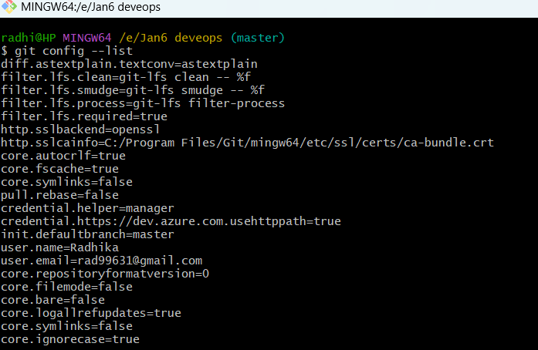

---------------------20/12/2023--------------Class 3---------------------------

What is aws

Aws account creation

----------------------21/12/2023-------------Class 4----------------------------

Creation of windows os(server) on cloud(AWS)platform.

Creation of Ubutu(Linux) os(servers-2) on cloud(AWS)platform.

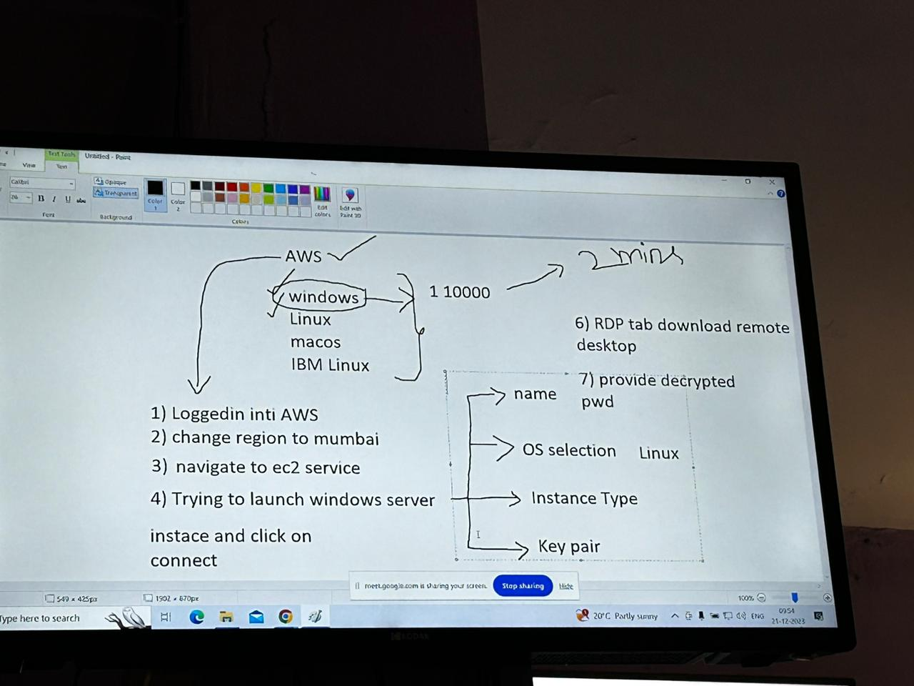

--------------------22/12/2023-----------------Class 5-----------------------------

Ctrl+ (for large screen)

Windows----ui

Macos (donot use it will charge)

1)terminal

2)ui

Linux—terminal

WORKING WITH LINUX

Terminal

1)Linux(versions or flavours: centos, IBM Linux, Amazon Linux, Soft sol)

2)Ubuntu(Ubuntu, Debain, Redhat)

Mostly ubuntu is used in organizations as linux platform

Only centos doesnot have linux extension but it is linux

Administartor

Linux-Ubuntu---root

Creation of windows os(server) on cloud(AWS)platform.

~Tilt path

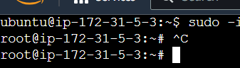

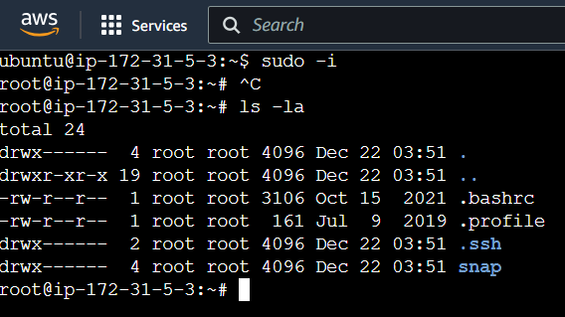

Tilt ane path upside all will present

/---Slash path

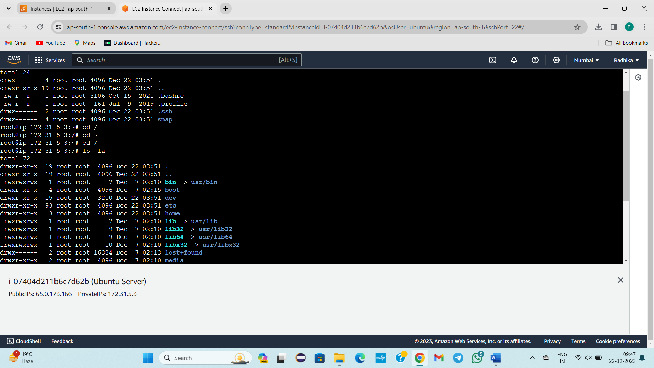

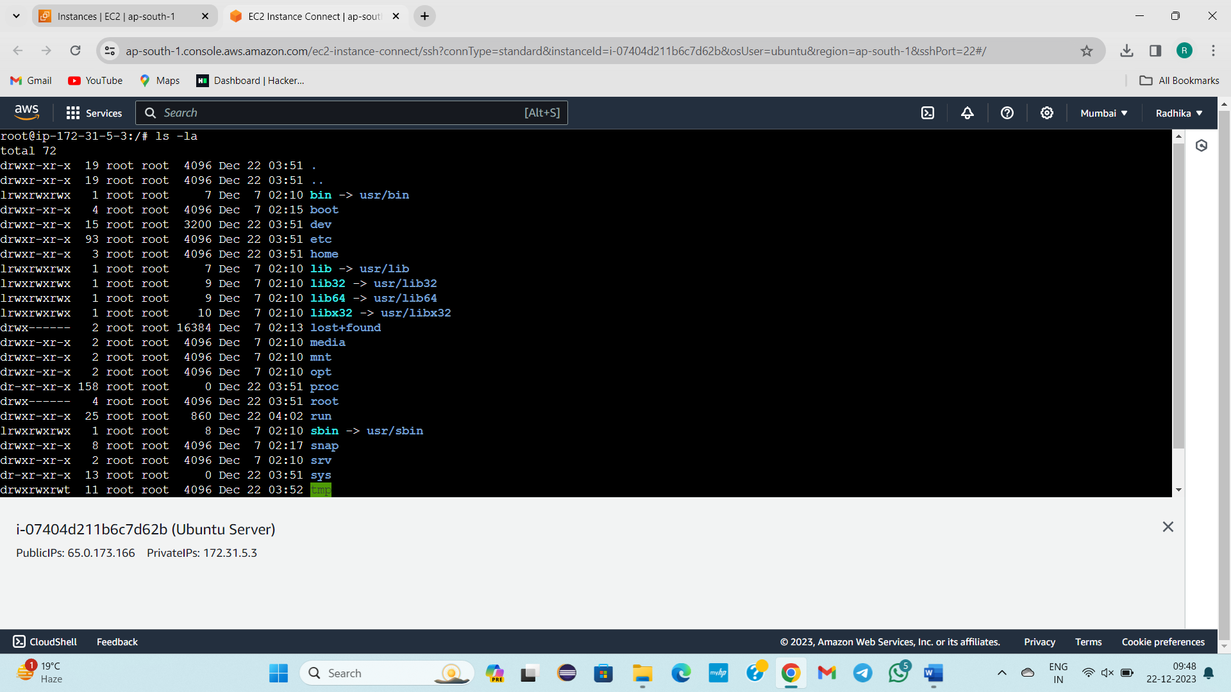

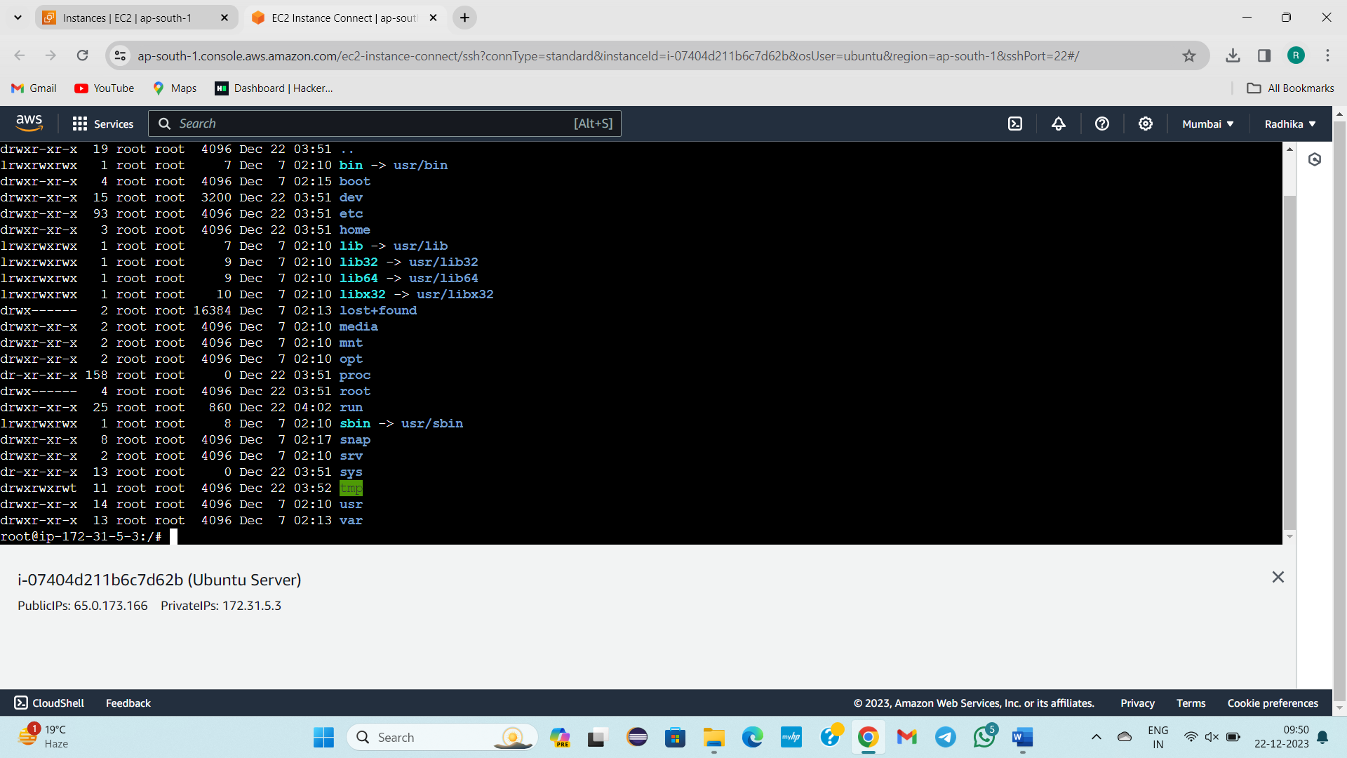

For clearing data – clear

Convert to root user 🡪 sudo -i

~ /

Boot-folder-directory—blue colur—starting d means directory

Lib—Library file

For creation of directory mkdir d1(name)

To check what is inside d1 directory--- cd d1

Ls-la

Empty

Pwd -present working directory

Inside folder , I want to create a file

Touch file1

To Check the Content in file (OR)Content is there in file or not

Cat file1

Another way of creation of file

Touch for empty files creation

Vi for creation of file with data insertion

Esc+I ==insert mode

Esc:wq!==For saving the file in linux

root@ip-172-31-5-3:/# ls -la

total 72

drwxr-xr-x 19 root root 4096 Dec 22 03:51 .

drwxr-xr-x 19 root root 4096 Dec 22 03:51 ..

lrwxrwxrwx 1 root root 7 Dec 7 02:10 bin -> usr/bin

drwxr-xr-x 4 root root 4096 Dec 7 02:15 boot

drwxr-xr-x 15 root root 3200 Dec 22 03:51 dev

drwxr-xr-x 93 root root 4096 Dec 22 03:51 etc

drwxr-xr-x 3 root root 4096 Dec 22 03:51 home

lrwxrwxrwx 1 root root 7 Dec 7 02:10 lib -> usr/lib

lrwxrwxrwx 1 root root 9 Dec 7 02:10 lib32 -> usr/lib32

lrwxrwxrwx 1 root root 9 Dec 7 02:10 lib64 -> usr/lib64

lrwxrwxrwx 1 root root 10 Dec 7 02:10 libx32 -> usr/libx32

drwx------ 2 root root 16384 Dec 7 02:13 lost+found

drwxr-xr-x 2 root root 4096 Dec 7 02:10 media

drwxr-xr-x 2 root root 4096 Dec 7 02:10 mnt

drwxr-xr-x 2 root root 4096 Dec 7 02:10 opt

dr-xr-xr-x 158 root root 0 Dec 22 03:51 proc

drwx------ 4 root root 4096 Dec 22 03:51 root

drwxr-xr-x 25 root root 860 Dec 22 04:02 run

lrwxrwxrwx 1 root root 8 Dec 7 02:10 sbin -> usr/sbin

drwxr-xr-x 8 root root 4096 Dec 7 02:17 snap

drwxr-xr-x 2 root root 4096 Dec 7 02:10 srv

dr-xr-xr-x 13 root root 0 Dec 22 03:51 sys

drwxrwxrwt 11 root root 4096 Dec 22 03:52 tmp

drwxr-xr-x 14 root root 4096 Dec 7 02:10 usr

drwxr-xr-x 13 root root 4096 Dec 7 02:13 var

root@ip-172-31-5-3:/# mkdir d1

root@ip-172-31-5-3:/# ls -la

total 76

drwxr-xr-x 20 root root 4096 Dec 22 04:21 .

drwxr-xr-x 20 root root 4096 Dec 22 04:21 ..

lrwxrwxrwx 1 root root 7 Dec 7 02:10 bin -> usr/bin

drwxr-xr-x 4 root root 4096 Dec 7 02:15 boot

drwxr-xr-x 2 root root 4096 Dec 22 04:21 d1

drwxr-xr-x 15 root root 3200 Dec 22 03:51 dev

drwxr-xr-x 93 root root 4096 Dec 22 03:51 etc

drwxr-xr-x 3 root root 4096 Dec 22 03:51 home

lrwxrwxrwx 1 root root 7 Dec 7 02:10 lib -> usr/lib

lrwxrwxrwx 1 root root 9 Dec 7 02:10 lib32 -> usr/lib32

lrwxrwxrwx 1 root root 9 Dec 7 02:10 lib64 -> usr/lib64

lrwxrwxrwx 1 root root 10 Dec 7 02:10 libx32 -> usr/libx32

drwx------ 2 root root 16384 Dec 7 02:13 lost+found

drwxr-xr-x 2 root root 4096 Dec 7 02:10 media

drwxr-xr-x 2 root root 4096 Dec 7 02:10 mnt

drwxr-xr-x 2 root root 4096 Dec 7 02:10 opt

dr-xr-xr-x 158 root root 0 Dec 22 03:51 proc

drwx------ 4 root root 4096 Dec 22 03:51 root

drwxr-xr-x 25 root root 860 Dec 22 04:02 run

lrwxrwxrwx 1 root root 8 Dec 7 02:10 sbin -> usr/sbin

drwxr-xr-x 8 root root 4096 Dec 7 02:17 snap

drwxr-xr-x 2 root root 4096 Dec 7 02:10 srv

dr-xr-xr-x 13 root root 0 Dec 22 03:51 sys

drwxrwxrwt 11 root root 4096 Dec 22 03:52 tmp

drwxr-xr-x 14 root root 4096 Dec 7 02:10 usr

drwxr-xr-x 13 root root 4096 Dec 7 02:13 var

root@ip-172-31-5-3:/# cd d1

root@ip-172-31-5-3:/d1# ls -la

total 8

drwxr-xr-x 2 root root 4096 Dec 22 04:21 .

drwxr-xr-x 20 root root 4096 Dec 22 04:21 ..

root@ip-172-31-5-3:/d1# pwd

/d1

root@ip-172-31-5-3:/d1# ls -la

total 8

drwxr-xr-x 2 root root 4096 Dec 22 04:21 .

drwxr-xr-x 20 root root 4096 Dec 22 04:21 ..

root@ip-172-31-5-3:/d1# touch file1

root@ip-172-31-5-3:/d1# ls -la

total 8

drwxr-xr-x 2 root root 4096 Dec 22 04:26 .

drwxr-xr-x 20 root root 4096 Dec 22 04:21 ..

-rw-r--r-- 1 root root 0 Dec 22 04:26 file1

root@ip-172-31-5-3:/d1# cat file1

root@ip-172-31-5-3:/d1# vi file3

root@ip-172-31-5-3:/d1# cat file3

radhika slokam

tech

hyd

root@ip-172-31-5-3:/d1#

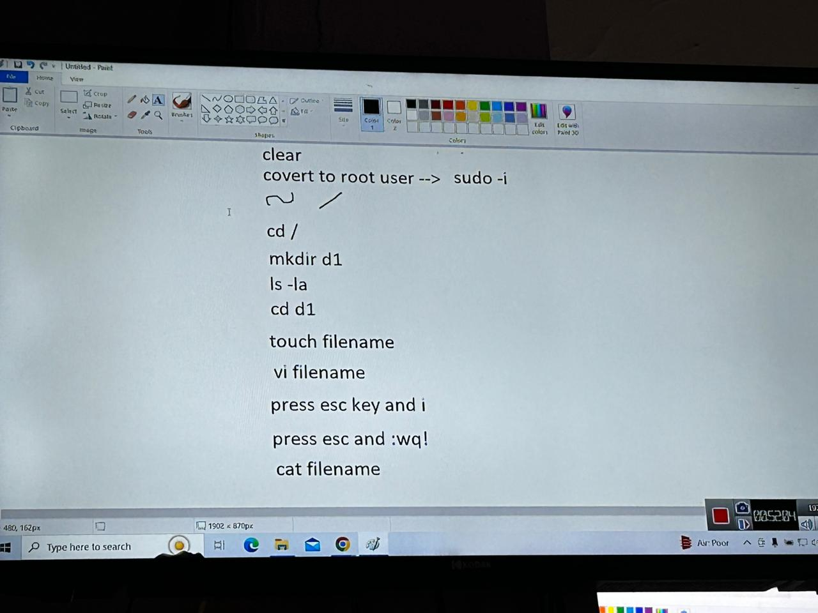

-------------------------------------23/12/2023-Saturday----------------------------------

Due to no network class was not taken

-------------------------------------25/12/2023-Monday---------Class 6-----------------

cd.. - to come back to before path from current path.

cd ../.. (cd /) - come back to slash path

cd press enter - come back to slash path

touch filename1..25 - to create empty files

nested mkdir using to create inside directory

mkdir -p d1/d2 - creating nested directory

esc yy - used to copy - for single line

esc p - used to paste - for single line

esc dd - to delete the line - for single line

esc 10dd -to delete 10 lines

esc u - get deleted data

esc :se nu - get data with line number

esc H - starting of the line in file

esc G - ending of the line in file

esc / - search mode

exit - get back fromroot user to ubtuntu user

by default

vi sudo - it is a file. provide details. Yes Y or No N Y+enter

to save file ctrl+x +enter

sudo touch file name - to create file in ubuntu

sudo mkdir directory name - to create directory in ubuntu

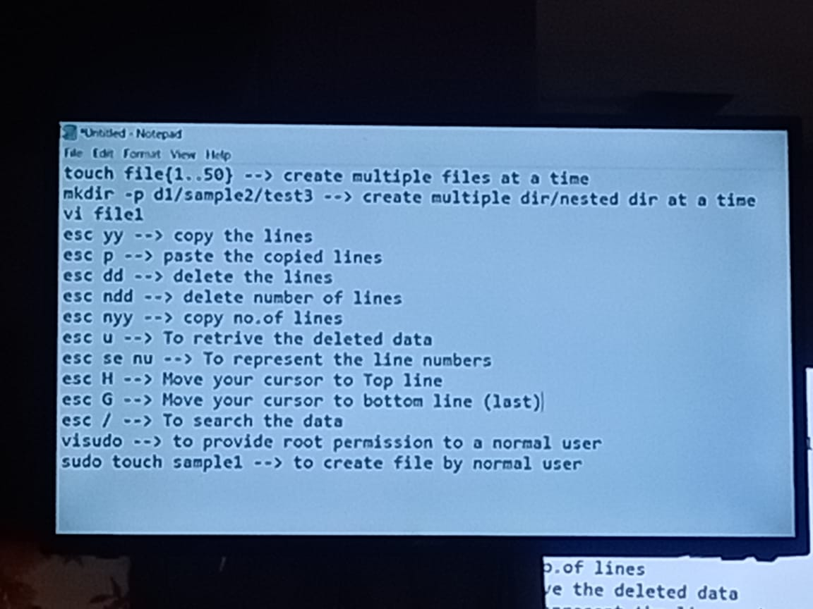

---26/12/2023-------------------Tuesday--------------Class 7--------------------------

Topic: Permissions(Directory Permission, File Permission)

Cd opt

Ls -la

Cat file 3 – For Printing All lines

I want to print only last 10 lines data

Tail file3 increment order

I want to print only first 10 lines data

Head file3 increment order

For Editing file -vi filename

Now I want only starting 2 lines = head -2 file3

Now I want only ending 2 lines = tail -2 file3

Cd ..

# path has no of dir,lib files

Any operating system will contain These permissions for directories and files

r-Read- 4

w-Write- 2

x- Execution- 1

Directory permissions:

7,5,5 is default permission of directory

Rwx||r-x||r-x

users(creator of directory[full access]),groups(cannot write),others

4+2+1 = full fledged permission value(777)

How to change a default directory to full fledged access

* Chmod 777 d1

Ls -la

Now when we come to windows

And check in properties, security and you change the permissions

FILE Permissions:

6 4 4 is default permission of file

umask—Internally value of directory

0022

Now change to full fledged access

* chmod 777 file1

Ls -la

Now I want to give execution permission to users,write access for the groups, write access for the others

6,4,4🡪1,2,2

* chmod 122 file2

Ls -la

umask—Internally value of directory

0022

022

7 7 7

0 2 2 –umask value

7 5 5

**Ctrl+c** for getting back if mistakes typed

Unmask value is only for Directory not for files

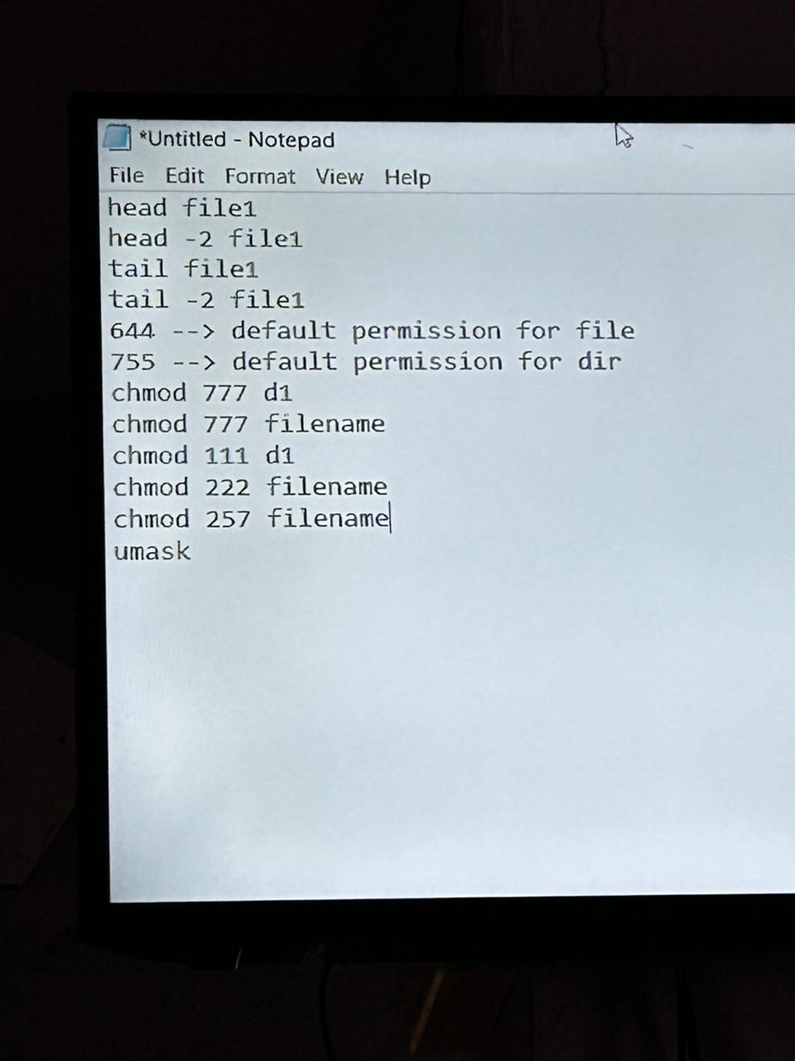

---27/12/2023-------Wednesday------------------------Class 8----------------------

Topic: Linux commands

We are using / path 🡪 Opt directory for practice

rm -rf file1 –remove recursive force – To remove file

rm-rf* -to remove everything in opt

rmdir –to remove directory

rm -rf file1 file2 – For removal of multiple files

In windows how we copy and paste in one folder to another folder just by ui usage.

But how to do in linux

Cp samplefile1 test1 ---For single file copy and paste in particular directory

Cp filename filename……directory name ---For multiple files copy and paste in particular diectory

Opt/test1

Opt

touch sample2

How to cut the particular file and paste in particular directory?

Mv sample2 test1

Source---destination

Mkdir test2

Ls -la

How to copy the particular directory and paste in particular directory?

Cp -r test2 test1(copy and paste)

Ls -la

Cd ..

Mkdir test3

How to cut the particular directory and paste in particular directory?

Mv -f test3 test1(for cut and move)

Mv -f test3 test4 test1(multiple for cut and move)

In windows in taskmanager we can see all ruuning, processors,cpu, memory, backgroundrunning processors.

How to see this all in linux by commands

Df -Th

free -m(memory related data)

//free -cpu()

du -h(how much memory used how they are using)

df -Th(disk related things)

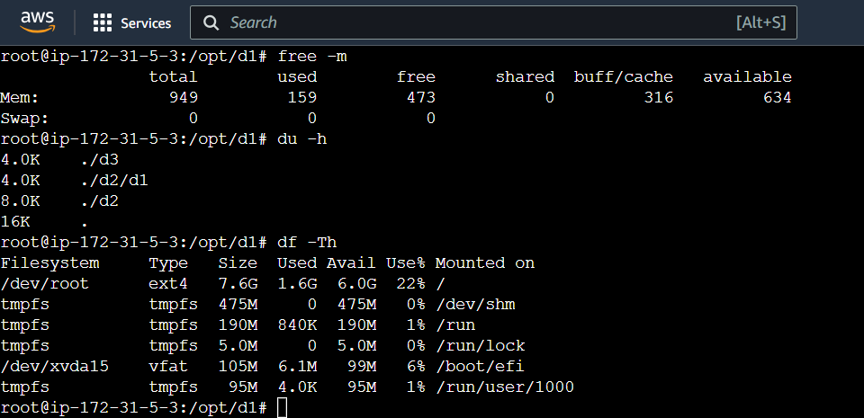

linux related data in # path& disk like c drive

When we creating os in aws

windows os creates with 30GB max

linux os creates with 8GB max

For logs for applictions in linux where they will store actuall\y

In var

cd var

cd log

where log files generate

var .log

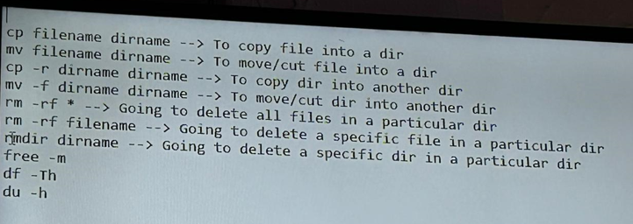

Commands:

root@ip-172-31-5-3:/opt/d1# free -m

total used free shared buff/cache available

Mem: 949 159 473 0 316 634

Swap: 0 0 0

root@ip-172-31-5-3:/opt/d1# du -h

4.0K ./d3

4.0K ./d2/d1

8.0K ./d2

16K .

root@ip-172-31-5-3:/opt/d1# df -Th

Filesystem Type Size Used Avail Use% Mounted on

/dev/root ext4 7.6G 1.6G 6.0G 22% /

tmpfs tmpfs 475M 0 475M 0% /dev/shm

tmpfs tmpfs 190M 840K 190M 1% /run

tmpfs tmpfs 5.0M 0 5.0M 0% /run/lock

/dev/xvda15 vfat 105M 6.1M 99M 6% /boot/efi

tmpfs tmpfs 95M 4.0K 95M 1% /run/user/1000

root@ip-172-31-5-3:/opt/d1# cd ..

root@ip-172-31-5-3:/opt# cd ..

root@ip-172-31-5-3:/# ls -la

total 92

drwxr-xr-x 20 root root 4096 Dec 27 04:53 .

drwxr-xr-x 20 root root 4096 Dec 27 04:53 ..

-rw------- 1 root root 12288 Dec 25 05:29 .file2.swp

lrwxrwxrwx 1 root root 7 Dec 7 02:10 bin -> usr/bin

drwxr-xr-x 4 root root 4096 Dec 7 02:15 boot

drwxrwxrwx 4 root root 4096 Dec 25 15:57 d1

drwxr-xr-x 15 root root 3200 Dec 27 04:53 dev

drwxr-xr-x 93 root root 4096 Dec 26 05:06 etc

-rwxrwxrwx 1 root root 0 Dec 25 15:56 file1

-r---w---x 1 root root 0 Dec 25 15:56 file2

-rw-r--r-- 1 root root 0 Dec 25 15:56 file3

-rw-r--r-- 1 root root 0 Dec 25 15:56 file4

-rw-r--r-- 1 root root 0 Dec 25 15:56 file5

-rw-r--r-- 1 root root 0 Dec 25 05:24 file{1...50}

drwxr-xr-x 3 root root 4096 Dec 22 03:51 home

lrwxrwxrwx 1 root root 7 Dec 7 02:10 lib -> usr/lib

lrwxrwxrwx 1 root root 9 Dec 7 02:10 lib32 -> usr/lib32

lrwxrwxrwx 1 root root 9 Dec 7 02:10 lib64 -> usr/lib64

lrwxrwxrwx 1 root root 10 Dec 7 02:10 libx32 -> usr/libx32

drwx------ 2 root root 16384 Dec 7 02:13 lost+found

drwxr-xr-x 2 root root 4096 Dec 7 02:10 media

drwxr-xr-x 2 root root 4096 Dec 7 02:10 mnt

drwxr-xr-x 4 root root 4096 Dec 27 05:06 opt

dr-xr-xr-x 160 root root 0 Dec 27 04:53 proc

-rw-r--r-- 1 root root 60 Dec 25 16:03 radhika

drwx------ 6 root root 4096 Dec 26 04:51 root

drwxr-xr-x 25 root root 840 Dec 27 04:54 run

lrwxrwxrwx 1 root root 8 Dec 7 02:10 sbin -> usr/sbin

drwxr-xr-x 8 root root 4096 Dec 7 02:17 snap

drwxr-xr-x 2 root root 4096 Dec 7 02:10 srv

dr-xr-xr-x 13 root root 0 Dec 27 04:53 sys

drwxrwxrwt 11 root root 4096 Dec 27 04:59 tmp

drwxr-xr-x 14 root root 4096 Dec 7 02:10 usr

drwxr-xr-x 13 root root 4096 Dec 7 02:13 var

root@ip-172-31-5-3:/# cd var

root@ip-172-31-5-3:/var# ls -la

total 52

drwxr-xr-x 13 root root 4096 Dec 7 02:13 .

drwxr-xr-x 20 root root 4096 Dec 27 04:53 ..

drwxr-xr-x 2 root root 4096 Dec 25 16:05 backups

drwxr-xr-x 11 root root 4096 Dec 22 04:02 cache

drwxrwxrwt 2 root root 4096 Dec 7 02:12 crash

drwxr-xr-x 40 root root 4096 Dec 22 03:51 lib

drwxrwsr-x 2 root staff 4096 Apr 18 2022 local

lrwxrwxrwx 1 root root 9 Dec 7 02:10 lock -> /run/lock

drwxrwxr-x 10 root syslog 4096 Dec 27 04:53 log

drwxrwsr-x 2 root mail 4096 Dec 7 02:10 mail

drwxr-xr-x 2 root root 4096 Dec 7 02:10 opt

lrwxrwxrwx 1 root root 4 Dec 7 02:10 run -> /run

drwxr-xr-x 7 root root 4096 Dec 7 02:17 snap

drwxr-xr-x 4 root root 4096 Dec 7 02:11 spool

drwxrwxrwt 6 root root 4096 Dec 27 04:59 tmp

root@ip-172-31-5-3:/var# cd log

root@ip-172-31-5-3:/var/log# ls -la

total 2296

drwxrwxr-x 10 root syslog 4096 Dec 27 04:53 .

drwxr-xr-x 13 root root 4096 Dec 7 02:13 ..

-rw-r--r-- 1 root root 444 Dec 7 02:13 alternatives.log

drwx------ 3 root root 4096 Dec 22 03:51 amazon

drwxr-xr-x 2 root root 4096 Dec 7 02:16 apt

-rw-r----- 1 syslog adm 35009 Dec 27 04:55 auth.log

-rw-rw---- 1 root utmp 5760 Dec 26 04:59 btmp

drwxr-x--- 2 _chrony _chrony 4096 Dec 22 03:51 chrony

-rw-r----- 1 root adm 21332 Dec 27 04:53 cloud-init-output.log

-rw-r----- 1 syslog adm 851192 Dec 27 04:53 cloud-init.log

drwxr-xr-x 2 root root 4096 Aug 2 15:53 dist-upgrade

-rw-r----- 1 root adm 41349 Dec 27 04:53 dmesg

-rw-r----- 1 root adm 41297 Dec 26 04:45 dmesg.0

-rw-r----- 1 root adm 13070 Dec 26 03:46 dmesg.1.gz

-rw-r----- 1 root adm 13133 Dec 25 15:55 dmesg.2.gz

-rw-r----- 1 root adm 13023 Dec 25 14:17 dmesg.3.gz

-rw-r----- 1 root adm 13308 Dec 25 05:17 dmesg.4.gz

-rw-r--r-- 1 root root 22158 Dec 7 02:16 dpkg.log

drwxr-sr-x+ 3 root systemd-journal 4096 Dec 22 03:51 journal

-rw-r----- 1 syslog adm 371179 Dec 27 04:53 kern.log

drwxr-xr-x 2 landscape landscape 4096 Dec 22 04:02 landscape

-rw-rw-r-- 1 root utmp 292292 Dec 27 04:54 lastlog

drwx------ 2 root root 4096 Dec 22 03:51 private

-rw-r----- 1 syslog adm 775232 Dec 27 05:08 syslog

drwxr-x--- 2 root adm 4096 Dec 25 16:05 unattended-upgrades

-rw-rw-r-- 1 root utmp 27264 Dec 27 04:54 wtmp

root@ip-172-31-5-3:/var/log#

LINUX COMPLETED

------------------------02/01/2024-----Tuesday------CLASS-9-----------------

GIT, GITHUB STARTED

Devops Tools:-

Git, ---5-7 days

Maven,

Tomcat server,

Docker,

Kubernetes,

Terraform,

Jenkins,

Ansible

AWS SERVICES

SO FAR EC2 SERVICE COMPLETED

* GIT is a source code management tool(SCM tool or Version Control tool)
* Developers, testers, …etc will use git
* A developer stores his code in github
* Github is for storage purpose. Github is not a software
* Git tool is in blw local system and github
* GIT helps to move the code written in local system to github
* SVN, GIT BUCKET, GIT LAVEN are other tools similar to git
* But GIT is widely used in organizations
* We can learn git in 2 ways
* 1)UI BASED 2)TERMINAL BASED(IN ORGANIZATIONS MOSTLY USED AND ASKED IN INTERVIEWS)
* Install Git
* D 🡪folder🡪gitdecpractice🡪git bash riht click
* Commands
* Git status
* Error will occur – fatal error(in that particular folder .git must be there)
* git init –initializing git(.git directory came)
* git status
* clear
* When you hit init command directories and folders cretes 3 phases
* 1)workspace area — untracked files message comes

2)staging/index area – changes to be committed

3)Local repository – working tree clean

* Touch filename(abc.java)—For creating empty file
* Ls -la

I want to check in which phase the abc.java

* Git status – untracked files
* Git add abc.java
* Git status
* Git commit -m “testing purpos[label message]”
* Configure email,username
* Git status
* Touch file1,java file2.java
* Git status
* Git add file1.java file2.java
* Git add .(untracked to staging area)
* Git commit -m ”1st commit”
* Git status

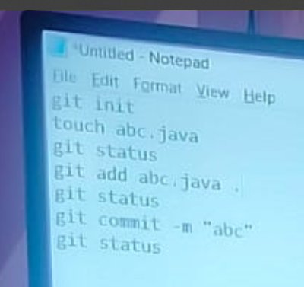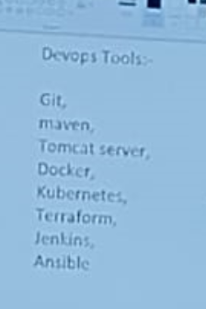  
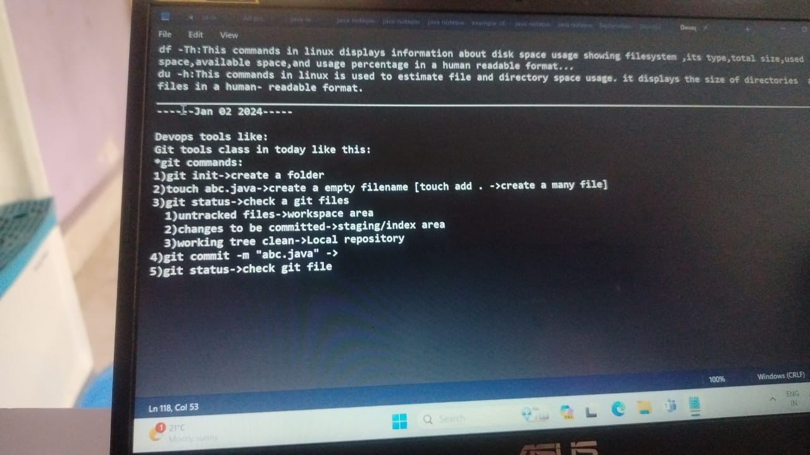

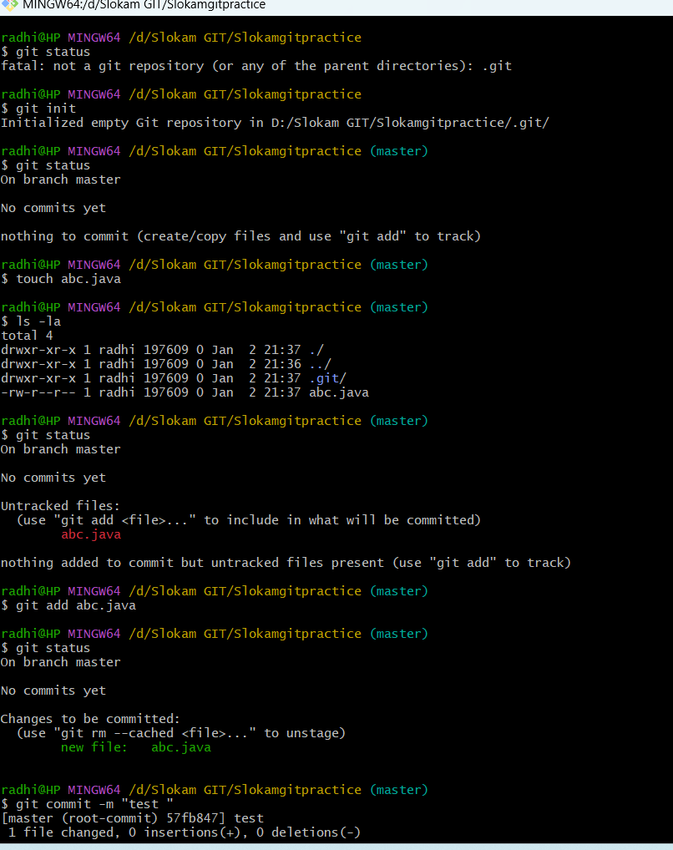

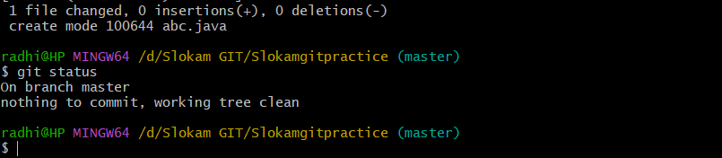

--------------03/01/2024---WEDNESDAY------------------DAY-10------------------

Git GitHub

1)workspace area — untrac How to move files from local repository

ked files message comes to Github?

We need to create a repository and

Store/move files to this repository.

Create Github account and create rep

ository for storing files

2)staging/index area – chang

es to be committed

3)Local repository – worki

ng tree clean

repository—decdevops

GitHub is running where?

It is coming from server, Running online. But git is running in my local computer

Git—github repository communication must build to move files for this we have 2 ways

1)got github 🡪code🡪https🡪url🡪d drive🡪slokam Git🡪gitbash🡪git clone copied url🡪done🡪check in slokam GIT🡪dec devops created[repository created as folder]

git clone url—builds communication b/w git and github

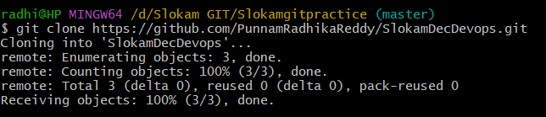

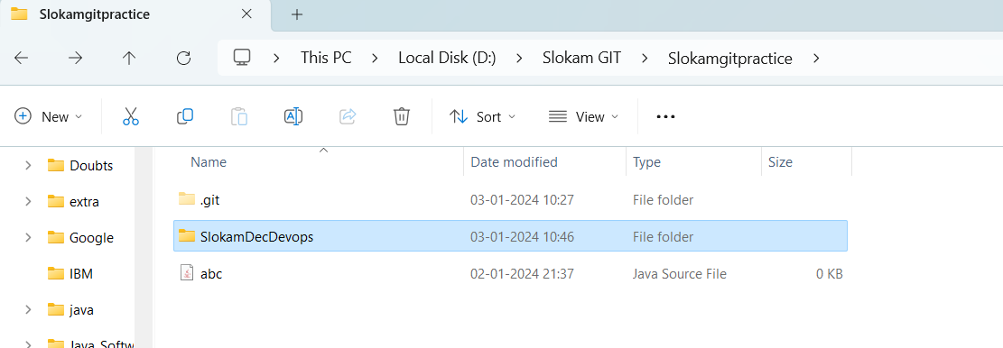

ls -la

cd decdevops/

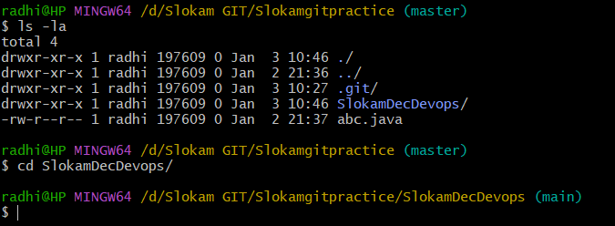

(master – main branch changed)

ls – la

touch test1.java test2.java

git status

When .git comes automacatically three stages creates

git add .

git commit -m “label message[slokam]”

git status

git push

[Sign in with browser for first time only]

Local[ main]🡪github repository [main]

How to add some data and create files and send to github?

vi file1

:wq! Save

cat file1

git status

git add .

Warning comes

git status

git commit -m “testdata in file”

git status

git push

Local, local repository, repository 3 are different terminologies

Cut paste outside the decdevops folder to inside decdevops 3 files abc, file1, file 2

git status

git add .

git status

git commit -m “yesterday files”

git status

git push

[main-main]

How to change username and email in the git and also how to check the changed email and username?

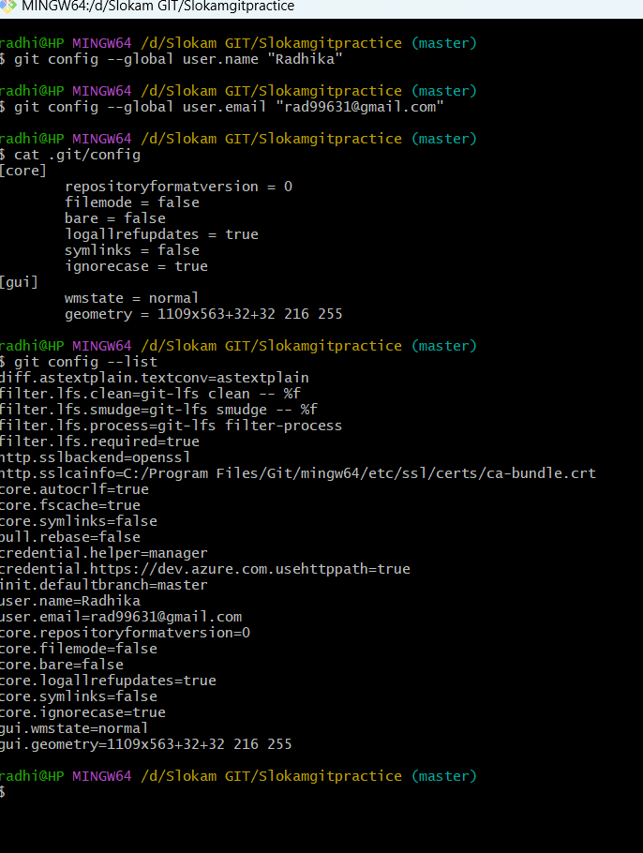

-----------------04-01-2024-------Thursday---DAY - 11-------------------------------

New repository in github

Click on new

I need create some files

I clone the repository into yesterday folder

So, that it comes as the folder

git clone url

ls -la

cd decdevops1/

master🡪main

creating files------------

touch file{1…10}

ls -la

git status(untracked files)

git add .

git status(changes to be committed)

git commit -m ”test”

git status(working tree clean)

Now I need to represent files along with working tree clean for that

Git log(By this command all commits will display)

By this only label message commitID

Git show commitID(take our own commitID)

CommitID is 42 characters by default

Each and every commitId is unique

Initial commit is label message(by default) for readme file which is generated by github due to cloning

Clear

Git show commitID(of Initial commit)

Touch file11

Git status(work space area)

Git add .

Git status(staging area)

Git commit -m “testing”

Git status(working tree clean[label message] )

Git log

Take commitID based on label message

Git show commitID

Git push

Create two files

Git log

CommitID is starting 7 charactes in github & 42 charcters in git

Touch sample1

Git status

Git add .

Git status

Git log

Git commit -m ”sample1 file commit”

Git status

Git log

Latest commit on upside or (HEAD->MAIN)OR based on label message

Same label message I will create another file

Touch sample2

Git add .

Git commit -m “sample1 file commit[same labelmessage but different file creation]”

Git status

Git log

With one label message we can do any no of commits

Git show commitID(sample1)

Git show commitID(sample2)

Now I want do some changes to sample2 which in local repository before sending to github

Git status

Git log

Take commitID below it

Git reset --soft commitID

Git status(staging area[sample2 is reverted back in to staging area])

Git reset head sample2

Git status

Now you can edit file

vi sample2

git add .

warning comes it is not a message ,it is warning

git commit -m” modified sample2 file”

git status

git log

Now only one commitID is for sample2

git show commitID

How to take directly from local repository to workspace area

Git log

Git reset --mixed commitID[Directly to work space area]

Git status

Sample1, sample2 reverted back

Git add .

Git commit -m “slokam”

Git status

Git log

5🡪4 commits

Git show commitID[which consists of 2 files ]

--------------take/GOTO initial commit directly-------------

Git log[4 commits]

Soft— to revert back in to staging area, from local repository

Git reset head file name – to revert back file from staging to workspace area

Mixed -- to revert back directly in to workspace area, from local repository

Git reset –mixed commitID[OF INITIAL COMMIT]

Git status

Vi file9

Git add .

Git status[staging area]

Git commit -m “final commit”

Git status[working tree clean]

Git log

[Only two commits present

1)final commit

2)initial commit]

Git push[error occurs because already we pushed some files in to github]

Failed to push is the error to resolve this use git pull

Git pull

Esc :wq!

Git push

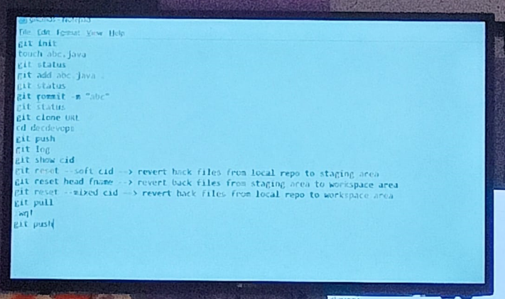

--------------------------05-01-2024-----------Friday----DAY - 12---------------------

Topic: BRANCHES

Git log---to display commitIds

To check particular commit

Git show commitid

A file in local repository to revert back we done it

Git reset—3 commands

Suppose we already pushed code in to github, again local repository files reverted back and pushed means we will get error. To solve this error, git pull then git push

Today’s topic BRANCHES

Git branches are very impotant

Ex:

Suppose take amazon application. When you login to amazon application, you can select products and you can do payment, when you login on special days, we have offers.

Amazon—1000

Amazon on special days(&updates)----5000

🡪🡪You go to any source code management tool the branches topic is common

For what branches used?

If we want to do changes for existing application, then branches are used

Branches:

1)main

2)master

Ex:

Google page changes

The updates will be done while in production server(already ruuning) only.

How to do changes without disturbing users

--------------------------06-01-2024--------Saturday----DAY - 13---------------------

Topic: GIT BRANCHING STRATEGY

Branches:

1)Main- Application related code[Final app code]

2)Develop-Final app code[Purpose of this develop branch is for backup]

Naming Conventions for branches: [If developer wants to work on new tasks/updates the developer need to give the naming convention as below]

1)feature- in application any new feature is to be added

2)Bugfix

3)Releases

1)Feature

Feature-update-task[mail notification-changes]

Feature-update-task[cameraoption-changes]

We need to give naming conventions for branches like above

2)Bugfix[HOTFIX]

To fix bugs the naming conventions are below

bugfix-gmail-release

hotfix nothing but bugfix

Ex:if bug comes

bugfix-gmail-release

3)Releases:

If any new features are added to an application then we release release1.x[it consists of 5 to 6 tasks

* Releases are rarely used
* Feature and bugfix are widely used

Repository is created by scrum master/ Manager in software industry

We as developer we create only 3 branches

1)Feature

2)Bugfix

3)Releases

gitdecbranches

gitbash here

git init

git clone url

ls -la

cd decdevops1/

Master🡪main

git branch [To represent /Check we are in which branch]

To create new branch in terminal the command is:

git branch features-updates-sample-updates[brach name]

git branch[It represents how many branches]

To switch/move from main to new created branch

git checkout features-updates-sample-updates[brach name]

ls -la

touch sampletest10 sampletest11

git status

git add .

git status

git commit -m “branches prac”

git status

git log [For commitIds]

git show commitid

For pushing different branch to github repository

git push origin features-updates-sample-updates[brach name]

[features-updates-sample-updates🡪 features-updates-sample-updates]

git checkout main

ls -la

git pull

ls -la

git branch

git branch bugfix-sample practice-release[from main branch it is creating]

git checkout bugfix-sample practice-release

ls -la

vi sampletest10—we added datain existing file

Slokamtech

git status[stages not staged for commit-madified]

git add .

git status

git commit -m ”bugfix test”

git status

git push origin branch name[bugfix-sample practice-release]

Merging in github in sample10

git checkout main

ls -la

cat sampletest10(no data visible)

For data visibility in our branch

git pull

cat sampletest10

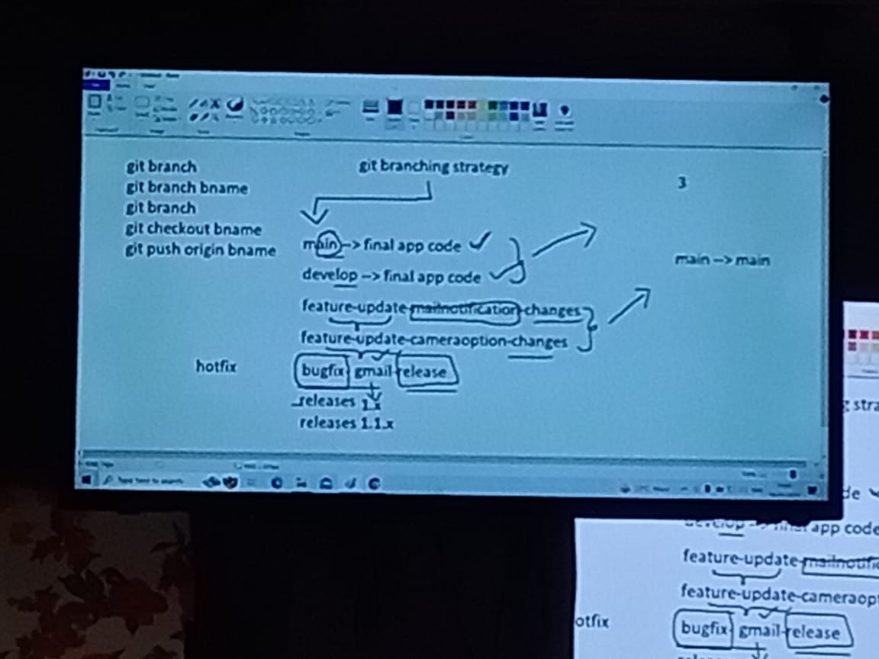

--------------------------08-01-2024--------Monday----DAY - 14---------------------

TOPIC: How to create file, commit, create branches in ui directly in github

* Open github
* Open existing repository in github
* Click on main
* Type Newtest in search box
* Click on create
* In terminal git branch newtest

For creation new file

UI:

Add file either upload or create

samplegitui

TERMINAL:

Touch filename

Vi filename

NEXT STEPS

UI:

Commit changes

Commit message

Commit changes

Terminal:

Git add .

Git commit -m “label message”

FOR CHECKING FILES

Git log

Git show”commitID”

STEPS:

UI:

1)File creation[Work space area]

2)commit[Local repository]

TERMINAL:

1)Workspace area

2)Staging area

3)Local repository

3 stages [11 – 12 rec listen]

WHY 3 STAGES means while creation of . git file these 3 stages creates

* Click on Compare and pull request in github
* Give Description
* Click on Create pull request

FOR DELETION OF BRANCHES:

* In ui[github] by single click
* Listen 19 -20
* Create another file
* Go to filefolder 🡪 we have already cloned repository
* Git bash
* Ls -la

Git pull

Git push

Ls -la

Git branch

Git branch terminaltest(branch name)

Git brach

Git checkout terminaltest

Ls -la

Touch Test.java

Git status

Git add .

Git status

Git commit -m “terminal changes”

Git push(main branch)

Git push origin branchname(Other branches)

INTERVIEW QUESTION:

[How merge directly in terminal and send to the github repository?]

OR

WITHOUT PULLREQUEST AND MERGE REQUEST HOW WE CAN MERGE?

Git branch

Git checkout main

**Git merge terminaltest**

Ls -la

Git push

==============================

Git checkout ternminal test

Touch test2.java

Git status

Git add .

Git status

Git commit -m “new file creation”

Git checkout main

Git merge terminaltest

Ls -la

Git push

--------------------------09-01-2024--------Tuesday----DAY - 15---------------------

COLLABORATORS ACCESS

Create branch clone repository

Branch name –Punnam RadhikaReddy

Git checkout to my own data

Some empty files 10 files

No pull requests

------------------------------10-01-2024---Wednesday------Day – 16-------------------

TOPIC: INSTALLATIONS

* UI Based Application
* Micro Services Application
* Deployment in different environment like docker, Tomcatserver
* In Devops process when can deploy any kind of application
* Jdk,ECSLPISE/VSCODE are required for preparing applications
* JDK INSTALLATION PROCESS EXPLAINED
* PATH SETTING

Application Deployment ways:

1)Tomcat Server

Web logic

IBM server[web Applications]

2)Docker

3)Kubernetes

--------------------------11/01/2024--------Thursday-----Day-17-----------------------

Topic: How To build UI pages using the html in maven project.

How to download tomcat server

How we are navigating from one page to another page.

---------------------------12/01/2024—18/01/2024--------------------------------------

SANKRANTI HOLIDAYS

-------------------------19/01/2024----------Friday--------------Day-18-----------------

Topic: How the Application is deployed on to the server.

How to install maven build tool and set path

Right click+view page source to view code

Applications deployment (5-9 min)

TestUI – maven project name

Bulid Tool

1)Ant

2)Gradle

3)Maven

.war/.jar/.ear are the server understandable languages

So finally,

* When you want to deploy the html pages on the server donot deploy the each and every individual page separately.
* When you try to deploy the each and every individual html page separately you will face the issues/ or you will get errors.
* Because there is always linkage between the html pages.
* When you deploy every individual html page separately. You will get errors.
* So, You we must deploy the whole application once.
* If we want to deploy the application to the server. I mean if the server want to accept the application, It must be in the server readable format right. For that we need to convert our whole application in to .war/.jar/.ear

SERVER READABLE FORMATS

* .WAR
* .JAR
* .EAR

For converting to any one of these server readable formats. We have the Build Tools

BUILD TOOLS FOR CONVERTING IN TO SERVER READABLE FORMATS

1)Ant

2)Gradle

3)Maven

In present software industry Maven is widely used

So, Download OR Copy from pen drive Maven Build Tool

If it is a Zip file unzip the file by extractall

Next Paste in any drive either C/D/E drives

After that Copy path as below

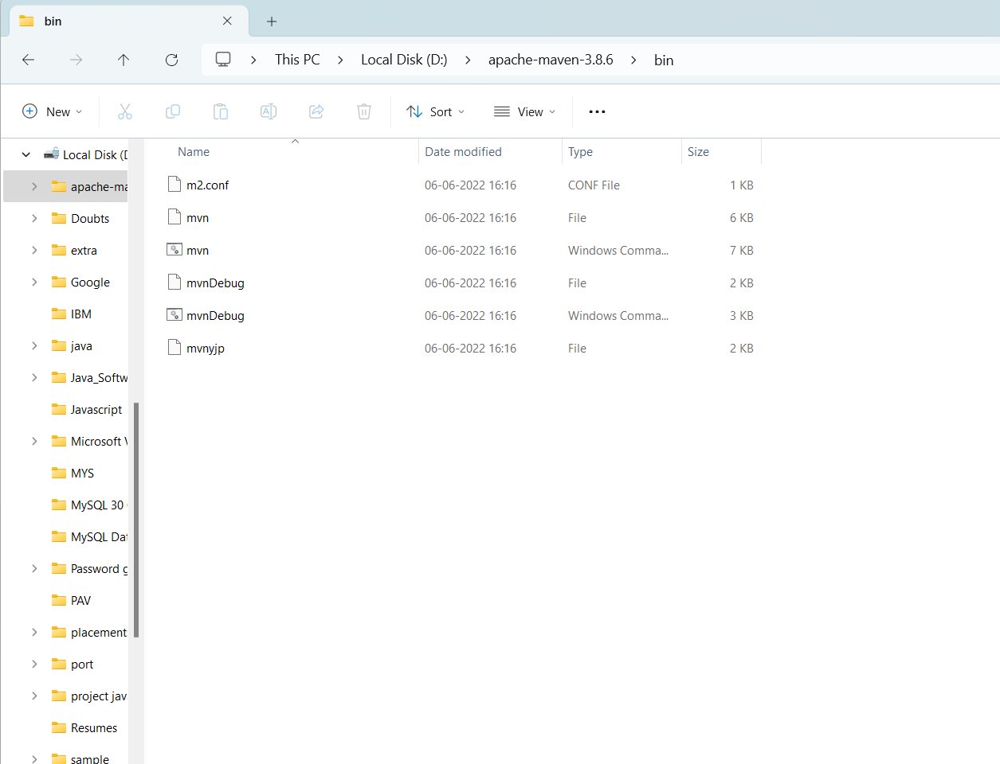

Now we need to set the path

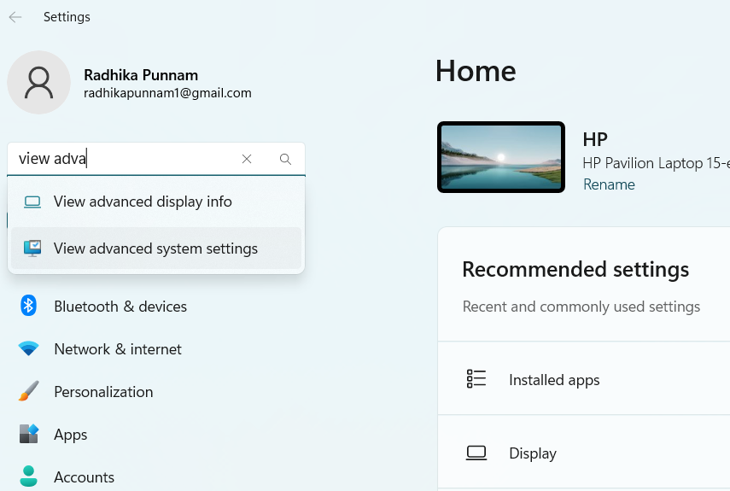

Go to View advanced System settings as above

Next go to environment variables

In User Variables click on new

Give Variablename: mvn

Give Variablevalue: D:\apache-maven-3.8.6 (Remove bin here)

In System variables click on path and come to last double click paste the below path

D:\apache-maven-3.8.6\bin

For checking either maven tool is successfully installed or not goto command prompt and enter mvn it must come BUILD FAILURE

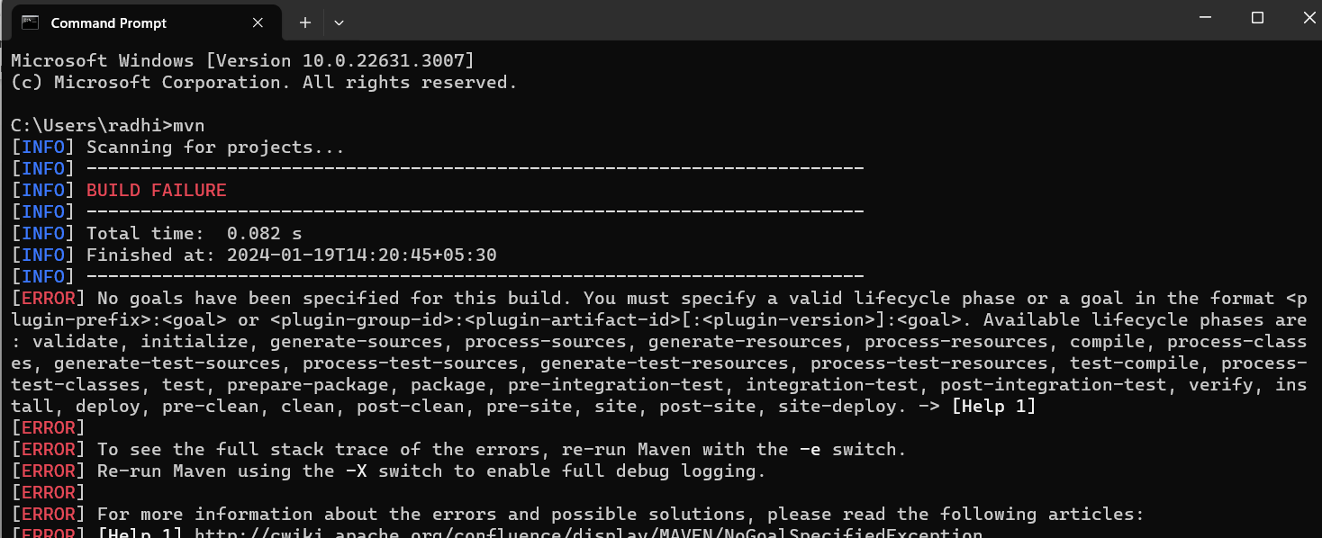

-----------------------------20/01/2024----Saturday------Day-19-----------------------

Topic: How to convert entire application/Project into single .**war/.ear/.jar** file using maven build tool to deploy in to server

* Maven is a build tool. Maven is not used for deployment. It is used to convert entire project into single file(**.war/.ear/.jar**).
* Deployment done in server.
* In organizations will have many developers in that one developer is working on **TestUI** application.
* If we are working on **TestUI** application, with this application name in eclipse we can observe **Folder Structure**
* In **TestUI** developer created number of files(file.HTML) and all files are tested in **Tomcat server**
* Every application is are giving excepted output. With this testing is completed in local
* Now developer move code to **Testing phase** with the help of connecting to **GitHub Repository** along with entire files here developer will add another file with **.war/.ear/.jar** format
* In real time files mostly converted into **.war/.jar format**
* Very rare cases files converted to **.ear format**
* Now totally 6 files will move to GitHub including with **.war** file
* With this development work is completed
* Now Testers will work on testing the project for this Tester will connect with GitHub
* With the help of GitHub Testers will collect code and they test in different ways like:
* Positive case
* Negative case
* Neutral case

All 6 files will check in these phases

After completion of testing testers will send to **UAT (user acceptance testing)**

Testers will send only .**war/.jar/.ear** files to **UAT** for testing purpose

Here they deploy **.war/.jar/.ear files** into some severs.

Physically few clients will test end-to-end in servers like application is working correctly or not.

How many seconds application is taking time to login?

Everything will be noted in **UAT environment**

Here also application is working correctly then finally they will deploy application in server

If any issues are occurring then **UAT team** will send **.war/.jar/.ear** files back to **Testing team.** For example, if application is taking more time to open another page, then here, we need waste time like this if we have any time out issue then immediately, they will report to testing team. Immediately testing will send bug to developers.

Then developer will fix the bug and developer will create new **.war/.jar/.ear** files and developer will push into GitHub repository. already in GitHub repository we have 6 files if we are pushing new then that file will replace with old folder

Again, testers will test where developers add new things in all cases. After completing the testing again testers will send **.war/.jar/.ear** files to **UTA Team.**

Now **UAT Team** will re-deploy the **.war/.jar/.ear** files into sample server. Then clients will check end-to-end. Now everything is fine.

Finally, **UAT Team** will deploy the **.war/.jar/.ear** files into **production server.**

Now real user can use application by using **URL.**  This will access from **production server**(**.war/.jar/.ear** files)**.**

**QAT – Quality Analysis Testing**

**Testers**

**Test UI**

**Git**

**repository**

**production server**

**.war/.jar/.ear**

S1

**UAT – User Acceptance Testing**

**war/.jar/.ear**

S2

S3

Before Devops all these is happening. Now all these are doing only Devops Engineer we by using some tools Devops engineer will deploy it will be **Tomcat, Docker, Kubernetes terraform** etc.…

**How to convert TestUI folder into .war/.jar/.ear fil?**

Now we are converting **TestUi folder** into **.war file**

* Right click on **application**

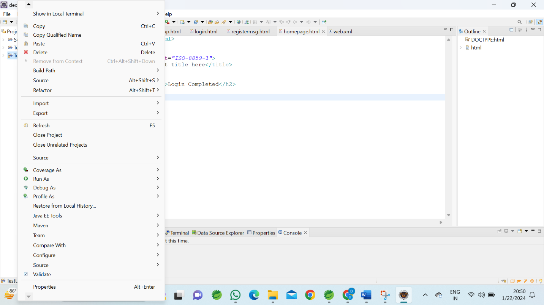

* Go to **Properties**

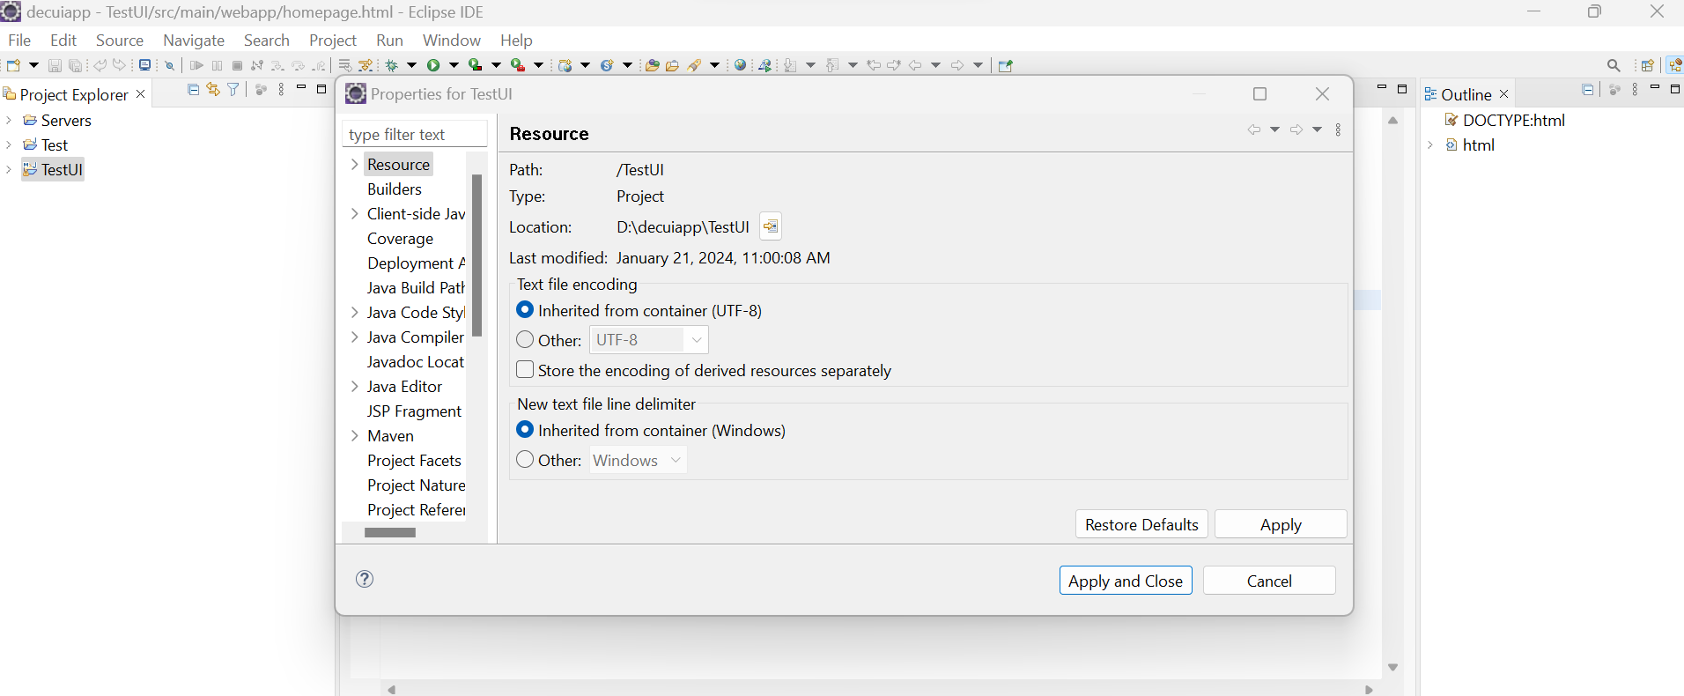

* Click on **Location – window**

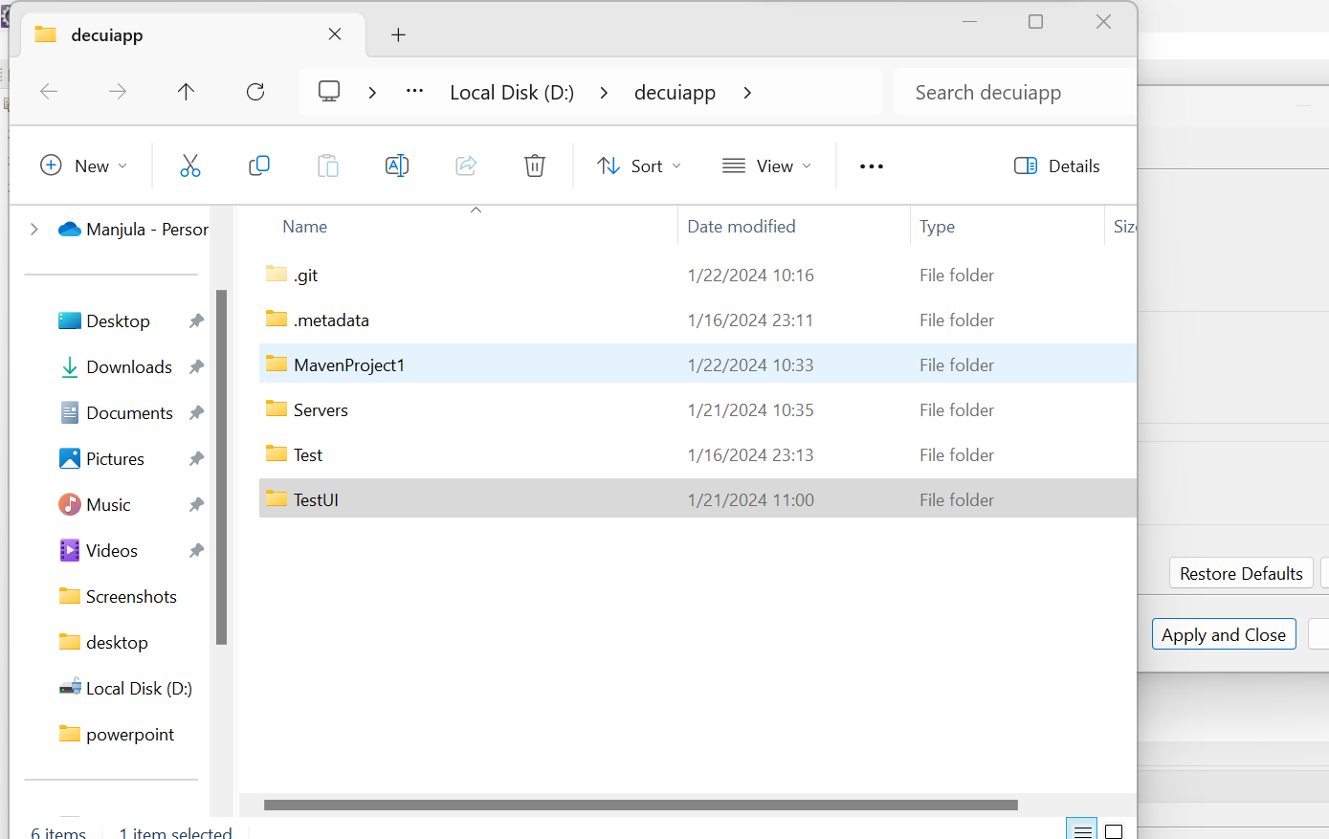

* it shows Location of **TestUI**
* open **TestUI**

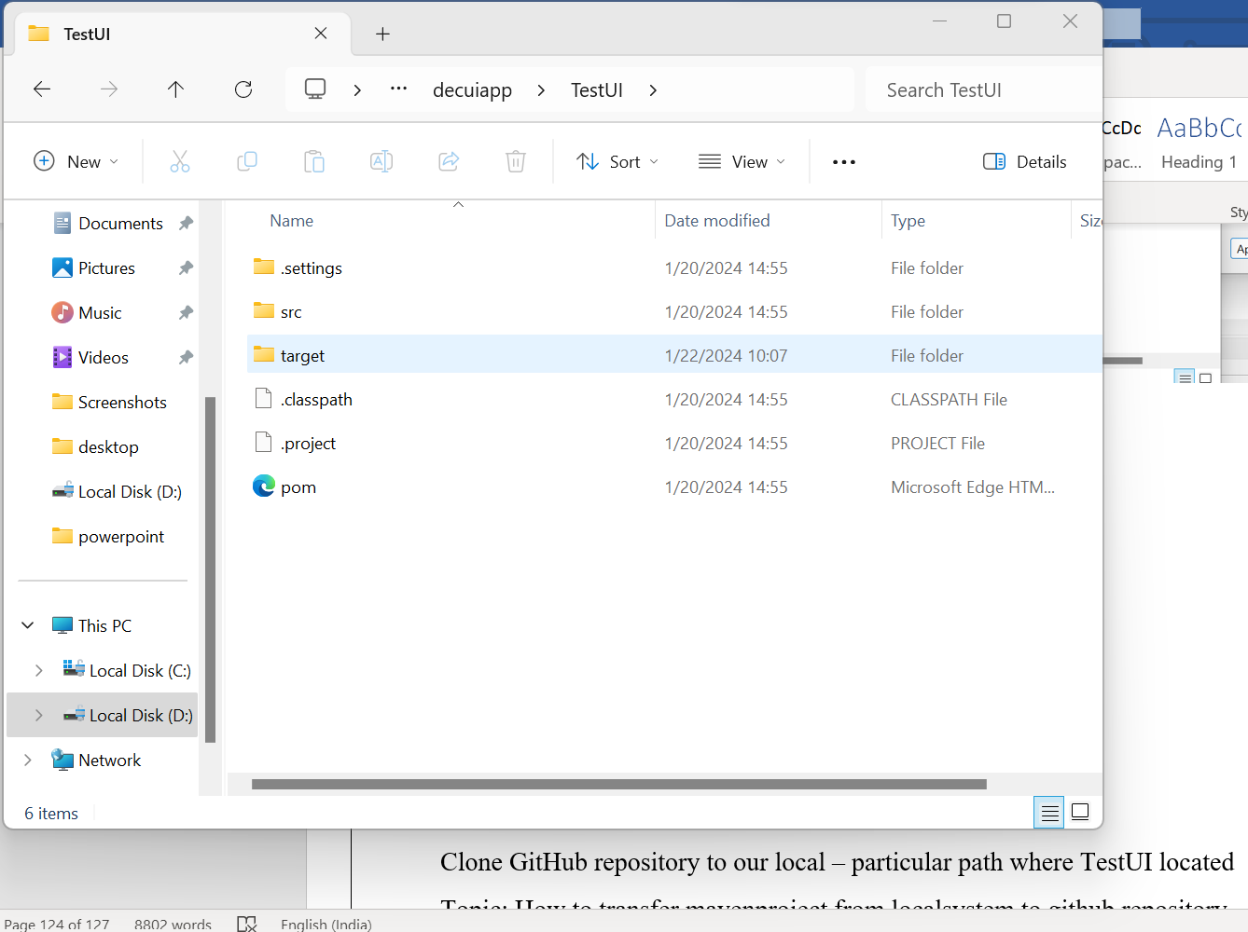

* edit address and type **cmd**

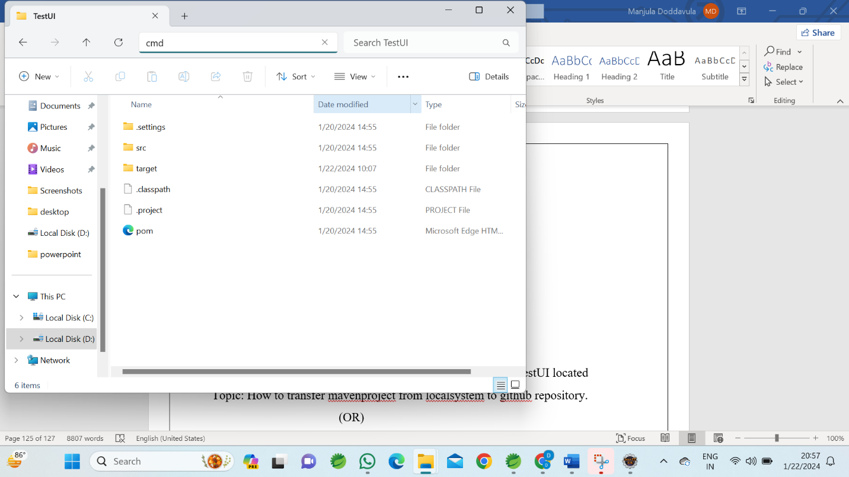

Then **cmd** will open

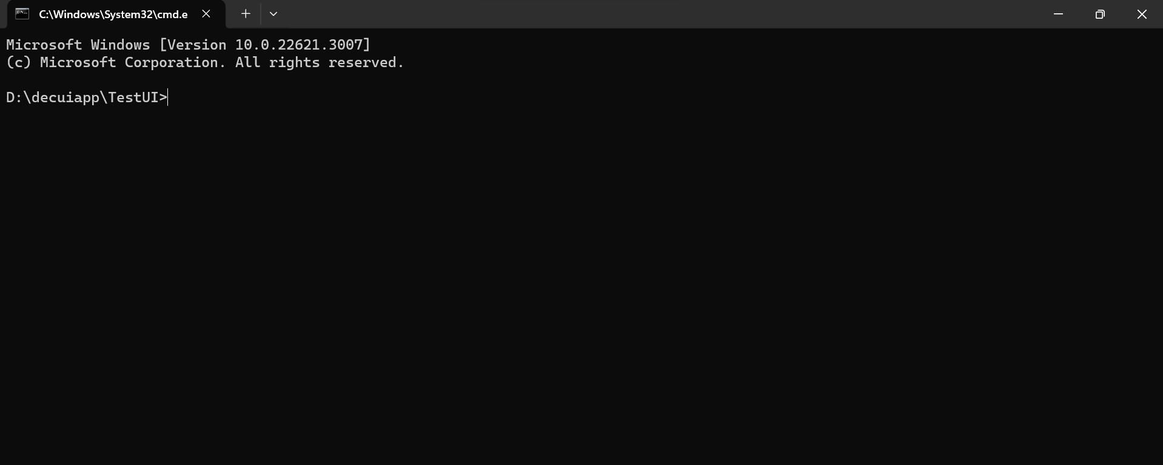

In this window we type **maven** commands to convert **TestUI application** into Single **.war file**

**Step 1:**

**mvn clean – press enter –** now entire **TestUI** application if we any issues immediately here it will clean if we have Any issue then it will display errors in **cmd**

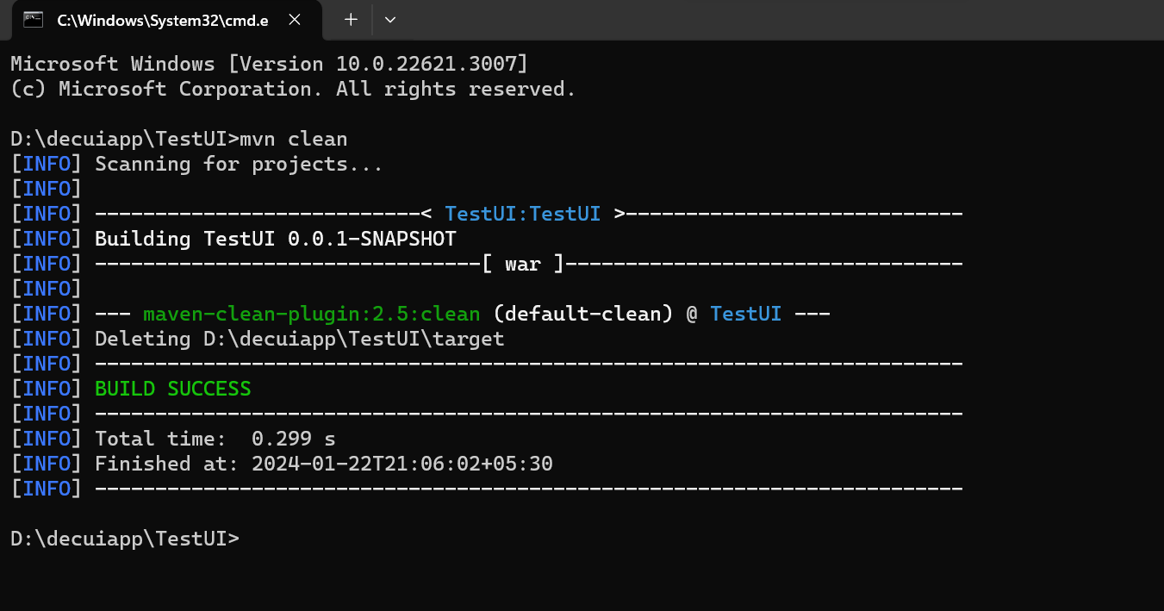

Here we don’t have any issues so here it will display **Build Success**

If we have any issues so here it will display **Build failure**

Here target folder deleted in **TestUI** folder

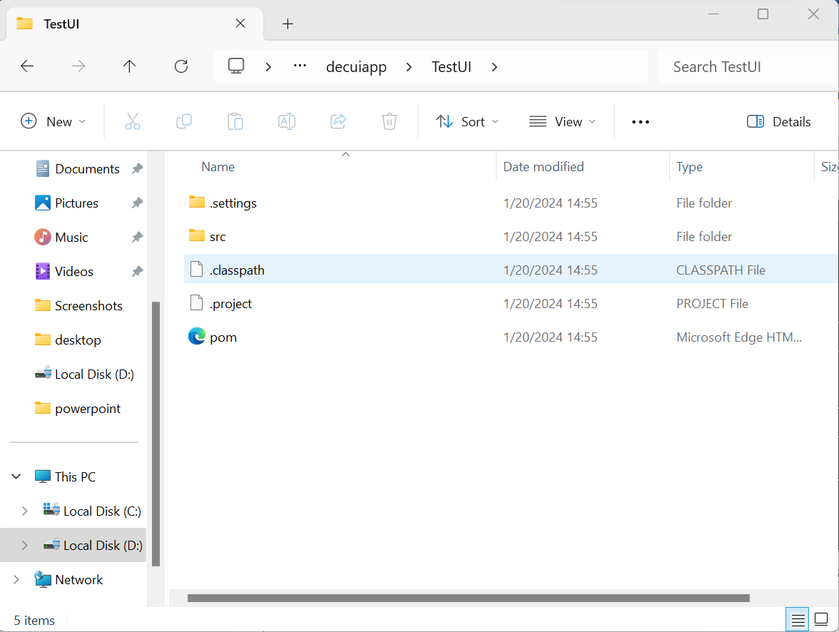

**Step 2:**

**mvn package – press enter –** now we can see target file in **TestUI** folder

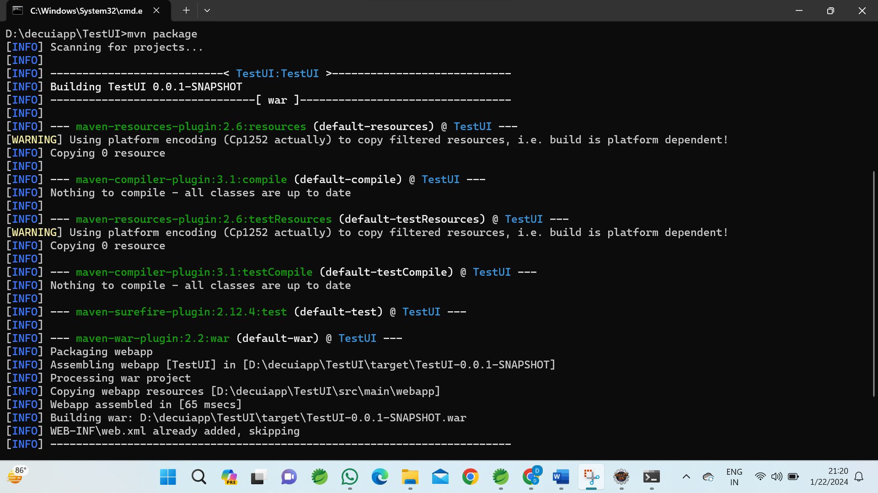

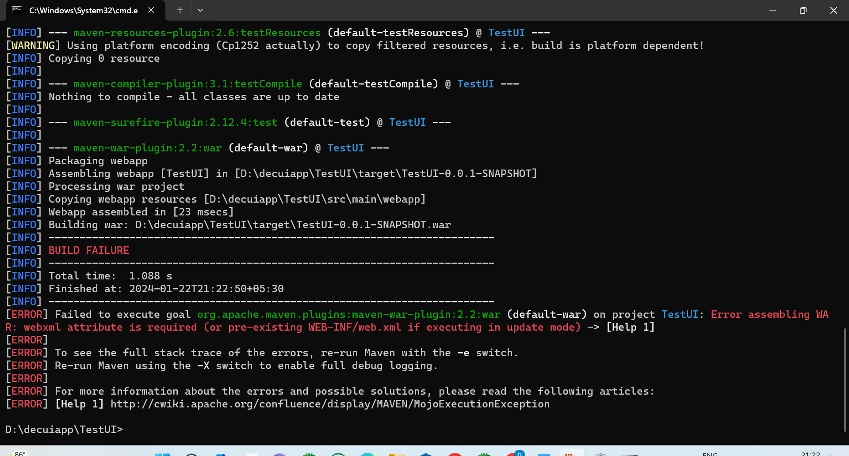

**TestUI: Error assembling WAR: webxml attribute is required (or pre-existing WEB-INF/web.xml if executing in update mode) -> [Help 1] –** now we need to create **WEB-INF** folder in **webapp**

In **WEB-INF** folder we need to create **web.xml** file

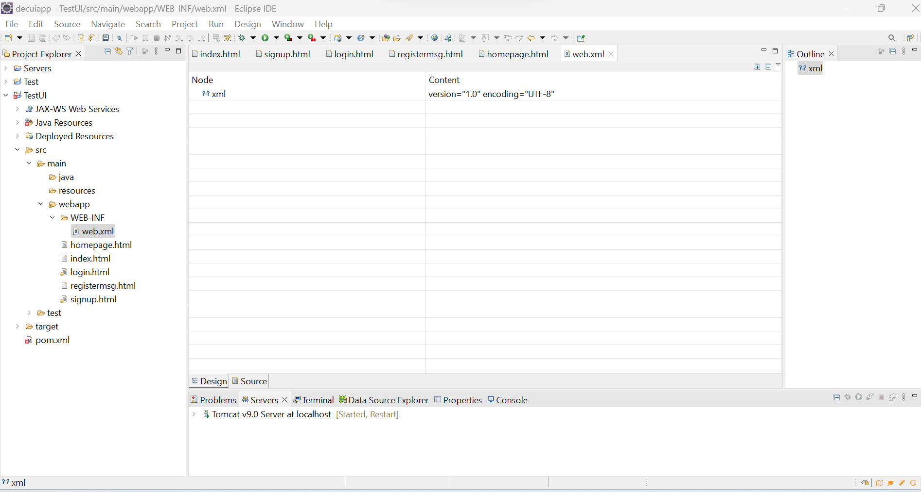

Again, we need to open again

* Right click on **application**



* Go to **Properties**



* Click on **Location – window**



* it shows Location of **TestUI**
* open **TestUI**



* edit address and type **cmd**



Then **cmd** will open



In this window we type **maven** commands to convert **TestUI application** into Single **.war file**

**Step 1:**

**mvn clean – press enter –** now entire **TestUI** application if we any issues immediately here it will clean if we have Any issue then it will display errors in **cmd**



Here we don’t have any issues so here it will display **Build Success**

If we have any issues so here it will display **Build failure**

Here target folder deleted in **TestUI** folder



**Step 2:**

**mvn package – press enter –** now we can see target file in **TestUI** folder

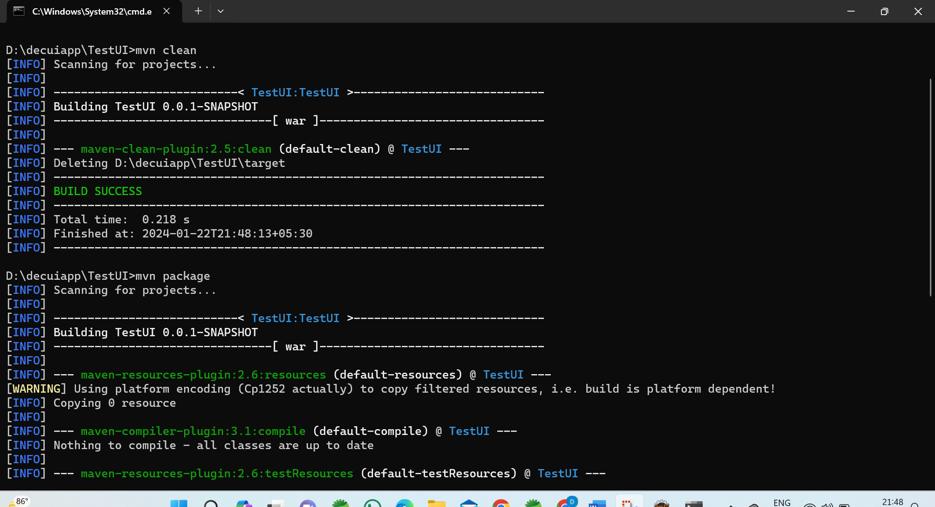

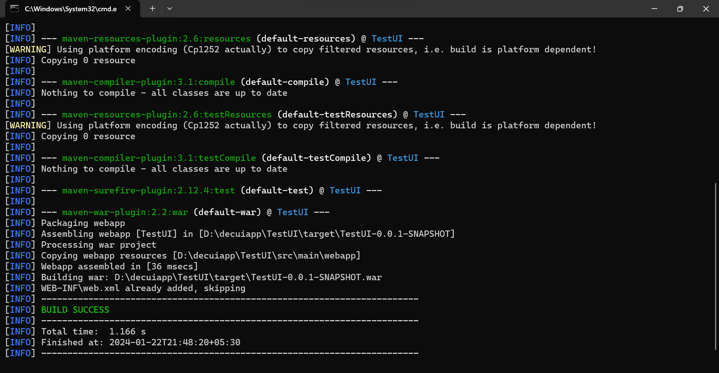

Now war file created in **TestUI – target – we can observe war file**

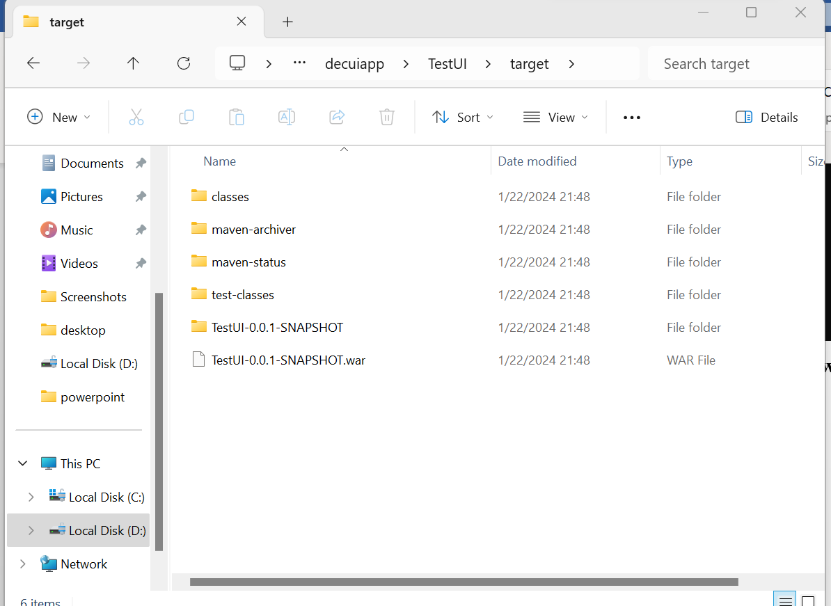

In this .war file entire project can observe

**mvn clean –** if we have any issue or syntax error immediately it will raise issue

**mvn package –** used to convert entire application into **.war file**

instead of using **mvn clean** and **mvn package** we can use only one command **mvn install – clean the issues and creates .war file**

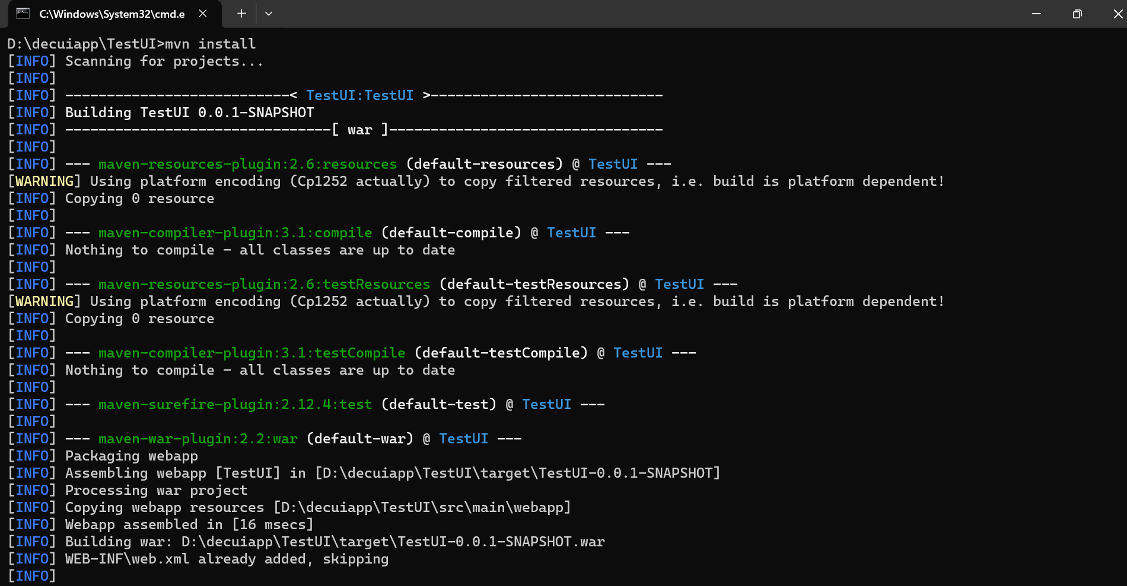

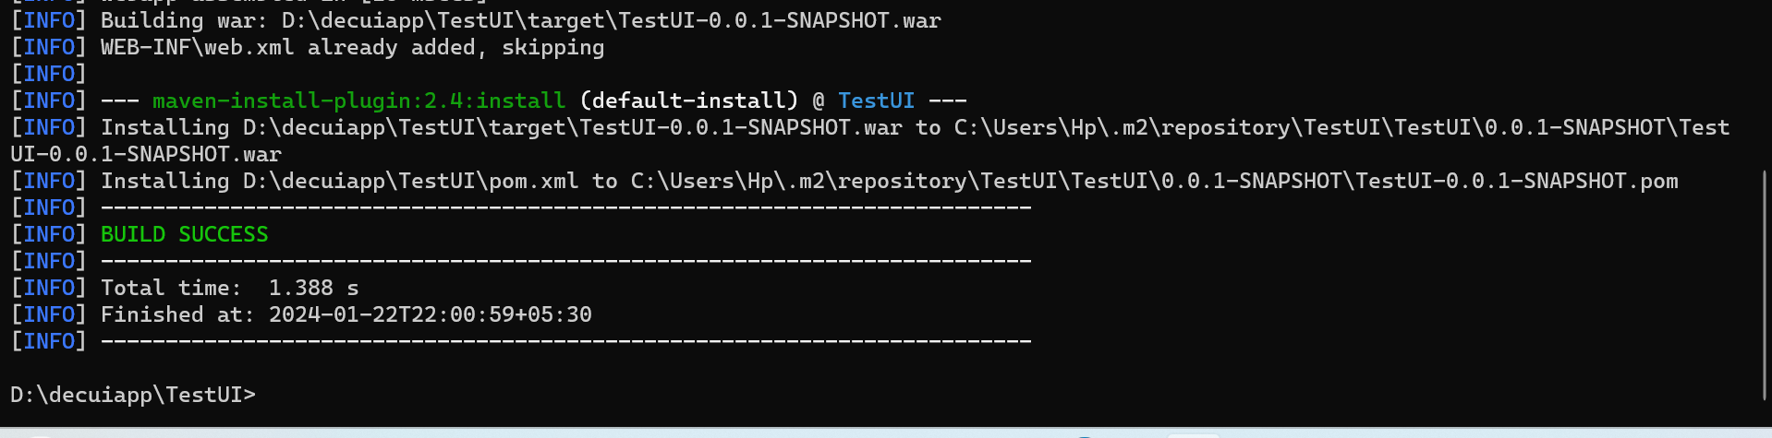

Now war file created in **TestUI – target – we can observe war file**

In this .war file entire project can observe

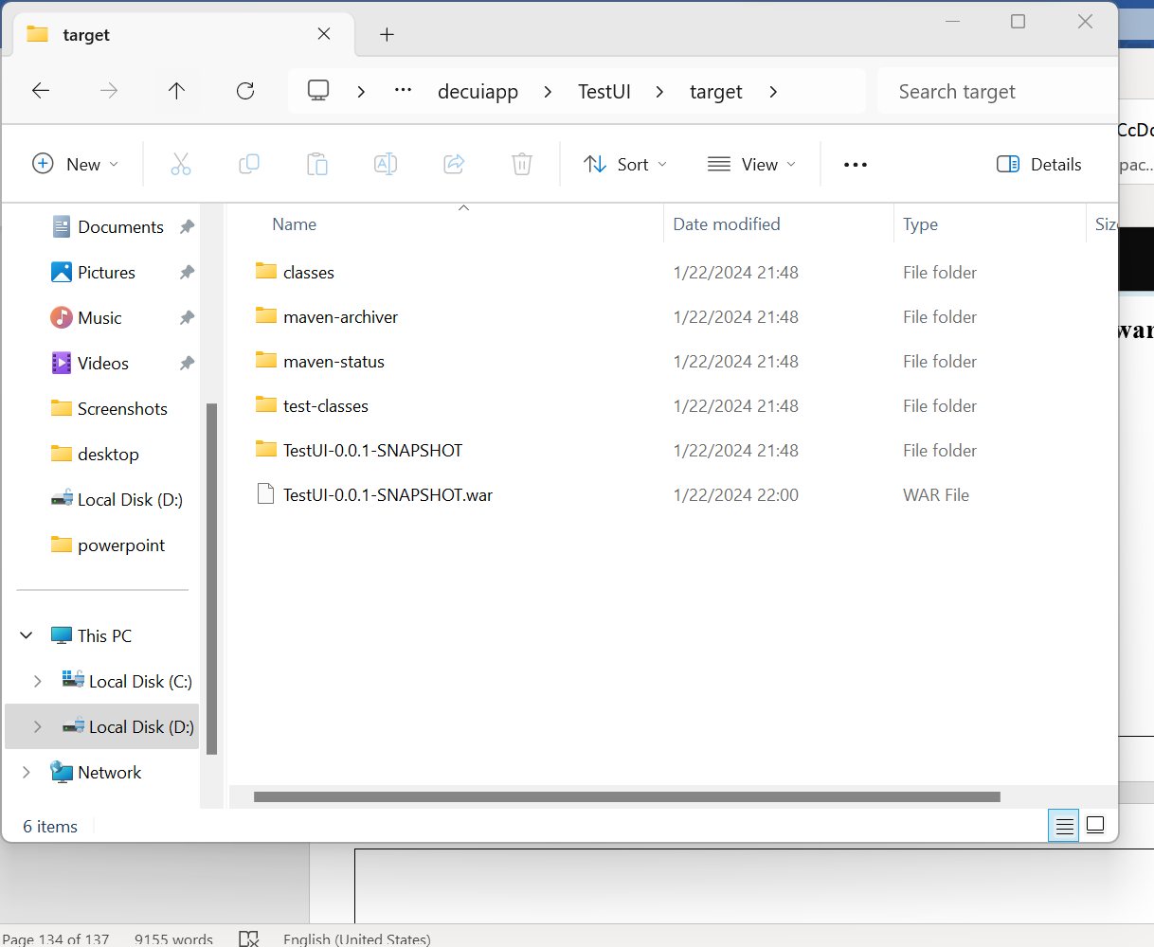

* Maven is a build tool using this tool entire project is converted in to the single jar/war/ear file not for deployment
* Deployments done in server
* For taking our project in to server we create/convert whole application in to single war/jar/ear file .For creating this war/jar/ear file we use this maven tool.
* After setting path according to yesterday go to command prompt type **mvn** we should get build failure, it represents maven is installed successfully
* Suppose we assume a organization, in that suppose a developer is working on TestUI project/Application.
* The developer is working on which application, the same application’s structure is created in eclipse with same name.

# [Error injecting: org.apache.maven.plugin.war.WarMojo](https://stackoverflow.com/questions/66920567/error-injecting-org-apache-maven-plugin-war-warmojo)

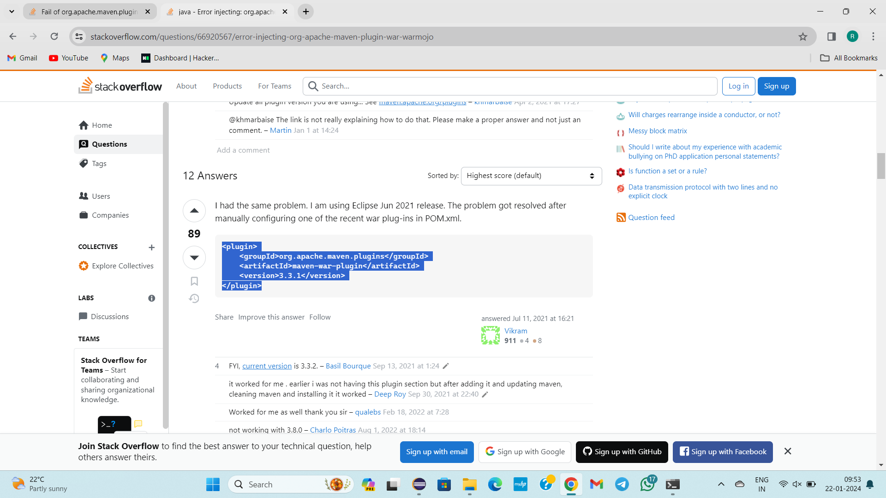

<https://stackoverflow.com/questions/66920567/error-injecting-org-apache-maven-plugin-war-warmojo>

--------------------------22/01/2024------------Monday-----Day-20--------------------

Topic: How to transfer mavenproject from localsystem to github repository.

(OR)

How to deploy yesterday’s maven project from our local system to github repository.

**TASK**

GitHub

Create repository

Clone GitHub repository to our local – particular path where TestUI located

* First create a new repository in the github
* Copy the url
* Go to the folder where all projects are there. Don’t enter in to any project.
* Open git bash
* Git clone URL
* Copy the selected project files and paste in the cloned repository folder in the File Explorer
* Come to git bash
* cd clonedrepositoryfoldername/
* git add .
* git status
* git commit -m “label message”
* git status
* git push
* Now everything my maven project which is in my local system went/transferred to the GitHub repository.

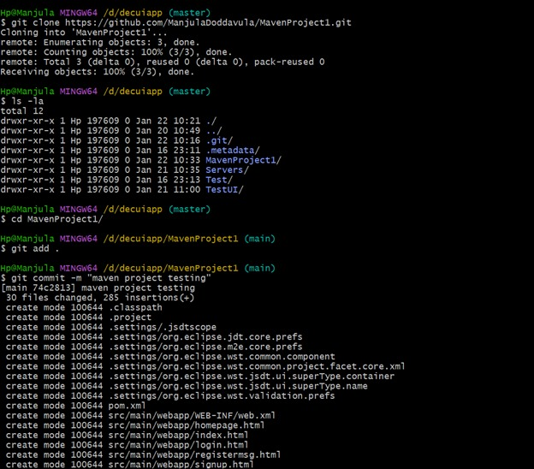

4 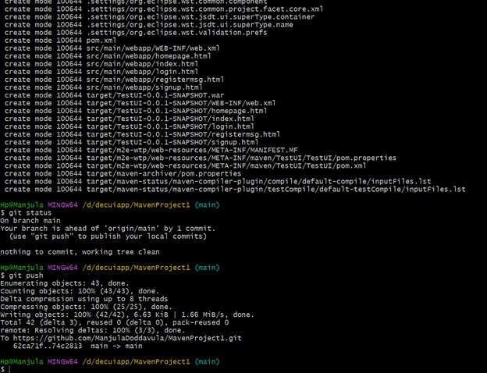

-------------------23/01/2024---TUESDAY--------DAY—21 -------------------------

TOPIC: Manual deployment Process

* Suppose on ui app we created 10 files
* On these 5 tasks 5 developer works.

1)signin/signup building

2)Signup

3)Registration page

4)Login page

5)Database related work

* After completion of 5 developers work they sends in to github repository(name assume as test)
* Now converting all files in to single war file by maven build tool
* This conversion is done by managers or team leads in organizations
* After that they will push in to github repository test
* Now generated .war should be deployed in to the server
* Many servers are available in the market.
* Weblogic,apache tomcat, Jboss are servers available in the market.
* Apache tomcat is lightweight, deployment can be done easily, Time is less taken(with in fraction of seconds). Apache Tomcat is widely used in organizations because of the above features.
* What is mean by application deployment?

Ans: .war file should be deployed in to tomcat server

* Finally, there are 3steps in manual deployment process

1)Check whether UI APP is ready

2)Convert in to .war file

3) Our application .war file is should be deployed in to tomcat server

* The 3 steps is done manually either writing code for creation of UI App application/project, converting this whole application in to the .war/.jar/.ear file, deploying the .war file in to the Tomcat server, everything is done manually
* This whole process is called Manual deployment Process
* So far, we are running the server in eclipse
* Stop the server
* Close the Eclipse
* But I want to run server in my local system not in eclipse
* Goto apache.tomcat-9.0.64 in file folder89

Launch apache.tomcat-9.0.64

Bin->startup(windows batch file) shell->In my local machine server starting->

Port number IS THE GENIUNE TO SERVERS, DATABASES

OS🡪IP ADDRESS GENINUE

OP->IP

PORTNUMBER->SERVERS,DATABASES

TOMCAT DEFAULT PORTNUMBER🡪8080

Tomcat is working, ruuning in my computer\

I want testing In mycomputer only

So I can give localhost

If I want to give another system tomcat syatem ip adderss:portno

Localhost:8080

For login username, pwd

Manager App

No username, pwd there

Apache->conf->tomcat users🡪edit with🡪check username🡪pwd

Click on signin

Tomcat web appln opens

we logged in Tom

Now local .war must be deployed in to tomcat

War file to deploy

Choose file

Target

Last white

Fail-war file(issue)

Webapp🡪 delete .warfile

If issues

bin

Shutdown (WBF)🡪server goes🡪 press *

Again start server

Localhost:8080

Deploy

Deployed

Webapp->delete->shutdown🡪start🡪open

Manual deployment is not using in 99%

Automation deployment replaces manual deployment can be taught in further classes

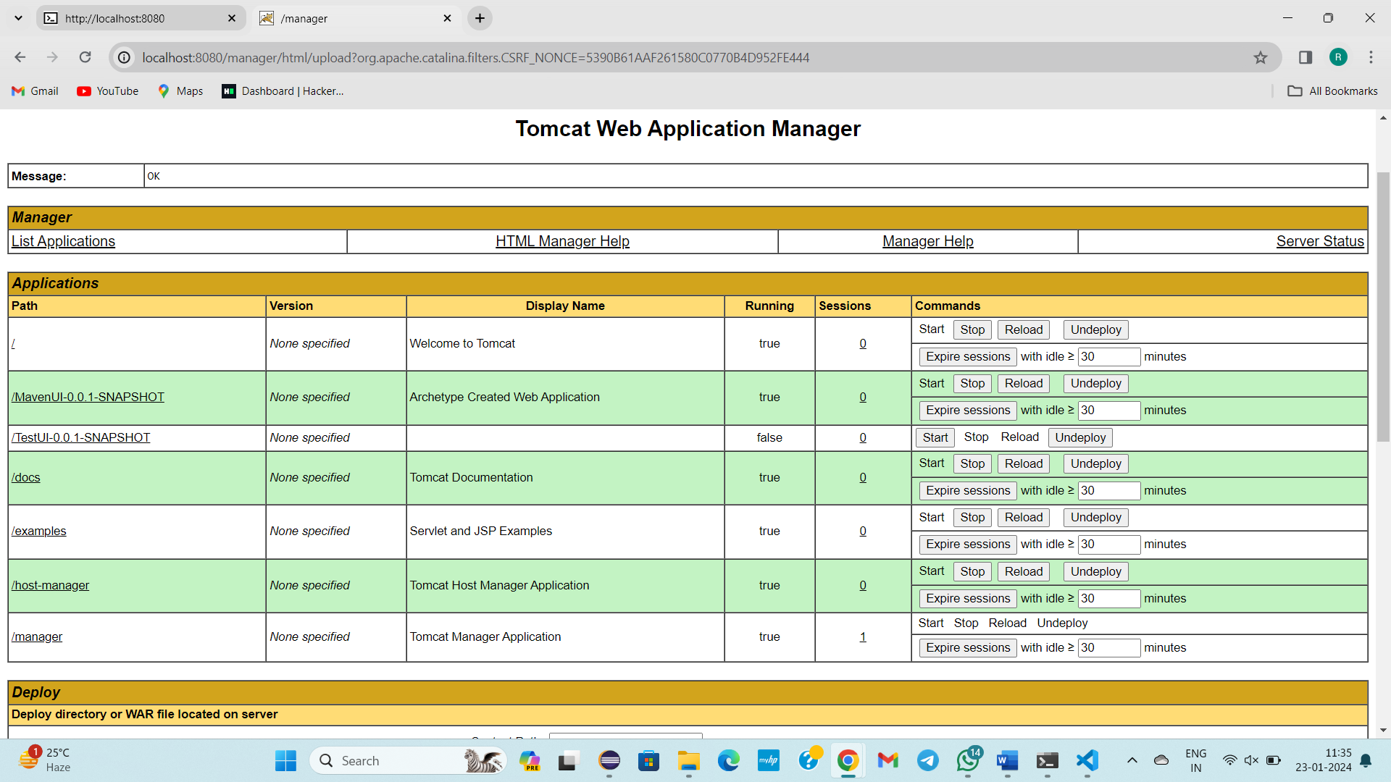

--------------------------24-01-2024----Wednesday---------Day-22---------------------

Topic: Manual deployment Process

how to deploy .war file in to server , Firstly changing xml file, deleting war file in tomcat webapps(if error occurs ), goto tomcat server again deploy and you can view the signin page,etc…

* Maven goals🡪mvn clean, mvn package or mvn install(these are not said as commands they are said as maven goals in the maven terminology )
* After developers completes coding work QA(Quality Analyst) tests code, .war,everything
* QA to UAT
* QA sends only .war to UAT(User acceptance testing)
* UAT Creates some sample servers and deploy .war file ,some real users use it.
* If everything is ok . Then they will deploy in to production server
* This whole process done in manual process, it can be done automation process

Manual deployment STEPS:

1)Developer develops code

2).war generated

3)deploy it in server

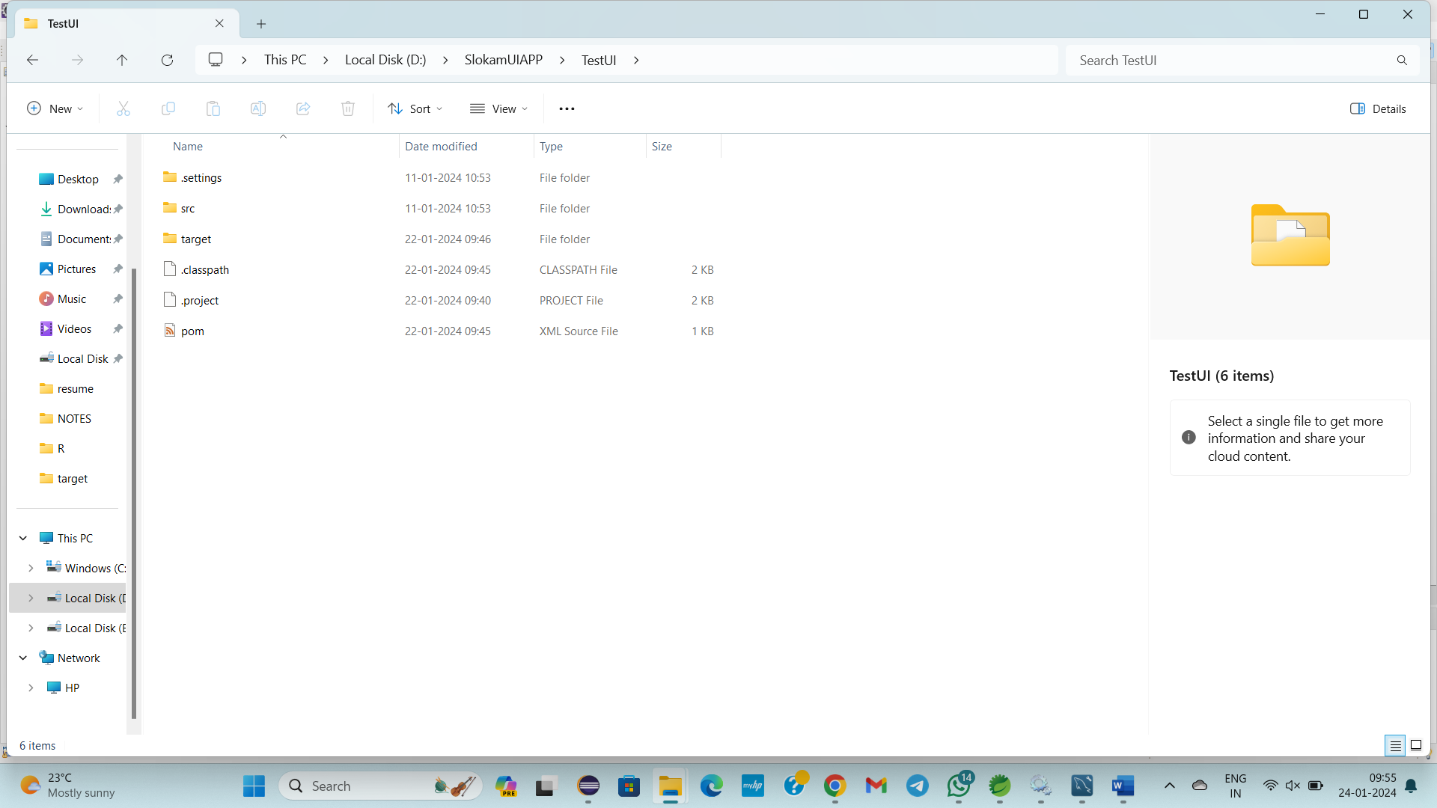

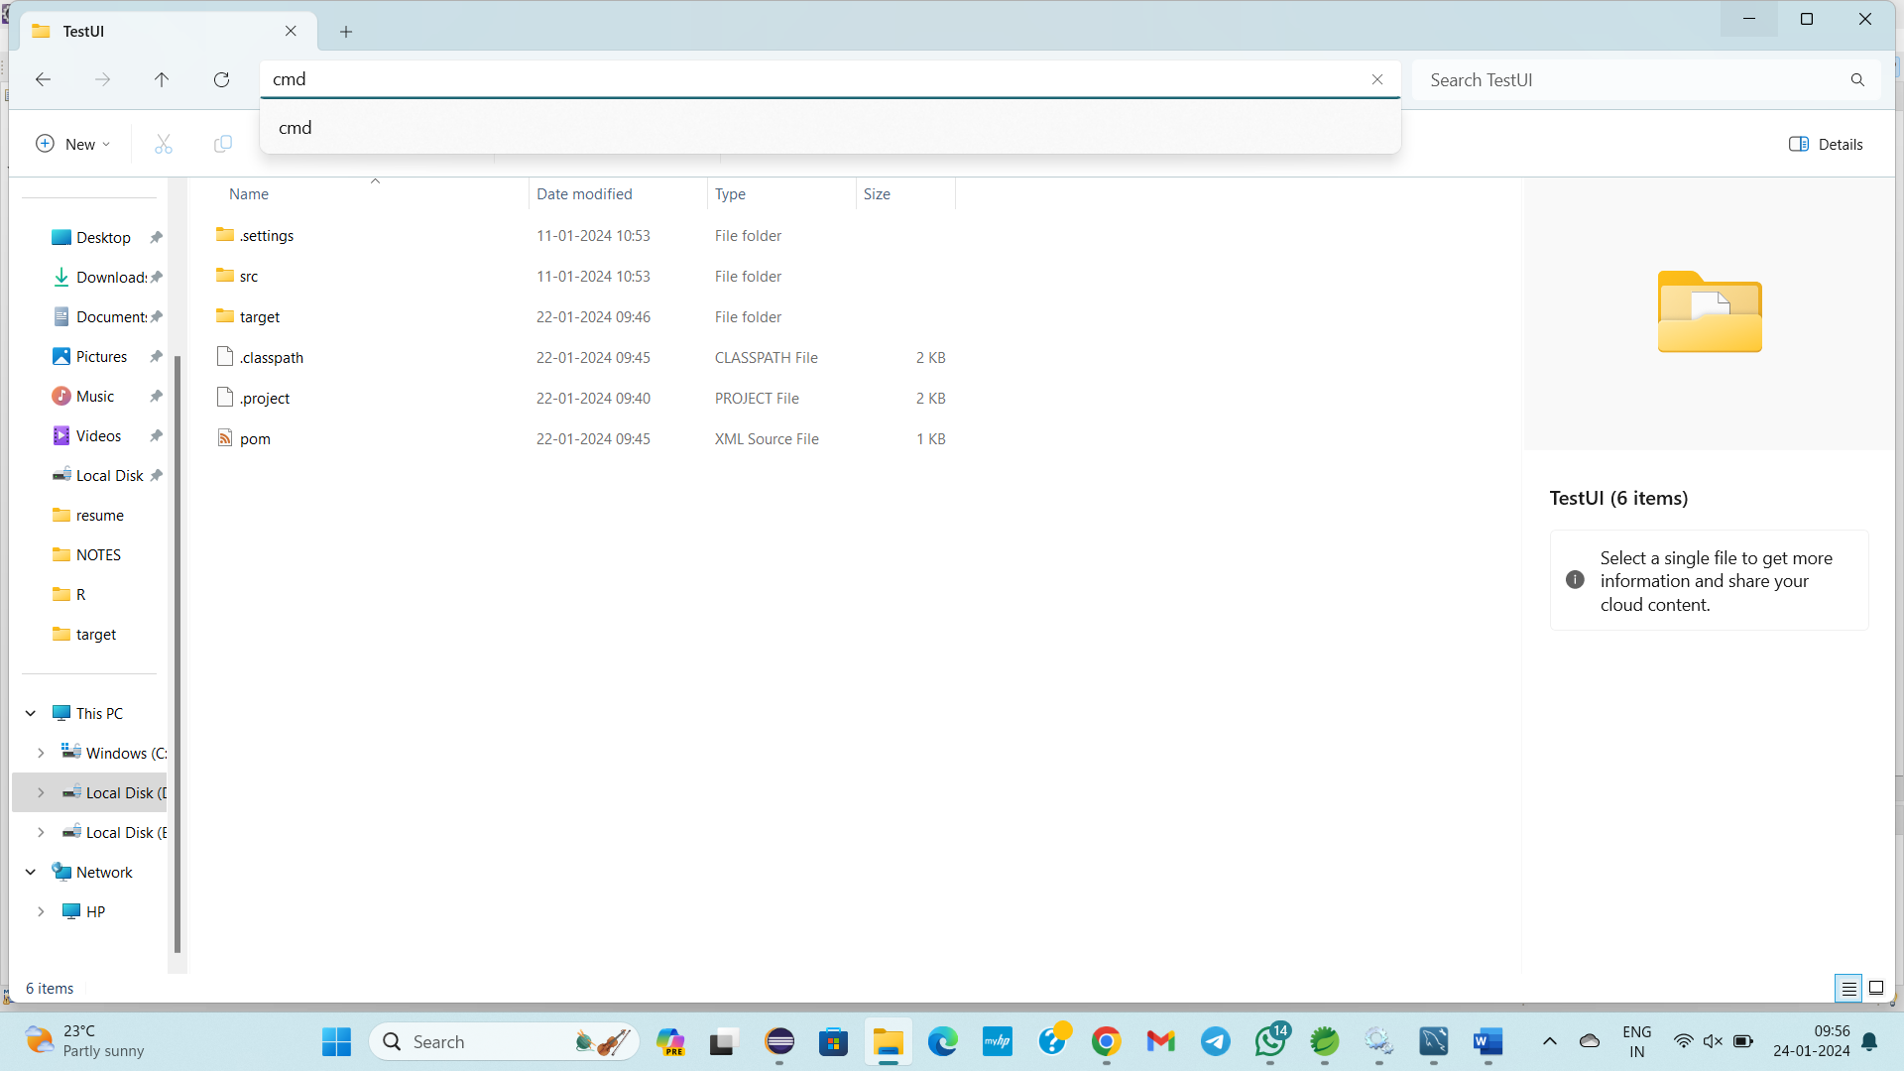

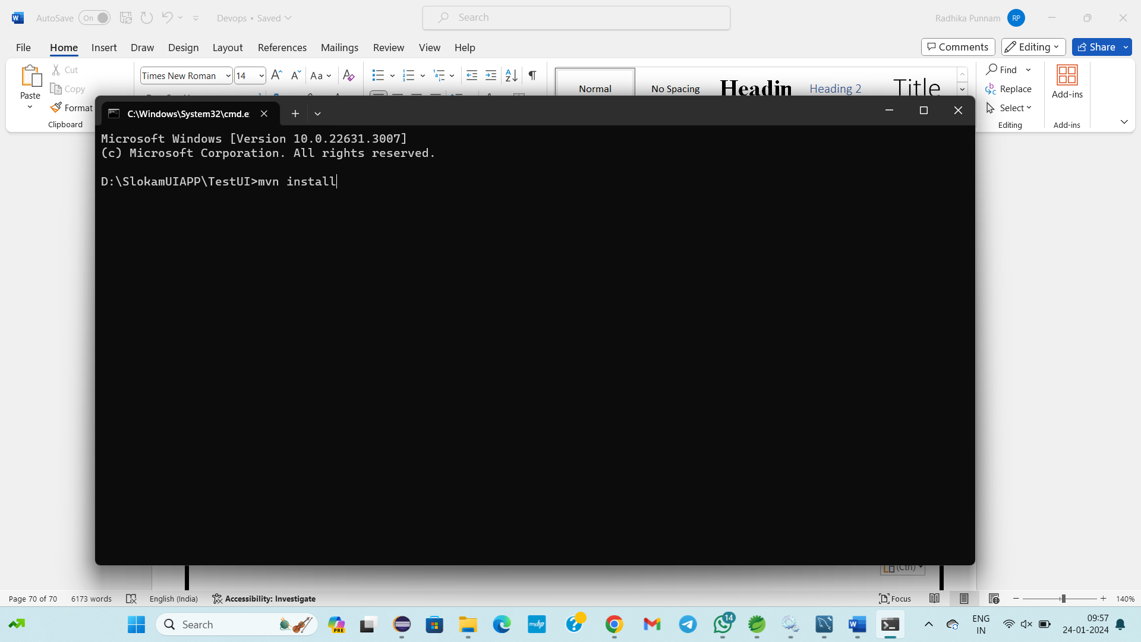

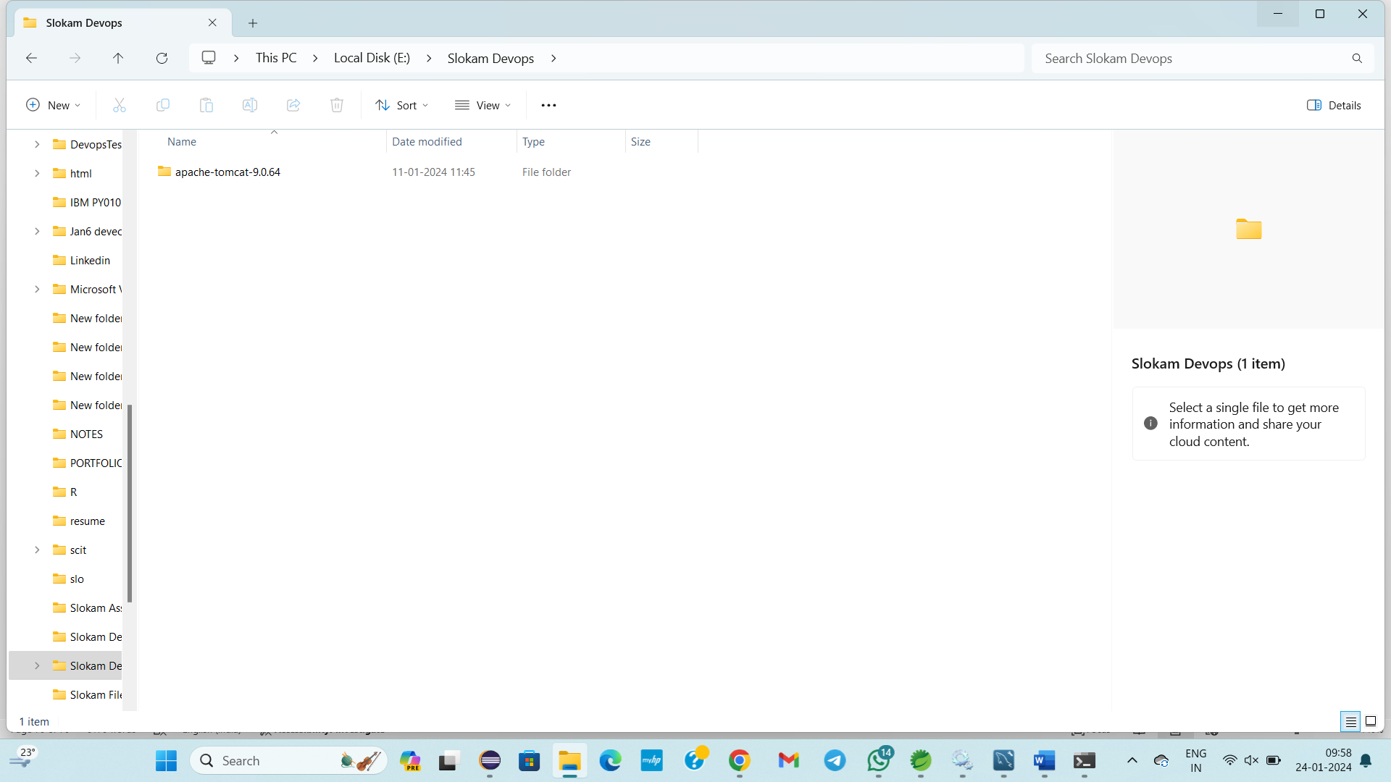

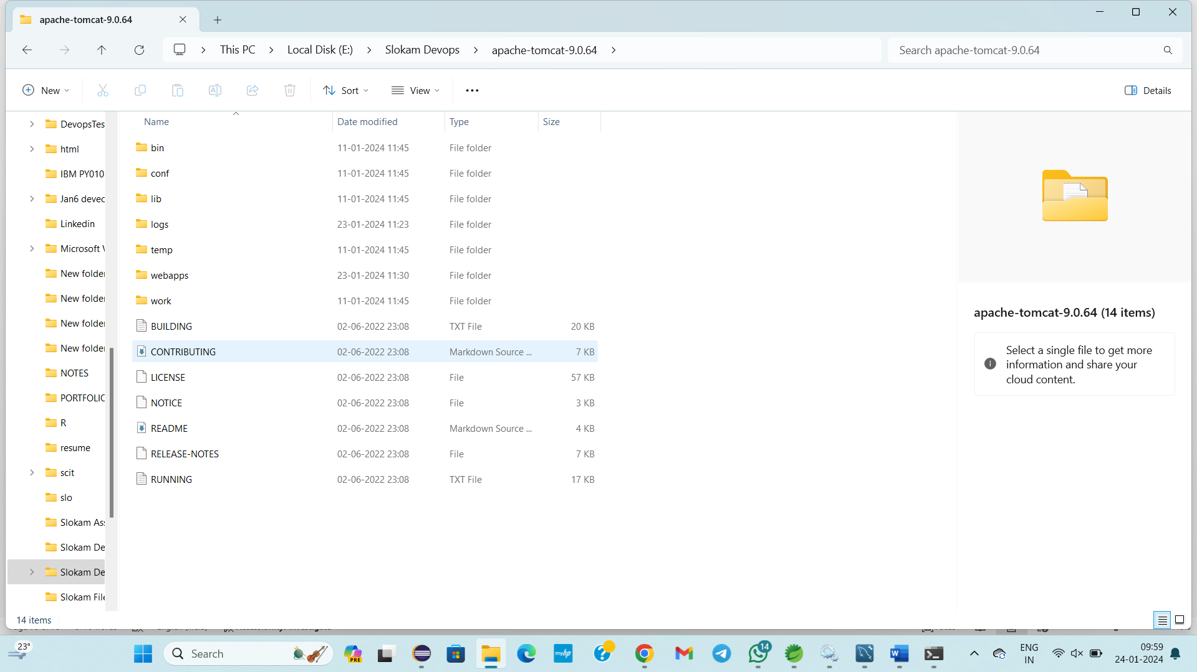

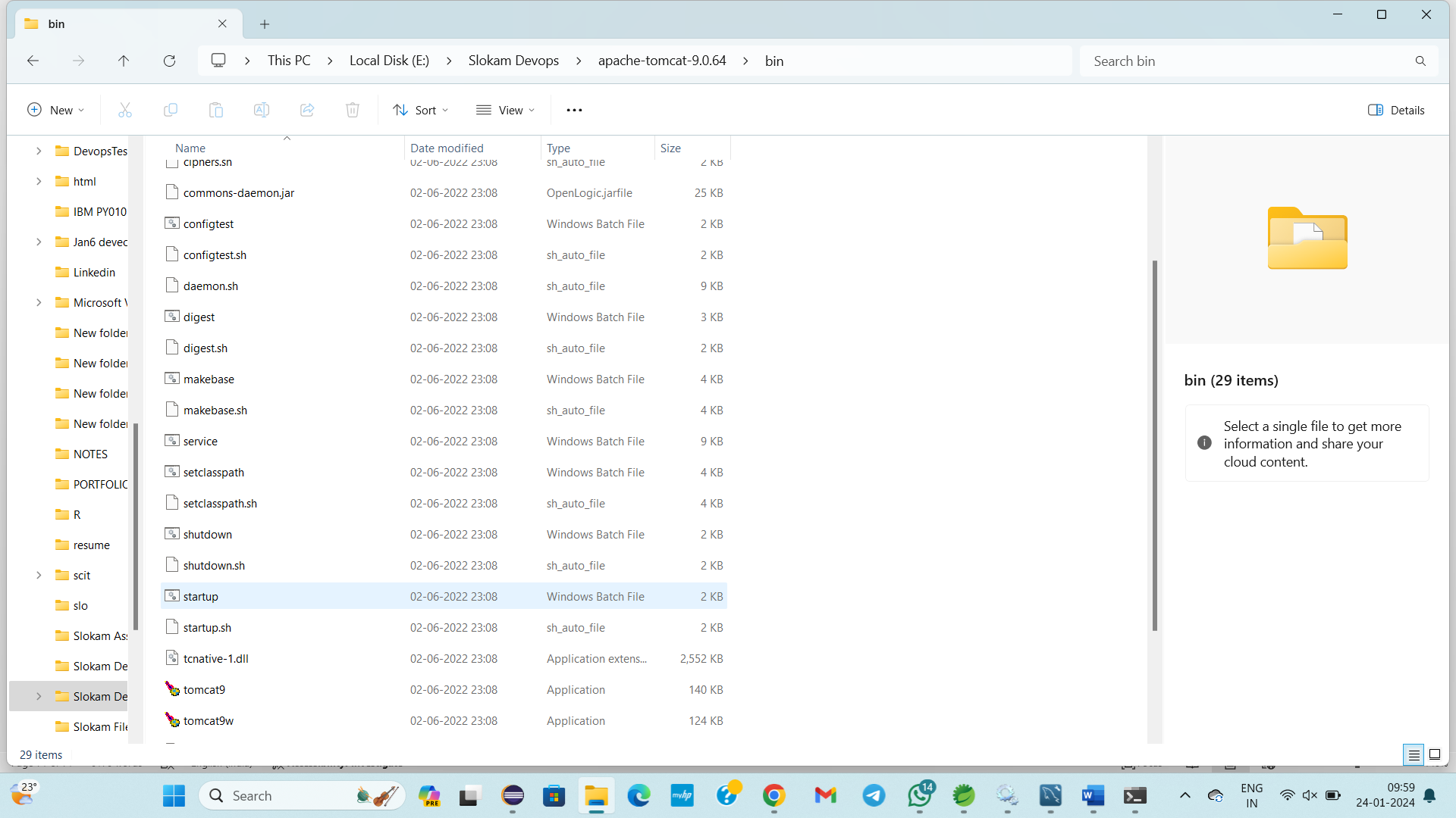

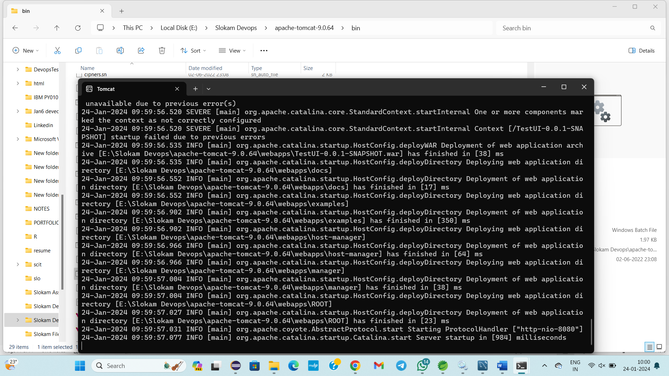

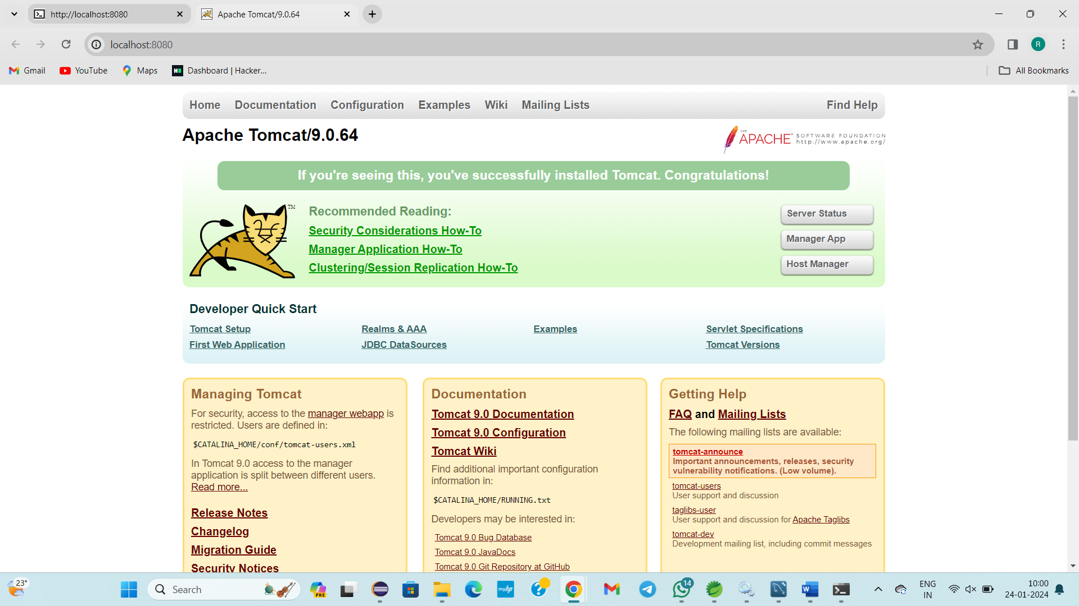

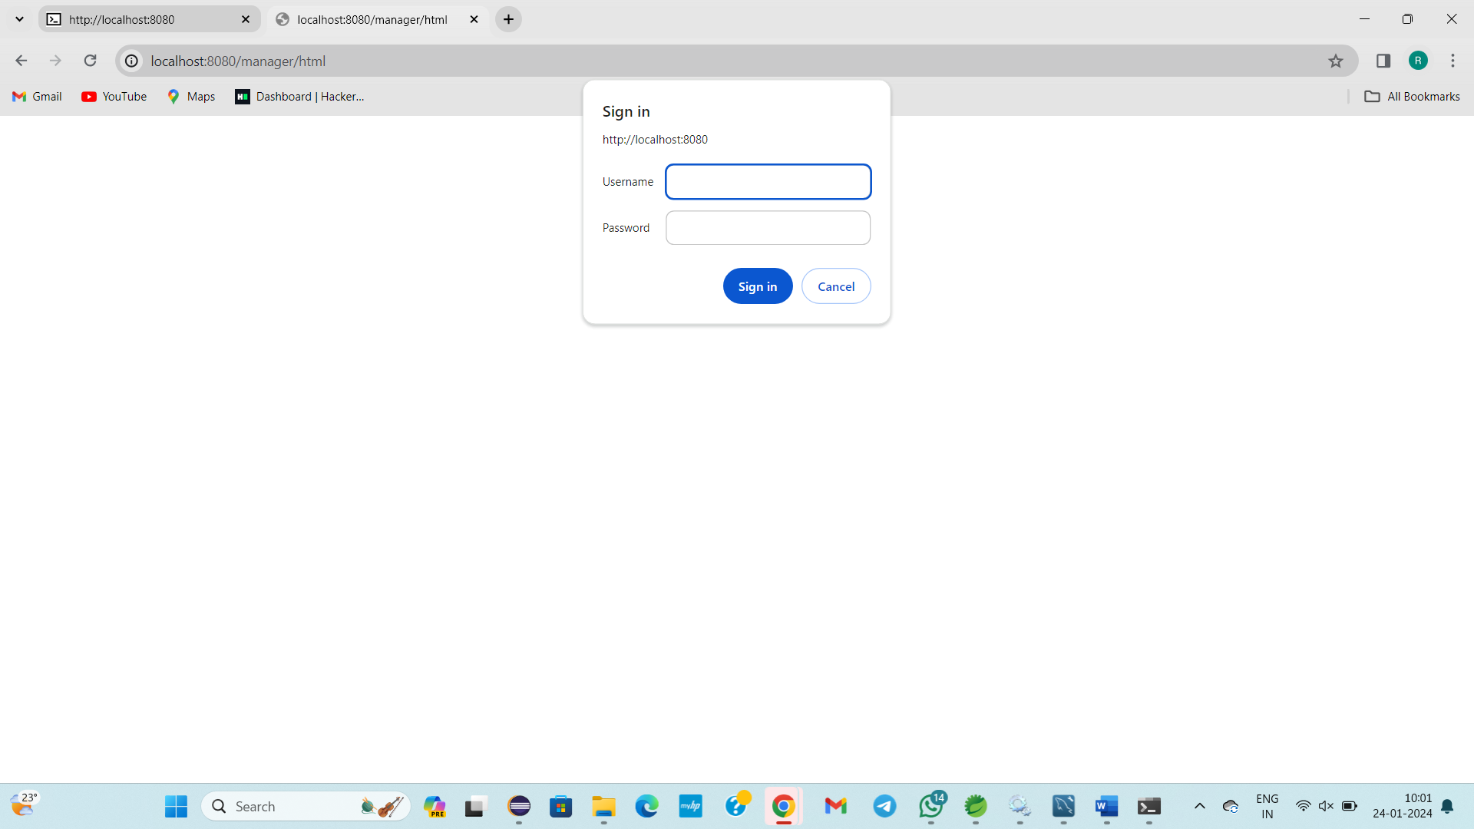

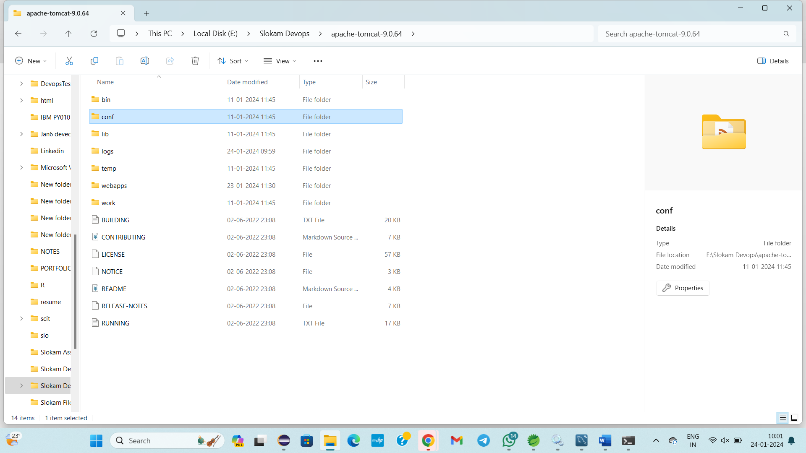

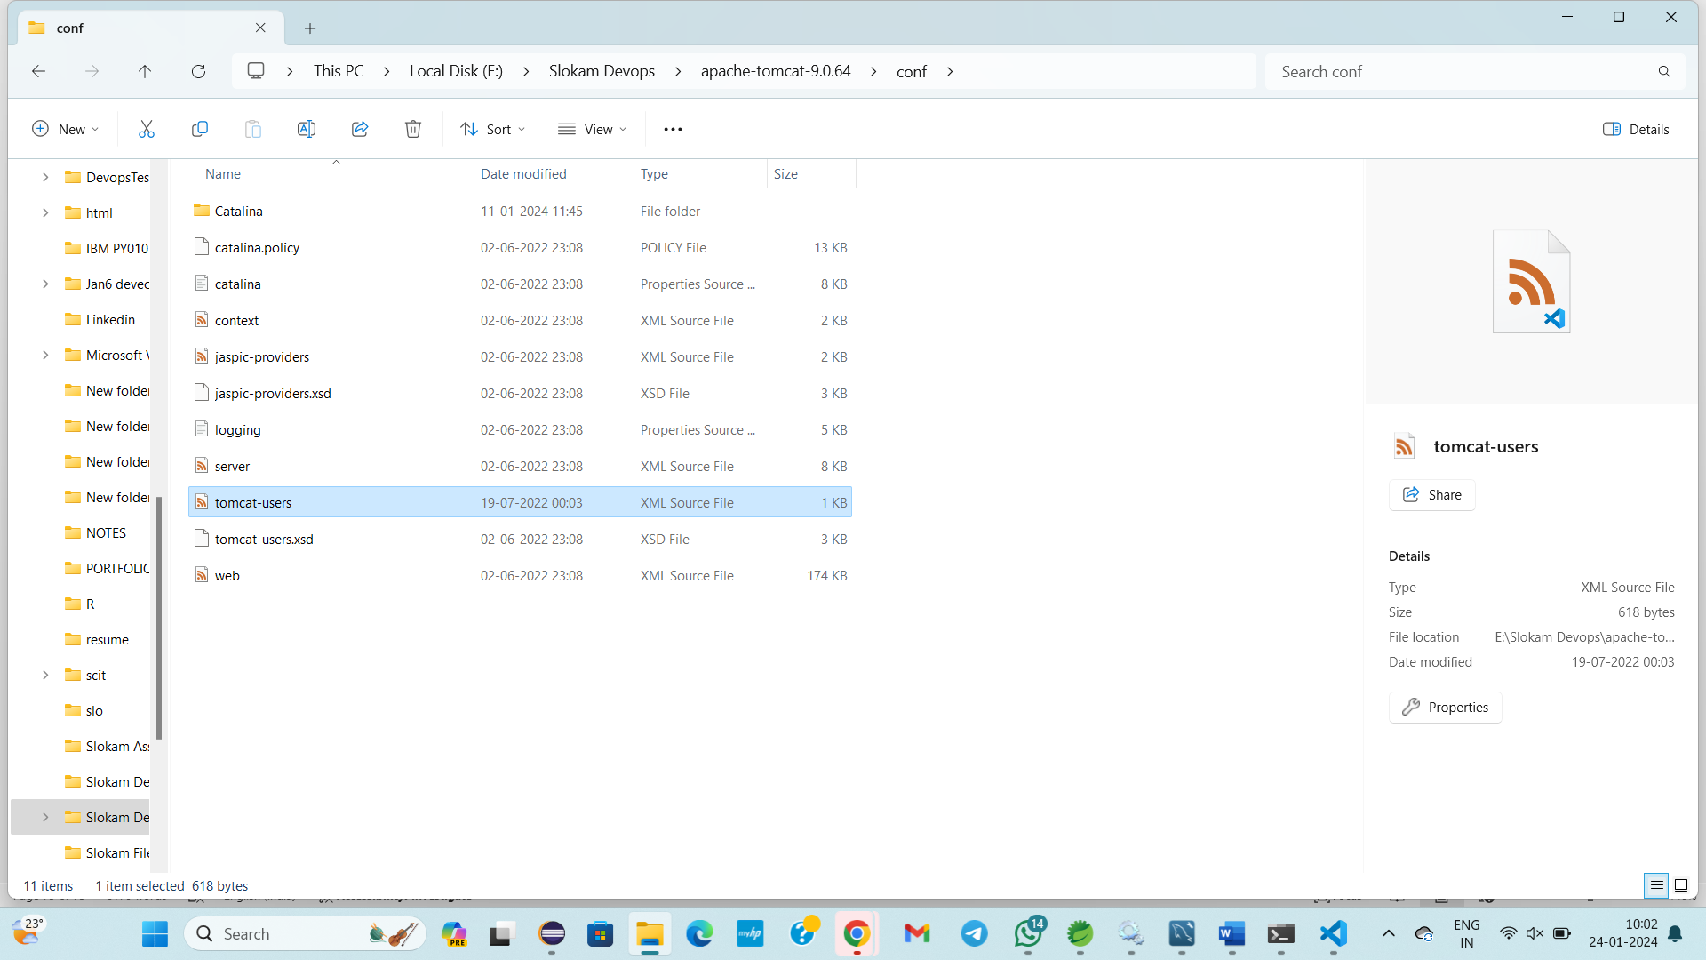

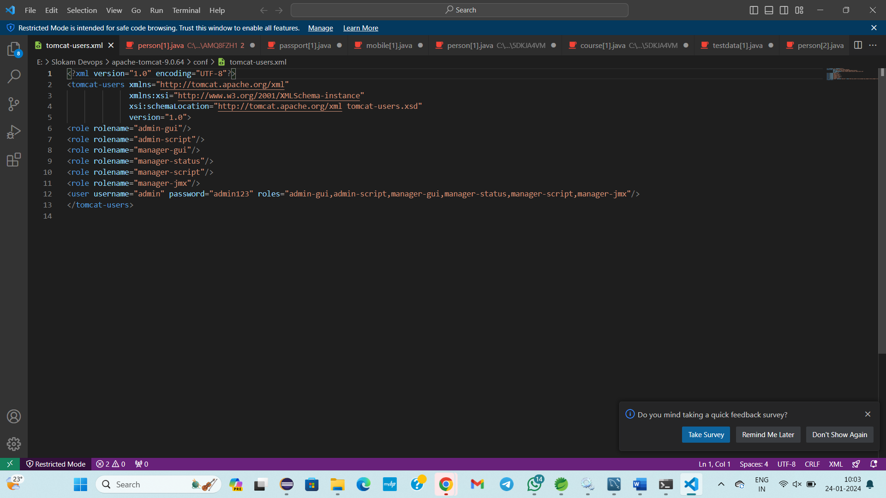

Then we need to upload **.war file**

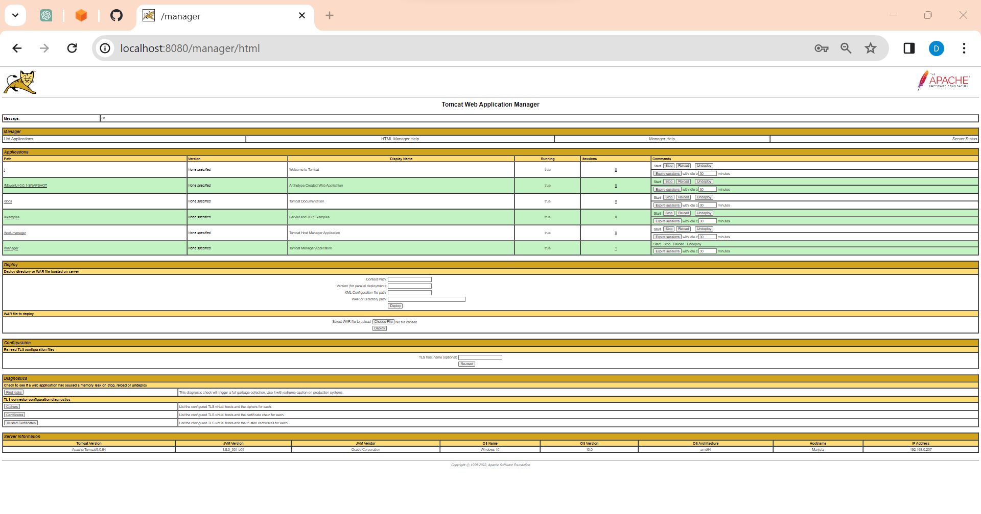

Select **.war file** from my computers

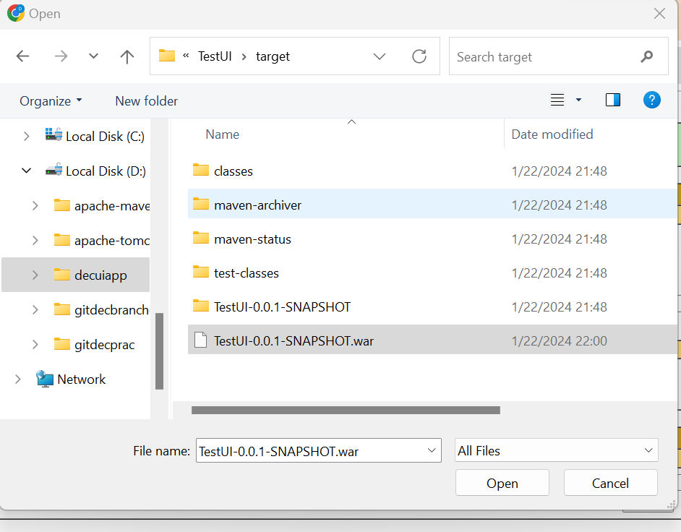

Click on **open**

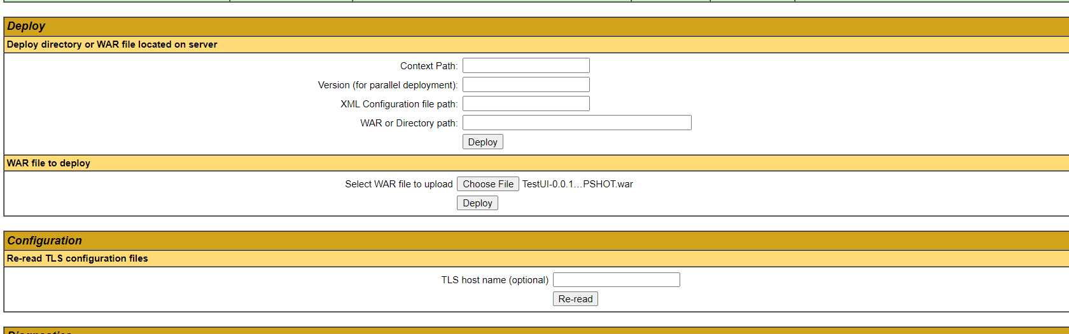

Click on **Deploy**

Then application will deployed successfully in **tomcat server**

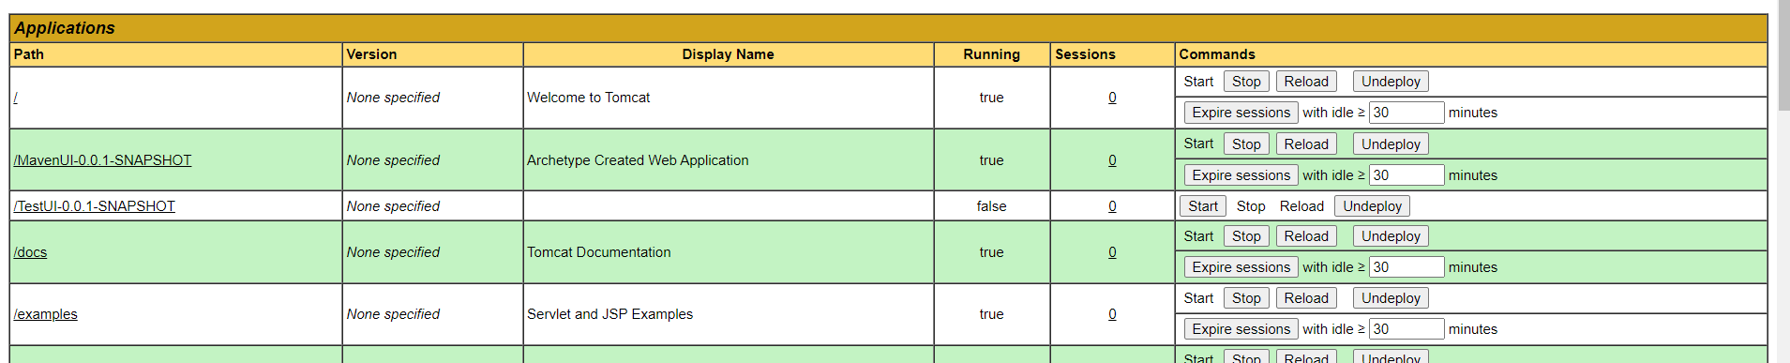

Now we need to stop the **Tomcat server** in local System

Open my computers

Select the location where **apache-tomcat-9.0.64** is located

Open **apache-tomcat-9.0.64** select **bin** folder in that select **shutdown with windows batch file**

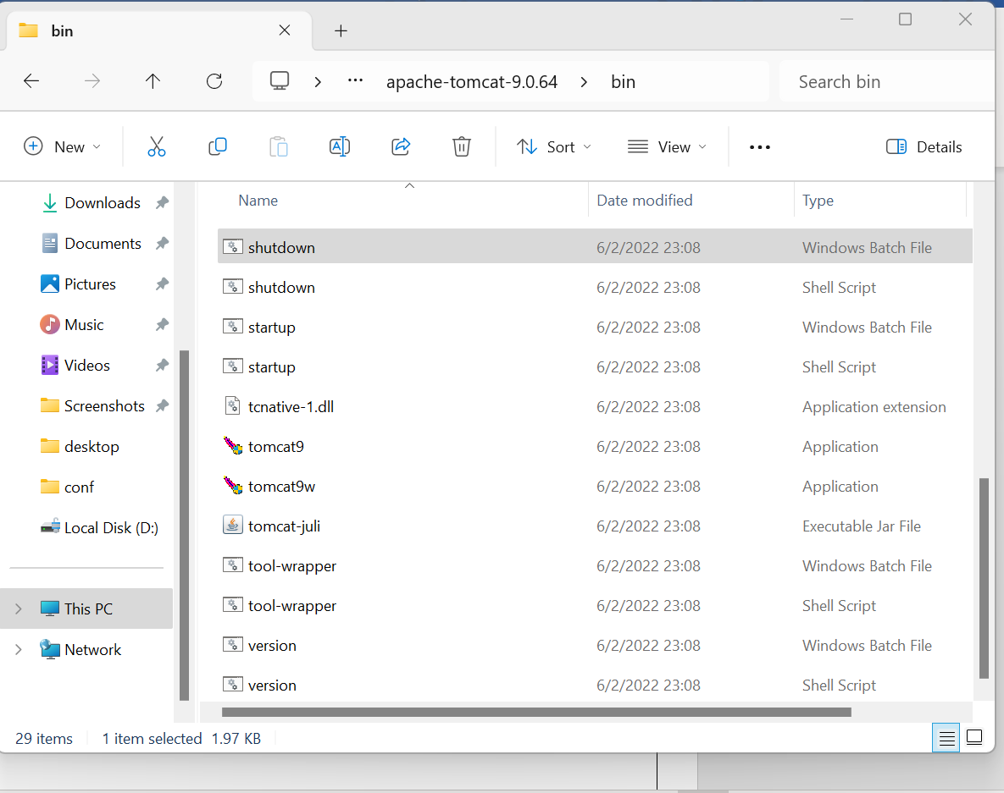

Then **tomcat server** will stop running in our local system

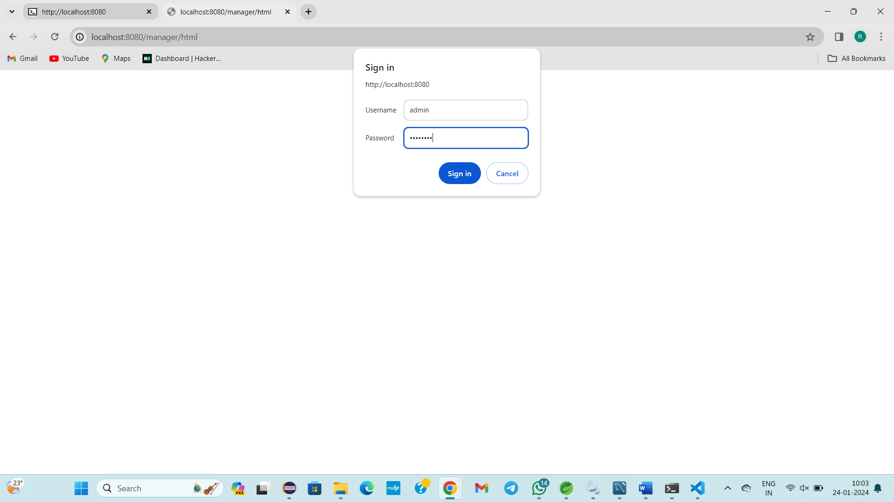

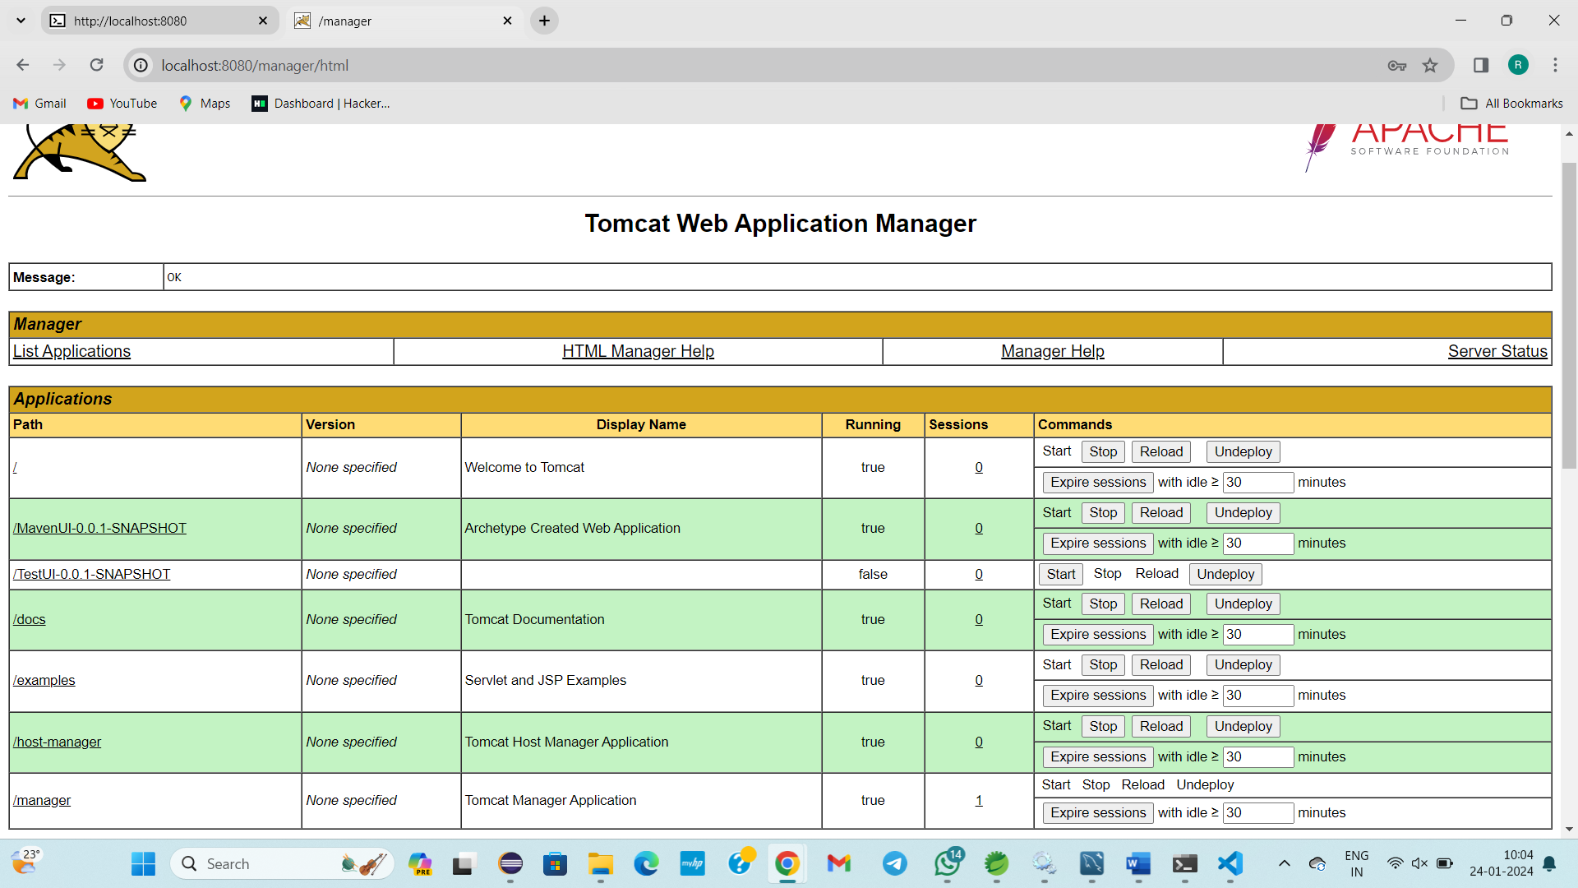

Actually,

Why all these deployment and process?

UI Application deployment

ways

1)Manual deployment process

a)Tomcat environment

b)Docker environment

c)kubernetes environment

2)Automation deployment process

a)Tomcat environment

b)Docker environment

c)kubernetes environment

Application is deployed in to tomcat

Today I have learnt how to deploy in server , changing xml file, deleting war file in tomcat webapps, goto tomcat server again deploy and you can view the signin page,etc…

1)Manual Deployment process

a)Tomcat Environment

Just do up to above step

Next steps as below

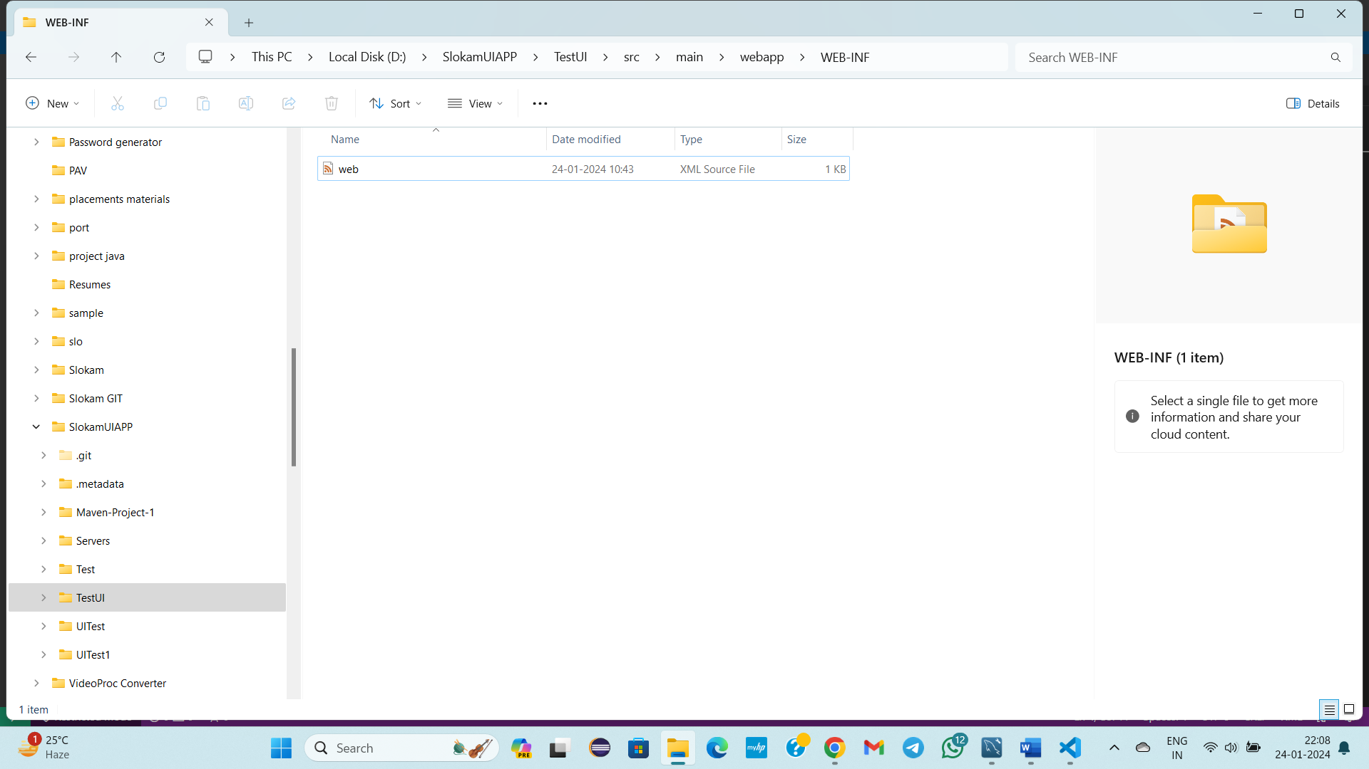

Copy&paste this code in web.xml

<?xml version="1.0" encoding="UTF-8"?>

<web-app>

<display-name>Archetype Created Web Application</display-name>

</web-app>

Comeback to TestUI open cmd

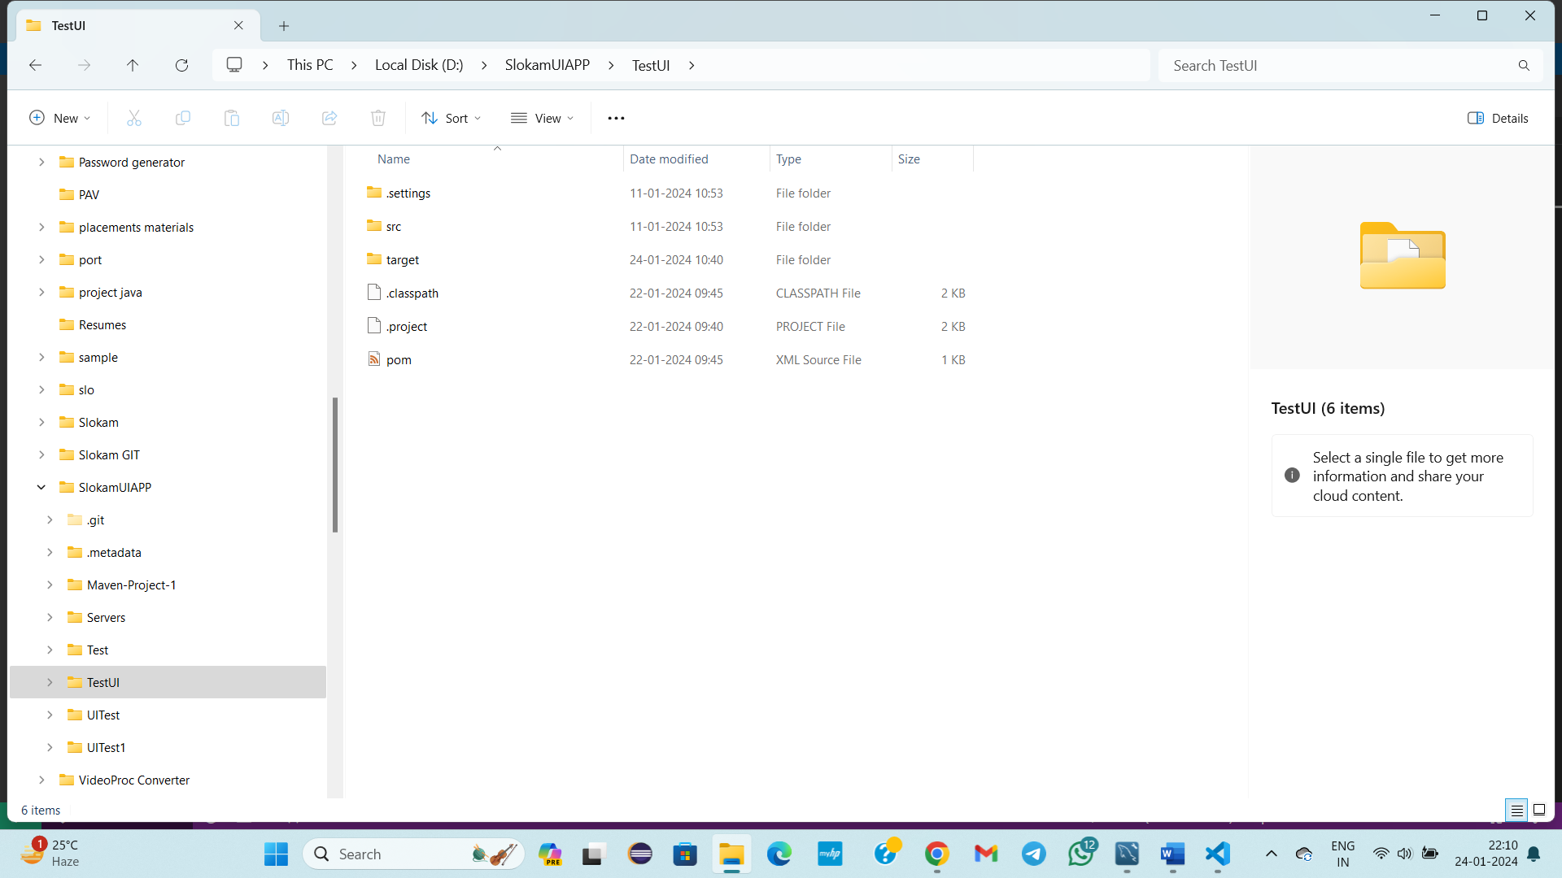

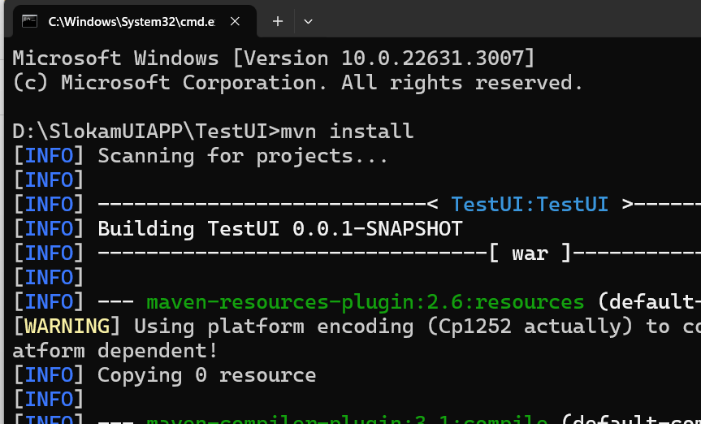

Delete TestUI in webapps (Error occurred in deployment means)

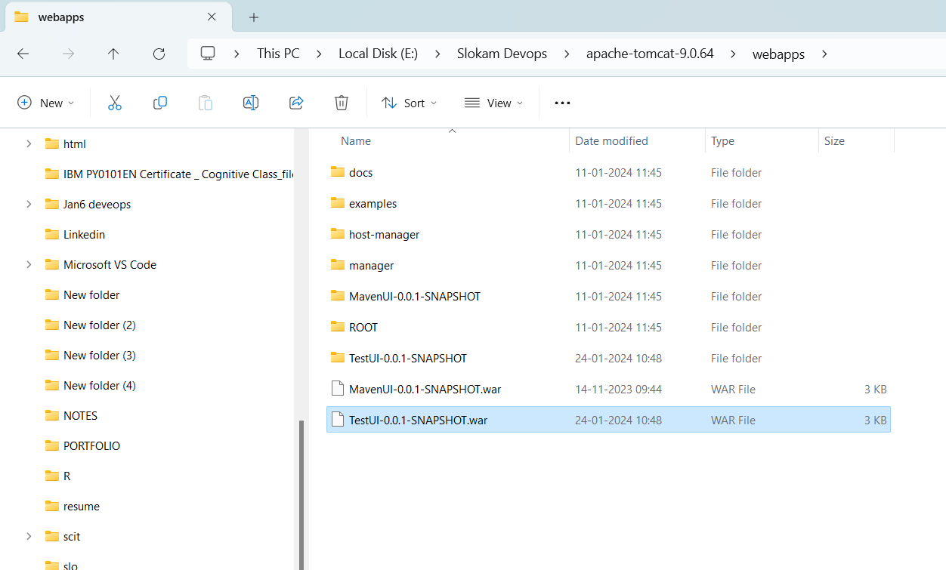

Start the server

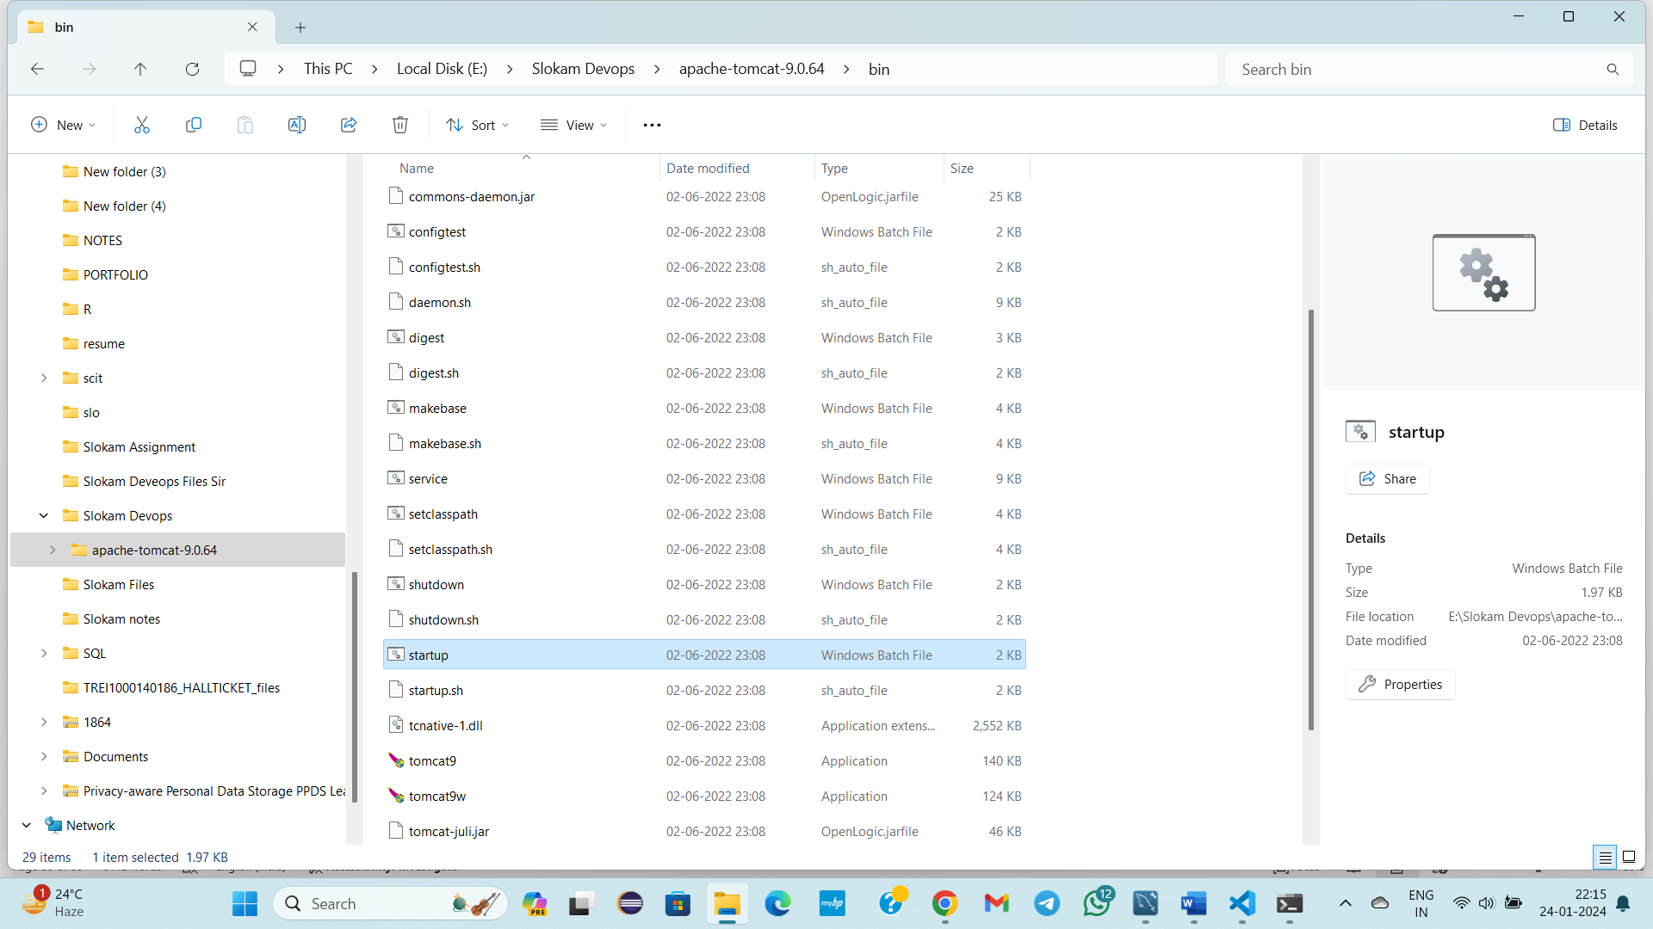

If any error occur shutdown, delete .war from webapps, start the server again

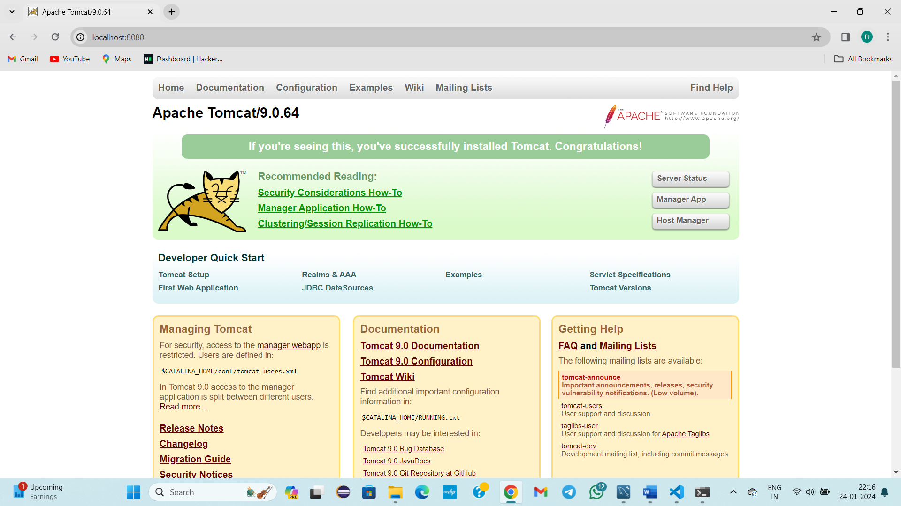

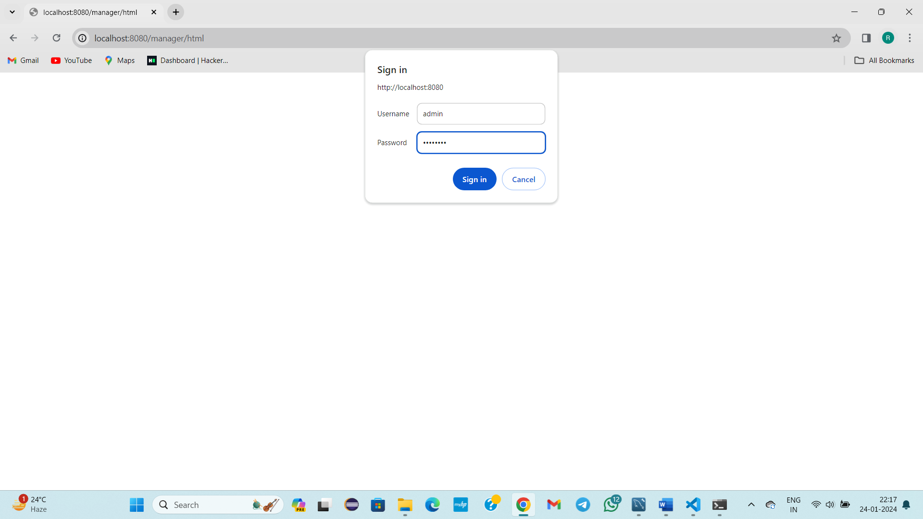

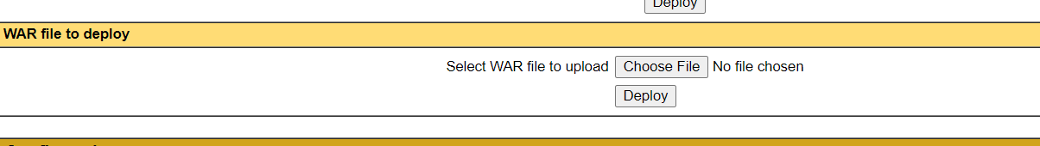

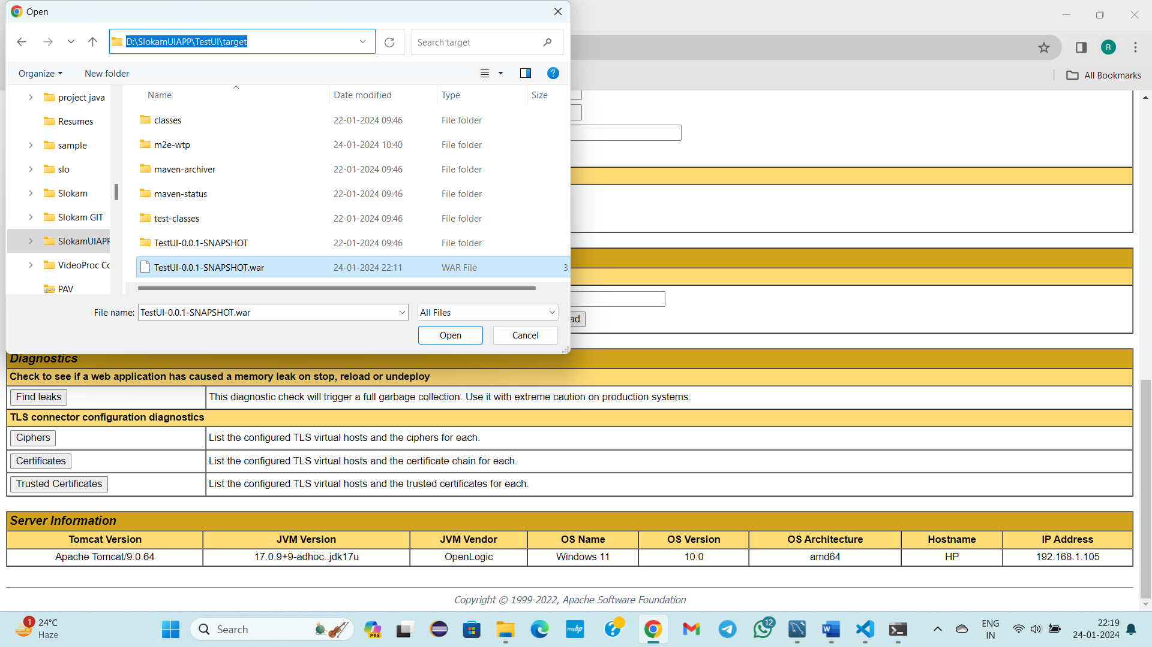

Click on deploy

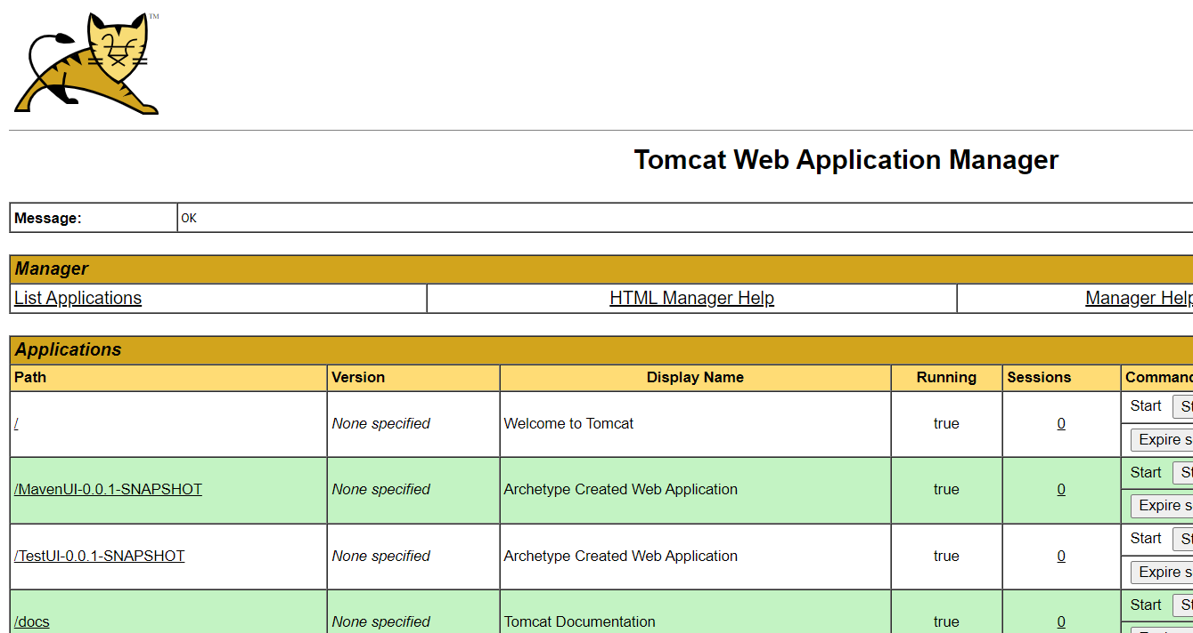

Click on /TestUI-0.0.1-SNAPSHOT

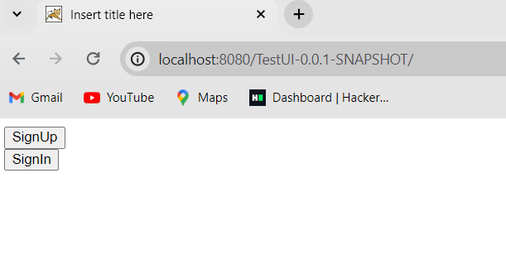

In the above process deployment is done in Tomcat Server in very less time.

----------------------------25-01-2024-------------Thursday--------Class-23----------

Topic: What is DOCKER?

Devops engineer-> Devops Engineer duty is to deploy one application in different environments

What is mean by server?

* A server is a computer or system that provides services, hosts applications, manages version control, or performs other tasks in a networked environment.
* One application can be placed in server
* We convert our whole project in to .war file because .war/.jar/.ear formats only the server readable formats
* .war is placed in server
* So far we used tomcat server for deploying
* We have weblogic,…. Etc No of servers in the world

Only Tomcat server should be taken as server?

* No
* From next class ->we take docker as server 🡪.war we will deployin docker
* And after that in Next class,

We will create a server with name k8s(Kubernetes)

* Today we are going to learn about what is docker, how we will create a server as docker, how we are going to deploy .war file in to Docker

What is mean by DOCKER?

* 99% fortune companies like  Huawei, Adidas, Buffer, IBM, Pinterest, OpenAI, and Spotify deploying their applications in Docker,Kubernetes but not in Tomcat server
* Docker is a kind of **“Containerization tool”**

Why we call Docker as Containerization tool?

Because,

* We can create number of servers
* We can implement number of coding technologies

Ex: Suppose, we are writing code in Spring , suppose if we want to write the program for printing the even numbers. We will write a code and we will get the output by running , but in background some processes will happen

--------------------26-01-2024-------FRIDAY--------Class-24-------------------------

Topic: Docker installation in Linux OS in AWS Platform

Viewing various images, Which image should be selected among all.

* Tomcat is webserver only used for placing application( mostly java, J2EE based applications can be placed in tomcat)
* Docker is used as webserver as well as used for technology related things, also used for build OS
* We can deploy any language project , we can accumulate easily in docker
* Play station , and for Gaming related things docker is used
* By using Docker organizations build OS(linux, macOS)
* We are going to learn two things in Docker

1)Image

2)Container

* Image: It is like blue print
* Image created converted in to container
* From image Container will come
* Docker will mostly work on linux

STEPS:

* Open AWS
* Launch instance
* Name: Docker
* Ubuntu(OS selection)
* Instance type
* Key pair creation
* 1
* Launch instance
* Created
* Launch it
* sudo -i(unbutu - root)
* cd /(Tlide -> slash)
* docker --version
* docker not installed
* apt-get install docker.io
* apt-get install tomcat/git/maven(For installing new software in linux)
* no installation candidate
* don’t go direcly install part
* apt-get update(s/w installation before)
* apt-get install docker.io
* Yes
* docker --version
* apt-get install git
* git – -version
* apt-get install maven
* Y
* mvn - -version
* docker – -version
* Docker is a containerization tool, Using docker we will work with image, From that container
* docker search Tomcat
* docker search linux
* docker search redhat
* docker search springmvc
* docker search is command redhat( is a OS)
* docker search javaprimenumbers
* The retrieved data is known as images
* Always 1st command docker search redhat
* No of images come
* Convert Image in to container
* Our UI based application is deployed in to Docker
* docker search tomcat
* No of results comes
* Every row is one image
* Which image should be taken among all?
* Which has more star rating, Offically ok select that(Recommended)
* Docker search centos🡪linux os flavour is centos
* Docker search javaprimenumbers
* If it is one then use that
* Using Docker we can use Mysql database, Oracle database, python, AI, Java .For any purpose we can use docker.

STEPS:

1)Open EC2 service

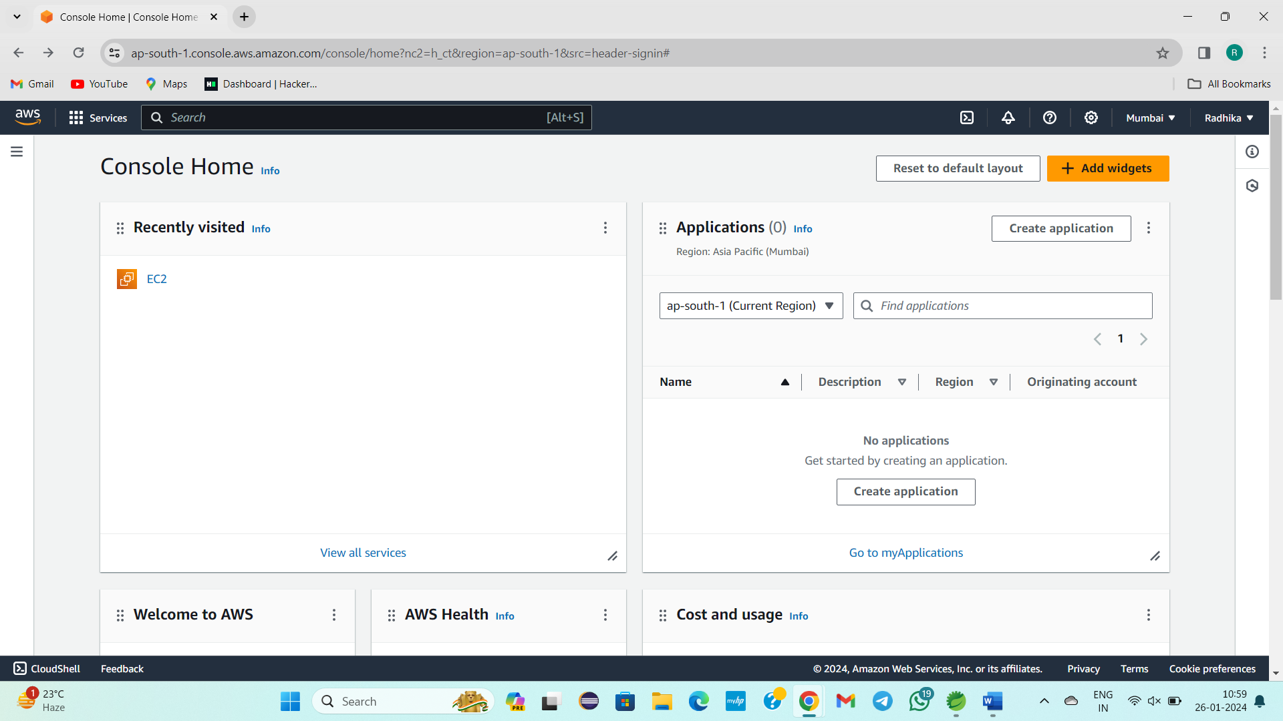

2)

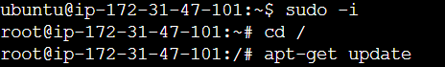

3)

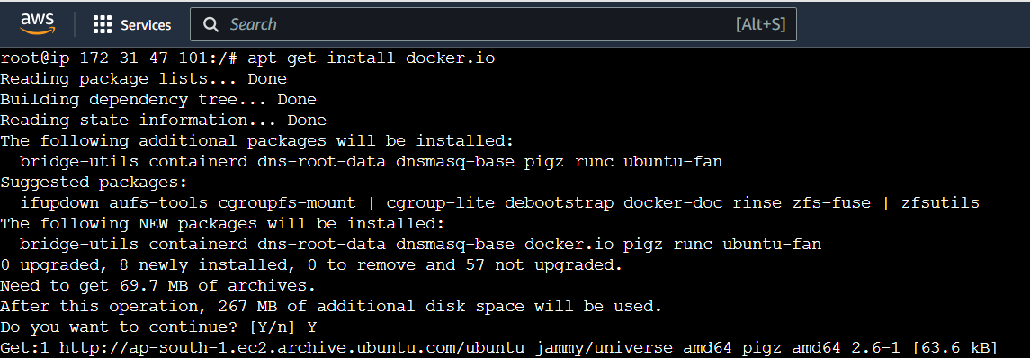

4)

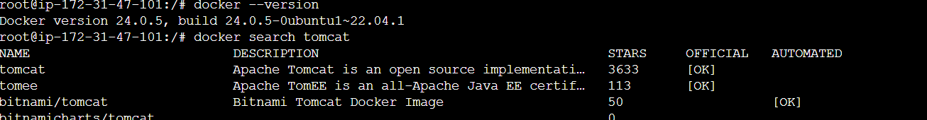

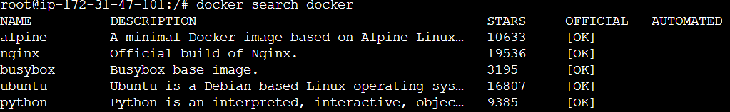

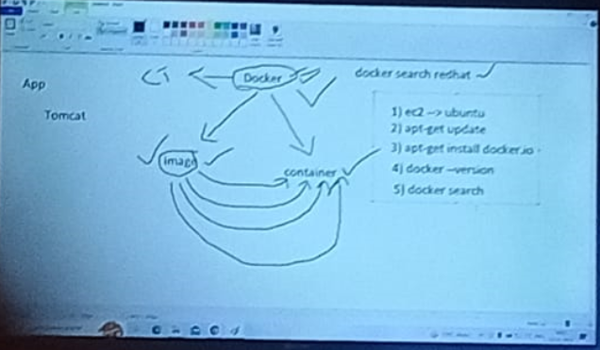

--------------------------27/01/2024-------Saturday----Class-25------------------------

Topic:

* Architecture of Docker
* How to search for particular OS/TOOL[docker search os/tool name]
* How to pull into our local[ docker pull os/tool name]
* How to view images[ docker images ]
* How to convert image into container[ docker run -itd imagename]
* How to view the container is either created or not[ docker ps -a]
* How to enter in to container[ docker attach containerid ]
* **docker attach containerid for entering in to os
* **docker exec containerid /bin/bash for entering in to technology related things
* How to exit from Container and comeback to Cloud OS[ exit ]

WE WORKED WITH 3 OS Our System Windows, Linux, Ubuntu

Image, container main in docker currently we are working

Docker also have structure/architecture/algorithm like maven

Do you know architecture of Docker?

|  |
| --- |
| CONTAINER |
| IMAGES |
| DOCKER |
| KERNAL |
| Host OS |

Without os I cant work

Host OS 🡪 Windows

Kernal 🡪 It will be present in Processor level(For working the windows)

Aws

Linux created

Docker installed

For Docker HOST OS 🡪 Linux

Kernal decides which activities should be done in HOST OS

When we enter in to docker

We work with images, container

We can convert docker in to os, server, technology related things with images and container.

Docker search ubuntu

Linux🡪Linux(UBUNTU) 🡪 copy which has more star rating🡪

From where these list of results are coming?

Docker serach ubuntu

Copied path

Docker pull ubuntu(Specified image name)

Docker images

Image came

Now we need to convert image in to container

Docker run -itd ubuntu(image name)

Image converted in to container

Docker ps -a

Container created

Iam entering in to container

Docker attach ContainerId

Ls -la

Exit(To come out from container to os running on OS)

We are inside os inside os

Ubuntu is converted in to container

Docker🡪OS level

From docker we will create maven

Docker search mavenproject

For bringing in to laocal

Docker pull ver/pro

Issue, image will not come in to my local

So I will go to another

Docker pull kdas

To check

Docker images

Docker run -itd image name

Docker ps -a

Docker attach containerid

Issue came

Docker ps -a

Docker exec (For entering into technology related things)

Docker search centos

Docker pull centos

Docker images

Docker run -itd image name

Docker ps -a

Docker attach container id

We are inside the container

Ls -la

**docker attach containerid for entering in to os

**docker exec containerid /bin/bash for entering in to technology related things

For Ubuntu

1)Search for ubuntu os

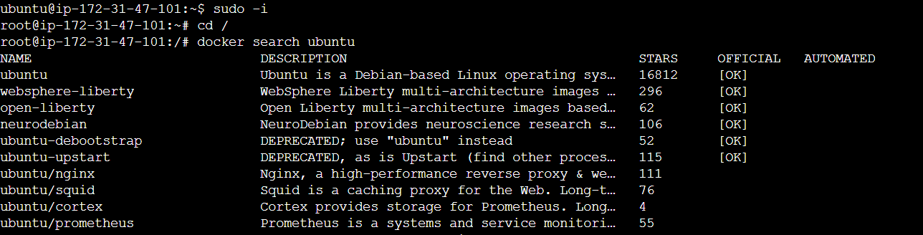

2) To get in to our local os

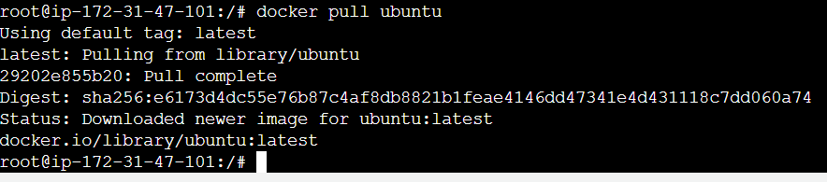

3)To check images

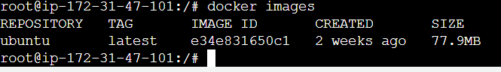

4)To create container

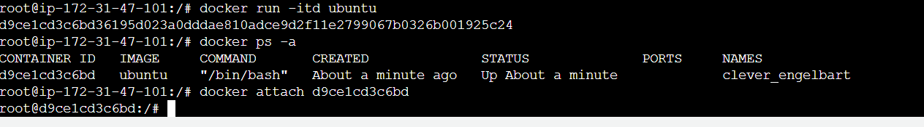

5)To enter in to container

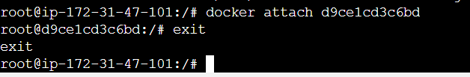

**For Maven**

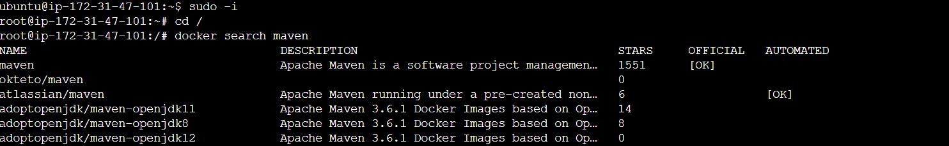

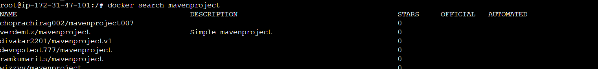



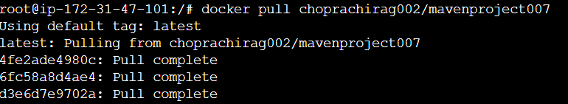

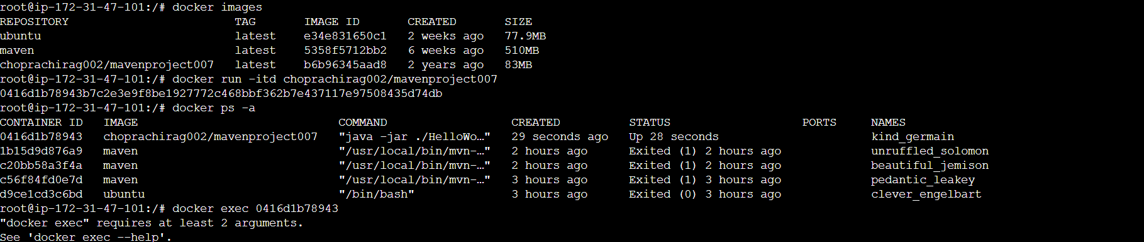

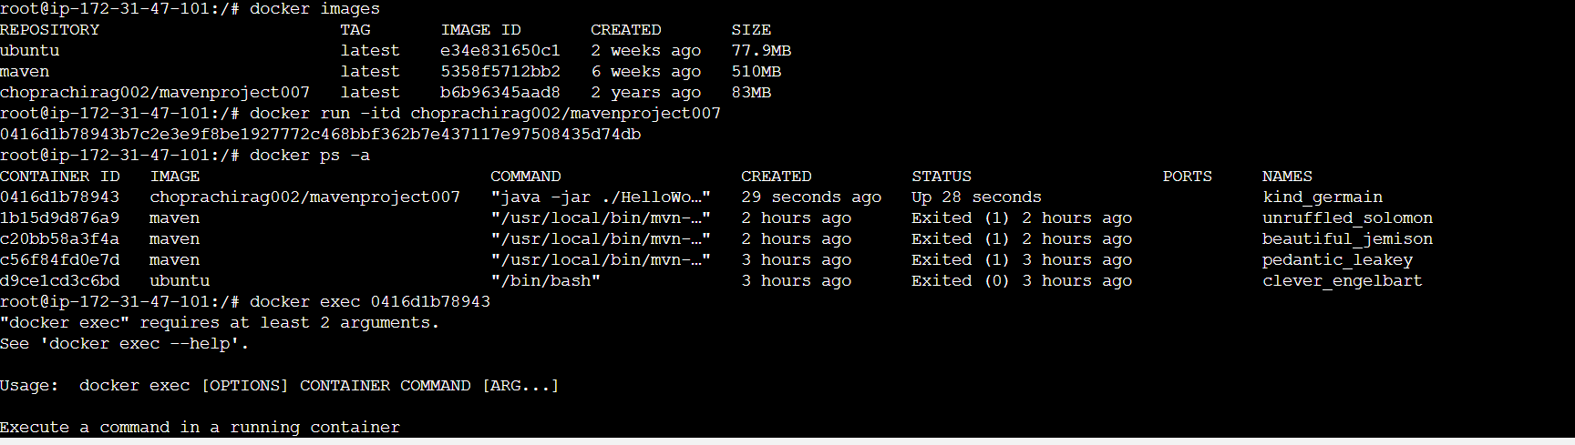

**For Centos**

1) Enter in to slash path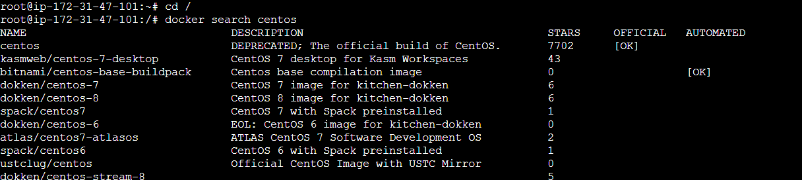

2) For pulling centos in to our local system

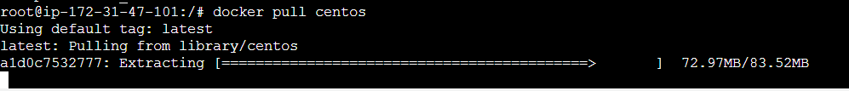

3) To check it is done or not

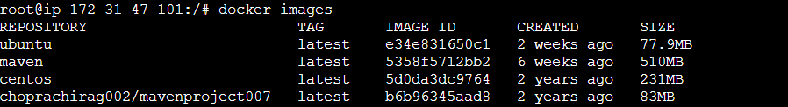

4) To convert centos image in to container



5) To check either the container is created or not

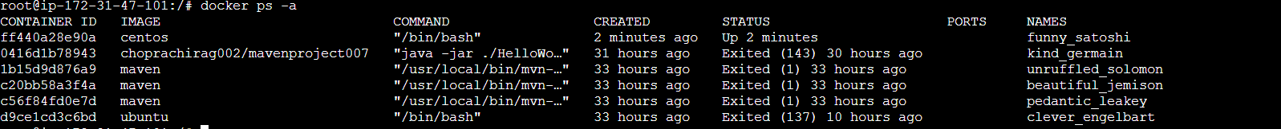

6)To enter in to container



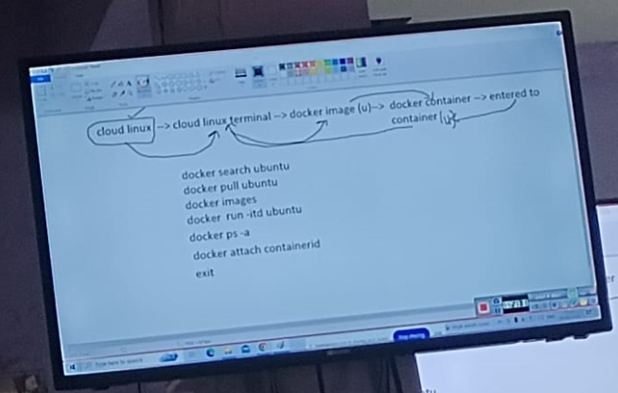

-----------------------28/01/2024---SUNDAY----Class—26---------------------------

Topic:

* How to create image and container
* How to enter in to container
* How to enter in to opt directory inside a container
* How to create files/ directories, tools / technology related things inside container
* How to Start/Stop the container/ image
* How to exit to cloud os while the container is in running state(CTRL+pq)
* How to remove single/multiple images and containers, How to remove all images/containers

In Docker container

OS Level images present

In cloud to launch a instance we take 5 minutes

In windows to install a OS it takes 1 hour

Using Docker I work with images in OS

We will pull image and convert in to container

STEPS:

Open aws

Connect with terminal

Cd /

We are in particular instance IP

docker images

we pulled imaged in to container

docker ps -a

Status 🡪 exited to up status

docker start containerId

docker attach containerId

Iam in docker related container

I am in slash path

This container is created due to ubuntu related image

I entered in to container

ls -la

Opt directory

I will create empty files & directories & install tolls like java, git, maven

cd opt

ls -la

touch file{1..10}

ls -la

mkdir d1 d2

ls -la

Now Tools/softwares installation in container

Before installing the Tools/softwares installation in container first we need to update

apt -get update

apt -get install maven

mvn – -version

we doing this work in docker container

apt -get install git

git – -version

java – -version(its there why? While installing maven docker installed java too )

Now I want to get out of container

exit

docker ps -a

ubuntu is in exited state

Now I want start again

docker start containerid

docker attach containerid

ctrl+pq to exit from container[ in backgraound container works we came back to the cloud related os]

docker ps -a

we can deploy applications, databases in further classes

Always container should be running state

Because all employees in company should use

docker images

Ubuntu, centos are floavours of os

docker start containerId

docker ps-a

//[docker exec -it containerid /bin/bash

docker images

docker search mavenproject

docker pull devopstest777]//

//[docker images

docker run -itd divakar2201/mavenproject]//

How to delete containers

docker rm -f containerid containerid containerid

docker stop containerid

docker ps -a

To remove all containers

docker rm -f $(docker ps -aq)

docker ps -a

(All deleted)

To remove images

docker images

docker rmi imageid

docker images

Docker rmi $(docker images -aq) -to remove all images

docker images

No images now

**Steps:**

1. Going in to slash path

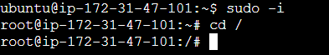

1. For checking images

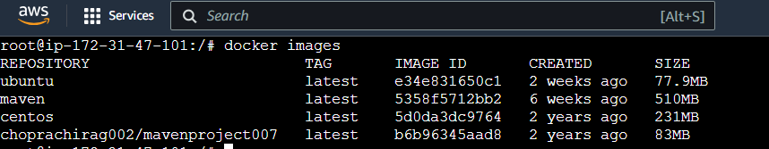

3)For checking for containers

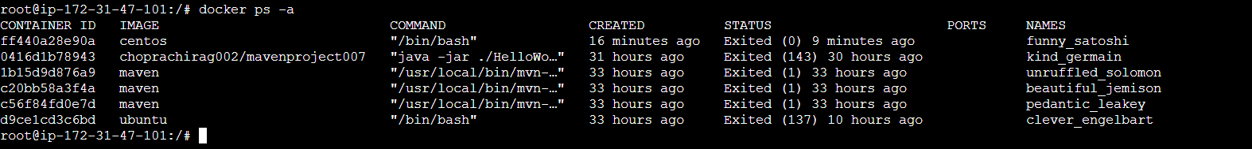

4)Here ubuntu is in exited state to bring it in to up state/start state



5)To enter in to container



6)To check what is in it

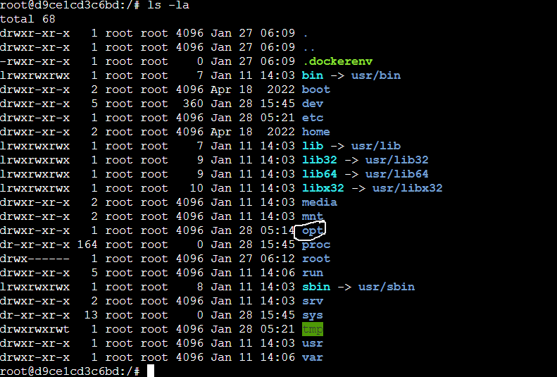

7) cd opt

8)touch dockerfile{1..10}

9)To remove file rm -rf filename1 filename2

10) To remove directory rmdir directoy name

11)To check opt dir

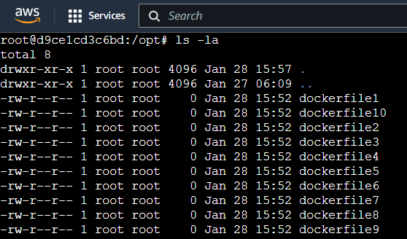

12)To create directories

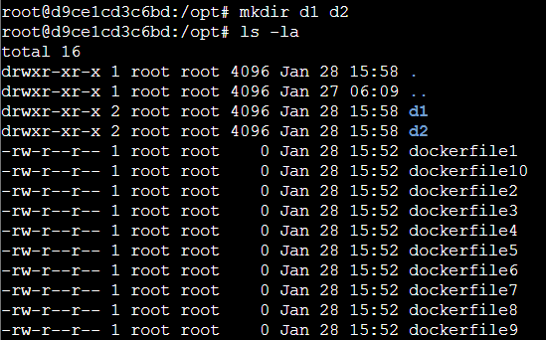

13)Before creating any tools or technology related things firstly we need to update

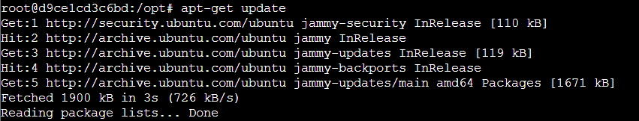

14) To install maven

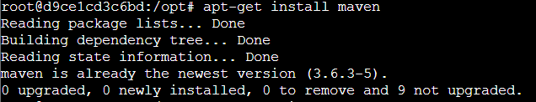

15) To check maven version

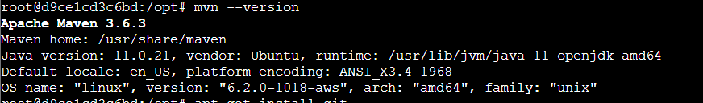

16)To install git

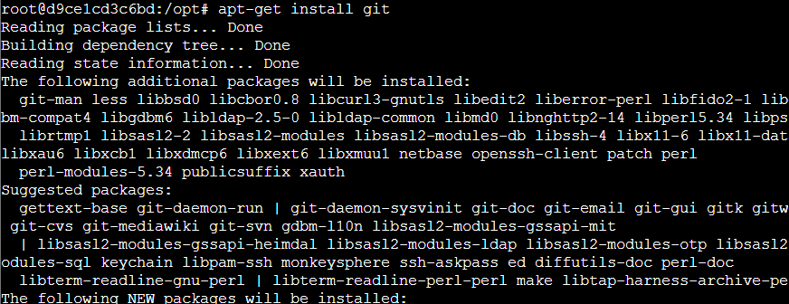

17)To check the git version



18)While installing maven java is installed automatically, why because without java maven cannot be worked. So no need to install java separately again, just check the version



19) How to exit from opt and container

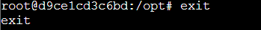

20) How to check the containers

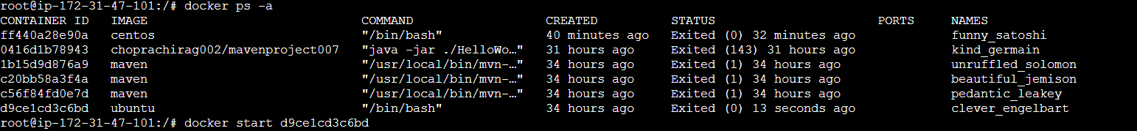

21) How to start the exited status ubuntu image in to upstate



22) How to enter into container



23)How to exit the container without actually exiting the container and comeback to cloud os CTRL+pq



24) Now you came back to cloud os , Still the ubuntu container is in up state, you can check in below image

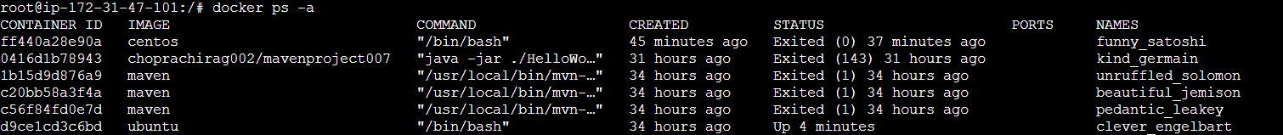

25) Then how to stop this ubuntu container



26)Check either it is stopped or running

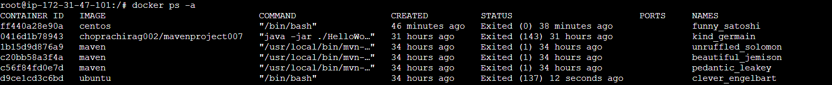

27) How to remove containers

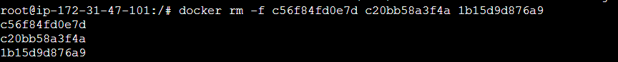

28)Check either the containers are removed or not



29)How to remove images

docker rmi imageid

30) How to remove all images

docker rmi $(docker images -aq)

31) How to remove all containers

docker rm -f $(docker ps -aq)

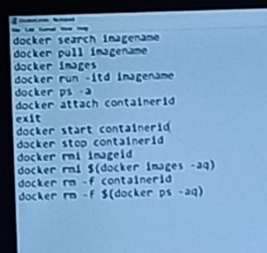

-------------------------29/01/2024------Monday---------Class – 27--------------------

Topic:

* In how ways we can use a Docker. [OS, Tool, DB]
* How to enter into search , create a container for tomcat
* How to create a container with our desired name and port number
* Comparison between windows os and the Cloud Linux on directories. In Cloud Linux we can view only .sh things
* By entering docker images we are getting data. Actually From where this data is coming ,DockerHub.
* Install DockerHub and create a account

Docker🡪image🡪Container (Ubuntu based Container)🡪 Files/Directories/Tools

STEPS:

AWS

CONNECT

clear

sudo -i

cd /

docker images

No images

docker ps -a

No containers

We we will work with tomcat

docker search tomcat

docker pull tomcat (image name)

Tomcat is a server

docker images

docker run -itd tomcat (To run image as a con tainer is one way)

docker ps -a

Names = busy_shirley( How to give our name to our container)

docker run -itd -p 8080:8080 –name testtomcat1 tomcat(This command is to run a container with desired port, desired container name)[Any way to create a container]

docker ps -a

docker exec -it containerid /bin/bash

We are inside container

ls -la

cd bin

ls -la

Here .sh things only

cd .. (come out from bin)

ls -la

cd conf

ls -la

Docker

1)Ubuntu

2)Tomcat (web server)

We did not gave any url in docker, In cloud Linux , we opened terminal, we created container

Cloud Linux

Cloud Terminal

Inside Container

It can be work as OS(Ubuntu)/Web Server(Tomcat)

* Spring mvc is a framework, it can be changed in to container
* CTRL+pq
* Came back in to cloud Linux without closing the container
* To create anything how?

docker search spring

pull, image, create container(2 ways)

* Container can be created in two ways

1)**docker run -itd imagename

2)**docker run -itd -p 1234:1234 –name containername imagename

* We can enter in to container in 2 ways

1. **docker attach -it containerid
2. **docker exec -it containerid /bin/bash

docker search redhat

Multiple results

From where these results are coming

We are having a environment called dockerhub

We need create account in dockerhub

Steps:

* Here images stored
* Signup
* Un, pwd
* Sign in
* Docker hub entered
* Repositories
* Images
* We you hit Docker search command in cloud linux terminal we get 15- 20 results we get these results from docker hub
* Goto dockerhub search for centos
* 10,000 images
* But in terminal only 15-20 coming because only top 15 will come
* Docker search ubuntu
* From 6 th one see once
* Ubuntu/squid……….
* Without slash means it is created by docker community. With slash created by employees in organization.[43-46]
* Why these results are coming.

1)Enter in to slash path

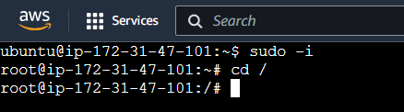

2)To View the images

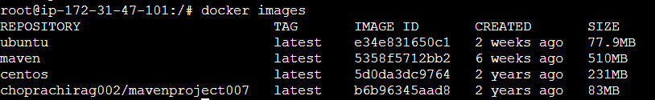

3)To view the containers



4)To search for Tomcat Server

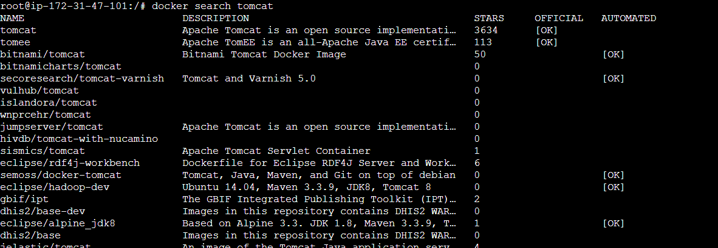

5)To pull tomcat in to our local

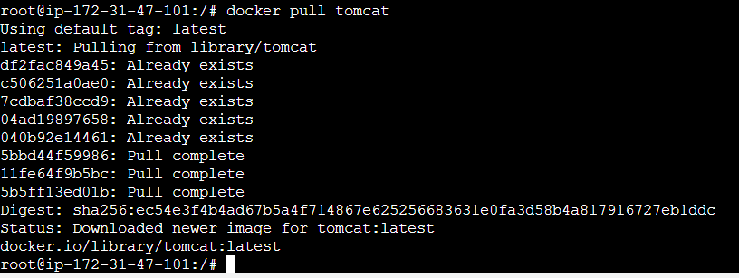

6)To view the images

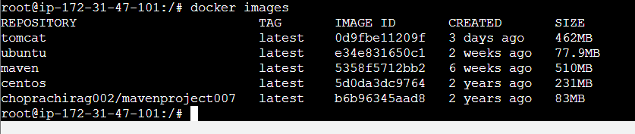

7)To convert the image in to container



8)To view the containers



9)To create a container with our desired name and port



10) Now you can view either it is created or not



11)Enter in to container



12)Now view what is inside the container

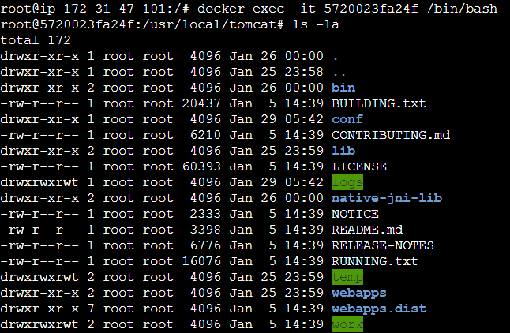

13)Enter in to the bin



14)Now view what is inside the bin

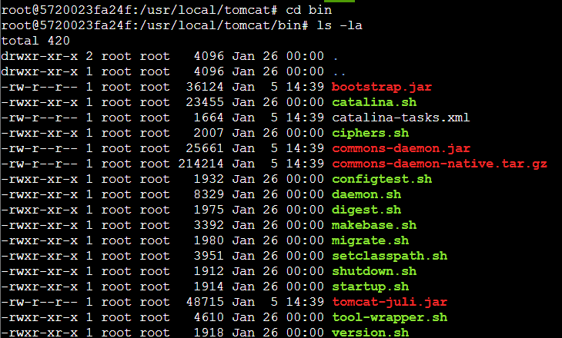

15) Now comeback to the tomcat by below command



16)Check what is inside the tomcat

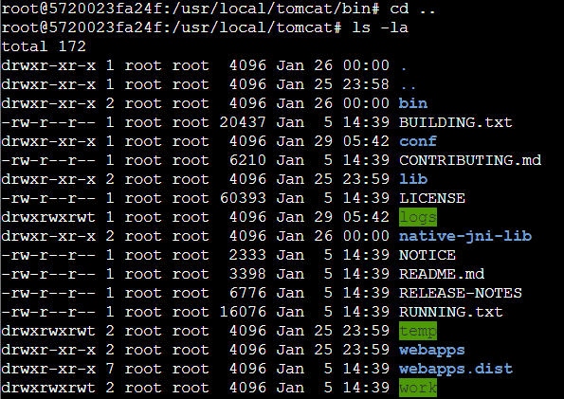

17)Enter in to conf



18)Check what is inside the conf

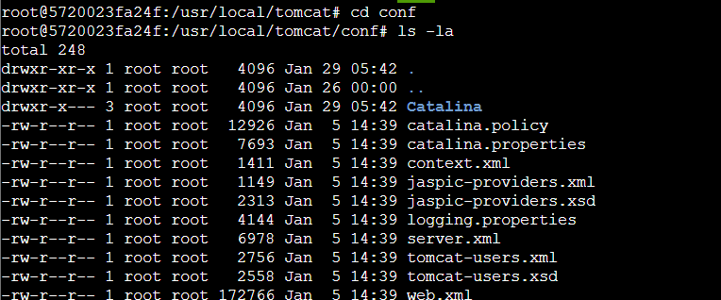

19) Enter CTRL+pq



20)To view the containers



21)To stop the containers in UP state

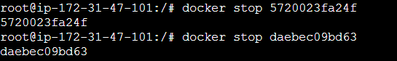

22) To view the containers

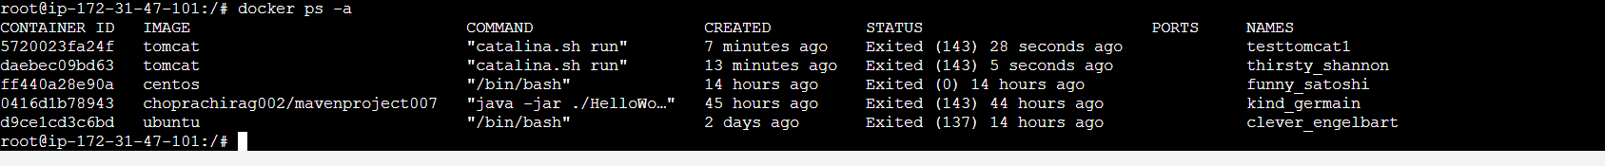

23)Enter in to dockerhub

Click on this link <https://hub.docker.com/>

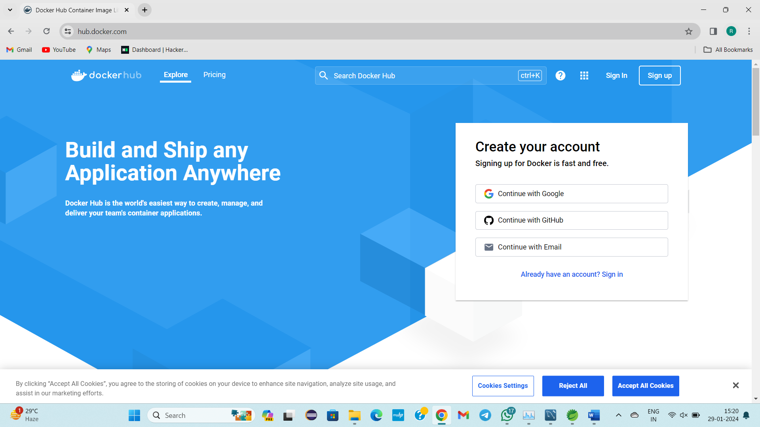

24) Create an account in dockerhub

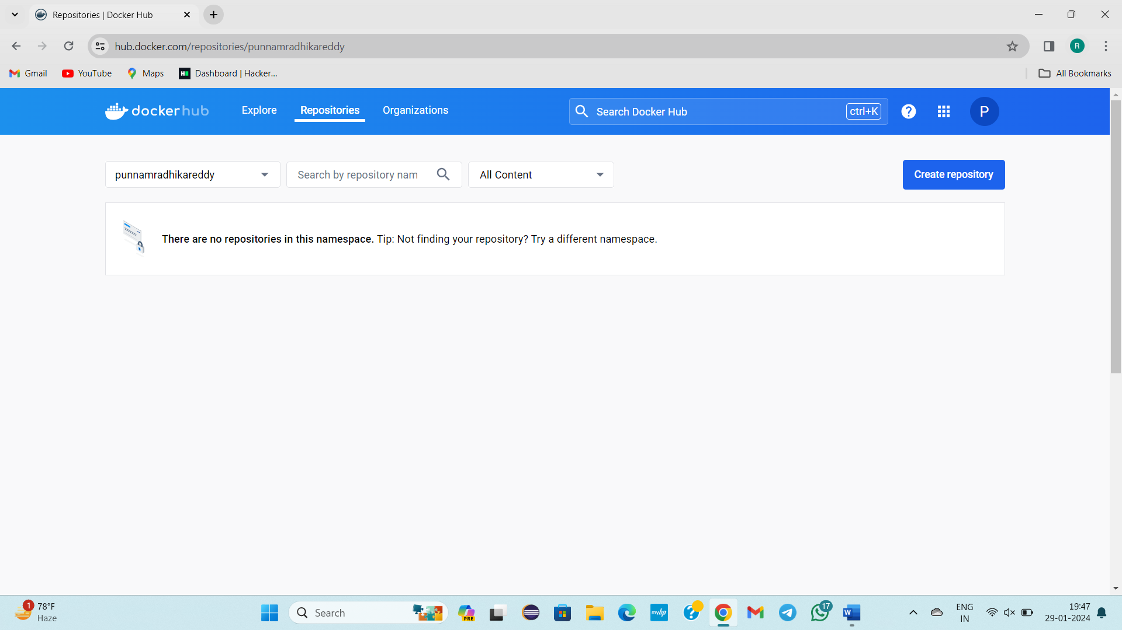

-----------------------30/01/2024---------Tuesday----------Class-28----------------

**TOPIC: LIFECYCLE OF DOCKER**

**Docker**

**Image**

**Container**

**Own image**

**dockerhub**

* In industry software developer work is Coding 🡪Creating Environment using docker(Ubuntu based os or Linux based os)
* Docker Life cycle
* Till now we saw Docker🡪image🡪container these three steps
* Docker🡪image🡪container🡪ownimage🡪created image send to docker hub(janawsbatch)[These steps we didnot perform which is in blue colour, we are going to do in this class ]
* Till now predefined image is converted in to container
* In dockerhub we can see our own images along with predefined images

* In cloud linux we can see by this command 🡪 docker search mysql

Today’s Requirement:

Docker🡪 Ubuntu image pull in to local 🡪 Convert in to Ubuntu container🡪 own image🡪dockerhub

**STEPS:**

* AWS
* Open Terminal
* sudo -i
* cd /
* docker images
* docker search ubuntu
* docker pull ubuntu(image name)
* docker images
* docker run -itd ubuntu(Image name)
* docker ps -a
* Now, I want to give my own name
* docker attach containerid
* We are inside the container in slash path
* To install tools
* apt-get update
* apt-get install maven
* mvn – -version
* apt-get install git
* Y
* git --version
* java --version
* We created 3 tools in ubuntu container
* Ctrl+pq
* Read escape sequence
* docker ps -a

* Go to dockerhub
* Create a repository
* Give RepositoryName(Any name-janawsbatch)
* Shortdescription:janaws batch
* Visibility: public
* Click on create
* Repository created
* Come back to aws cloud
* docker commit containerid imagename [image name should be same as repository name(with Id) in dockerhub]
* docker images
* Our own image created along with predefined images
* One container is created in to our own image
* For moving in to dockerhub repository
* docker login
* Username:punnamradhikareddy
* Password:…..
* Login Success
* docker images
* docker push imagename

This whole process is known as dockerlifecycle

* docker search ourownimageid/ ourownimagename

In dockerhub when you search for ubuntu, centos we will get no of images

When you search for janaws only one result comes

Search🡪pull to local🡪container🡪enter in to container🡪already git, maven, java is already present

Docker provides the Environment to the users to work with any tool like git, maven, java using Image , container containers

Docker is for creation of environment to work with different tools/OS/DBs

In Docker create once, use

Predefined image is pulled in to local

STEPS:

1. Go to / path

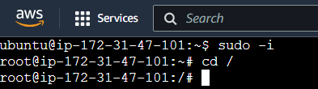

2)apt-get update

3)Apt-get install maven

4)

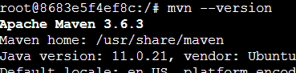

5)

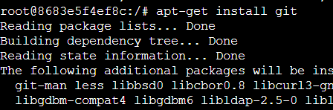

6)

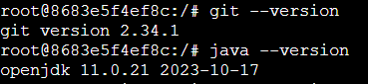

7)CTRL+pq



8) To view the containers



9)Go To Docker Hub create a repository with a meaningfulname

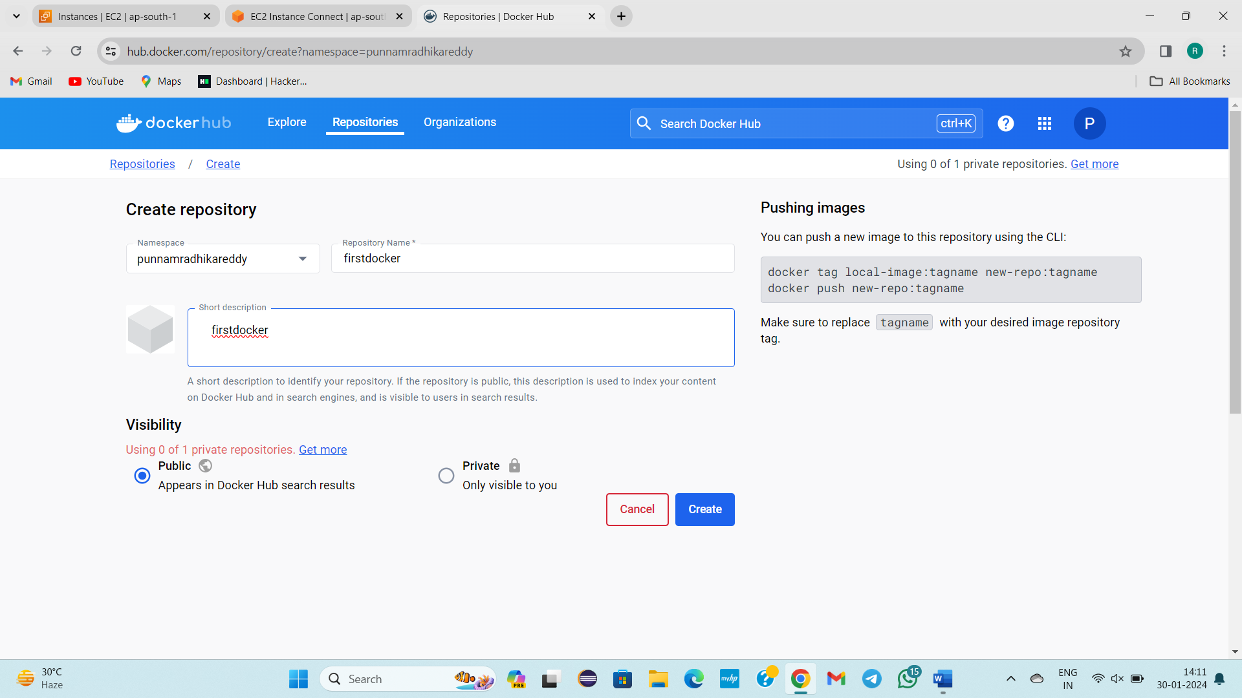

10)Comeback to aws cloud commit the changes



11) To view the images



12)To push the local images in to docker repository

Docker login

Give username and password

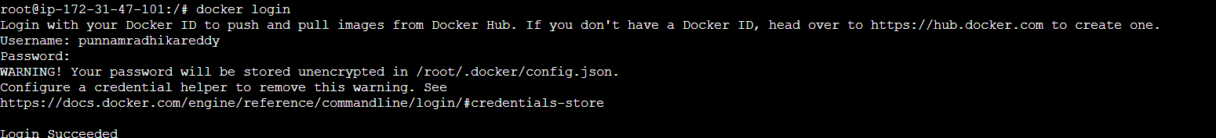

13) To view images



14)To push to dockerhub repository

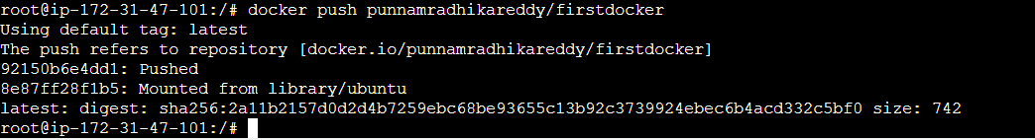

15) Go and check in dockerhub repository

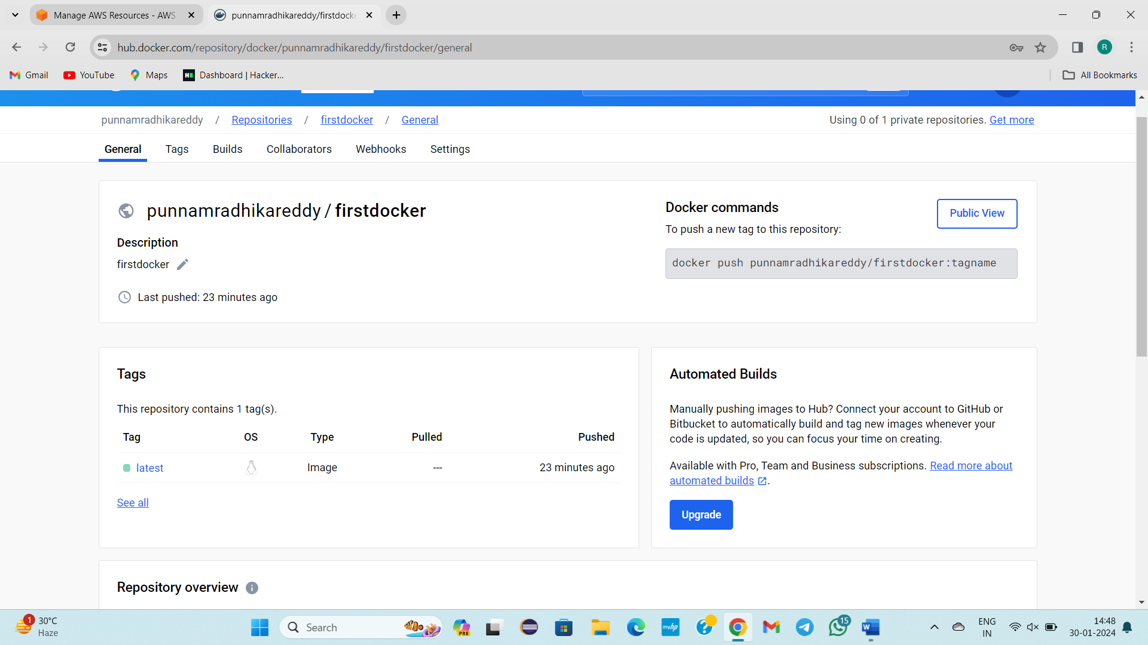

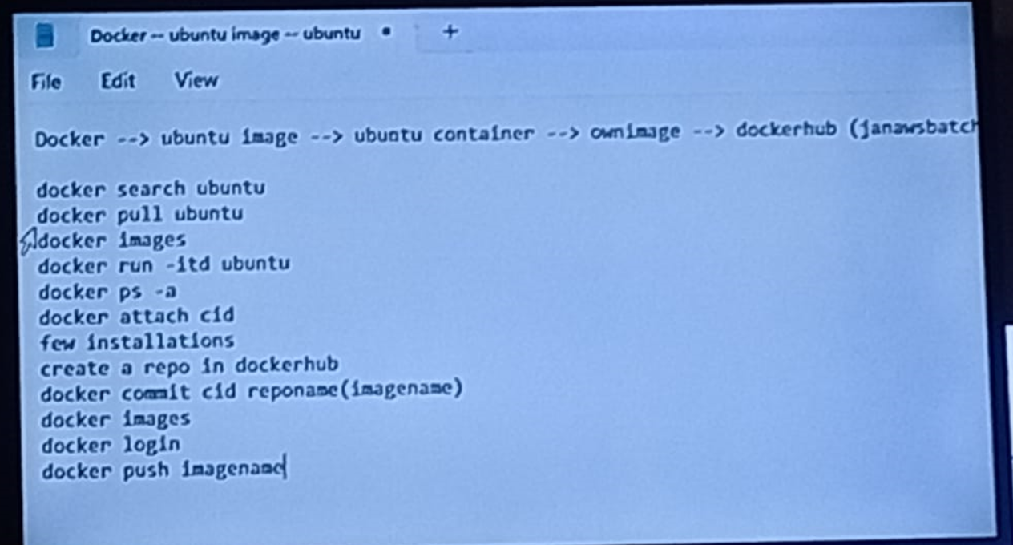

----------------------31/01/2024-------WEDNESDAY------CLASS—29----------

**Topic:**

**TASK:**

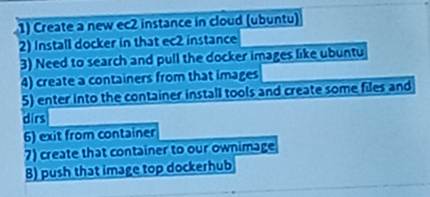

**-------------------------01/02/2024------Thursday----------Class -30--------------**

**Topic:**

* **What is Docker file and it’s use?**
* **Purpose of creation of Docker file.**
* **How we can create new directories, install tools by run instruction by Dockerfile outside the container, how these changes are reflected inside the container?**

In detail in notes

**STEPS:**

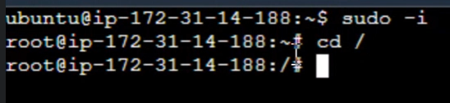

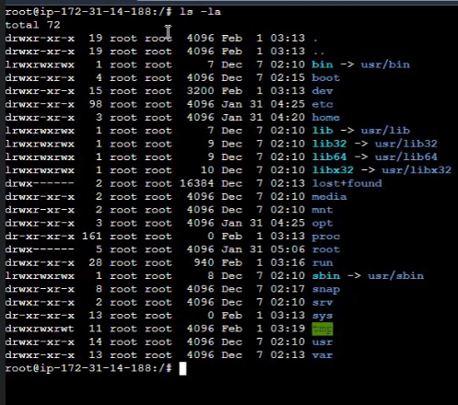

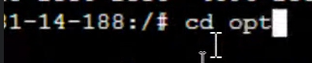

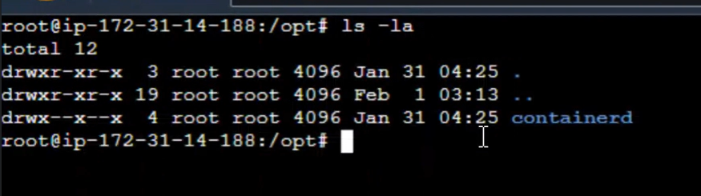



ESC+I

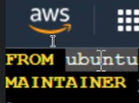email

:wq!



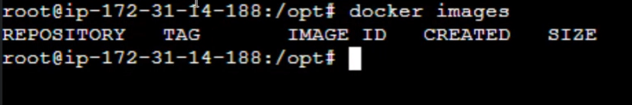



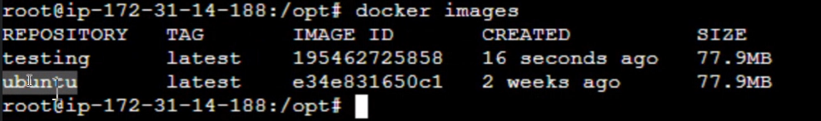



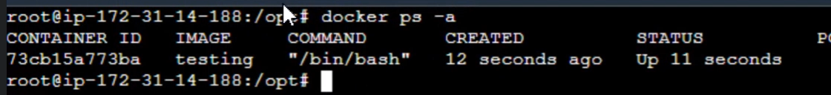

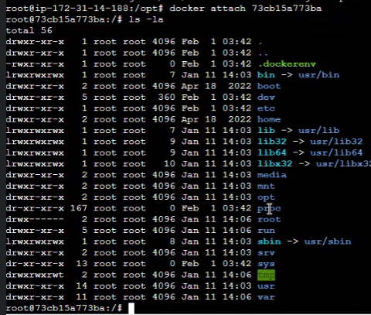



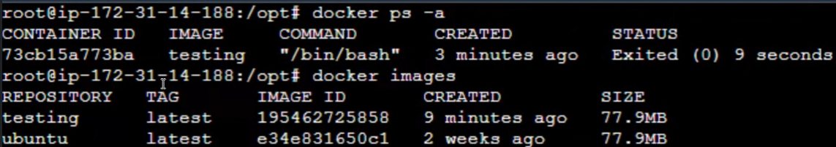

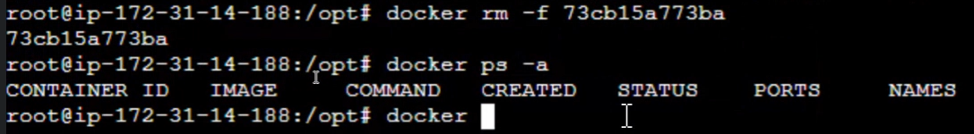

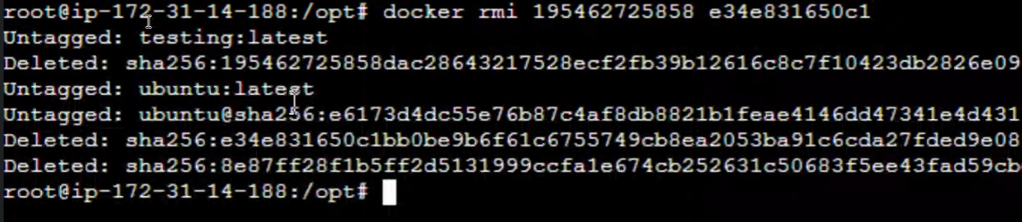

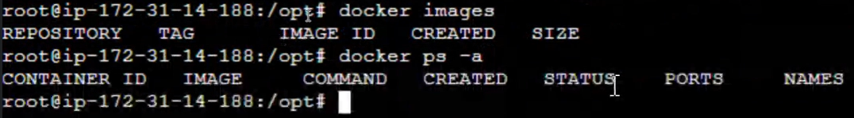



Esc+i

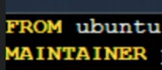email

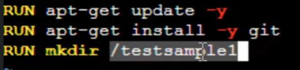





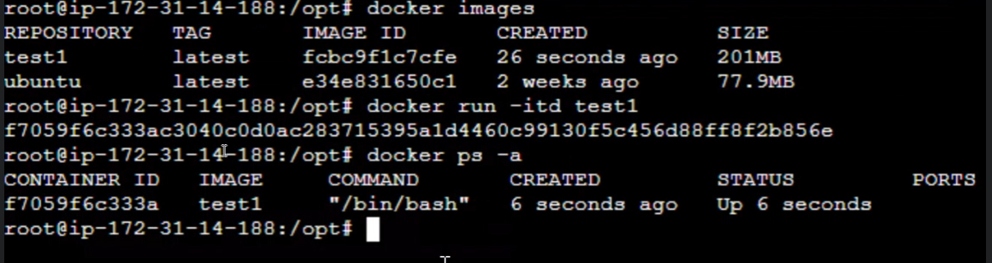



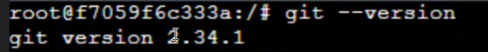

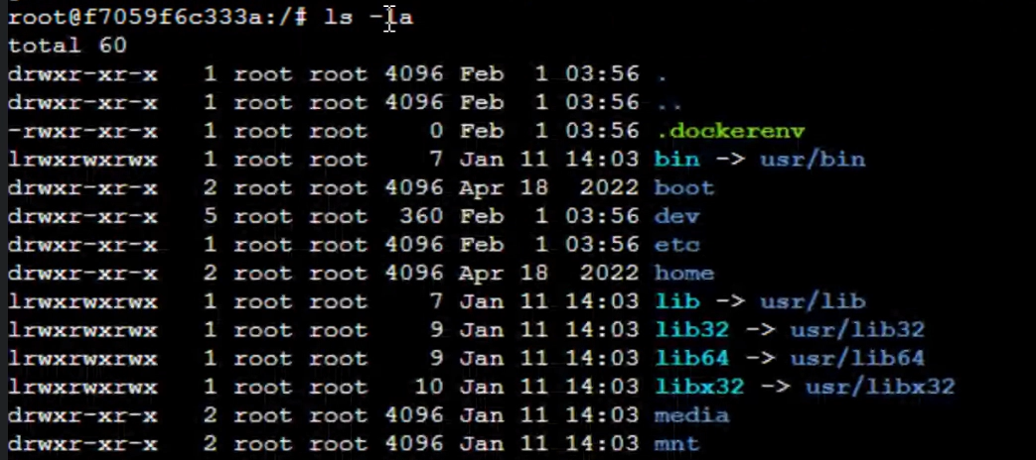

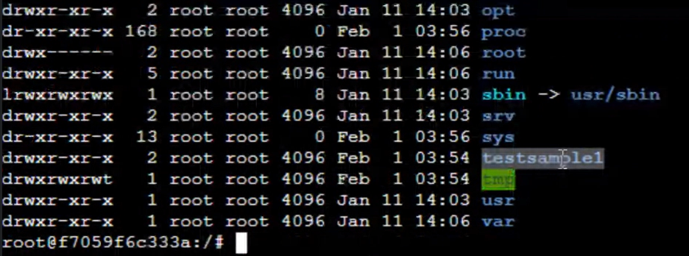

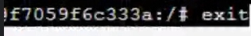

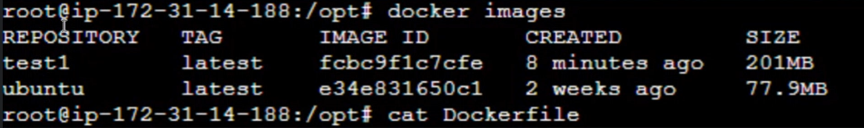

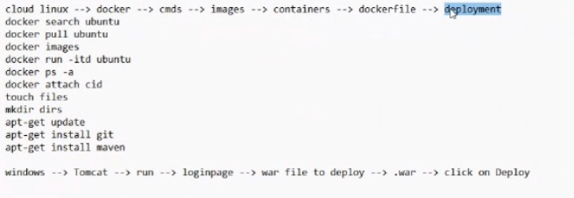

**------------------------02/02/2024----------Friday-----------Class -31--------------**

**Topic:**

* **There are 2 ways to run the container**
* **docker run -itd imagename**
* **docker run -i - - tty imageid /bin/bash(if automatically goes to exited state then use this command)**
* **Where we will use CMD instruction?(Not Told)**
* **Where we will use COPY instruction and Purpose?**
* **Where we will use ADD instruction and Purpose?**

In detail in notes

**STEPS:**

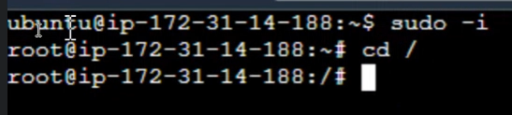

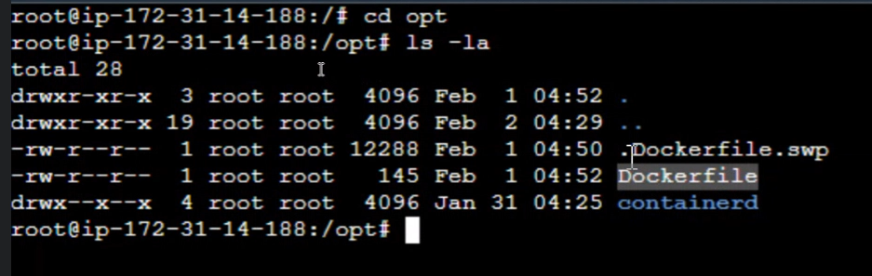

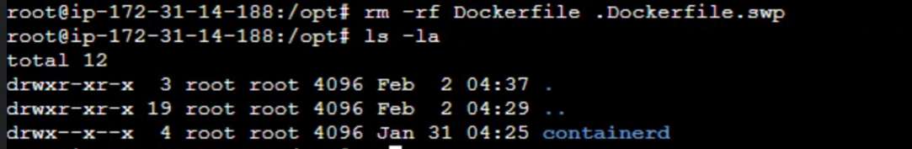

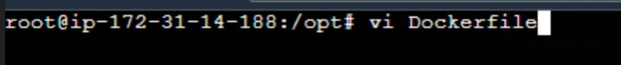

Esc+i

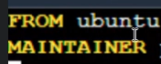email

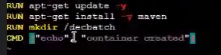

:wq!



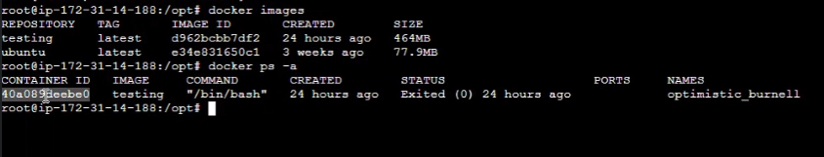



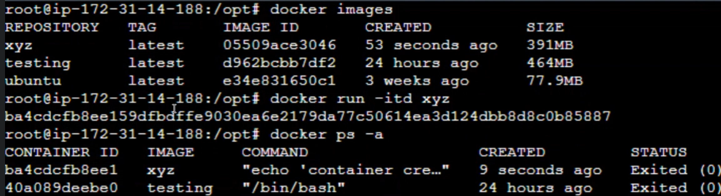

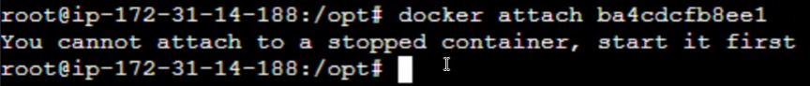

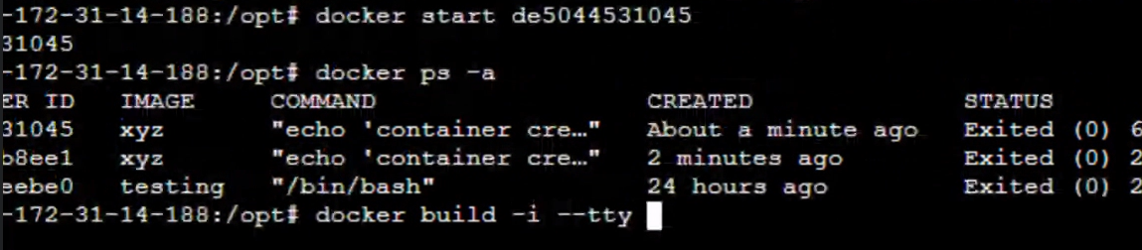



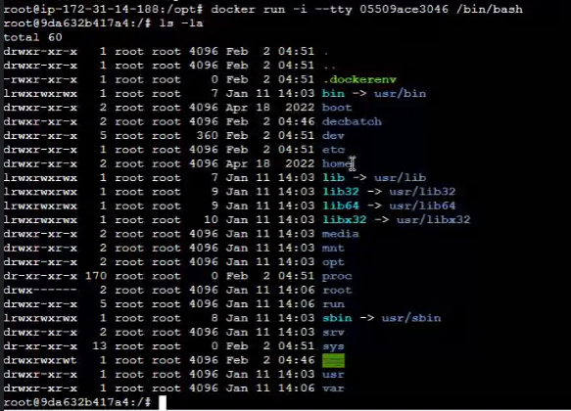

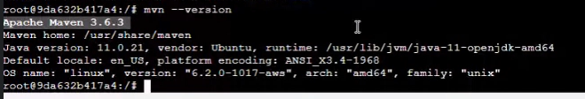

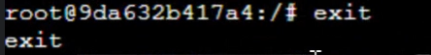

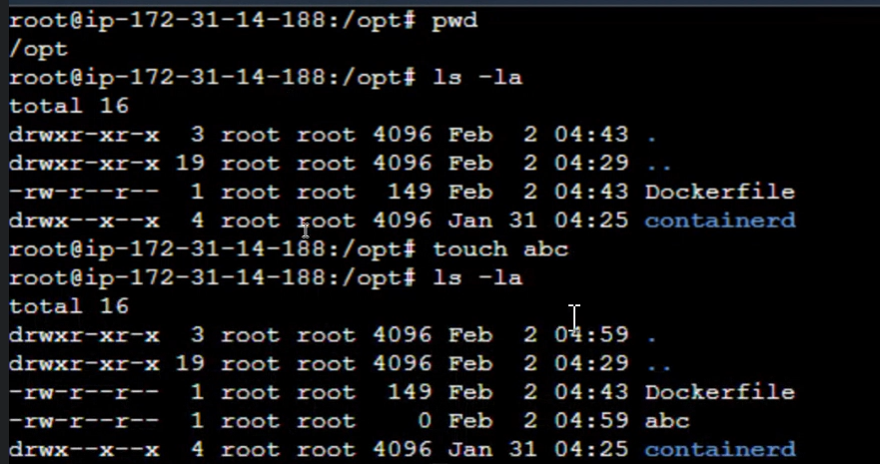

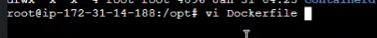

Esc+i

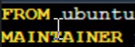

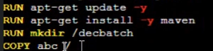



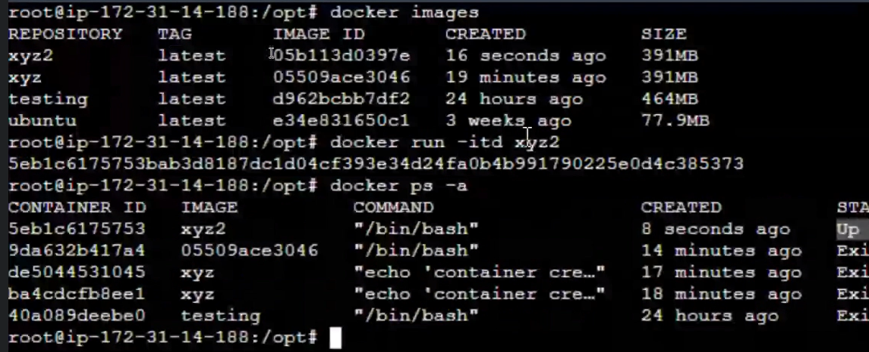

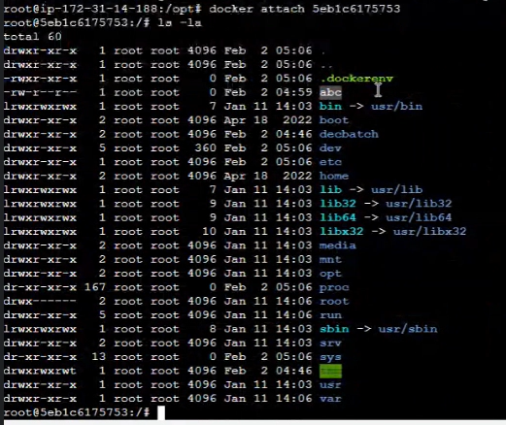

Esc+pq



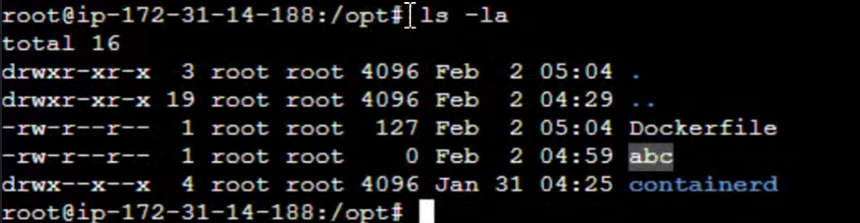

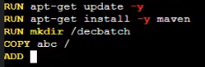

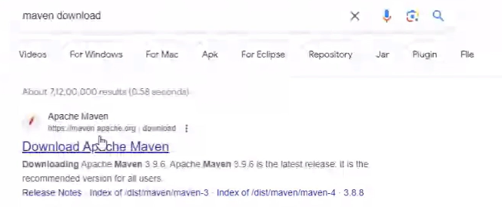

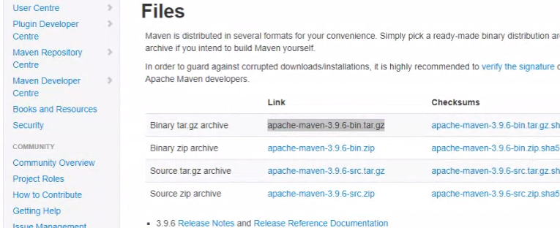

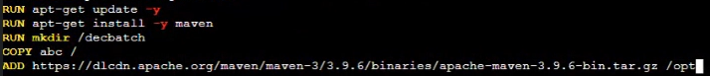

:wq!



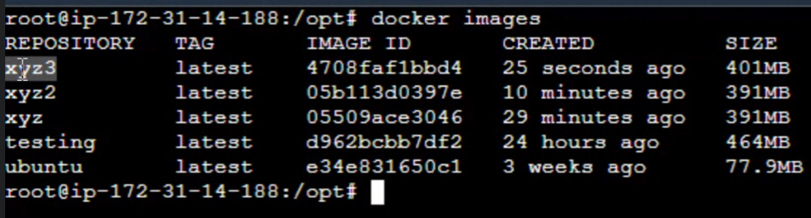

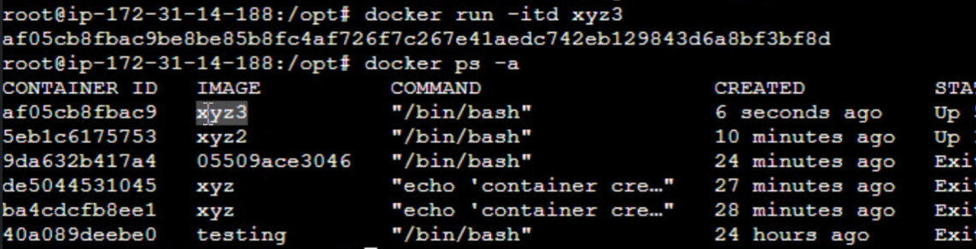



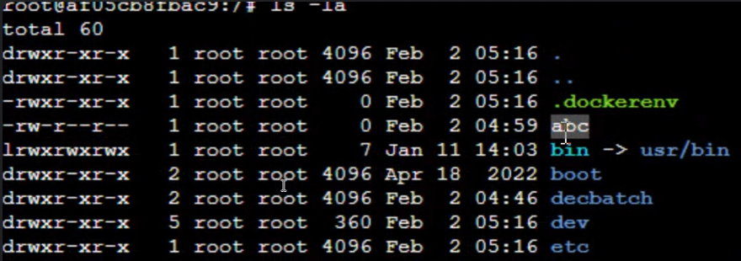

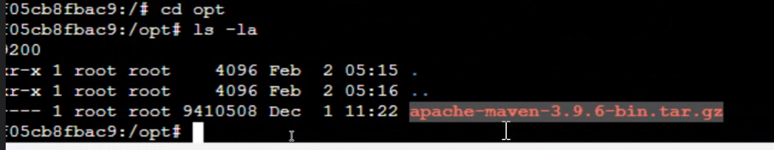

**--------------03/02/2023----------------Class-32------Saturday------------------------------**

**Topic: Deployment Process in Docker**

How to deploy application in Docker Environment?

Before docker we have deployed our application in **Tomcat server.** In tomcat server we deploy **.war file.**

To generate this file, we have few steps

* Code should be available in **GitHub repository**
* From GitHub repository to we need clone into local repository
* Whenever we that particular repository to local we can provide **maven goals**
* By providing maven goals it is going to create **.war files**
* **.war file** will be created by our project name
* We can start the tomcat
* In tomcat we going login as **admin**
* In tomcat we have one area to deploy **.war file to deploy** there we can choose our **project file** for deploying by click on **Deploy** button

In this way we are going to deploy manually in tomcat. Same process we are going do in **Docker**.

Even in GitHub repository here we have few repositories here I’m considering **Maven Project** as my repository for deployment purpose these repository files are also created in eclipse only.

All these happened in windows operating system. Same process we are going do in **Docker**. Currently we are working in **cloud Linux** same steps we are going to use in Linux Operating System**.**

* GitHub repository clone into Linux
* Install **maven** in **Docker**
* By using maven goals I’m going to generate **.war file**
* Going deploy **.war file** in **Docker**

These steps we are using to deploy **.war file** in docker. We are going to **clone GitHub repository into Linux operating system** and here we need to install **maven**. Once maven got installed, we are going to create few goals automatically **.war** file is going to create. After **war file** got created, we are going to deploy by using **Docker.**

**Step – 1**

* Login to AWS
* Launch Ec2 instance
* Connect to cloud Linux
* Change from **ubuntu user** to **root user**
* Change from tilt(~) path to slash(/) path

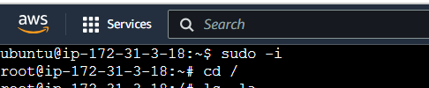

To check pre-define libraries and pre-defined files by using **ls -la** command

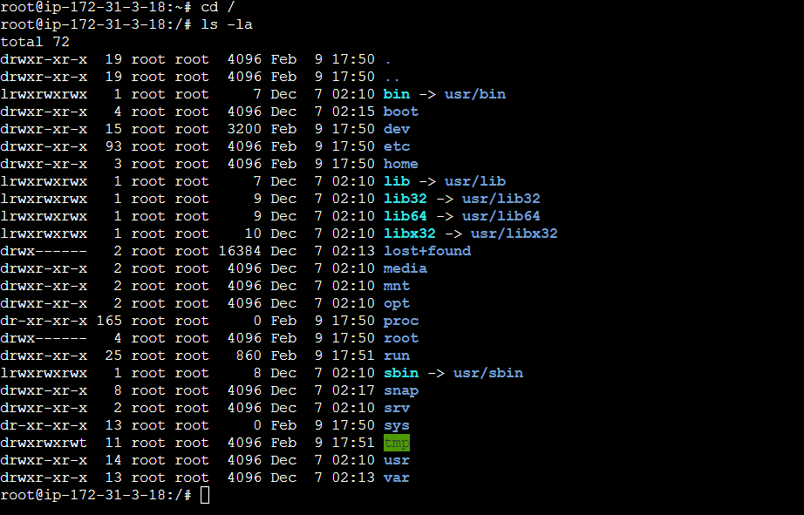

Here we observe all pre-defined file and libraries. We already installed git.To check version of **git** we use **git --version** command

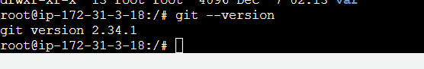

Now I’m trying to clone particular repository into my Linux operating system

we can copy URL from GitHub repository

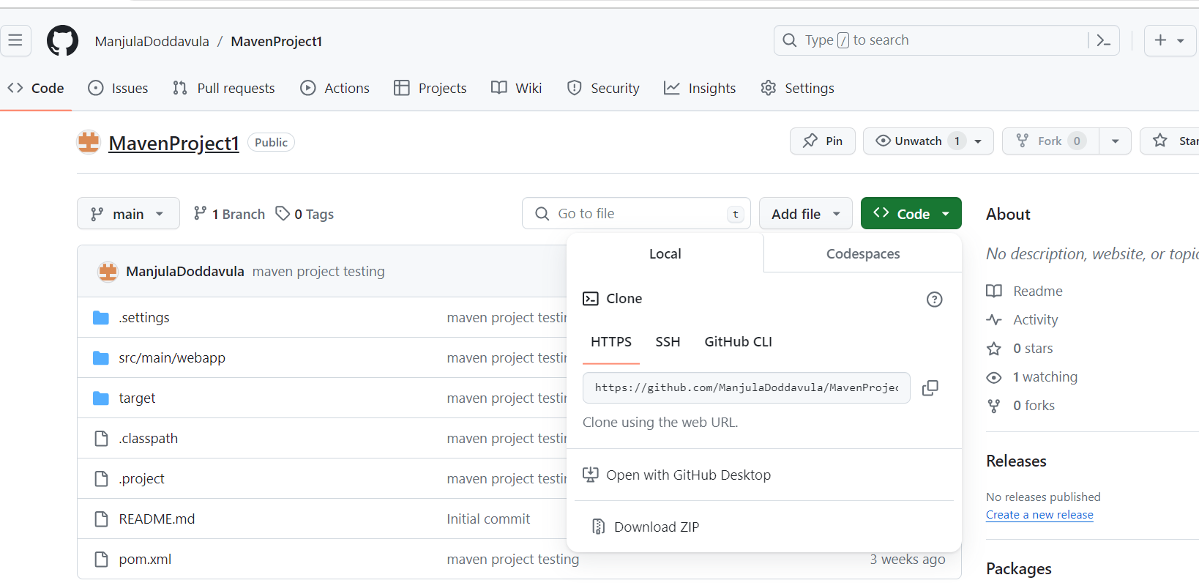

by using **git clone** [**https://github.com/ManjulaDoddavula/MavenProject1.git**](https://github.com/ManjulaDoddavula/MavenProject1.git)command

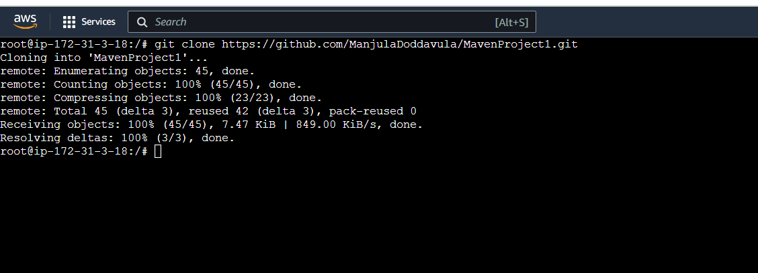

Here we observe **MavenProject1** repository was cloned into Linux operating system. By using **ls -la** command we see files which is located in Linux operating system.

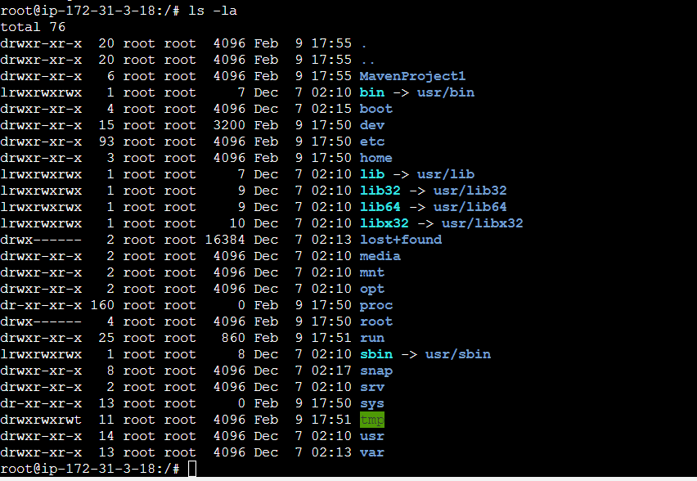

Here we can observe **MavenProject1** was cloned successfully. Same command we used in windows in gitbash then project cloned in local repository.

Now we entering into MavenProject1 by using **cd MavenProject1** command. We are checking files by using **ls -la** command

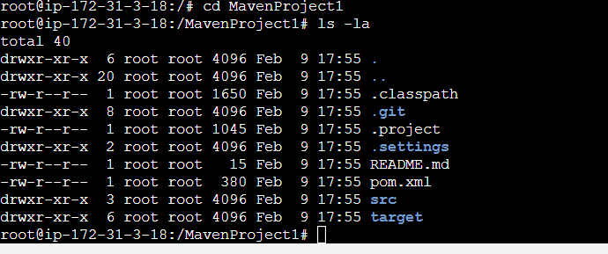

These are all files which is located in MavenProject1

**Step – 2**

* We need install **Maven.**
* First, we need to check weather **maven** installed or not by using **mvn --version** command.

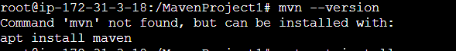

Maven is not yet installed for installation purpose we need to use **apt-get install maven** command

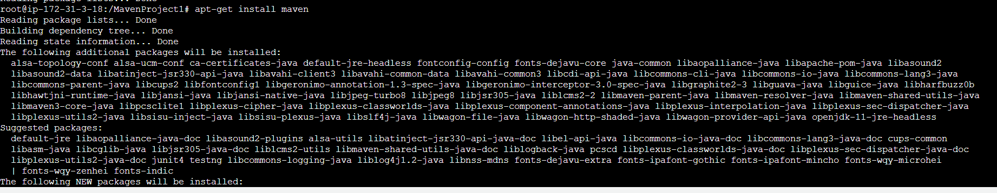

Now we check weather maven correctly installed or not by using **mvn --version** command

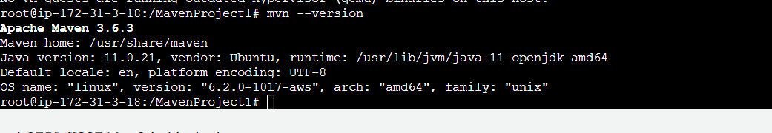

Here we can observe version of maven that means maven got installed successfully.

**Step – 3**

After installing maven, we need execute **maven goals** for creating **.war file**

Currently we are in **Mavenproject1 repository** here we need to give **mvn clean** command.

Usually, **mvn clean** command we are giving in cmd in windows operating system. In Linux operating system we are giving **mvn clean** command in clone repository.

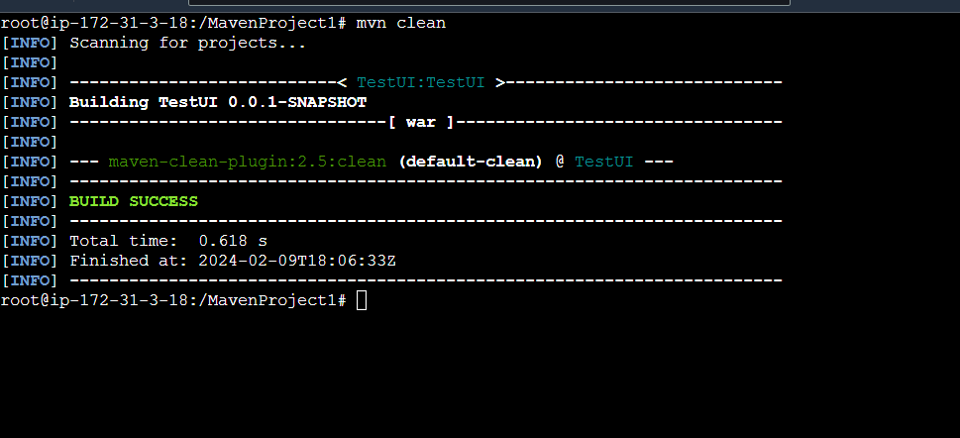

Here we observe “**BUILD SUCCESS**” message

Here we need give **ls -la command** to check weather target folder is deleted or not

Target folder was deleted successfully. Even in windows operating system also target folder got deleted when are giving **mvn clean** command

Now we need to give **mvn package** command. With this command **target folder** is going to create

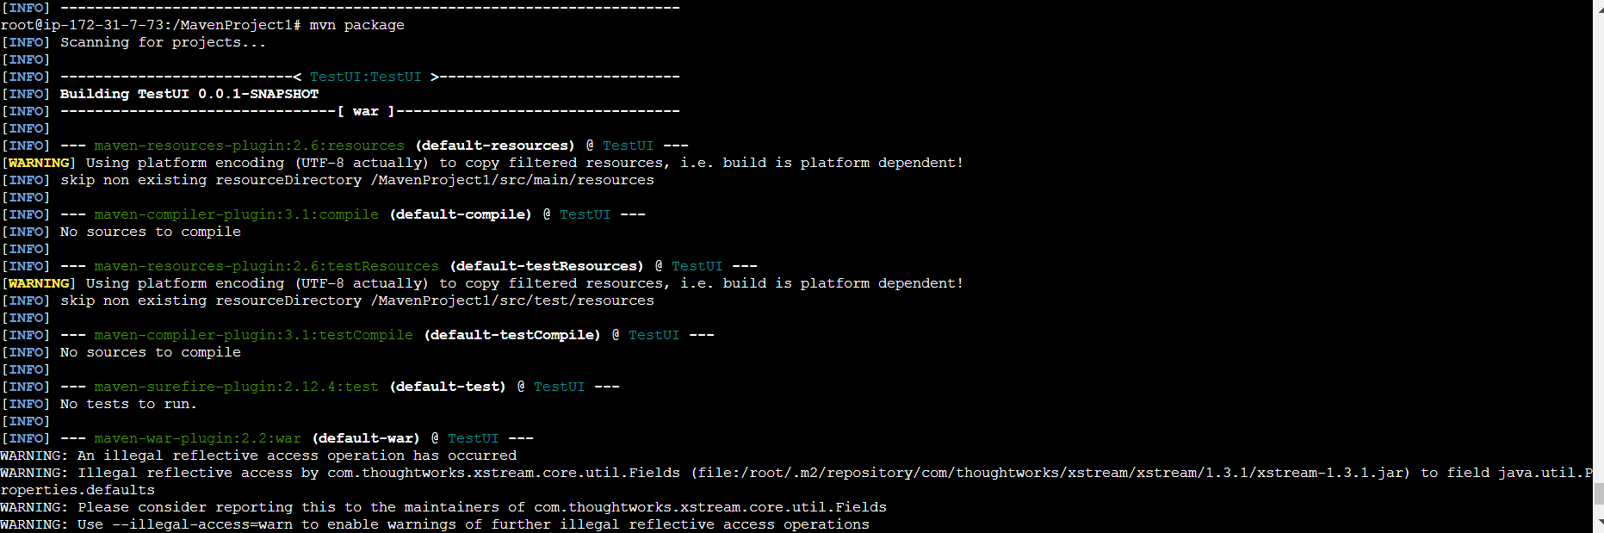

Now we need to provide **ls -la** command to check weather again target folder created or not

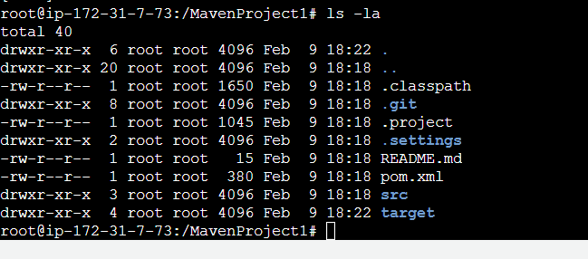

We can observe again target folder was created

Now we are moving into target folder by using **cd target/** command.

Now by using **ls -la** command to check weather .**war file** is generated or not

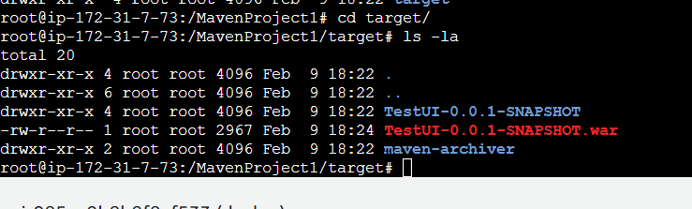

We can observe war file got created with the name of **TestUI-0.0.1-SNAPSHOT.war** inside the **target directory** war file got generated.

To come back from the target directory, we are using **cd ..**  command



In our deployment process 3 steps got completed.

Now we need to deploy this particular generated **war** file. In windows we can deploy our generated war file in tomcat. Even in **Docker deployment** process we deploy our war file in tomcat server. Whenever we are going to use maven goals then it is going to create **.war/.jar/.ear**(any file is going to create)file. In our case **.war** file created by providing **mvn clean** and **mvn package**. Now I’m going to deploy this particular file into some area for example in **windows environment** I deployed into **tomcat area.** Usually in real times also definitely whatever file it may be either **.war/.ear/.jar** file we need to deploy in server.

Usually, we have number of servers:

* tomcat
* ngnix
* apache2
* weblogic
* jboss

we have many servers available. Whatever environment it may be windows environment or Linux environment. Even that to in Linux environment we are using **Docker** and **Kubernetes** etc... whatever tool we are going to use so definitely common base line is we are generated a **.war/.ear/.jar** file we can deploy that particular file in server. Tomcat, ngnix, apache2, weblogic, jboss these are servers usually in organization these servers used.

In cloud Linux howwe work

Docker container – host operating system cloud Linux - host operating system windows operating system

Docker container

Cloud Linux

Windows operating system

These the common architecture in **Docker. without windows operating system did cloud Linux will work? Did we launch Docker containers? No.** So for one by one it is inter-related. Now I’m going to create **tomcat container** in docker. Till yesterday we worked with Ubuntu and centos based, OS related container. Now I’m going to launching server related container

My 4 step is I’m going to deploy my war file. To deploy this war file definitely we need to create a **docker file**

Where we need to write Docker file?

Where we have cloned our repository is located. Currently I’m in **MavenProject1** where your able to see **src, target, pom.xml, .git, .classpath, .settings, .project, REAME.md**  in that particular path only definitely we need to create **docker file**  by using **vi Dockerfile** command

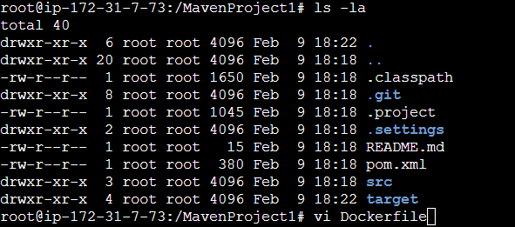

* **vi Dockerfile**
* **esc i –** by using this command we can able to insert information in **Dockerfile**

here I’m providing my first instruction is **FROM** – to create a image

what I’m going to do?

Tomcat container going to create. Finally, my agenda is Tomcat container need to create. For that purpose, I’m going give the image name is **FROM** **tomcat.** If you want to create ubuntu related container means what we want to provide **FROM Ubuntu.** If we want to create centos related container means what we want to provides **FROM centos**. Same like that I want to create a container which kind of container tomcat related container so that’s why I’m providing **FROM tomcat**.

So, for this particular tomcat definitely **java** and **JRE** must be required. Here I’m providing **JDK version – 8.0.20 – jRE – 8** no need to provide 1.8 like that just we can provide 8. Internally it will take it as 1.8. for example, if we required java 11 version means we can provide **JDK version – 11.0.20 – JRE – 11**.So, in my case **tomcat** need to create container internally that container needs to create **JDK -1.8** and as well as **JRE 1.8.**

What I provided in Docker file?

**FROM tomcat:8.0.20-jre8**

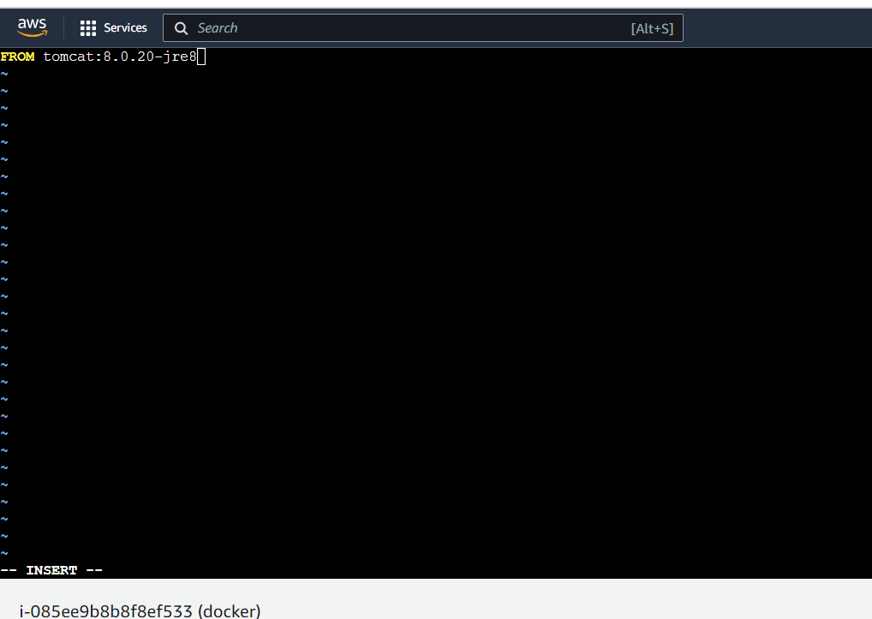



Next, we need to provide **MAINTAINER** – means who is the owner of this container [**manjuladoddavula@gmail.com**](mailto:manjuladoddavula@gmail.com)

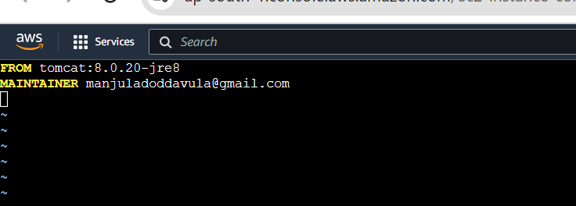

now we need to create one **tomcat container** in docker file what we have given

* FROM tomcat8.0.20-jre8 – image is going to create – what it is going to create – container – in that container what is going to happen means – in target directory which contains **.war file** this war file is located in **MavenProject1 🡪 target🡪 TestUI-0.0.1-SNAPSHOT.war** these war file need to deploy in docker container.

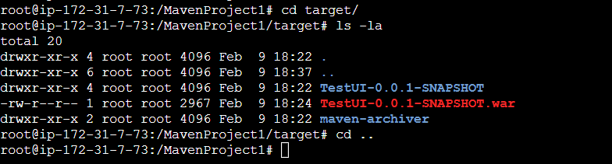

For that purpose, I’m providing information in Docker file by using **vi Dockerfile** command.

COPY **targer/TestUI-0.0.1-SNAPSHOT.war /usr/local/tomcat/weapps/TestUI-0.0.1-SNAPSHOT.war** need copy this particular container from cloud Linux to Docker file

COPY – used to copy .war file into container

After creating container in which particular path we need to locate means **/usr/local/tomcat/webapps/ TestUI-0.0.1-SNAPSHOT.war(**these war file is copying from cloud Linux 🡪 MavenProject1 🡪 target 🡪 TestUI-0.0.1.SNAPSHOT.war**).**

With these steps is completed deployment process

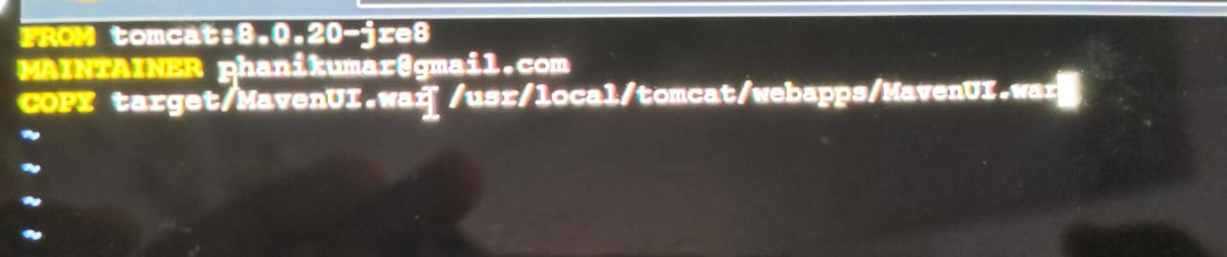

**From** instruction is used to create a tomcat image. Anywhere we can deploy our war file server itself but deploying process will be changed. The process of deploying war file is different but finally our agenda is need to deploy our war file in server.

By using **ls -la** command we can observe all files.

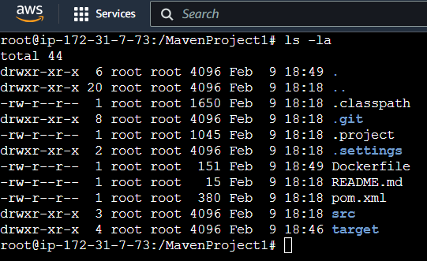

We can observer Dockerfile is in our cloned repository.

To build **docker build -t “image name”** command

For example, **docker build -t “testdockerdeployment”**

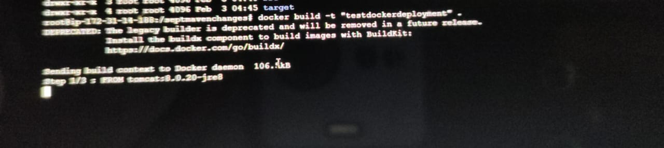

What is trying to pull the image? Which image – tomcat image. For tomcat what should be required – **jdk** and **jre**

Finally build got succeeded

Just we can entire **docker images** command

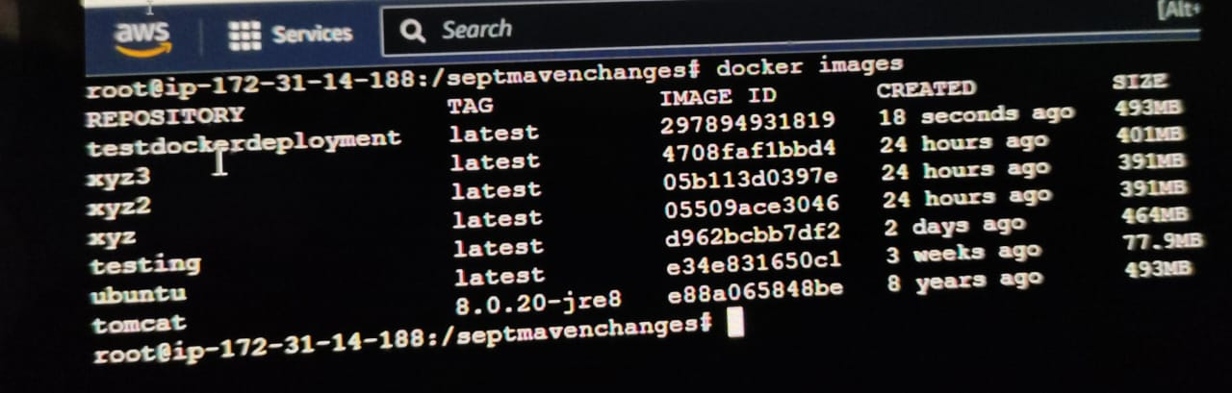

Then here we can observe with the name of **testdockerdeployment** image iscreated

I need to convert this image into container by using **docker run -itd -p**(I need to generate a pots here) normally pot is required for tomcat same like that I’m creating the container with some port number 8080:8080 not only this we can provide any port number but default port number for tomcat is 8080:8080. **--name** here we name provide name to create docker **testdockercontainer** from which image container need to create from **testdockerdeployment** by using this image I need to create a container

**docker run -itd -p 8080:8080 --name testdockercontainer testdockerdeployment**

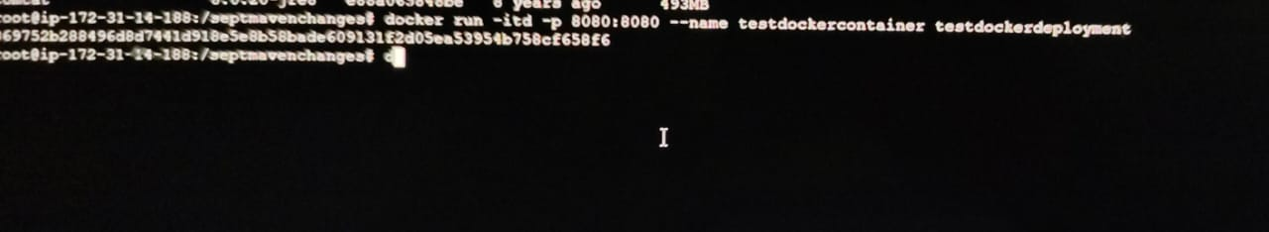

now we can observe image is created

by using **docker ps -a** command

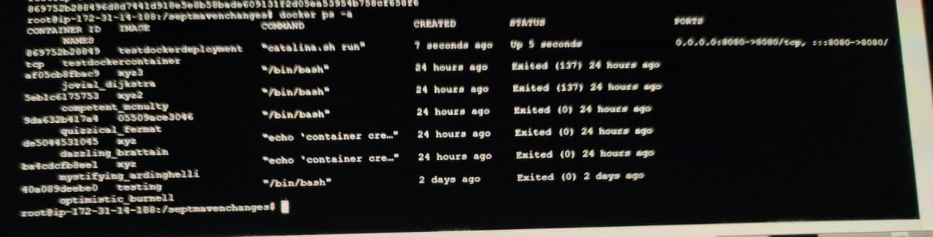

we can observer container is created

now I need to test my application so docker container is generated and currently it is in upstate. If now I need to test definitely, I need to go with cloud Linux all these I did in cloud Linux. Now we copy the IP address where all these processes are happened. I’m taking public IP address and paste it in google application along with port number 8080

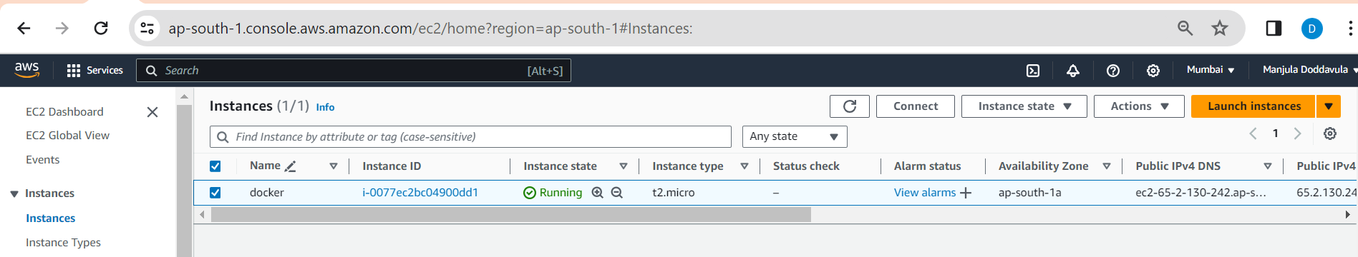

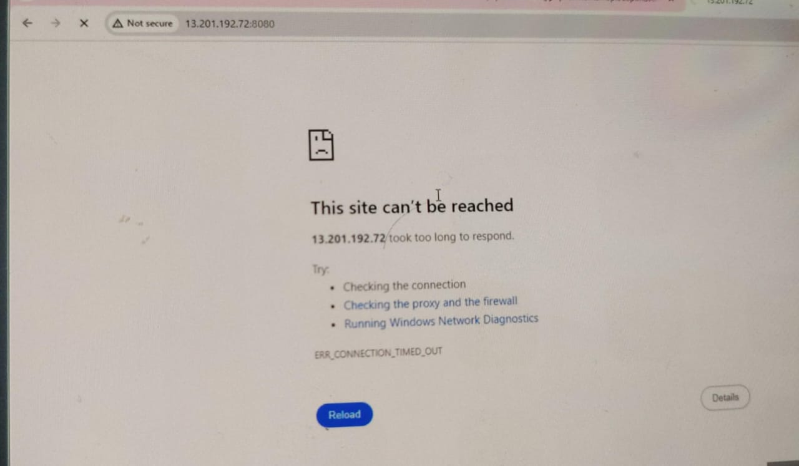

so basically, application is not going to because normally if we are searching for application for example, I’m searching for google what I’m searching for [www.google.com](http://www.google.com) by clicking we get google page.





Google Page will display like this. Once copy the url and paste it in notepad

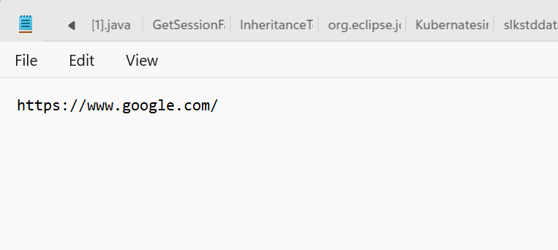

We can observe <https://www.google.com/> this URL

I provided [www.google.com](http://www.google.com) this URL after loading the page the URL came with the attachment of **https:** <https://www.google.com/> normally URL will came with **http** and **https** for any application. Here I’m providing few examples below

<https://www.facebook.com/>

<https://www.youtube.com/>

for any application by default https is getting after loading the application.

Once application got deployed in any environment if we want access means for some sites or ports, we need to access that sites or ports it may be http or https with some other all process is doing in cloud

In cloud we can observe **security** option. Present we can observe **TCP** protocol. If we access applications means we need to access with either **http** or **https** protocol.

* Select your Linux operating system



* Go to security tab
* Click on security groups link

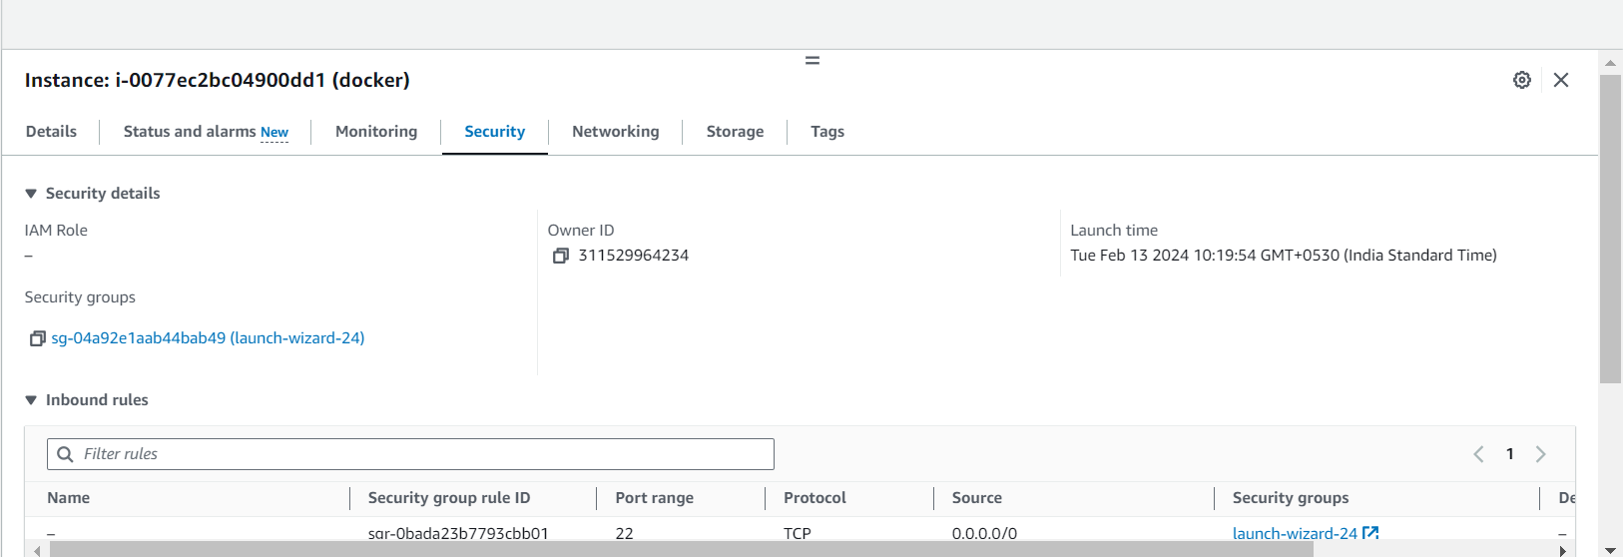

* We can observe two types of rules **inbound rule** and **outbound rule** currently we are in **inbound rule**
* Edit **inbound rule**

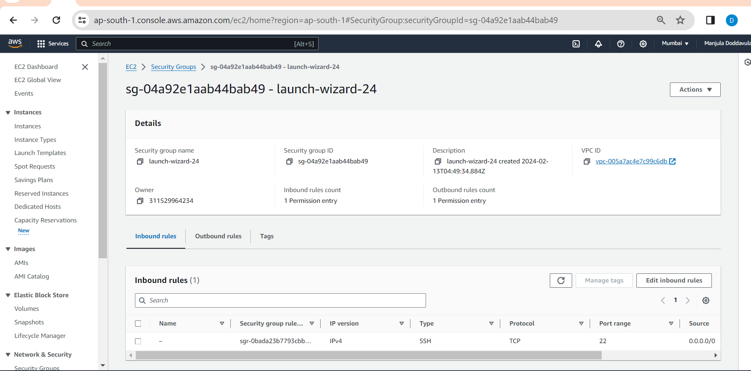

* Click on **add rule**

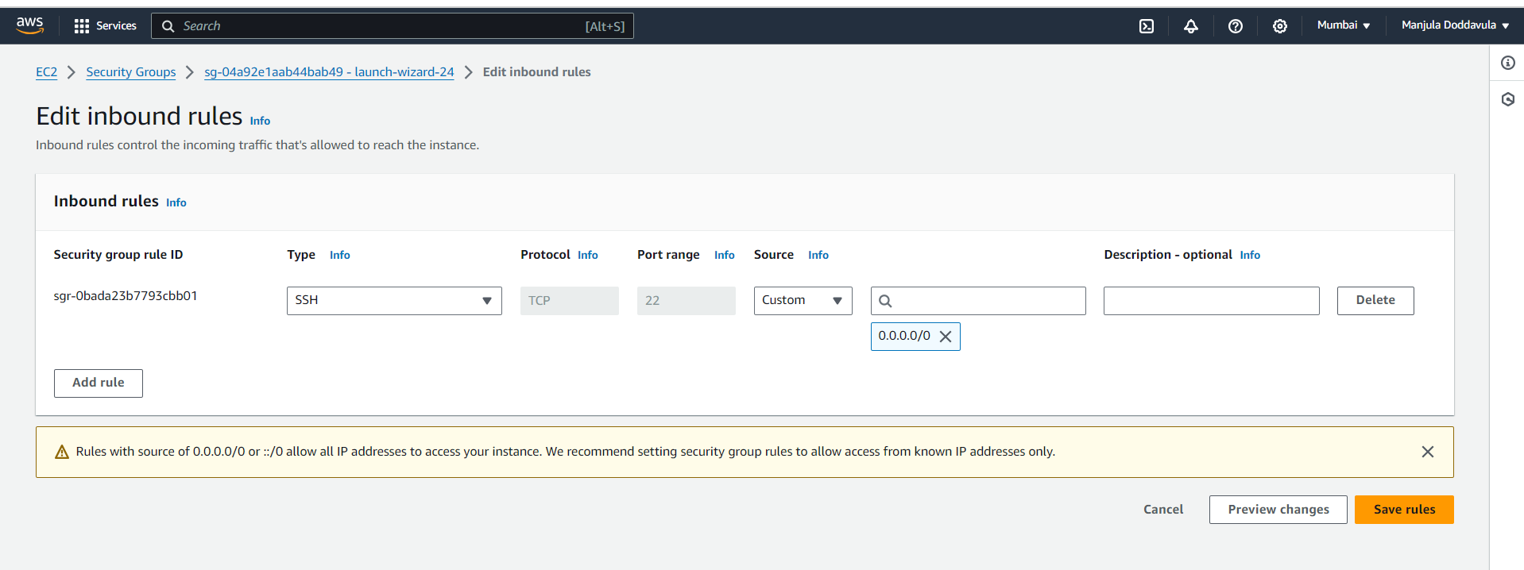

* Add **http -0.0.0.0/0**
* Add **https – 0.0.0.0/0**
* Add **Custom TCP – 8080** **– 0.0.0.0/0** (What is the port number we are provide in Linux operating system 8080. Whatever we are proving port number in Linux operating system we need to provide that port number in **Custom TCP**)

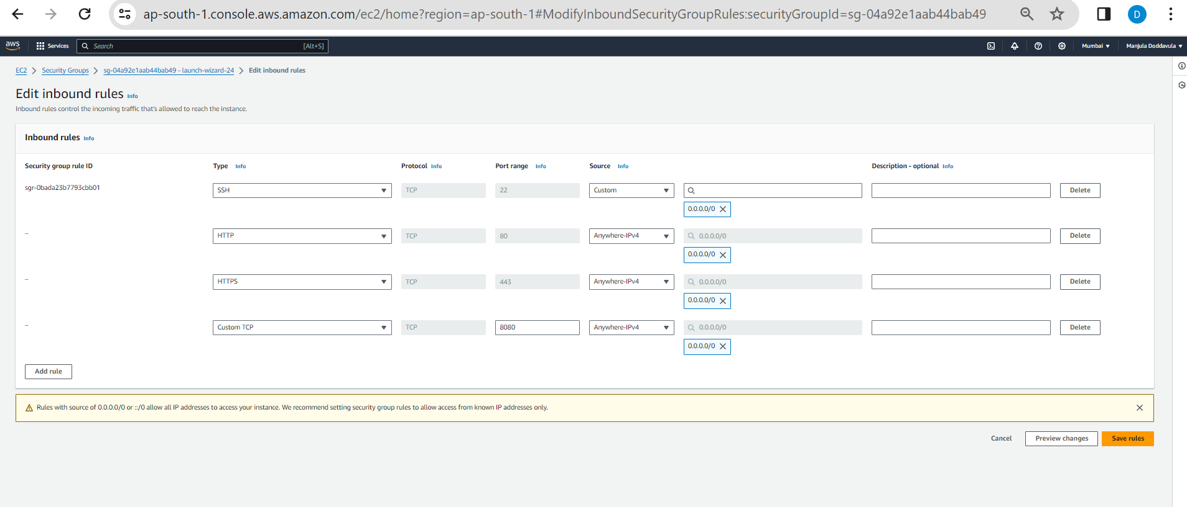

* Click on **save rules**

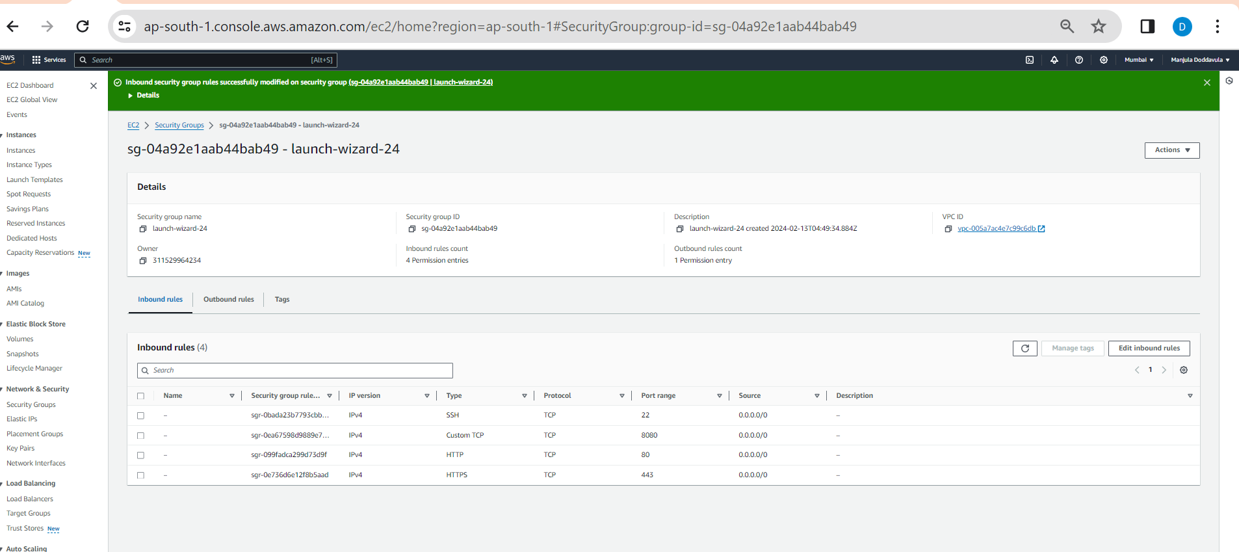

* Copy **public ID:8080** paste itin google
* Open instance and copy the path of war file
* **Public id:8080 .war file** paste in google
* Now we can observer the application we can access application

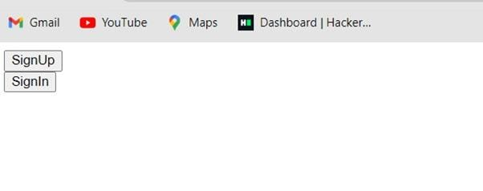

Inside docker file we given 3 instructions:

* **FROM** - pull the tomcat image. Tomcat requires JRE and java
* **MAINTAINER** – owner of that particular docker file
* By performing maven goals, we generate a war file. we need to deploy that particular war file into tomcat container. For this purpose, we are using COPY statement
* **COPY** – need to copy war file. We get this war inside the target folder (MavenProject1 🡪target 🡪war file) same path we need to specified in docker file
* we have provided instruction where we need to store war file in Docker file **/usr/local/tomcat/webapps/MavaenProject1.war.**

**Note:**

* **sudo -i**
* **cd /**
* **ls -la**
* **git --version**
* **git clone** [**https://github.com/ManjulaDoddavula/MavenProject1.git**](https://github.com/ManjulaDoddavula/MavenProject1.git)
* **ls -la**
* **mvn --version**
* **apt-get install maven**
* **mvn --version**
* **mvn clean**
* **mvn package**
* **ls -la**
* **cd target/**
* **ls -la**
* **cd ..**
* **ls -la**
* **vi Dockerfile**
* **esc + i –** to insert
* FROM tomcat:8.0.20-jre8
* MAINTAINER [manjuladoddavula@gmail.com](mailto:manjuladoddavula@gmail.com)
* COPY target/TestUI-0.0.1-SNAPSHOT.war /usr/local/tomcat/weapps/TestUI-0.0.1-SNAPSHOT.war
* **esc + :wq!** -to save the file
* **ls -la**
* **docker build -t “testdockerdeployment”**
* **docker images**
* **docker run -itd -p 8080:8080 --name testdockercontainer testdockerdeployment**
* **docker ps -a**

**-----------05/02/2023-----------------------------------Tuesday---------------------------**

**NOCLASS**

**-----------06/02/2023----------------Class-33-------------------Tuesday-----------------**

**Topic: KUBNERTES Introduction**

Docker deployment process we saw till last class

1)In Tomcat sever we deployed **.war** file

2) In Docker we deployed .**war** file in Docker container

From today Kubernetes we are going to learn

3)Kubernetes

Docker and Kubernetes are very important in case of deploying .war/.jar/.ear files. 99% organizations using the Docker and Kubernetes. Only 1% companies using Tomcat server for deployment

Kubernetes is individual tool which has it’s own speciality

It is used as sever for application deployment as .war file

Kubernetes is a kind of **ORCHESTRATION TOOL**

Kubernetes is often referred to as a **container orchestration tool**

Git is a source code management tool

Maven is a build tool

Docker is a Containerization tool

What is meant by ORCHESTRATION and Kubernetes? How Kubernetes is used in real time?

We are using daily applns google, banking applns, Tesla(Product creation company)

Google will launch Launching means it’s .war file is deployed in some where server right

Somewhere means in 3 areas

1)Tomcat server

2)Docker container

3)Kubernetes

* Google is application🡪.war🡪Tomcat Server(It is a light weight . it is in GB’s).

10 -15 minutes time it will take when we deploy in tomcat server.

For searching data also takes 10 minutes time.

Time:10 minutes

Accessiable Count when increases server downs—1L

Bandwidth is low

* Google is application🡪.war 🡪DockerContainer(MB’S)

Docker search ubuntu

Docker pull ubuntu

Docker images

In last you can see the size like 72mb. Size is in mb’s

Time: 1minute

Bandwidth increases—20L--1cr

Compare to Tomcat server in docker container the time is decreased and size also decreased.

* Google is application🡪.war 🡪Kubernetes(KB’S)

1TB Google Application can also be deployed in to Kubernetes in kb’s

Fortune 500 companies using Kubernetes for deployment.

Kubernetes developers, Kubernetes admins are there in software industry.

Time: 1-2 milliseconds—10L—10CR—Autoscaling

What is mean by Autoscaling?

Ans: When users increases it automatically creates same Kubernetes Environment and deploys .war from that users can access the application.

There is no server down issues.

* Because of size, Time Consumption, Autoscaling(Only available in GitHub) we came from Tomcat server🡪Docker container🡪Kubernetes

**Important Interview Question: Explain kubernetes Architecture.**

**\*\*\*\*Kubnertes Architecture:**

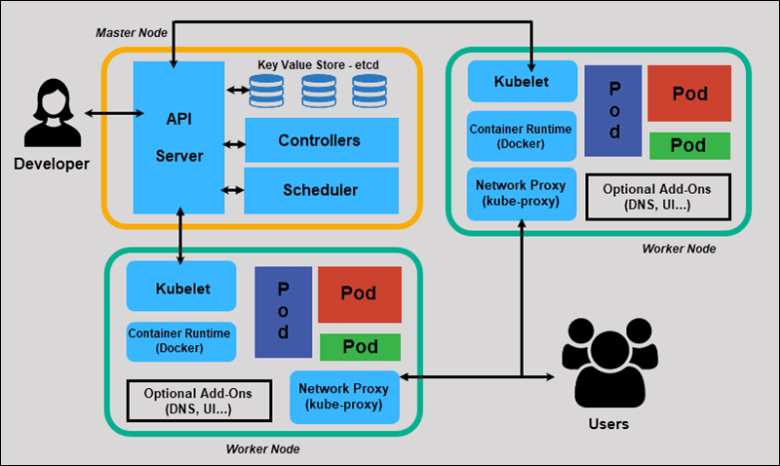

MasterNode, WorkerNode are important names in Kubnertes

Request:WWW.GOOGLE.COM

Response is coming

Journey from request from response internal working explaination can be explained in Kubnertes Architecture.

**---------07/02/2024--------------WEDNESDAY--------Class-34---------------------**

**TOPIC:**

* Why we came to Kubernetes?
* How we need to work with kubernetes?
* Kubernetes Architecture
* What are the components present in Masternode, Workernode?
* What is the internal working of request to response?

Why we came to Kubernetes?

Ans:-Reasons to come to kubernetes

1)Time consumption

2)size

3)AutoScaling(Only available in Kubnertes not in tomcat, docker container)

Developers will use the Kubnertes.

90% organizations are using kubnertes

How we need to work with kubnertes?

You can work with kubnertes in 3 ways

3 WAYS

1)eks

This is process / Service available in AWS

2)kube adm

This is process / Service is not available in AWS

3)helm

This is process / Service is not available in AWS

We can use any one of the three ways

How we worked with docker?

In linux OS.

Enter in to aws

Search for **Elastic Kubernetes Service(EKS)**

Elastic Kubernetes Service is the service to create Kubernetes Environment

**Kubernetes architecture:**

MasterNode

WORKERNODES

What components present in Masternode, Workernode?

What components present in Masternode?

1. API SERVER
2. ETCD
3. CONTROL MANAGER
4. SCHEDULER

What components present in Workernode?

1. KUBELET
2. KUBEPROXY
3. CONTAINER RUNTIME

Google page is launching based on my request

The response is based on my request is coming in fraction of milliseconds. But the user doesnot know how the response is actually coming what is the internal working.

[www.google.com](http://www.google.com)

**How request is going to work inside the server and how response is coming?**

Let us see the functionality,

1. First User will keep the request
2. Request goes to Kubernetes environment based on ip, bandwidth
3. Firstly it goes masternode area in Kubernetes Architecture
4. In Masternode Area there are 4 components
   1. API SERVER
   2. ETCD ("Extended Distributed Tabular Data Store".)
   3. CONTROL MANAGER
   4. SCHEDULER
5. API SERVER have the capability to receive the request from user, it will not provide response, it will just accept request
6. API SERVER will forward request to ETCD
7. ETCD is kind of database in the Kubernetes environment
8. KEYS, URL’S Is stored in this ETCD
9. ETCD is going to check related keys or url’s are available (valid) which are requested from the user, then API server.
10. If you are searching for particular url for the first time then that url will not present.
11. If not there in ETCD means(Very first means it will not present)
12. Then, ETCD I don’t have🡪API server🡪same request🡪Control Manager🡪 This will verify/check application related server will check where this url , in which application is deployed entire kubnertes environ🡪and every info gathered and given to scheduler🡪scheduler will give to api server.-->api server is going to communicate with worker nodes.

API SERVER will communicate with 🡪Kubelet(will receives api server request)🡪 it will communicate with Container runtime🡪 Internally it is having some pod, in that pod appln was deployed

In docker where we deploy .war file?

In docker Container

In Tomcat where we deploy .war file?

Direct Click

In Kubernetes where we deploy .war file?

In pod

Where this pod created?

In container runtime

What is pod?

Appln deployment area

To create pod Containerruntime will use the docker

Appln🡪cr🡪request related response🡪kublet🡪API server🡪User

If this the first above process

If 2nd time same request

API server🡪ETCD🡪it gives response to API server🡪API server

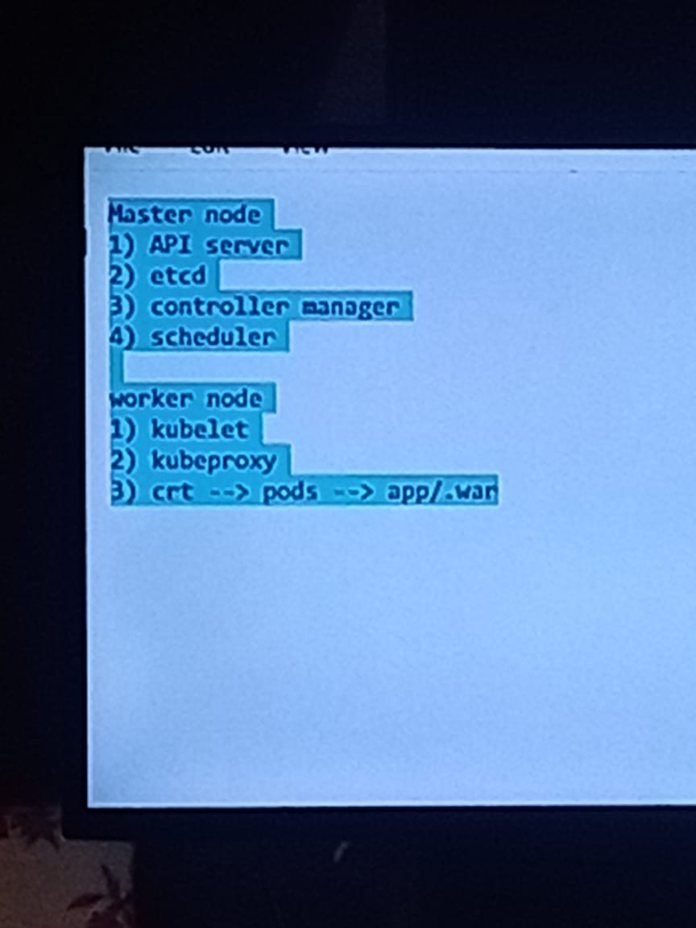

**---------08/02/2024-------------THURSDAY--------CLASS--35---------------------**

**TOPIC: KUBERNETES INSTALLATION**

EKS [Elastic Kubernetes Service]is existing in AWS but cosyly

So we perform operations by KUBEADM(Actually Kubeadm is not available in AWS but we will create 2 instances by EC2 service and we will perform steps to perform those servers as one as Masternode, and another as Worker Node)🡪EC2🡪

We are going to launch 2 servers

* + 1. First server consider as a master node
    2. Second Server consider as a Worker Node

Steps:

* Masternode
* Ubuntu
* 20.04 version select(Free tier)
* Instance type🡪t2 .medium(Becoz kubnertes is very big)
* Create new key pair
* Launch instance

Now I need to create workernodes.

Masternode should be one, Workernodes can be any no.

Steps:

* Workernode
* Ubuntu
* Version: 20.04
* Instance Type: t2.medium
* Create a new pair/or use a existing one
* Launch instance

We have to create one masternode, one workernode.

Connect

**---------------09/02/2024------------Friday---------------Class--36-----------------**

**TOPIC: KUBERNETES INSTALLATION PROCESS**

In Kubnertes Architecture we have Masternode[Control Plane]&WorkerNode[Slave Node]

1)MasterNode/Control plane

Four components

1. API SERVER
2. ETCD("Extended Distributed Tabular Data Store".)
3. CONTROL MANAGER
4. SCHEDULER

2)WorkerNode/SlaveNode

Three components

1. KUBELET
2. KUBEPROXY
3. CONTAINER RUNTIME

STEPS:

1)Launched 2 servers

2)Add Security groups

Steps:

Goto AWS

Set Version as --- 20.04

Set Instance Type --- T2 medium

1 for Workernode, 1 for Masternode create 2 servers.

**Add Security Groups**

* Select MasterNode/Workernode
* Select security tab
* Drag down , and Click on Securitygroups link
* You can see Inbound rules, outbound rules
* Click On Edit inbound rules
* Currently only ssh rule you can see
* Add ALL TCP
* 0-65000 Portrange(To bulid communication between masternode & workernode)
* 0.0/00/00
* Click on Save rules

Same process for worker node

Go to masternode and connect

Follow the steps given in the document

Document Starts from here:

Agenda: Kubernetes Setup Using Kubeadm In AWS EC2 Ubuntu Servers

=======

Prerequisite:

=============

3 - Ubuntu Serves

1 - Manager (4GB RAM , 2 Core) t2.medium

2 - Workers (1 GB, 1 Core) t2.medium

Note: Open Required Ports In AWS Security Groups. For now we will open All trafic.

==========COMMON FOR MASTER & SLAVES START ====

# First, login as ‘root’ user because the following set of commands need to be executed with ‘sudo’ permissions.

sudo su -

# Install Required packages and apt keys.

apt-get update -y

apt-get install -y apt-transport-https

curl -s https://packages.cloud.google.com/apt/doc/apt-key.gpg | apt-key add -

cat <<EOF >/etc/apt/sources.list.d/kubernetes.list

deb https://apt.kubernetes.io/ kubernetes-xenial main

EOF

apt-get update -y

#Turn Off Swap Space

swapoff -a

sed -i '/ swap / s/^\(.*\)$/#\1/g' /etc/fstab

# Install And Enable Docker

apt install docker.io -y

usermod -aG docker ubuntu

systemctl restart docker

systemctl enable docker.service

#Install kubeadm, Kubelet And Kubectl

apt-get install -y kubelet kubeadm kubectl kubernetes-cni

# Enable and start kubelet service

systemctl daemon-reload

systemctl start kubelet

systemctl enable kubelet.service

==========COMMON FOR MASTER & SLAVES END=====

===========In Master Node Start====================

# Steps Only For Kubernetes Master

# Switch to the root user.

sudo su -

# Initialize Kubernates master by executing below commond.

kubeadm init or **kubeadm init --pod-network-cidr=10.244.0.0/16**

#exit root user & exeucte as normal user

exit

mkdir -p $HOME/.kube

sudo cp -i /etc/kubernetes/admin.conf $HOME/.kube/config

sudo chown $(id -u):$(id -g) $HOME/.kube/config

# To verify, if kubectl is working or not, run the following command.

kubectl get pods -o wide --all-namespaces

#You will notice from the previous command, that all the pods are running except one: ‘kube-dns’. For resolving this we will install a # pod network. To install the weave pod network, run the following command:

kubectl apply -f https://raw.githubusercontent.com/flannel-io/flannel/v0.20.2/Documentation/kube-flannel.yml

kubectl get nodes

kubectl get pods --all-namespaces

# Get token

kubeadm token create --print-join-command

=========In Master Node End====================

Add Worker Machines to Kubernates Master

=========================================

Copy kubeadm join token from and execute in Worker Nodes to join to cluster

Before pasting the copied token change to root user then paste the token so, first enter **sudo -i** command in worker node, now paste the entire token.

Come back

kubectl commonds has to be executed in master machine.

Check Nodes

=============

kubectl get nodes

**Output is in below format:**

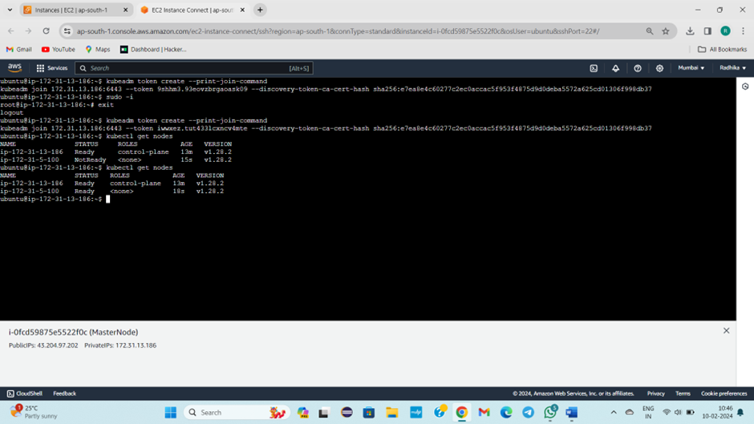

STEPS:

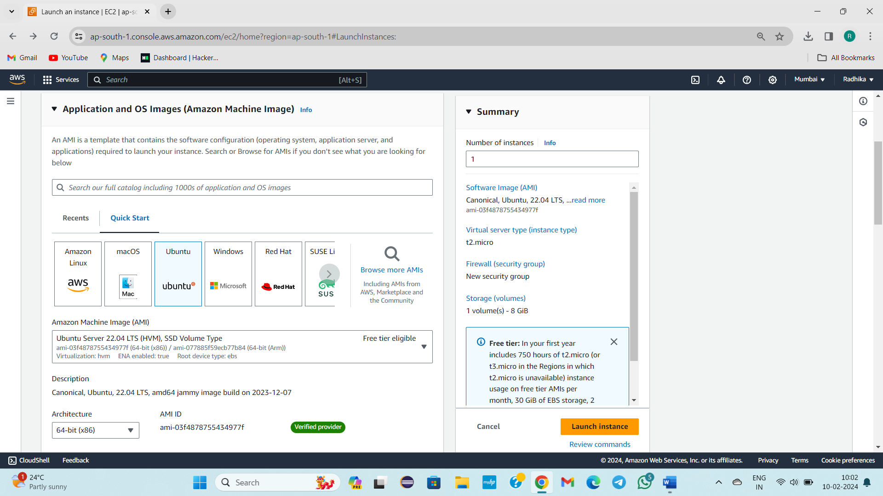

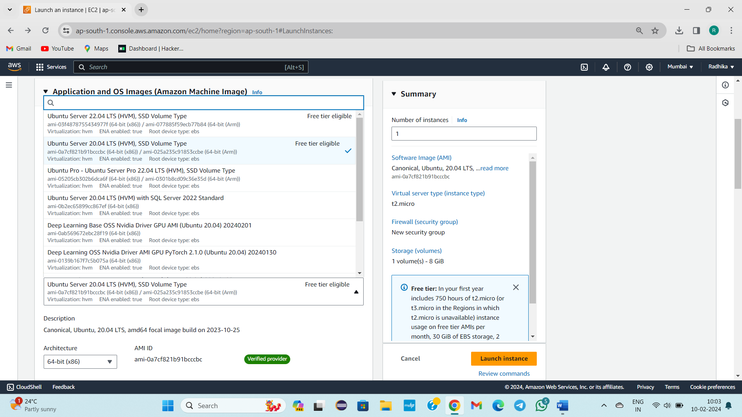

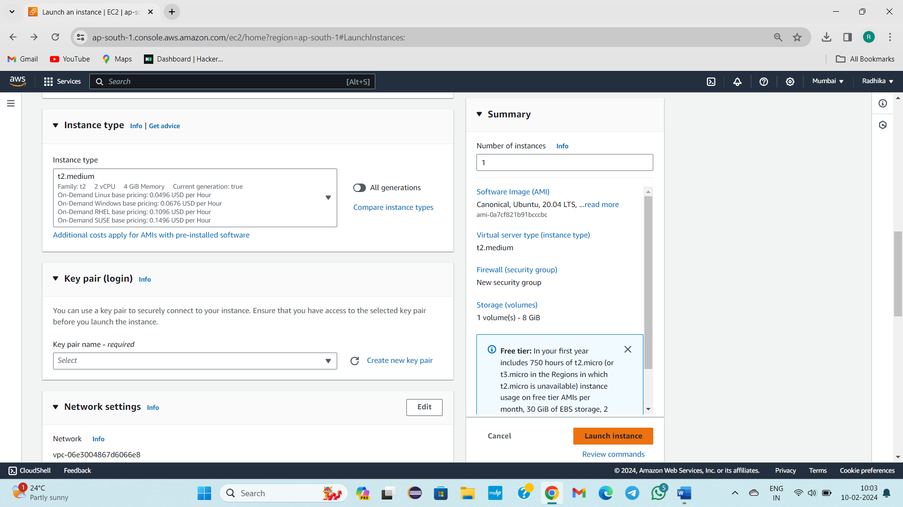

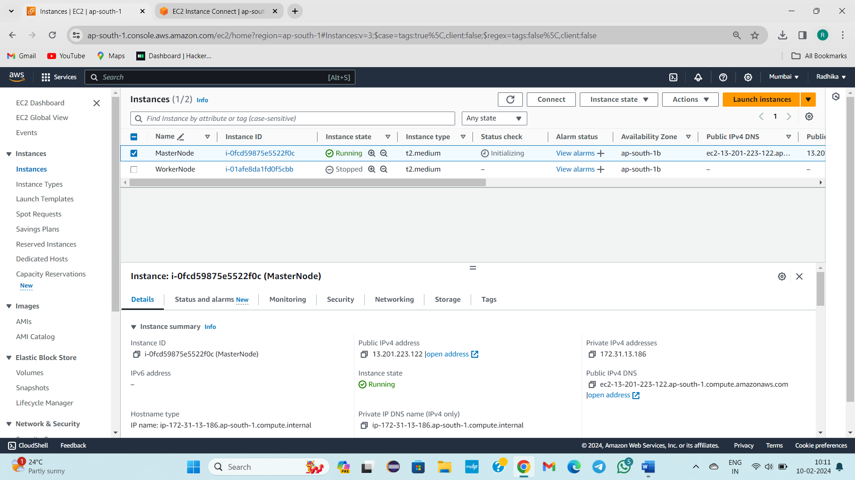

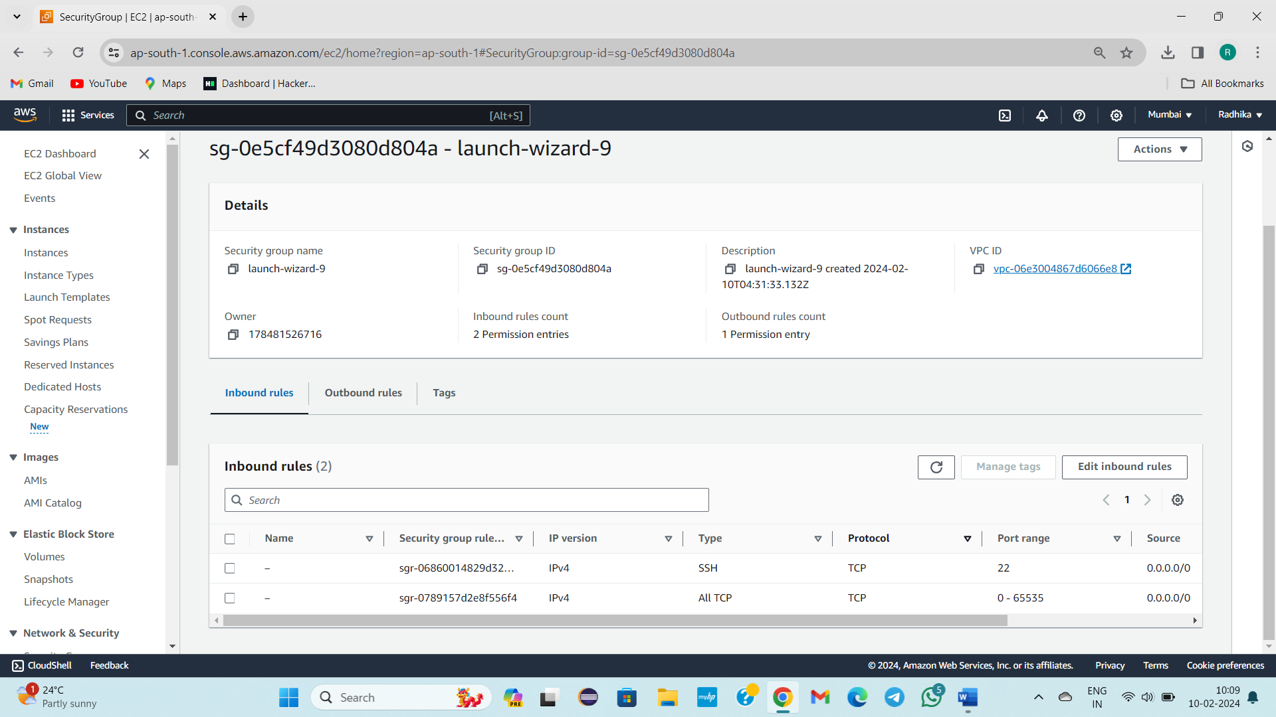

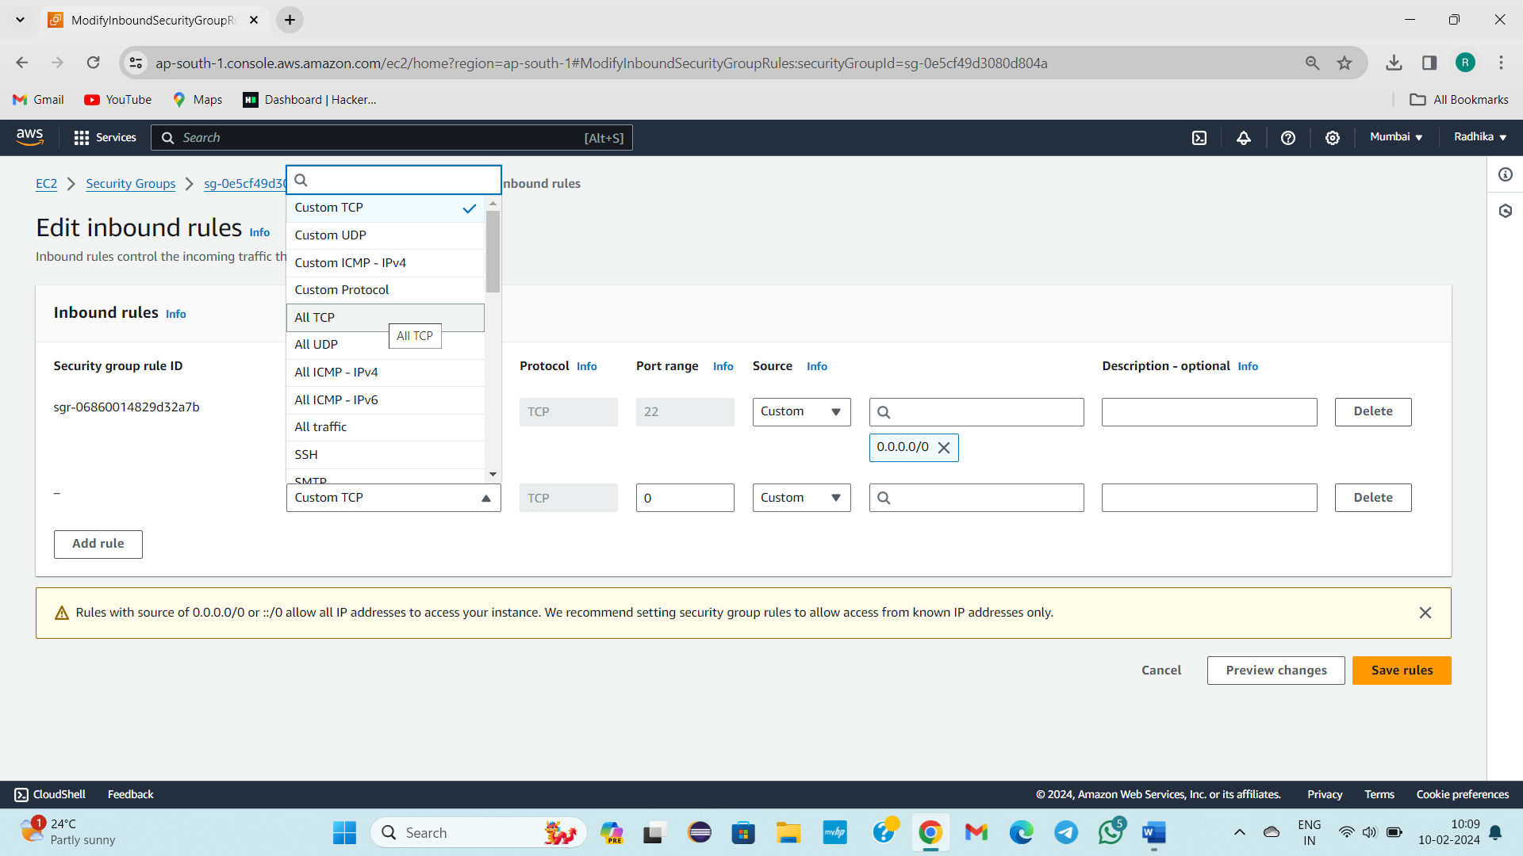

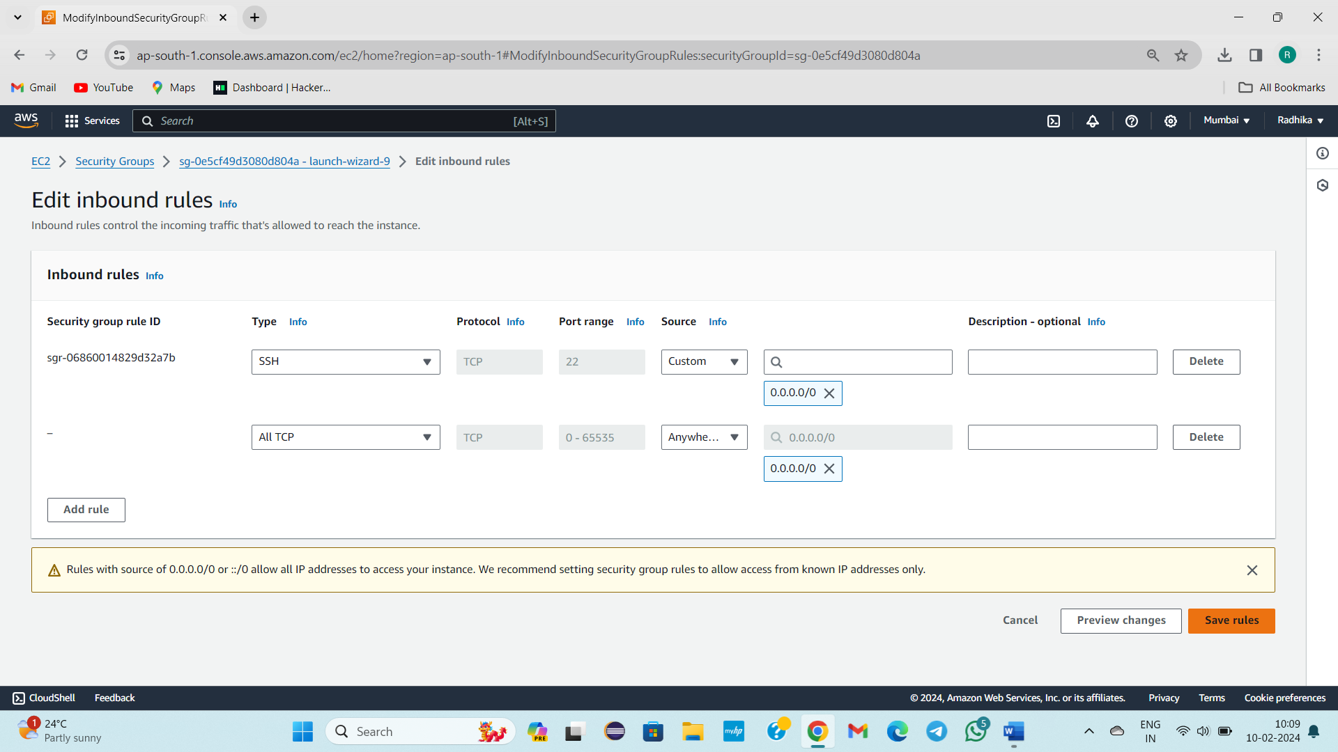

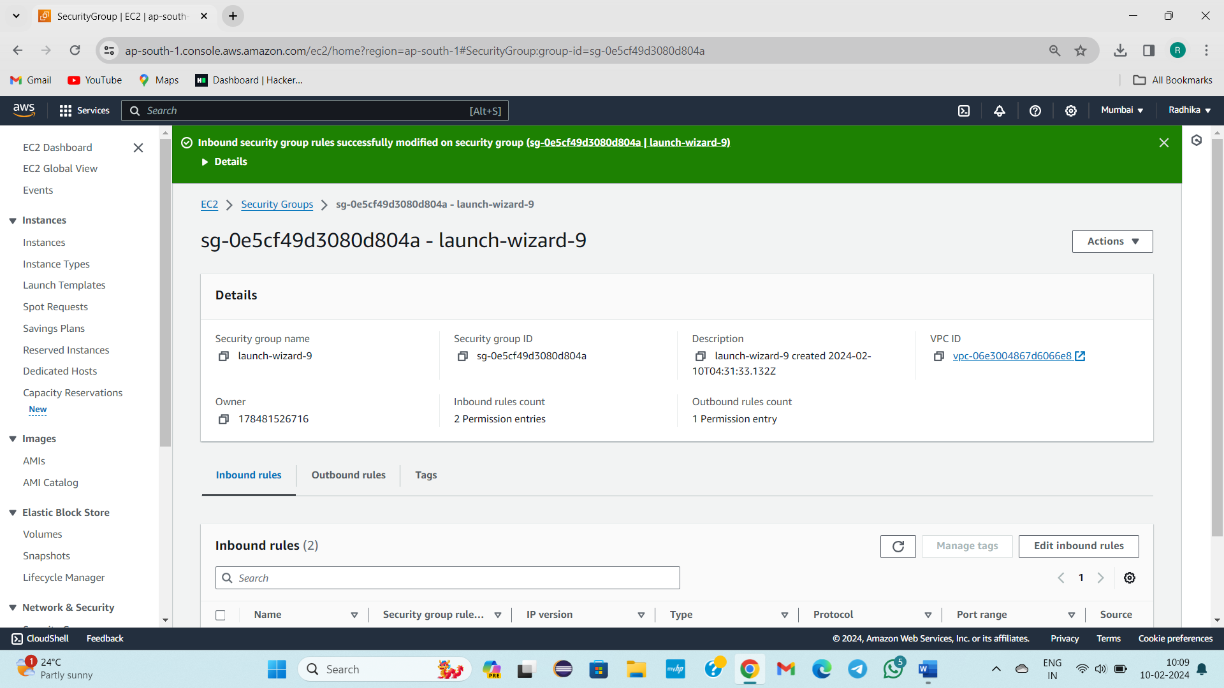



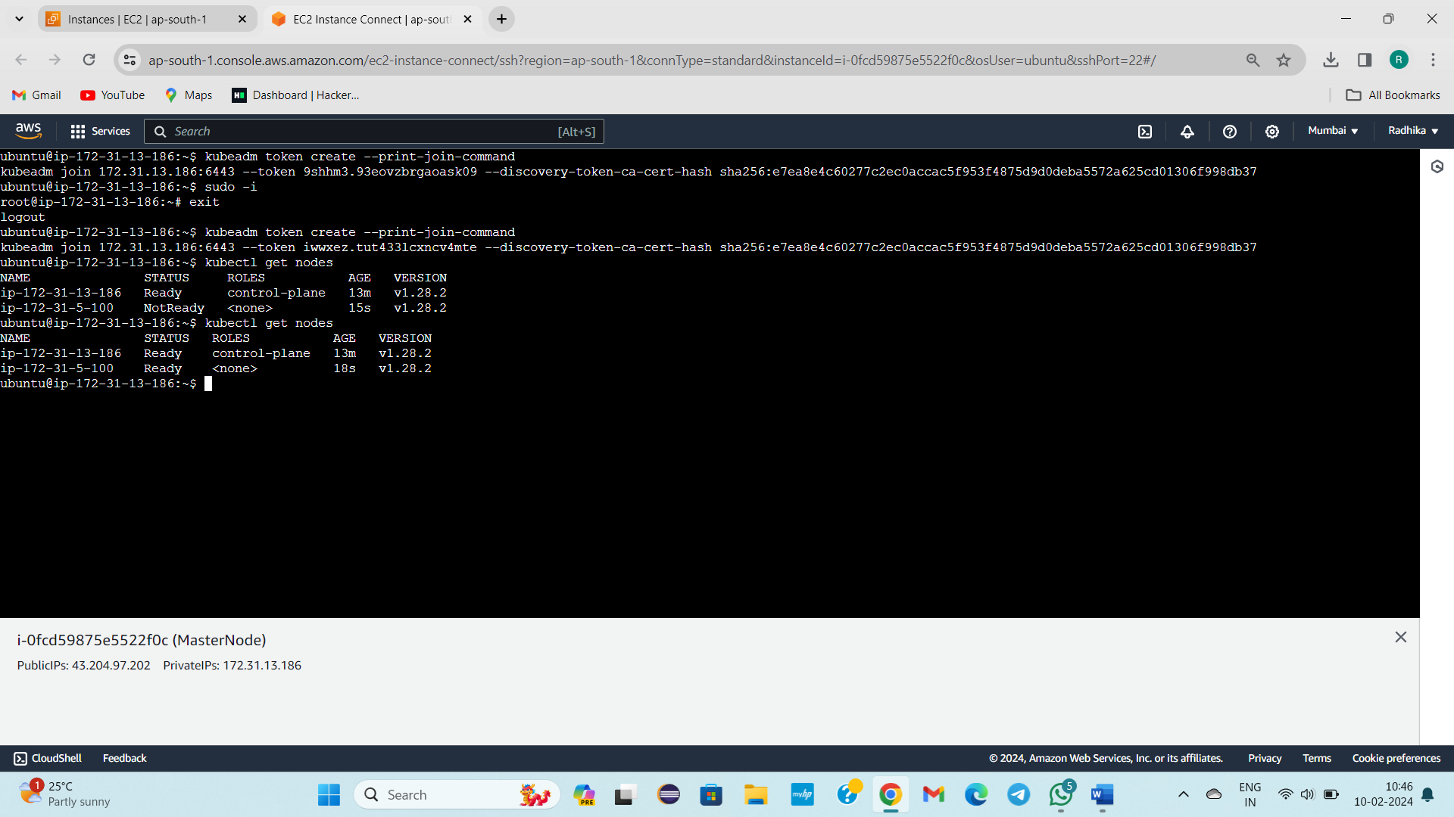

**-------------10/02/2024----------SATURDAY-----------------------------------**

**TOPIC:**

**KUBERNETES INSTALLATION SAME AS YESTERDAY CLASS.**

**-------------12/02/2024---------MONDAY--------CLASS -37-----------------------**

**TOPIC:**

* **HOW TO DEPLOY APPLICATION IN KUBERNETES ENVIRONMENT?**
* **WHAT IS THE USE OF YAML SYNTAX AND IMPORTANCE?**
* **HOW TO EXCECUTE YAML SYNTAX?**

Kubernetes is used for creating environment for application deployment.

What is environment in kubernetes?

* Masternode/control plane(4 components)
* Workernode/slave node(3 components)
* We have some applications🡪Maven UI app

Spring boot

Microservices

* We will deploy above in Kubernetes environment.
* By writing **YML/YAML SYNTAX** we will deploy applns in kubernertes environment.
* **YAML should be provided in Key:value basis**

**SERVERS**

* Tomcat
* Ngix
* Apache2
* Httpd
* Jboss
* Weblogic
* We need install and launch it for working with any server above
* No installation needed, by using Kubernetes environment , unified severs launch, userdefined applns deploy

Where we need to write YAML Syntax/file either in masternode or worker node?

* Master node we will write
* Syntax in masternode, effect is in worker node
* Ngix is a predefined server
* I want to launch ngnix server

STEPS:

* Connect to Master Node
* Actually Master Node, Worker Node are in Running state
* Don’t convert in to root user
* cd /
* Enter in to slash path
* ls -la
* Sudo vi sampleserver.yml 🡪creation of yml file
* Esc+i
* Writing yaml syntax

apiVersion: v1

kind: Pod

metadata:

name: slokamawsbatch

labels:

app: ngnix

spec:

containers:

~ name: slokamawsbatch

image: ngnix

ports:

~ containerPort: 80

---

apiVersion: v1

kind: Service

metadata:

name: slokamawsbatch

labels:

app: ngnix

spec:

selector:

app: ngnix

type: NodePort

ports:

~ port: 80

targetPort: 80

* In Kubernetes we have to follow the Indendation
* :wq!
* Cat sampleserver.yml
* Ls -la
* Kubectl get pods
* Kubectl get svc
* Ls -la
* To execute YAML SYNTAX
* **Kubectl apply -f sampleserver.yml**
* Pod will be created
* kubectl get pods
* kubectl get svc
* cat sampleserver.yml

When you execute YAML SYNTAX present file

1)POD will be created with the given name

2)SERVICE will be created with given name

This whole process will be done in masternode, but all effects will be done in workernode.

**To execute anything YAML syntax process is only process in Kubernetes.**

**------------13/02/2024----------TUESDAY----------CLASS-38------------------**

**TOPIC: HOW TO LAUNCH THE NGNIX AND TOMCAT SERVERS USING YAML SYNTAX IN KUBERNETES ENVIRONMENT**

* Yesterday we have written Yaml syntax in Masternode in Kubernetes Environment.
* Yaml Syntax is written in the format Key: value
* Now, I need to launch Server : ngnix using Kubernetes in master node.
* If suppose, Kubernetes is not there.
* And I need to install the Tomcat, ngnix server
* Then it is Mandatory to install the setup file of Tomcat, ngnix
* Suppose, Kubernetes is there, And we are using Kubernetes
* By using YAML syntax in Kubernetes Environment, in Masternode, I can view the Tomcat, ngnix pages without installing the setup files of Tomcat and ngnix. Let’s get in to the process.

STEPS:

* AWS Launch
* Enter in to masternode
* cd /
* ls- la
* sampleserver.yml is present
* cat sampleserver.yml
* I will delete existing sampleserver.yml
* Sudo
* ls- la
* Currently I am in masternode
* sudo vi abc.yml
* Keys are constant, values are only going to change.

apiVersion: v1

kind: Pod

metadata:

(2 tab spaces) name: awsbatch

labels:

(under b)app: awsbatch

spec:

containers:

~ name: awsbatch

image: ngnix (server we are going to launch)

ports:

~ containerPort: 80(ngnix default port number)

---

apiVersion: v1

kind: Service

metadata:

name: awsbatch

labels:

app: awsbatch

spec:

selector:

[L] app: ngnix

type: NodePort

ports:

~ port: 80

targetPort: 80

* Everything we will consider as server in our system.
* To create pod we are writing above YAML syntax. To deploy ngnix with server port number 80
* ****Image, port, type: NodePort, port, targetport are the four important things to remember.
* :wq!
* cat abc.yml
* kubectl get pods
* kubectl get svc
* kubectl delete pod pod name
* kubectl delete svc svc name
* kubectl get pods
* kubectl get svc(No services)
* I will create NodePort Service. Currently CusterIP service is present.
* In YAML Syntax whole creation of pod and service is done.
* kubectl apply -f abc.yml
* awsbatch pod, awsbatch service created
* kubectl get pods
* kubectl get svc
* Pod and Service created with the given name

1)abc: yml

2)Key: values 🡪ngnix

3)Masternode

4)POD

5)SERVICE

These 5 steps is performed in masternode

But the Pod and Service will be created in worker node.

Actually POD and Service creation is done in worker node but how? I want to check once?

* Take Public Ip of WorkerNode.
* Go to google, copy and paste the publicIp
* Come to masternode
* Copy the port number of recently created pod[30331].
* Go to google and paste the port number after the Public IP
* Eg: Public IP:30331[NGNIX]
* Press Enter
* How to create Tomcat Server?
* sudo vi abc.yml
* Esc+i

apiVersion: v1

kind: Pod

metadata:

(2 tab spaces) name: awsbatch1

labels:

(under b)app: awsbatch1

spec:

containers:

~ name: awsbatch1

image: tomcat: 8.0.20-jre8 (server we are going to launch)

ports:

~ containerPort: 8080(ngnix default port number)

---

apiVersion: v1

kind: Service

metadata:

name: awsbatch1

labels:

app: awsbatch1

spec:

selector:

[L] app: aws batch1

type: NodePort

ports:

~ port: 8080

targetPort: 8080

Further steps

* :wq! 🡪To save
* kubectl apply -f abc.yml(Apply command everytime)
* kubectl get pods
* kubectl get svc
* PORT(S)
* 8080:31650/TCP
* Workernode related IP address
* Copy the IP address
* Go to Google Paste the copied IP address
* IP address/Port no
* In one Operating System launching 2 servers is a complex task.
* But by using Kubernetes we can launch n no.of servers
* Finally, we have launched the NGNIX and TOMCAT servers using the Kubernetes environment

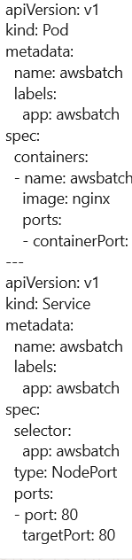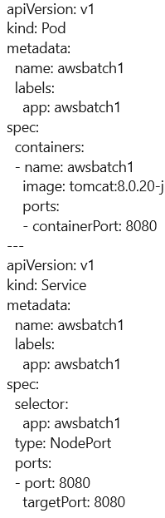

**------------------14/02/2024----------Wednesday-------------CLASS – 39-----------**

**TOPIC:**

We have launched ngnix, Tomcat servers(Predefined servers). We have only YAML file to launch any predefined server.

In YAML file we need to remember the 4 important things.

1) Image name

2) Container Port

3) names and app name

4)Port and targetPort

**1)Image name:**

* What particular server we are going to launch that particular server name we need to give it as image name. For example if you want launch tomcat means you need to provide tomcat related name,or if you want to launch ngnix, weblogic, apache2 then give the related names.

**2)Containerport:**

* What particular name we have given as image name, we have give that server port number should be given in containerport. For example I want launch mysql server, then default port number for mysql is 3306, If I want to launch oracle(Actually Oracle is Database, but in computer everything is considered as server, so oracle is also a server now).

**3)Name and app:**

* Name and app name should be same in pod and service

**4)Port and targetPort**

* Port and targetPort should be same as the containerPort

Indendations are also important in YAML syntax

If thes 4 things are understood, then we can write any kind of YAML syntax’s using Kubernetes.

Till now we have launched predefined servers.

In place of image: we have given only the predefined server names.

In future place of image: we will give our own application names.

In Entire Kubernetes we need to concentrate on below things.

1)POD

2)Service

3)Deployments

4)Ingress

5)Egress

Above 5 things are going to rule the Kubernetes, we don’t any of 5 above things and their working also we don’t know.

Without having any knowledge about above 5 things we have created Pod and Service using yml file yesterday.

By that one pod and one service created yesterday.

In Yesterday class , I have launched the ngnix server.

If I want to see the ngnix server particularly means, I copied worker node Public IP :Port number(Randomly generated port number).

How this Process happens?

Suppose in my environment, I deployed something, and you are the front end developer, you are not having any knowledge about what I did, so, I given some Ip address and port I said you to access that(Eg: 1.2.3.4:567). Any person in the world press same ip: port then it displays the same page.

But what is the internal process?

When I provided workernode publicIp: portno and hit on it. Then a request object is raised from my side(Browser side), Actually what is inside the request? What url you hit that will be present in request object. This request object with the url it goes to Appropriate instances. Suppose in one instance we have master node running and in another instance we have worker node running.

Then where the Ip should go either it should go to master node or worker node?

All the requests which are coming from outside will go to firstly to master node.

In Master node we have 4 components.

In Master node API server, has the capability to receive the request. API Server reviews the content.

API server will take the request and it sends to ETCD.

Its is very first time that we are creating ngnix or tomcat by using Kubernetes concept, So ETCD also doesnot provide any information.

ETCD returns back to the request to API server.

API server now communicates with control manager.

Now Control Manager scans the content and checks whether it is a ip address content, url content, text context, so firstly it validates the content. It gathers the information by checking all worker nodes till it finds the corresponding response to request.

It gathers the information, and the send the information to the scheduler.

Scheduler gathers some extra information and sends to the API server.

Scheduler decides that to whom the retrived response should be given.

In Worker node to whom the response should be given is decided by the Scheduler.

Suppose there are 100 workernodes, then Control Manager going to decide that with which worker node we are going to communicate. After that Scheduler will decide by communicating with whom the work will complete.

The difference between the CONTROL MANAGER AND SCHEDULER is mentioned above

In Workernode there are 3 components are present.

1)Kubelet

2)Kube proxy

3)Container runtime

Now , API server will give the request the kubelet, Kubelet moves the request to Container runtime, Container runtime internally creates pod(very first time),Inside that pod application is deployed[Actually which application is deployed means which image name we given as image that application I only deployed, how it deploys we don’t know].

Presently, we wrote ngnix

Presently 99% applns was deployed in Kubernetes environment.

Suppose you hit <https://skoda.com/> as request the process is performed to get the corresponding request.

So when hit request the reponse comes by communicating the application inside pod, the response is took by the kubeproxy .

This kubeproxy gives the response to kubelet.

Kubelet Communicates with the API server and kubelet gives the response to the API server

This API server gives the response to the user. In browser the webpage is displayed.

In Kubernetes internally there is long and lengthy process, but the response is coming in fraction of seconds.

WHY ALL THESE LENGTHY PROCESS SHOULD BE PERFORMED?

WHY KUBERNETES GOT FAMOUS IN THE MARKET?

Due to multiple reasons.

1. Auto scaling concept
2. Due to size(small)
3. Due to memory
4. Any application can be easily deployed in Kubernetes.

Apart from that, an application mainly requires the security. Heavy Security is provided by the Kubernetes.

In Java we need to remember the microservices architecture.

In docker we need to remember the docker architecture.

Spring Architecture, Hibernate Architecture, JDBC Architecture, In Hibnerate First level and Second level caches are going to be asked in interviews.

Kubernetes Architecture is very important topic in interviews.

Either you create POD, service, deployment, Ingress, Egress it travels in above procedure.

Once when we recall the yesterday process. We wrote YAML SYNTAX( NGNIX) in master node.

I connected to masternode, created a .yml file(abc.yml). In abc.yml we create a pod and a service. In pod given image name application should deploy. When it deploys and when the pod creates

When **kubectl apply -f abc.yml** command is executed then this .yml file is going to create a pod and deploys the application in that pod.

I hit all commands in master node. But execution will happen in the worker node. When I hit **kubectl apply -f abc.yml** command inside worker node, container runtime is present internally, So When I hit the **kubectl apply -f abc.yml** command in master node , the information is taken by the worker node(information is given by API SERVER). API server, gives information to kubelet, kubelet gives the information to the container runtime, This container runtime inside the worker node going to create pod, in that pod it going to create application(ngnix application).

When the end user hits worknode public ip and some random generated port number, the process above discussed will be takes place.

Creation part is done🡪Master node

Result/Execution part is done🡪Worker node

Where our application deployed ?

Workernode🡪POD🡪our application is deployed.

**KUBERNETES ARCHITECTURE:**

APISERVER🡪ETCD

Control Manager Kubelet🡪Containerruntime🡪POD

🡪Application(The info

Information and given to

Scheduler kubeproxy)🡪KubeProxy

**MASTER NODE**

**WORKER NODE**

Next I we will go to deployments

What is pod, what is use of it.

**---------------15/02/2024------------Thursday------------------------------**

**No Class**

**----------------16/02/2024-----------Friday----------Class – 40--------------------**

**TOPIC:**

**NGNIX LAUNCHED IN KIND AS DEPLOYMENT**

* **Kind as Pod**
* **If Pod deleted by mistakenly, then how?**
* **Kind as Deployment**🡪**AutoScaling Technique**
* **Pod created with memory in kbs**
* Ngnix, Tomcat Servers launched by 🡪YAML syntax
* Image name is going to convert as application and deploy in pod

Suppose in case pod have deleted, or any other issues then what to do?

Kubectl delete pod awsbatch1

Kubectl get pods

* Application running pod can crash when no of users increases in Flipkart on special days
* **In one pod only one application can be deployed.**
* Kind as a pod
* Kind as a deployment🡪when that file execute it creates no of pods. It places only one appln.

Now I will launch ngnix, But I will take kind as a deployment in YAML syntax

**STEPS:**

sudo vi deploymentaws.yml

Esc+i

Write the YAML SYNTAX

apiVersion: apps/v1

kind: Deployment

metadata:

name: nginx-project

spec:

replicas: 20

selector:

matchLabels:

app: nginx-project

template:

metadata:

labels:

app: nginx-project

spec:

containers:

- name: nginx

image: nginx

ports:

- containerPort: 80

---

apiVersion: v1

kind: Service

metadata:

name: nginx-project

spec:

selector:

app: nginx-project

type: NodePort

ports:

- port: 80

targetPort: 80

kubectl apply -f deploymentaws.yml

kubectl get pods

kubectl get svc

replicas==pods

worknodeipaddress:ip

Now we are accessing which pod among 2 pods?

It can come from any one of pod, we cannot say

kubectl delete pod awsbatch

kubectl get pods

kubecl delete pod podname

kubectl get pods

It will be deleted. And another pod created

kubectl delete pod podname podname

kubectl get pods

These two pods deleted and 2 two pods created again.

This technique is called as **Auto scaling technique**

**Kind as pod🡪 If pod deleted by mistakenly 🡪It cannot recreate🡪**

**Kind as deployment🡪if pod deleted by mistakenly🡪it can recreate**

**Why to go kind as deployment means due to Autosacling Techniques**

**Pod🡪kbs**

**STEPS:**

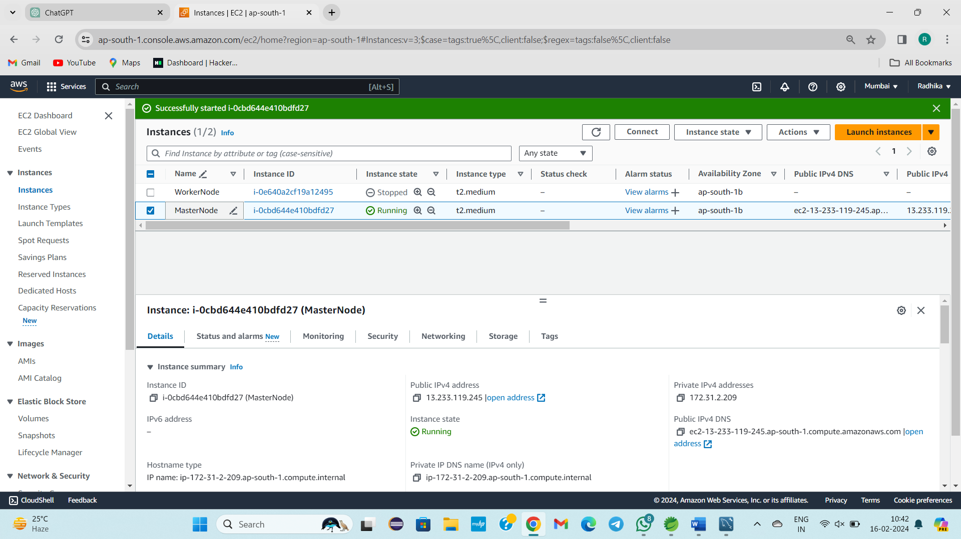

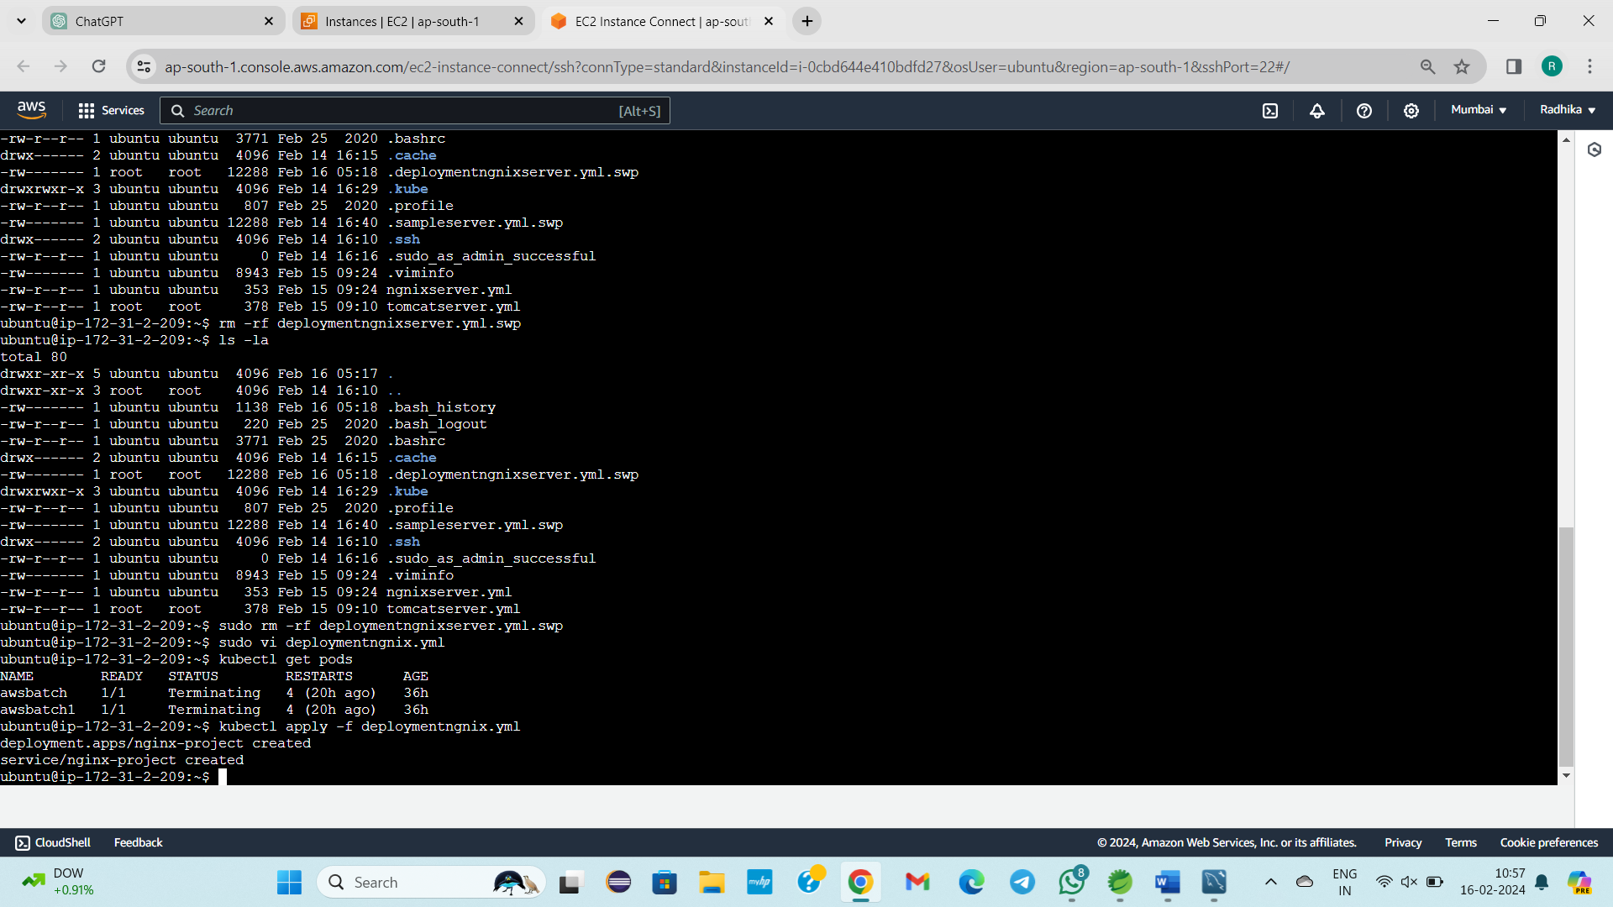

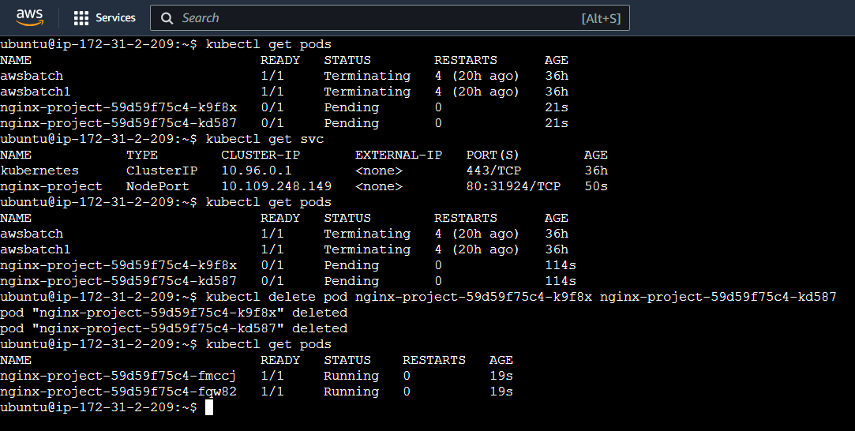

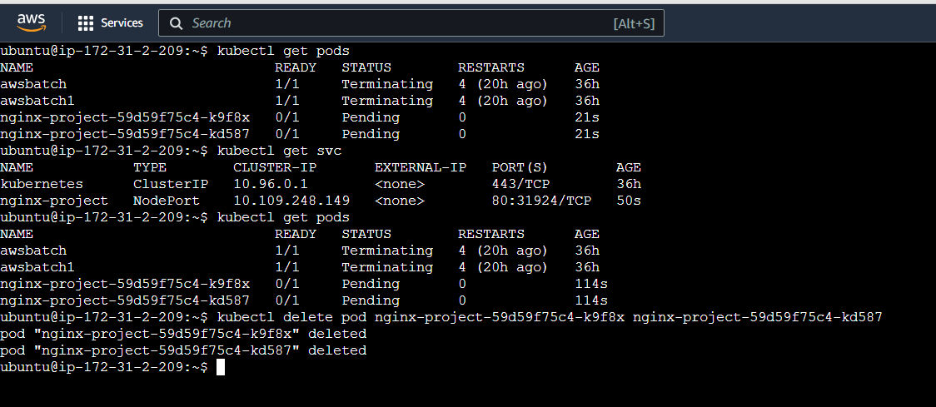

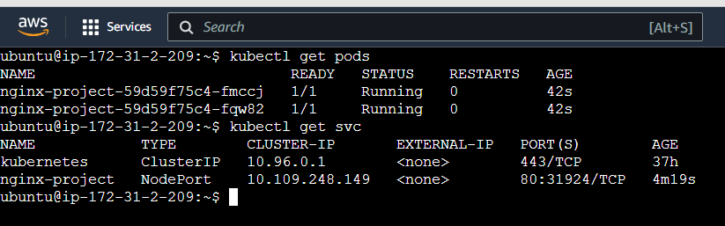

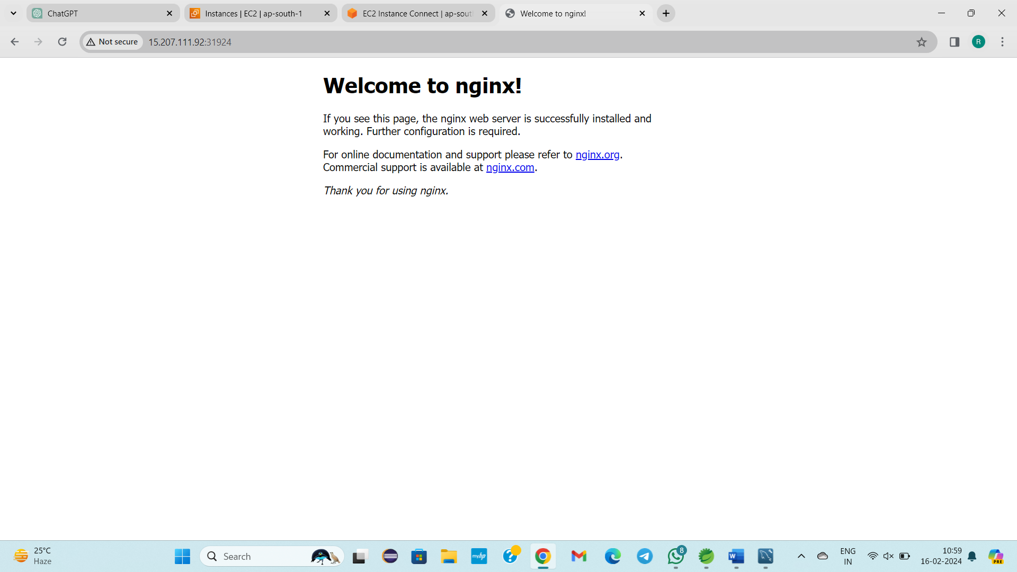

This will be the Final Output.

**--------------------17/02/2024------Saturday----------Class – 41--------------------**

**TOPIC: LAYER TECHNIQUE IN KUBERNETES. MANUAL PROCESS**

Tomcat 🡪 .war file

Docker container 🡪 .war file

Kubernetes 🡪 .war file

In Git repo – Developers written code placed—clone— to deploy – mvn goals -- .war file

Git to repo

Maven 🡪 To generate .war file

Docker

Kubernetes

To deploy .war in doc or kub

Steps:

Github.com

Septmavenchanges repository

I will deploy with k8s environment

Connect to master node

Ubuntu user

sudo -i

cd/

ls -la

git clone url

ls -la

We can view septmavenchanges

cd target/

To check .warfile is present

I will create new .war file

mvn clean

No maven in Kubernetes environment,

apt -get install maven

mvn clean

ls -la

Target folder will be removed. To recreate mvn package

mvn package

ls -la

Now you can view Target folder

Inside the Target folder, you can view .war file

cd target/

ls -la

cd ..

ls -la

vi Dockerfile

FROM tomcat:8.0.20-jre8

MAINTAINER Mailid

COPY target/MavenUI.war /usr/local/tomcat/webapps/MavenUI.war:

[cd target/

ls- la

Copy this .war file name]

docker images

docker ps -a

ls- la

docker build -t “dockerk8sdep” .

docker images

docker run -d -p 8080:8080 –name dockercontainertest dockerk8sdep

docker ps -a

Master node public IP copy /MavenUI(warfile name remove .war extension)

Paste in google:8080(Port number)

Ls -la

Cd target/

Ls -la

----------

Go to google

Enter <https://hub.docker.com/>

Login

Create a repository with a name k

This is for UIbasedApplication

Public

Create a repository

Come back to aws linux

Docker images

Docker login

Username:

Pssword:

Login Succedded

Docker push dockerk8sdep(image name)

Requested acess deniesd[Error occured]

Docker tag dockerk8sdep (space) dockerHub reponame [To rename image name in cloud linux]

Docker images

Docker push imagename

------------------

Now I will deploy in Kubernetes

Ls -la

Exit

Now I am a ubuntu user

Cd/

Ls -la

Cd septmavenchanes/

Ls -la

Sudo k8sdeployment.yml

Esc+i

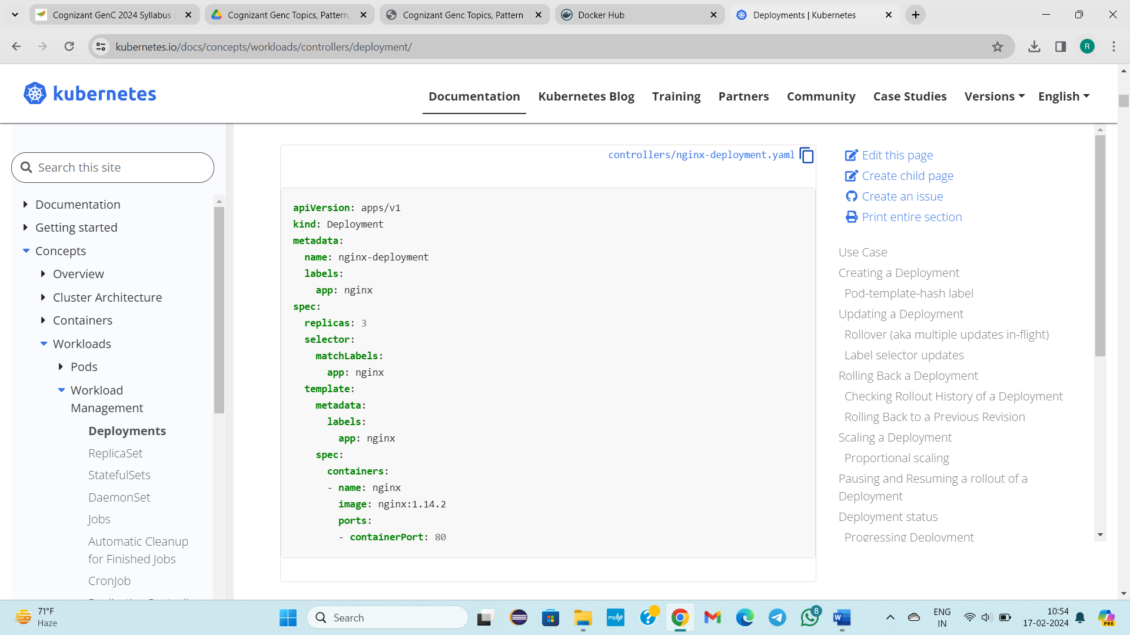

<https://kubernetes.io/docs/concepts/workloads/controllers/deployment/>

apiVersion: apps/v1

kind: Deployment

metadata:

name: mavenuitest

labels:

app: mavenuitest

spec:

replicas: 3

selector:

matchLabels:

app: mavenuitest

template:

metadata:

labels:

app: mavenuitest

spec:

containers:

- name: mavenuitest

image: dockerhubreponame or imagename[samename for both]

ports:

- containerPort: 8080

----

apiVersion: v1

kind: Service

metadata:

name: mavenuitest

labels:

app: mavenuitest

spec:

selector:

app: mavenuitest

type: NodePort

ports:

- port:8080

targetPort:8080

:wq!

Kubectl get pods

Kubectl get svc

Kubectl apply -f k8.yml

Kubectl get pods

3 pods created

Kubectl get svc

1 service created

Copy worker node publicIp

Publicip: portno/MavenUI

Copy Master node publicIp/MavenUI

Publicip: portno/MavenUI

Layer Technology

Docker Container, Kubernetes env we deployed war file

Advantages

End use🡪 request in browser🡪www.google.com🡪API server--- 🡪con 🡪pod(if kind as deployment then no of pods will create)🡪 If one pod is in busy and it transfers to another 🡪 no response is 🡪 then maser node re 🡪if pro -🡪 Then Tomcat gives response

3 Layers

tomcat

Container

Pods

If pods are busy and unable to provide response then master node take response from docker container or tomcat server.

In Kubernetes the deployment is done by Layer Process. If 1-layer doesn’t responds, then it go to On top of the layer.

This is about Layer Technique in Kubernetes. This is called Manual Process.

**STEPS:**

Step -1: Login in to master node as a root user.

Step -2: Clone GitHub repository🡪git

Step-3: I will hit maven goals to create .war file

Step-4: Firstly, I will deploy in Docker Containers, even being in master node.

* Create a docker file
* From
* Maintainer
* Copy

Step-5: Login into Docker Hub

* Create a repository

Step -6: Docker push

Local image🡪 Docker hub

Step -7: Kubernetes

* Exit from root user

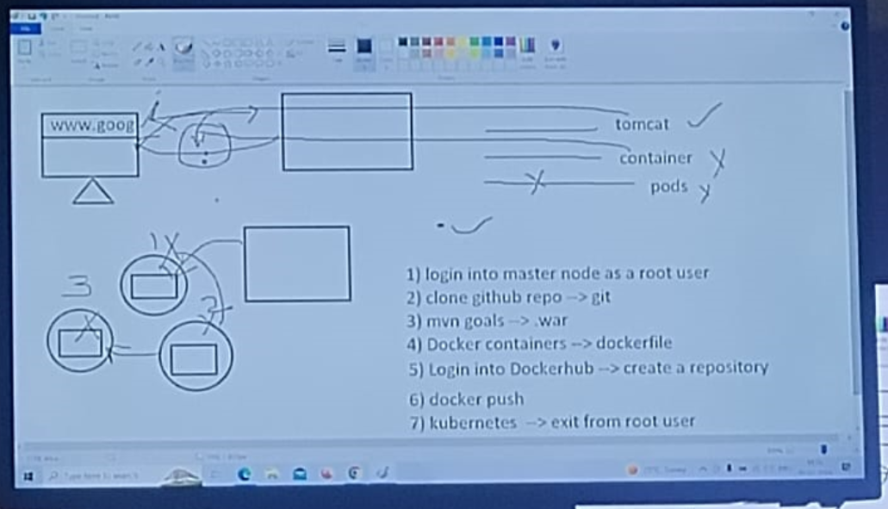

STEPS:

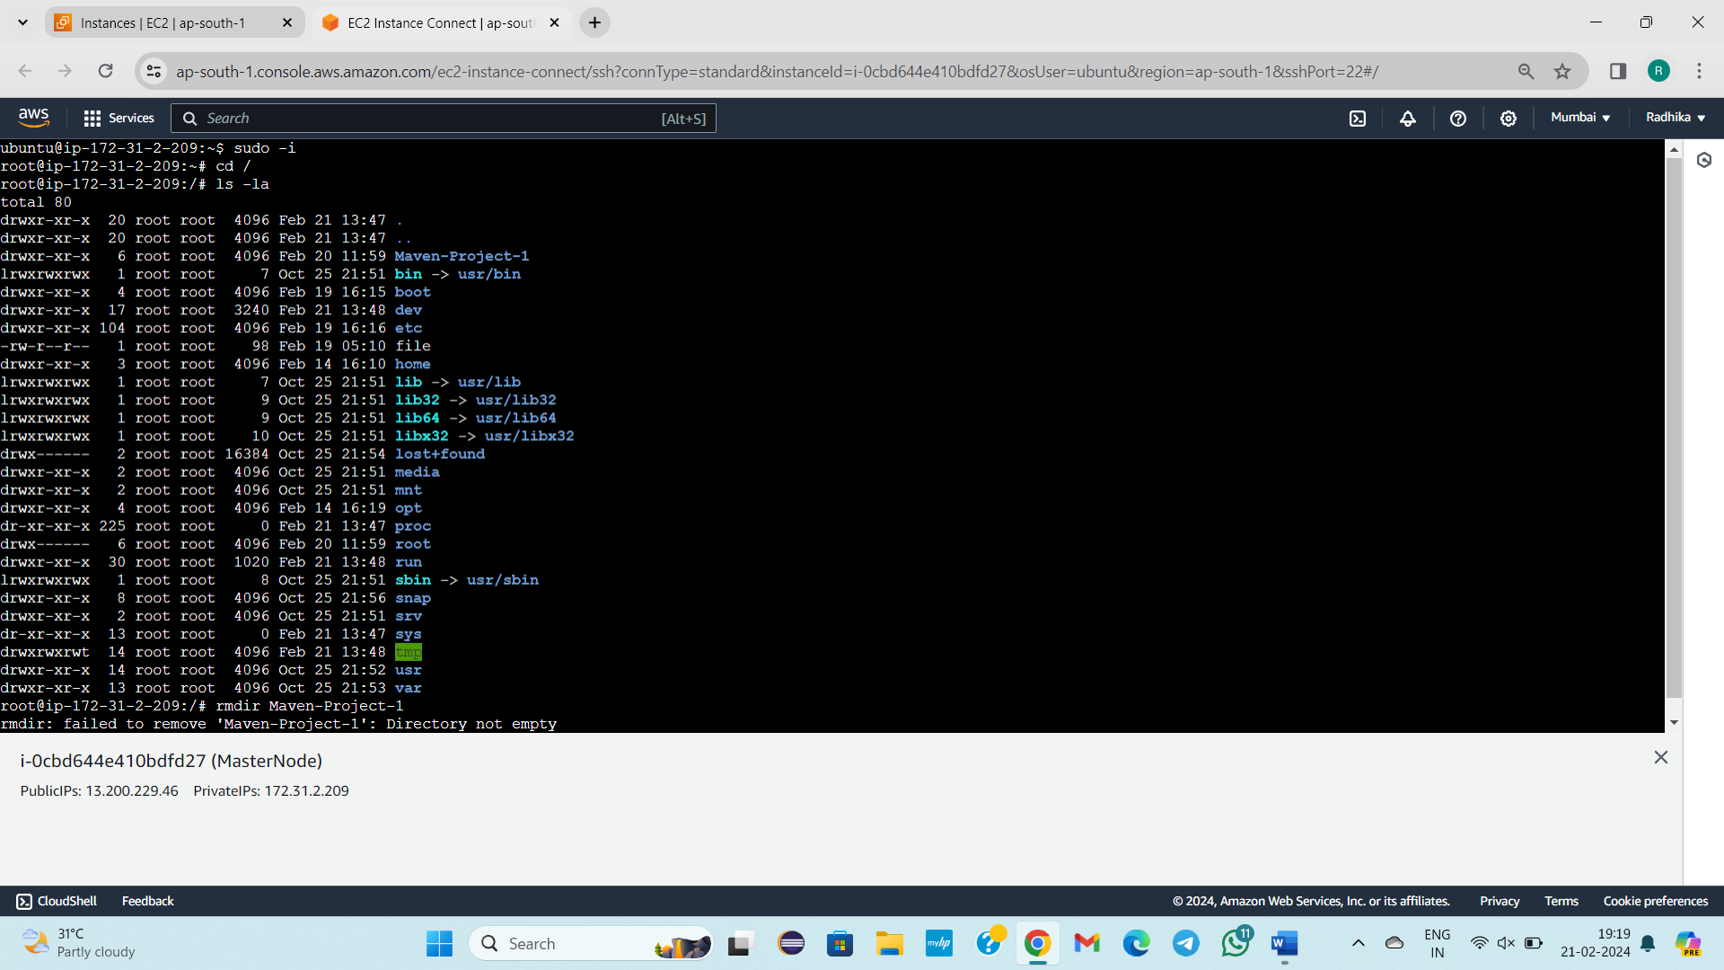

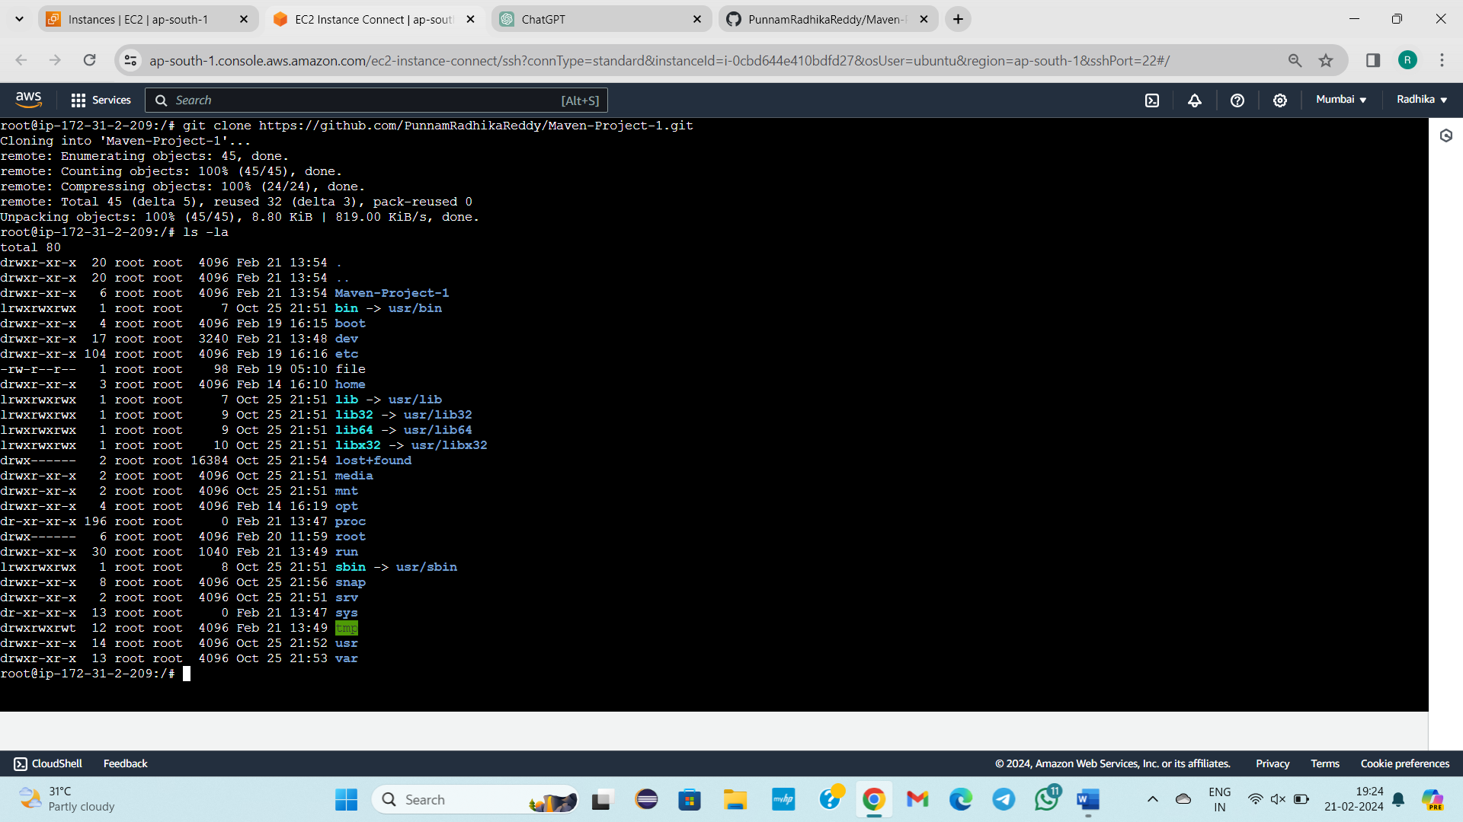

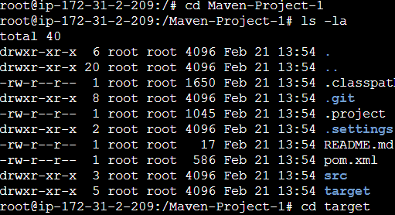

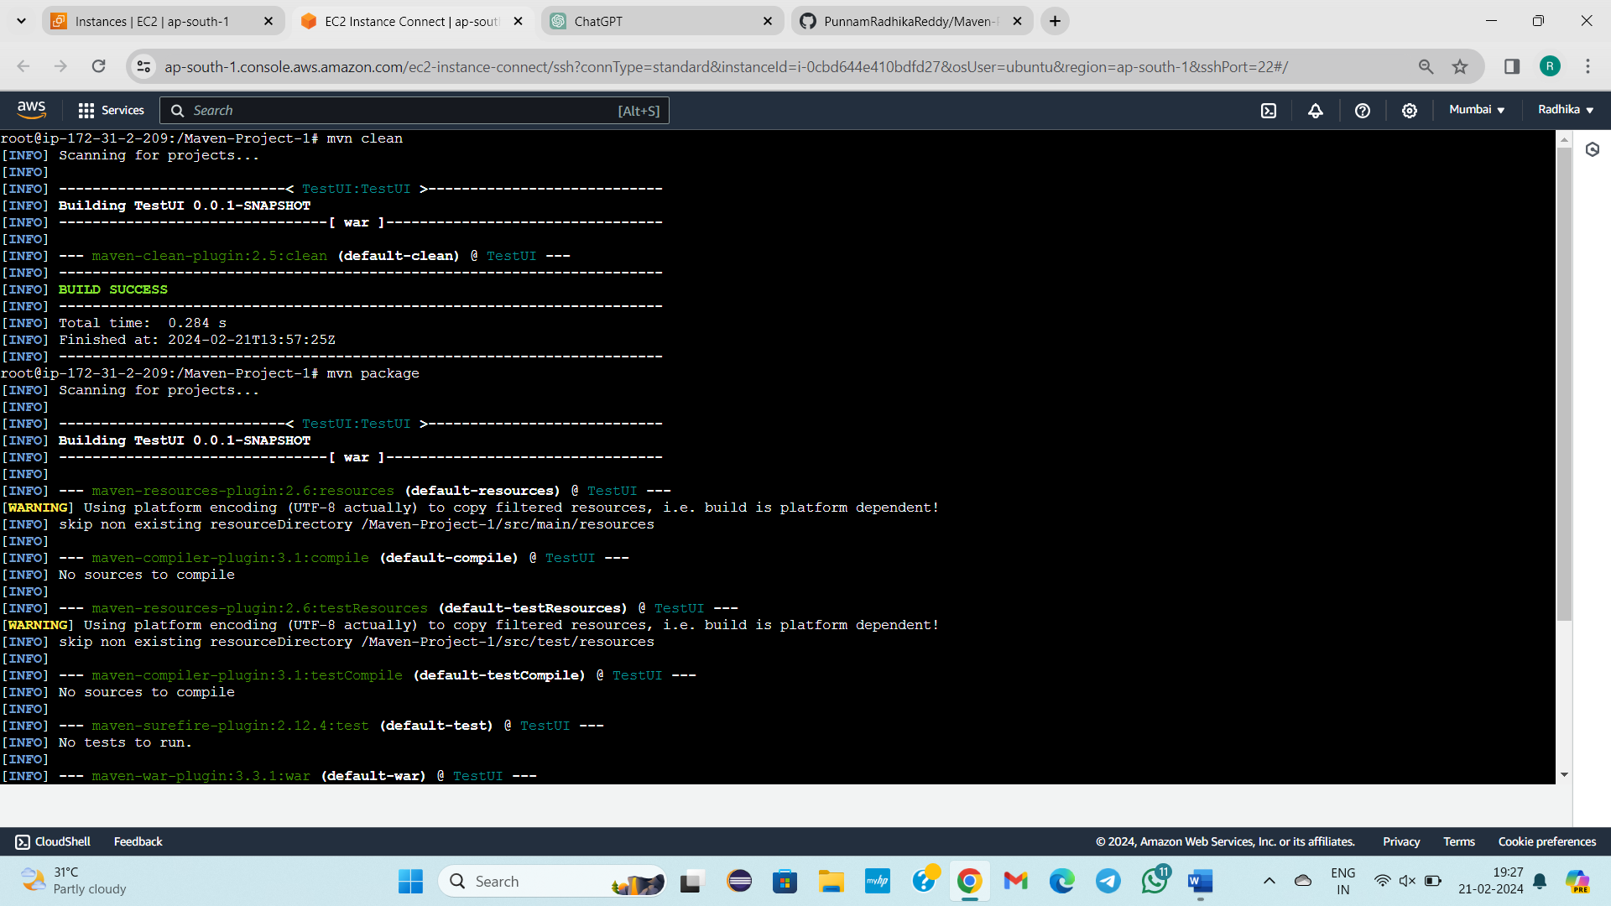



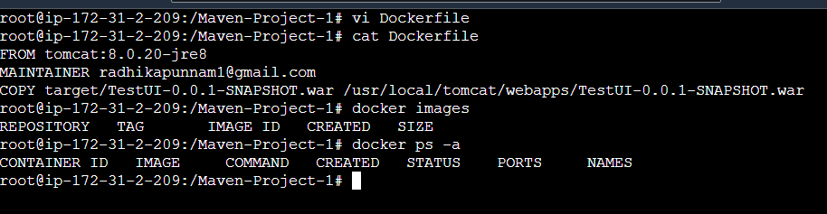

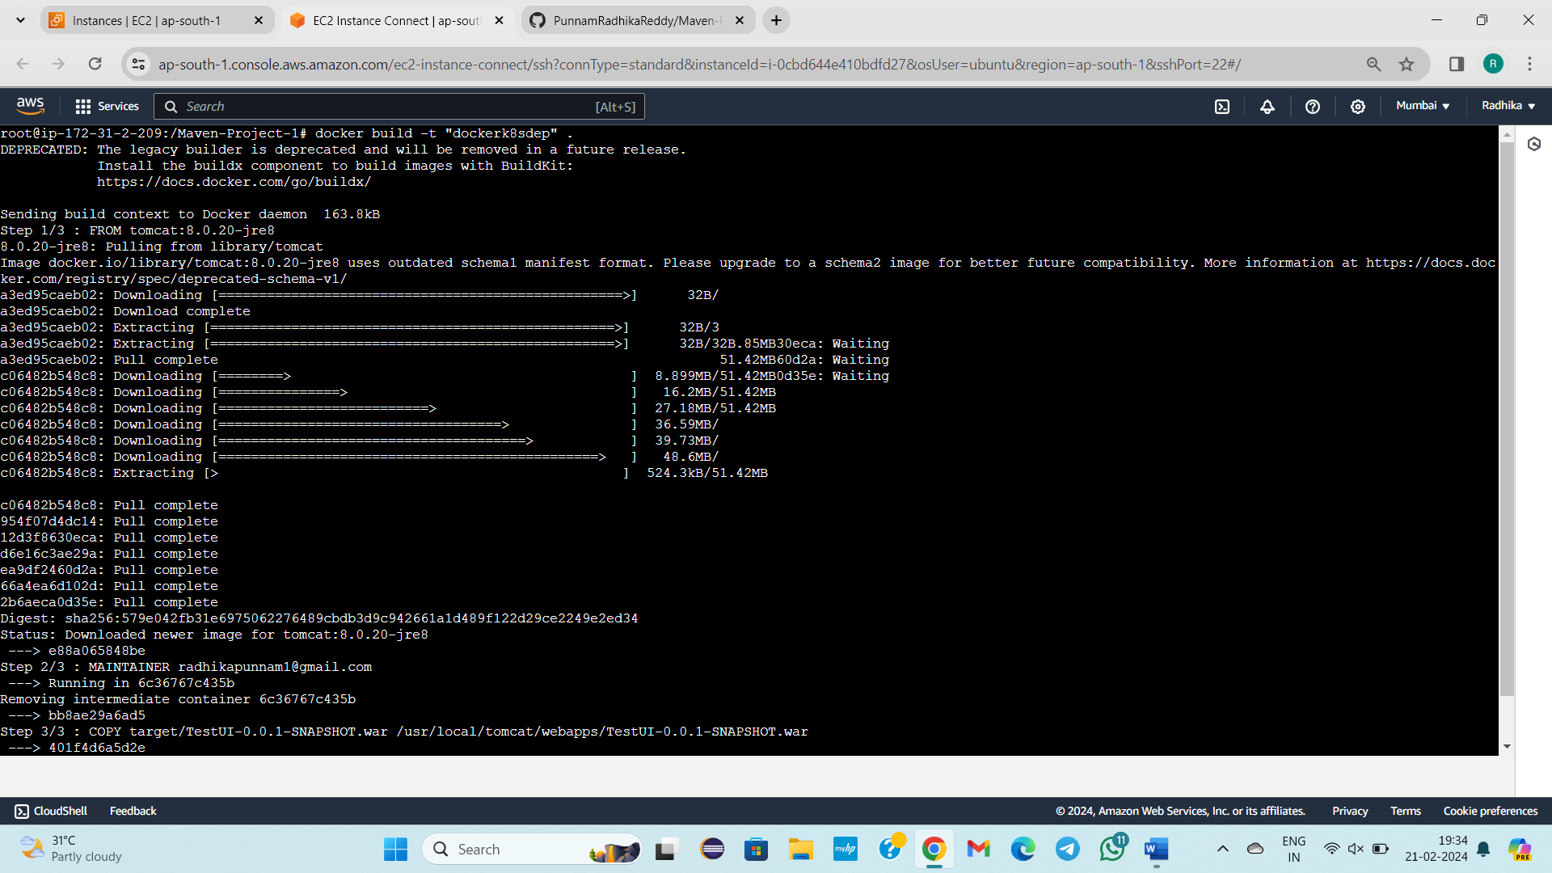

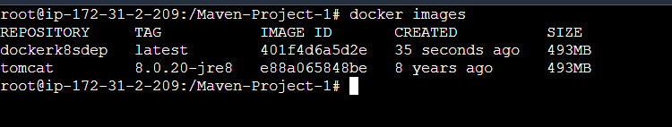

Docker tag



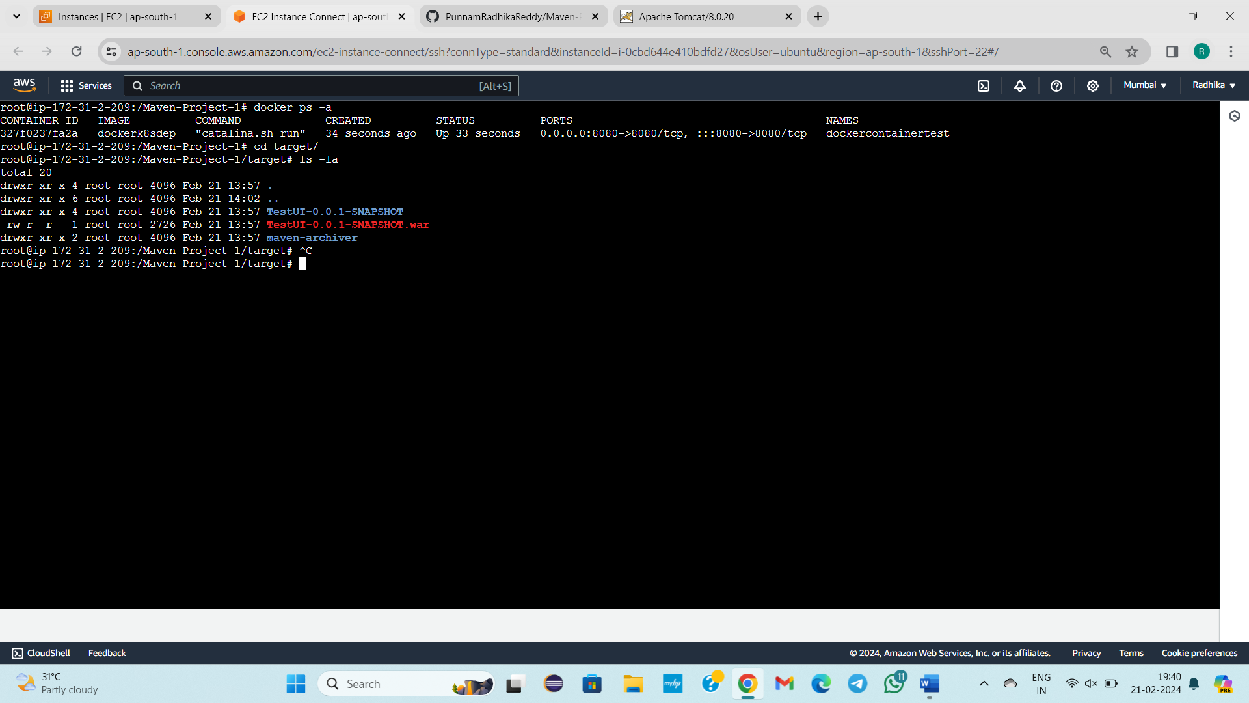

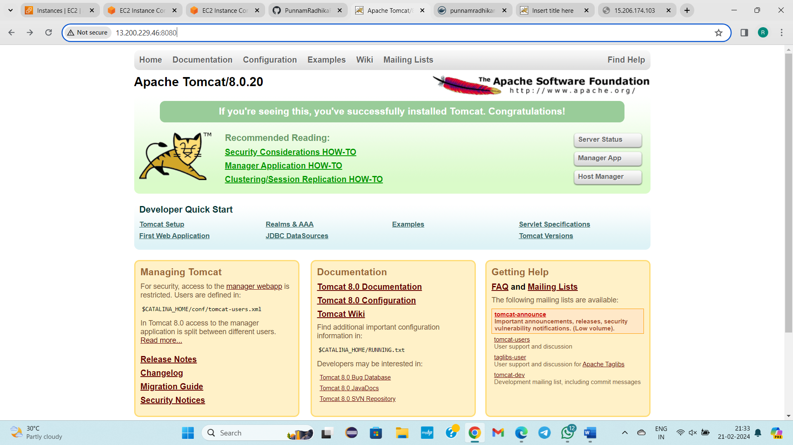

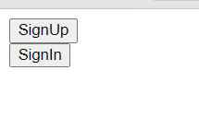

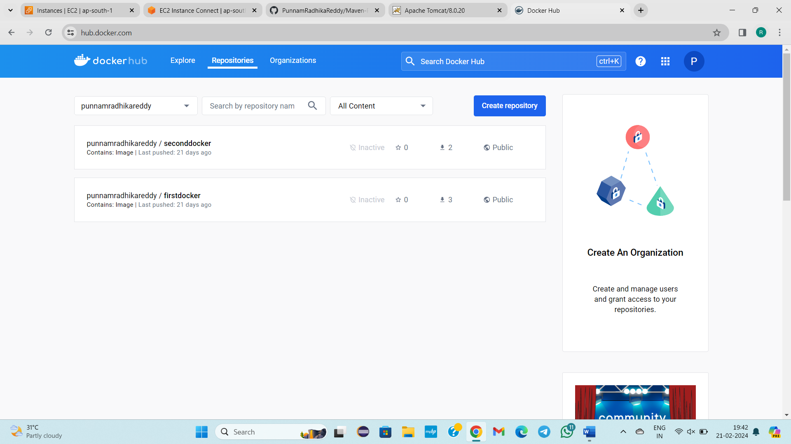

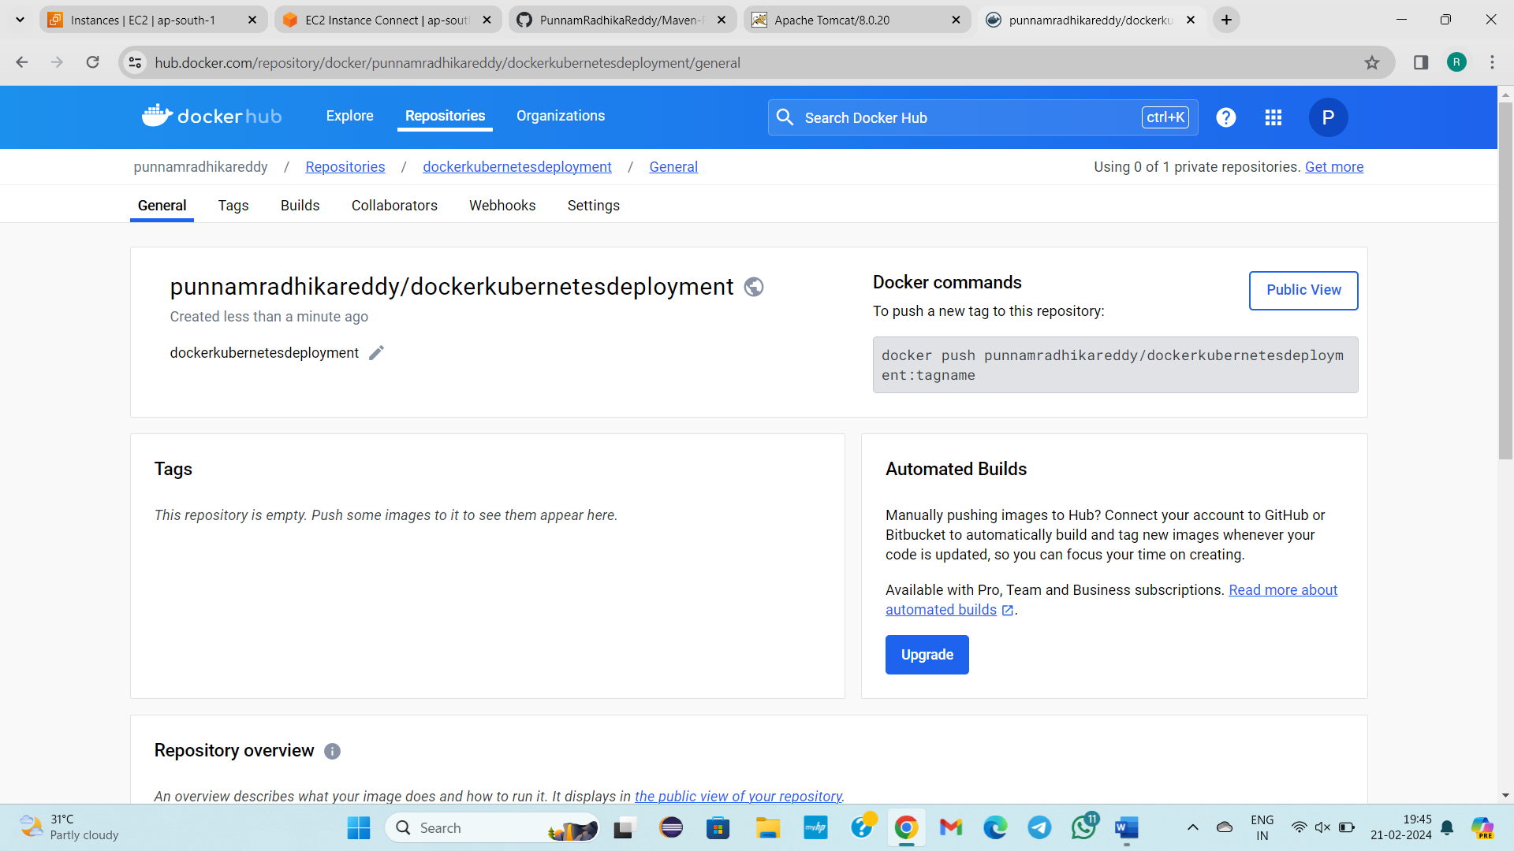

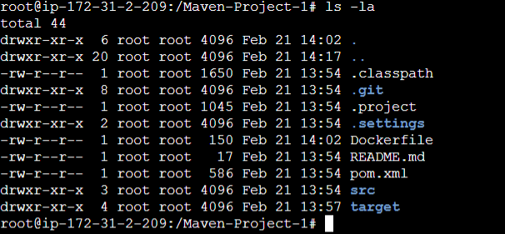

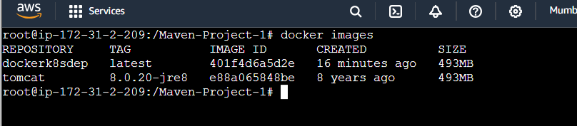

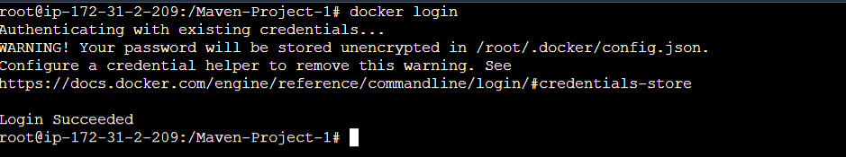

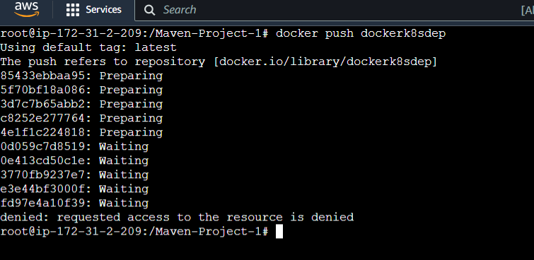

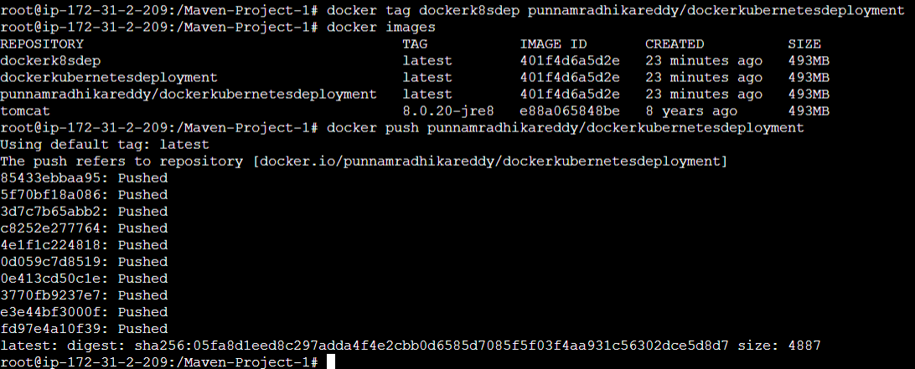

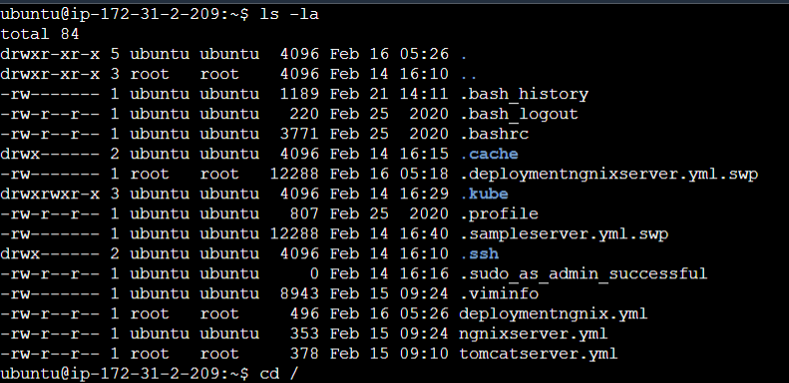

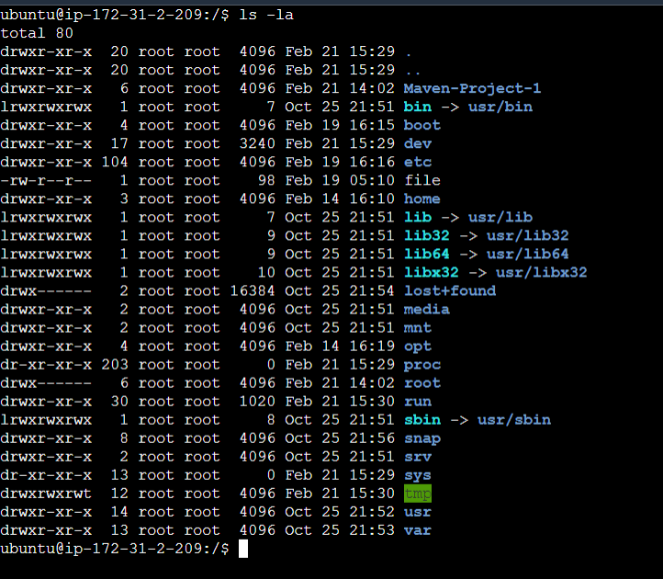

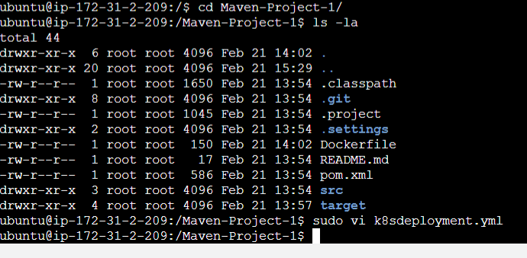

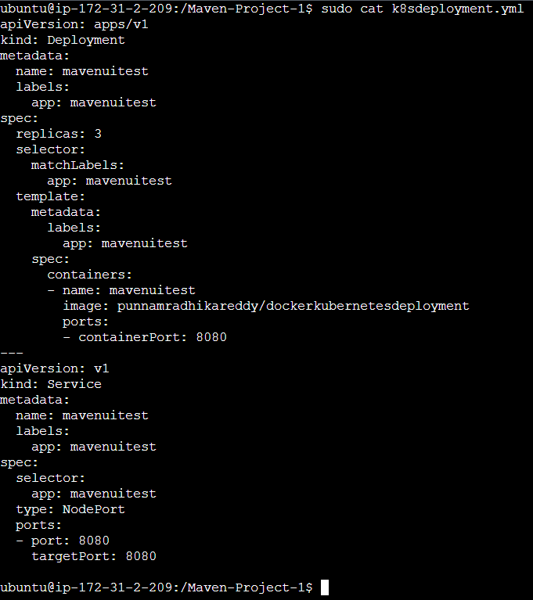

TestUI-0.0.1-SNAPSHOT.war

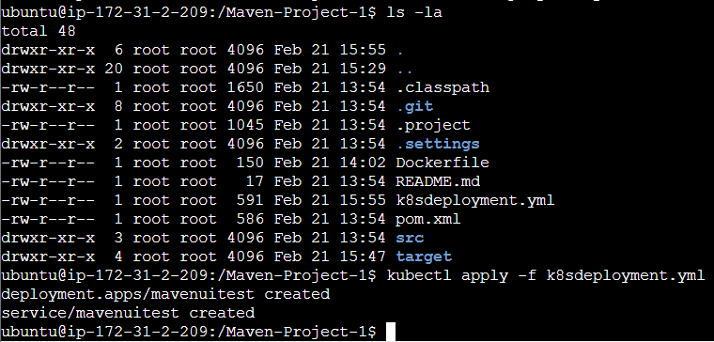

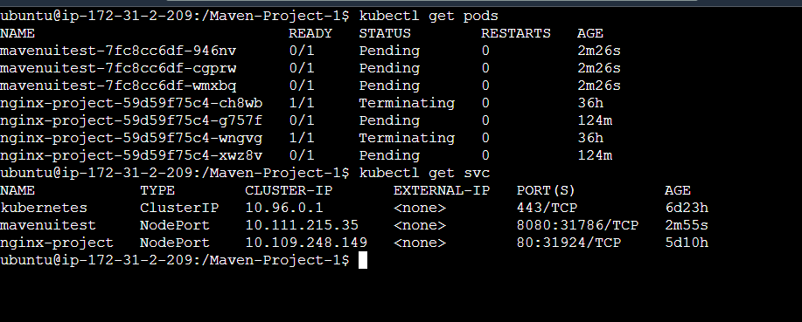

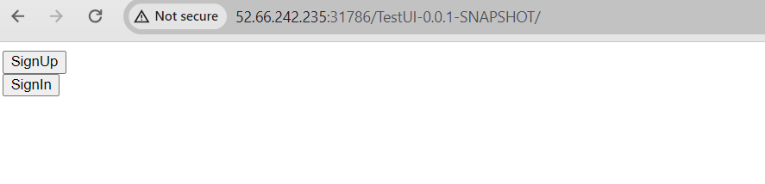

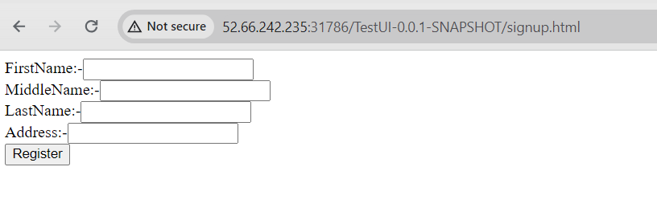

**--------------19/02/2024-------Monday-------------------------------------**

**DUE TO NETWORK ISSUE NO CLASS TAKEN**

4 tools:

1)git

2)Mvn

3)Docker

4)Kubernetes

Master/control plane

Workernode/slave node

CRT is not having capilibity to create the pod, It uses docker.

6-7

Image: name 🡪why?

Due to Layer kind of deployment

Request🡪API server🡪……

**--------------20/02/2024-------Tuesday------------------Class – 42-------------------**

**TOPIC: JENKINS INSTALLATION**

Git –Storage area for developers code by using git

, maven – build tool(.war)

, tomcat manual deployment

Docker

Kubernetes

Any of 3 tools

5 tools

Jenkins is a tool we can do deployments automatically.

It is a **Ci/Cd Tool**(Continuous Integration and Continuous deployment) OR **Automation Tool**.

To install JENKINS

We need

JDK

Progarmfiles 🡪java🡪jdk

Check is path been set in Environment variables for java

JAVA_HOME

Check in these 2 areas

Jenkins related Setupfile

Jenkins related .war file 🡪jenkins.war

Long time standards – 1month

10 days—right

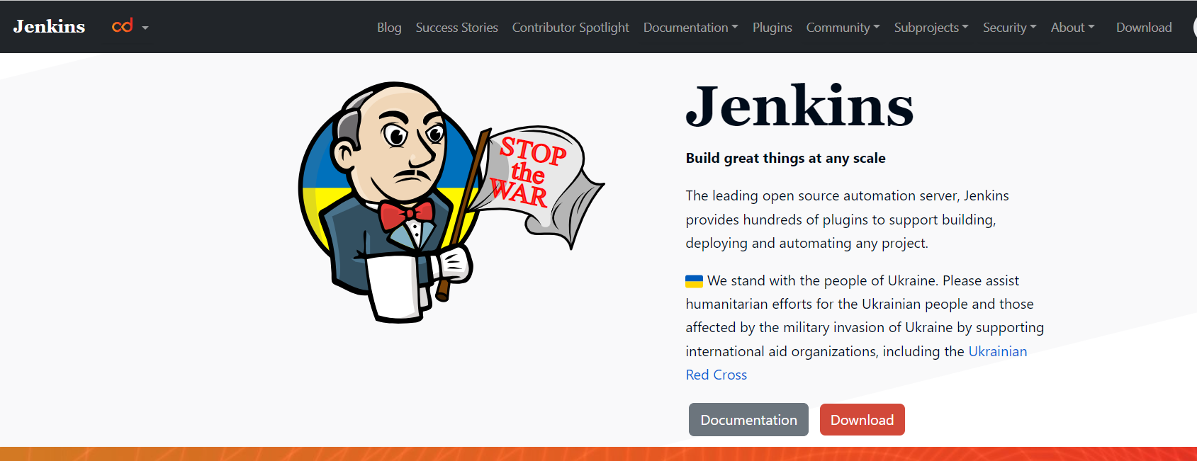

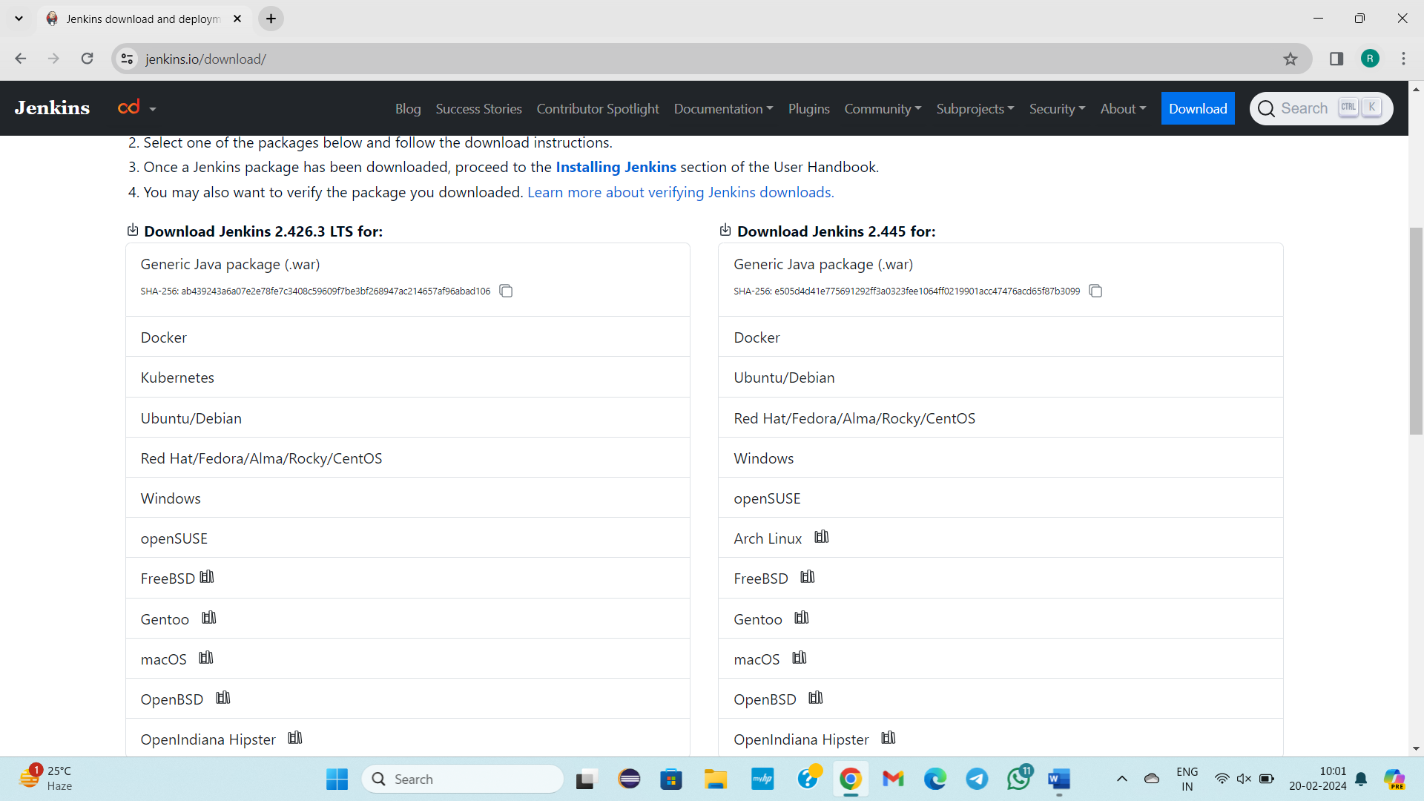

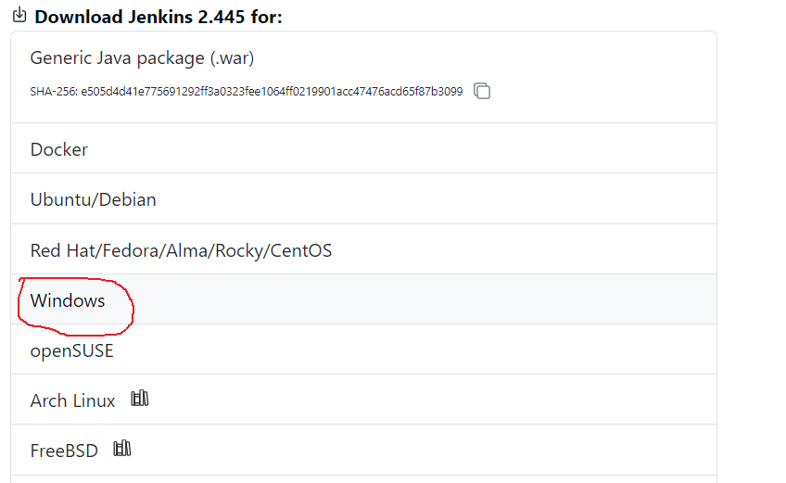

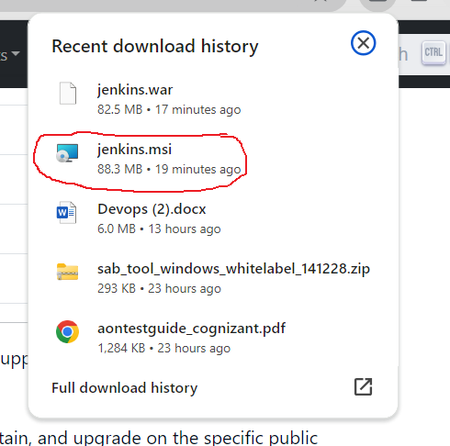

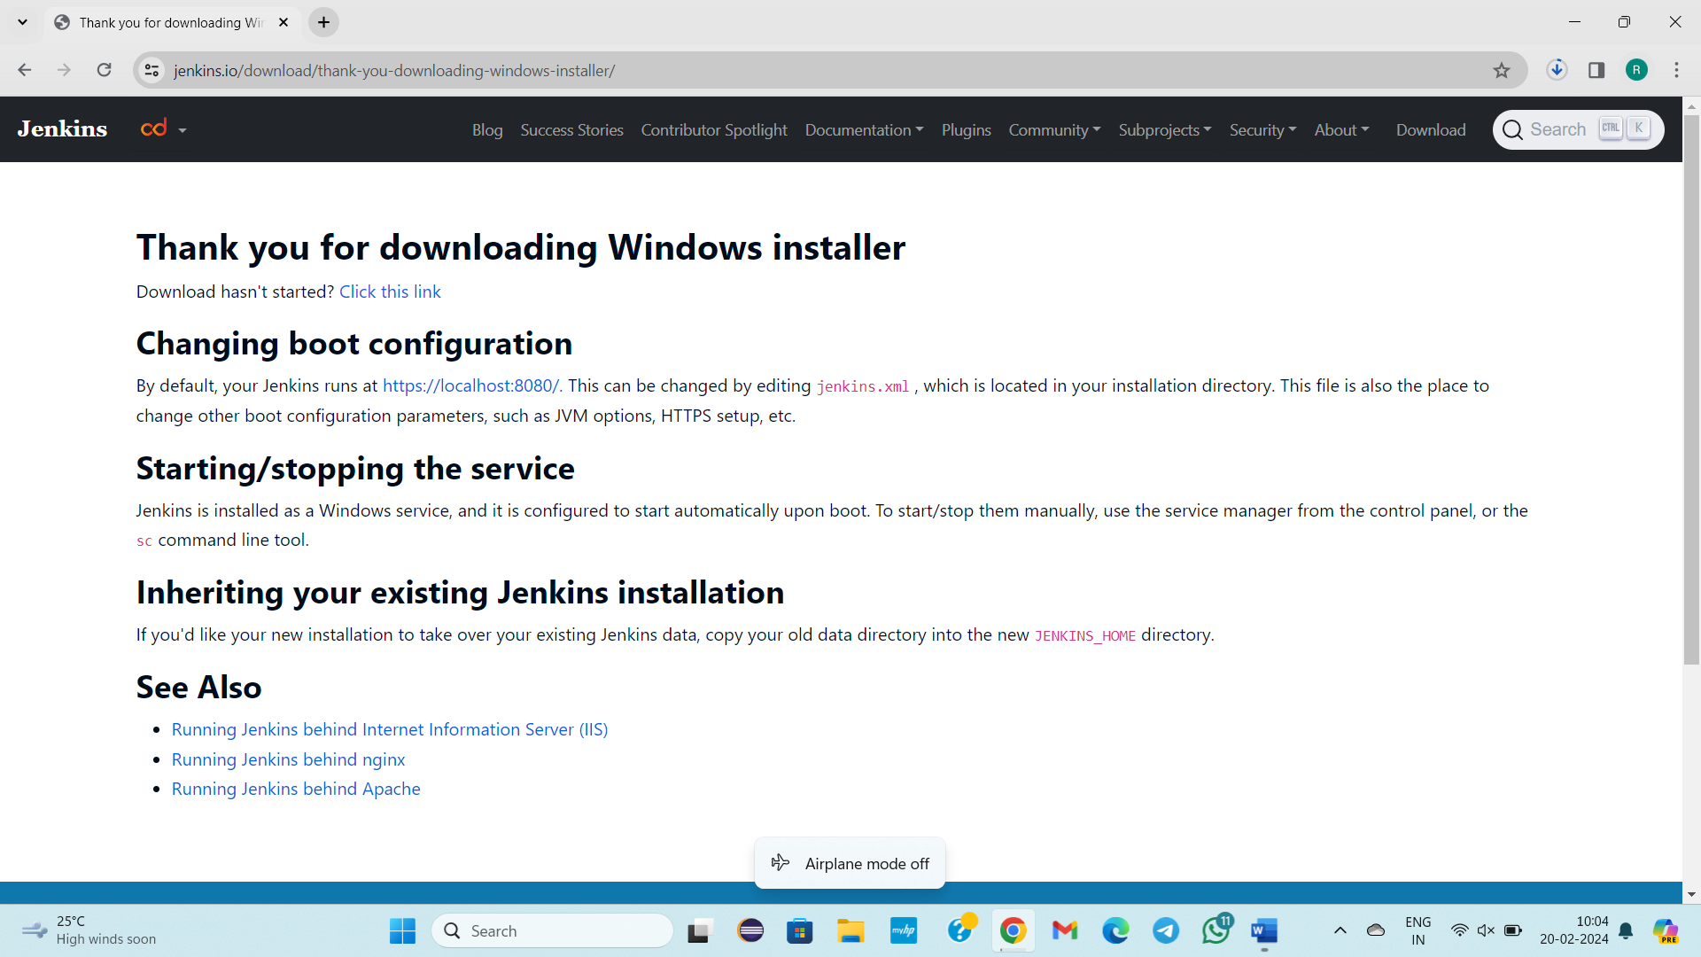

Download Jenkins.war file

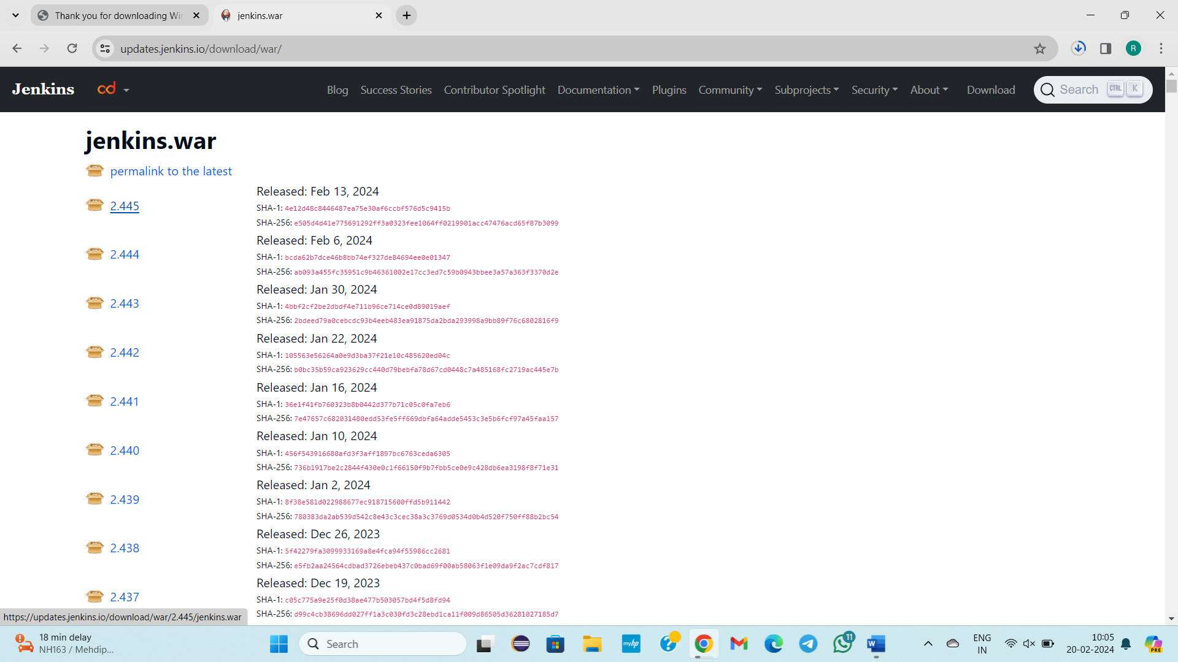

Cut from downloads

D drive folder 🡪JenkinsPractice

Paste the copied 2 files

We will launch Jenkins

In that folder only that 2 files must present otherwise problem occurs

cmd

To launch Jenkins

java -jar jenkins.war --httpPort=8087

Jenkins 11,21,17

Jdk 11,17

Change the path to jdk 17 in environment variables.

java -jar Jenkins.war --httpPort=8087

Still error

How to download jdk new versions

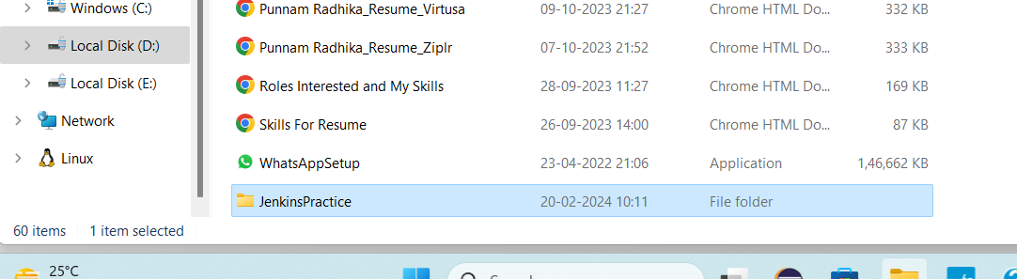

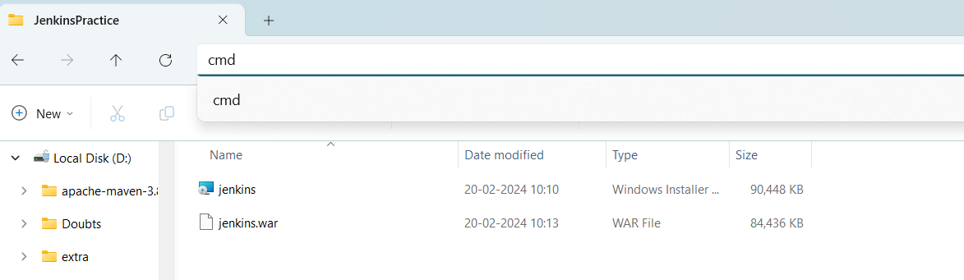



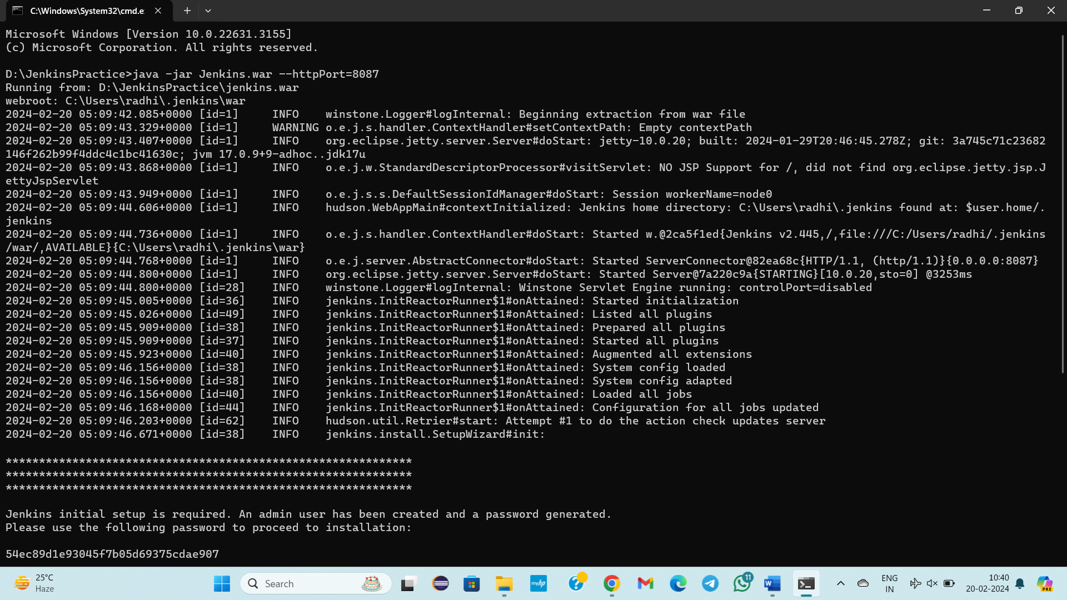

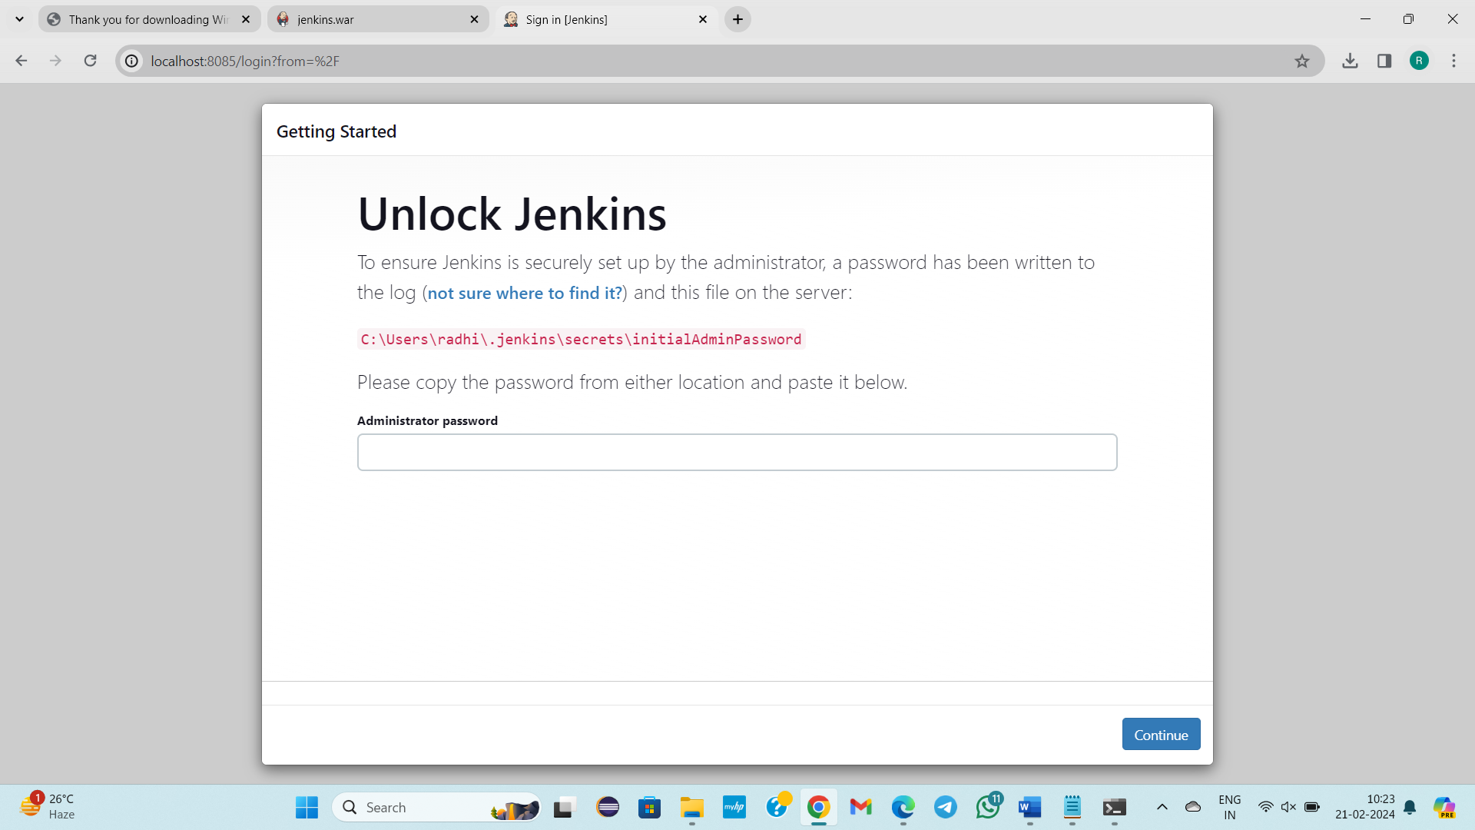

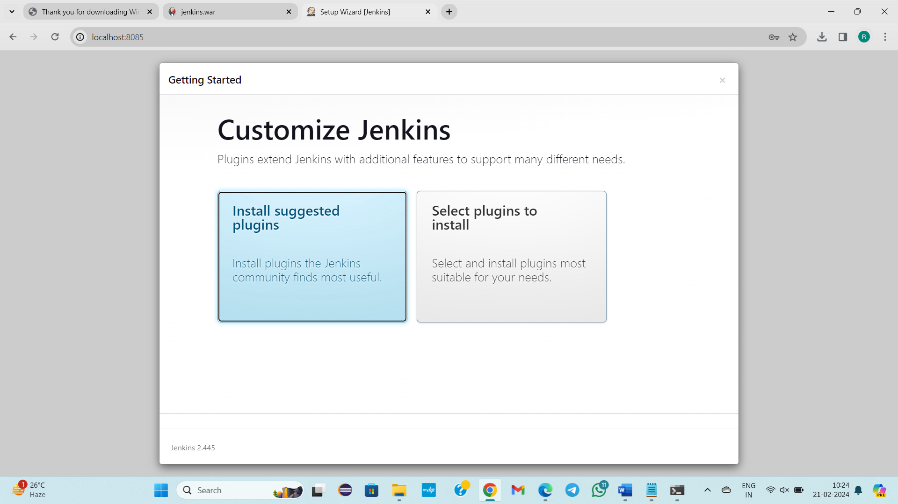

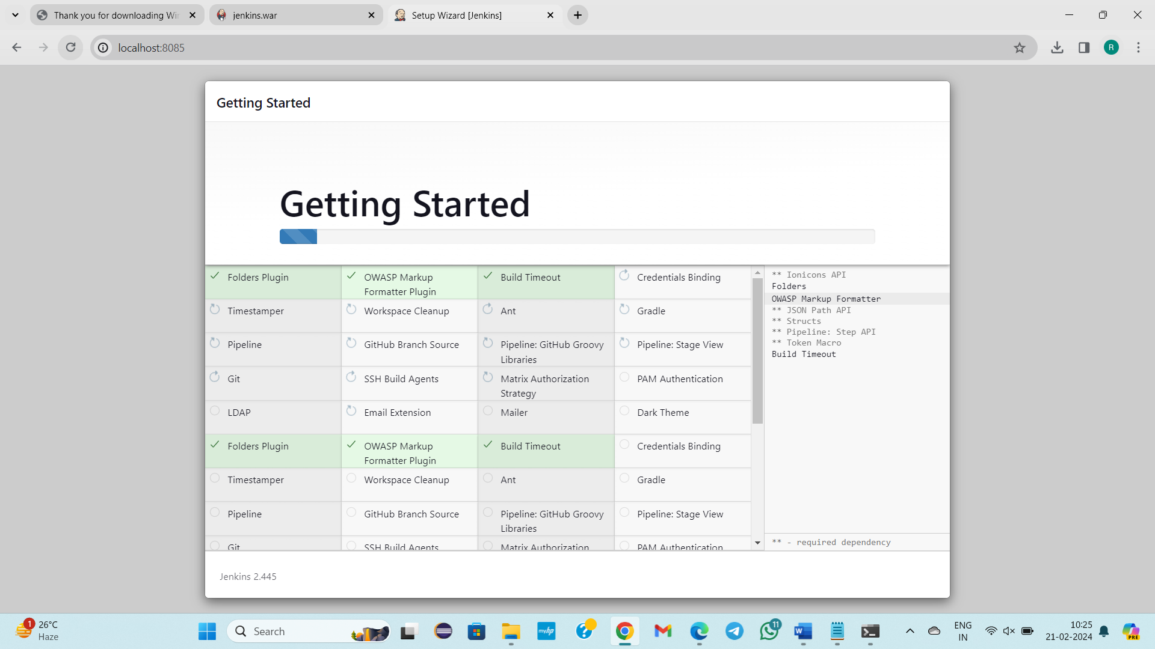

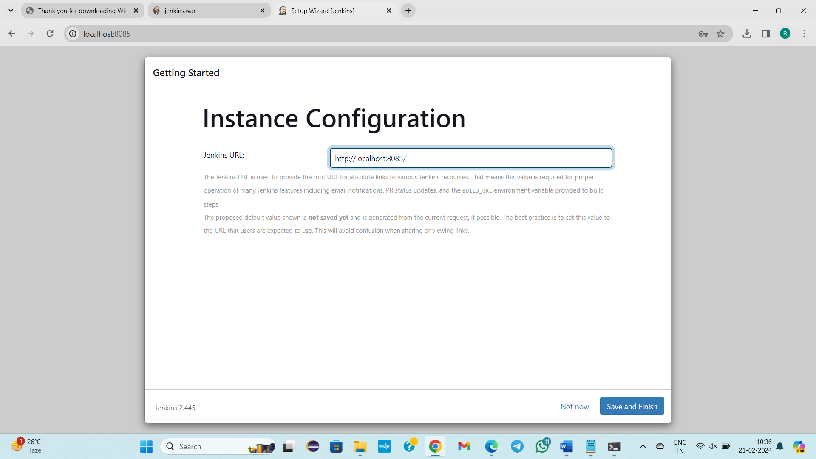

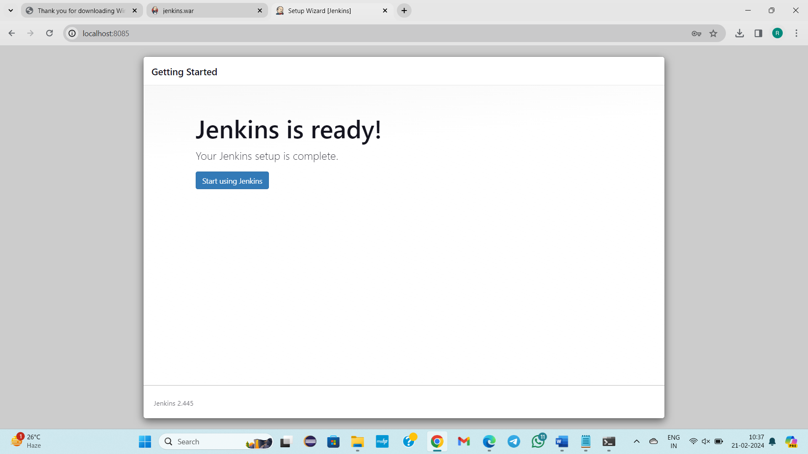

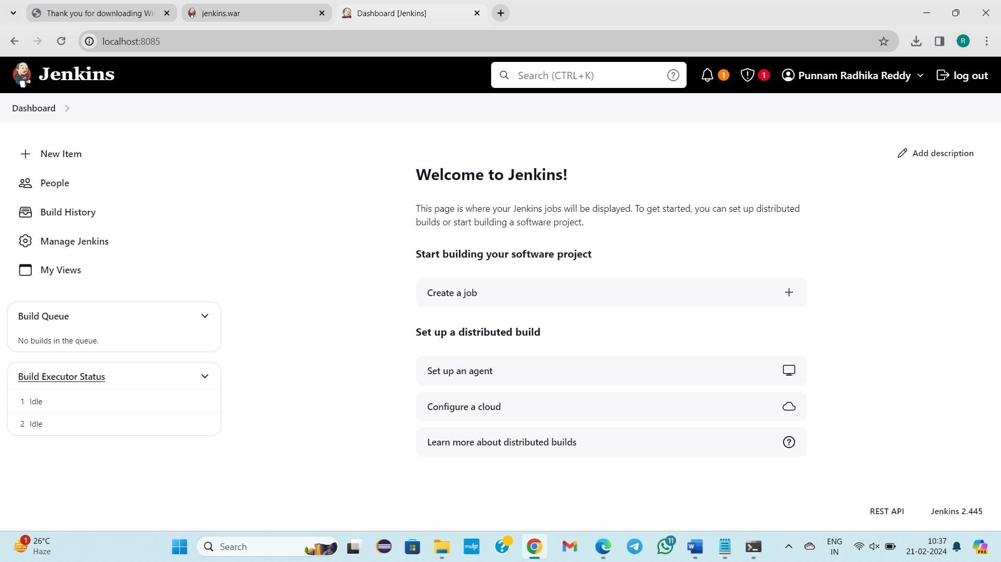

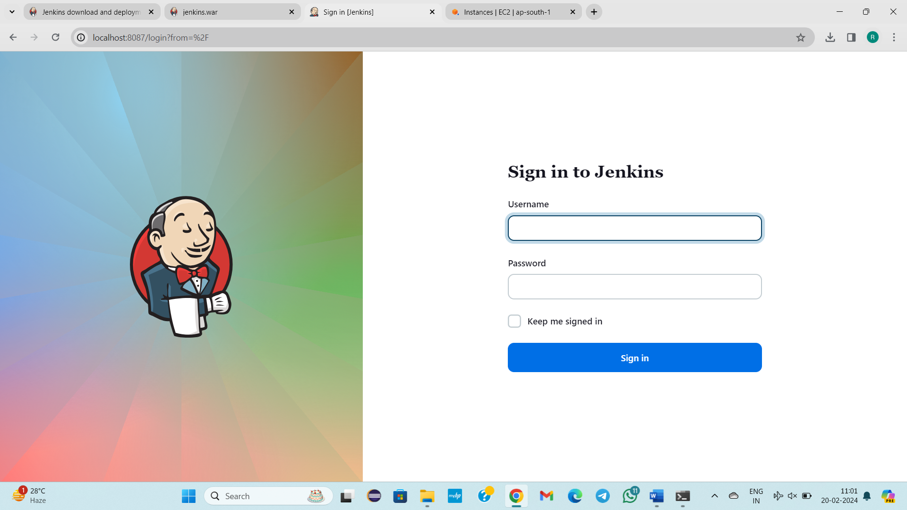

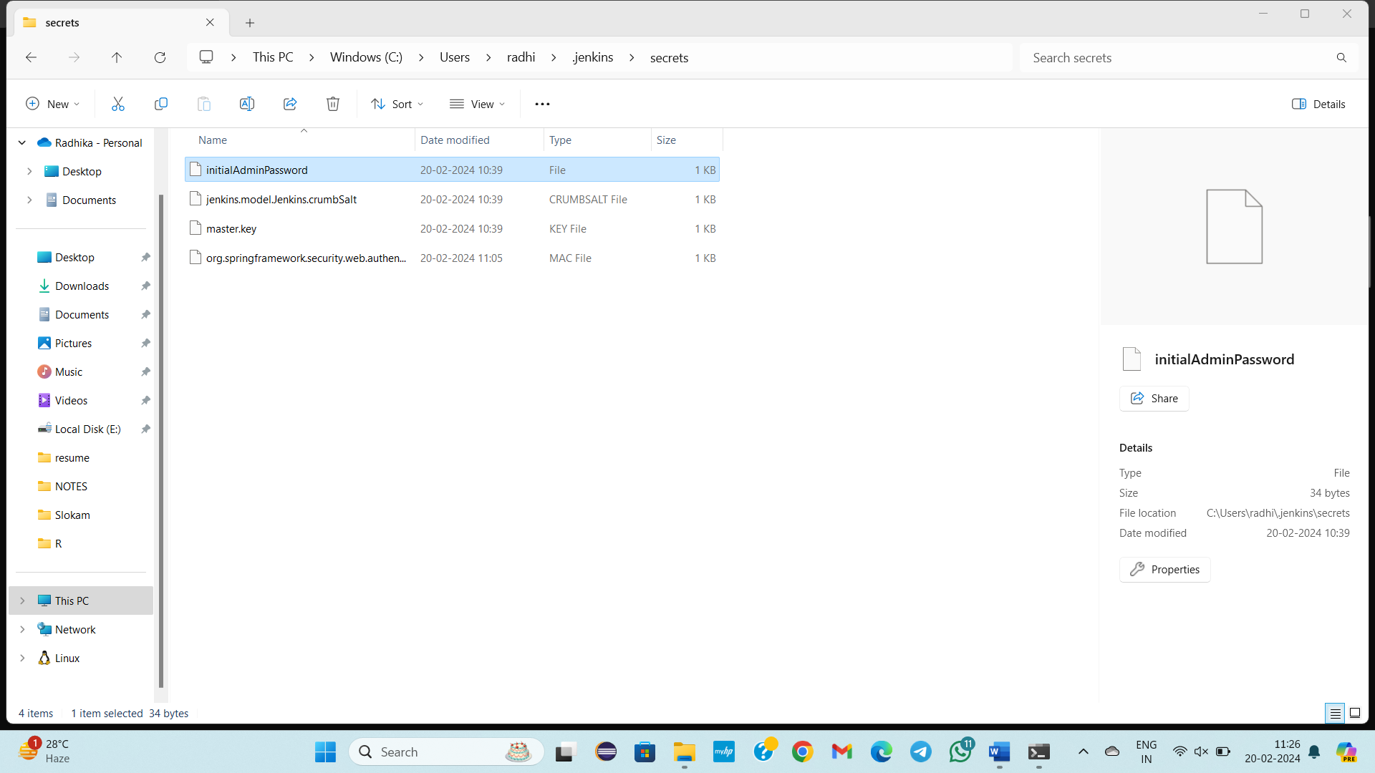

**-----------21/02/2024-------Wednesday------------------Class – 43-------------------**

**TOPIC:**

* **JENKINS IS A CI/CD TOOL OR AUTOMATION TOOL, WHICH IS USED FOR AUTOMATION PURPOSE**
* **JENKINS STEP BY STEP INSTALLATION, SETUP, SETTING UP THE USERNAME AND PASSWORD. INSTALLATION OF REQUIRED PLUGINS**
* **HOW CREATE A JOB, IMPORTANCE OF THE JOB**
* **HOW MANY TYPES OF JOBS?**
* Declartive Pipeline job
* Scripted Pipeline job

**Refer steps for execution below**

In Jenkins the initial process

1)initial admin pwd

2)plugins installation 🡪install suggested plugins

3)create user

JENKINS IS USED FOR AUTOMATION PURPOSE

In Jenkins jobs are very important

In Jenkins by creating which kinds of jobs we can automate the process?

1. Declartive Pipeline job
2. Scripted Pipeline job

The above two types we can have jobs

1. For Declartive Pipeline job, we need to mention url’s
2. For Scripted Pipeline job, By writing groovy script we will write

Jenkins is a tool is used by the aws &devops engineer, Networking team, Maintainence team, Security team.

When you first entered in to Jenkins you need to setup the configuration

Manage Jenkins🡪

1)System Configuration

2)Security

We will work with above 2 tools only

Why we need to check all ?

But firstly create a job.

How to create the job?

🡪job1🡪FreeStyleProject🡪Click on Ok

General 🡪Ok

New Item🡪job2🡪FreeStyleProject🡪Click on Ok🡪Dashboard came🡪save

When you press play button, Job will be built.

Build success message will be appeared.

Click on job1

How many job1 built?

2 times

On left green colour symbol you can see the output.

New item, Manage Jenkins with these 2 areas we will work

New item is for creating jobs

Manage Jenkins is like Environmental Variables

Git is not a part of Jenkins. It is a separate

We will integrate all tools in Jenkins

Git, maven,docker,Kubernetes we need to integrate all these in jobs in Jenkins.

ManageJenkins, we need to provide the information about the tools.

Jenkins is automation/ci/cd tool

We will create jobs in 2 ways and how?

Why we need to create jobs in Jenkins?

For automation process eg: Git clone url

**STEPS FOR EXECUTION :**

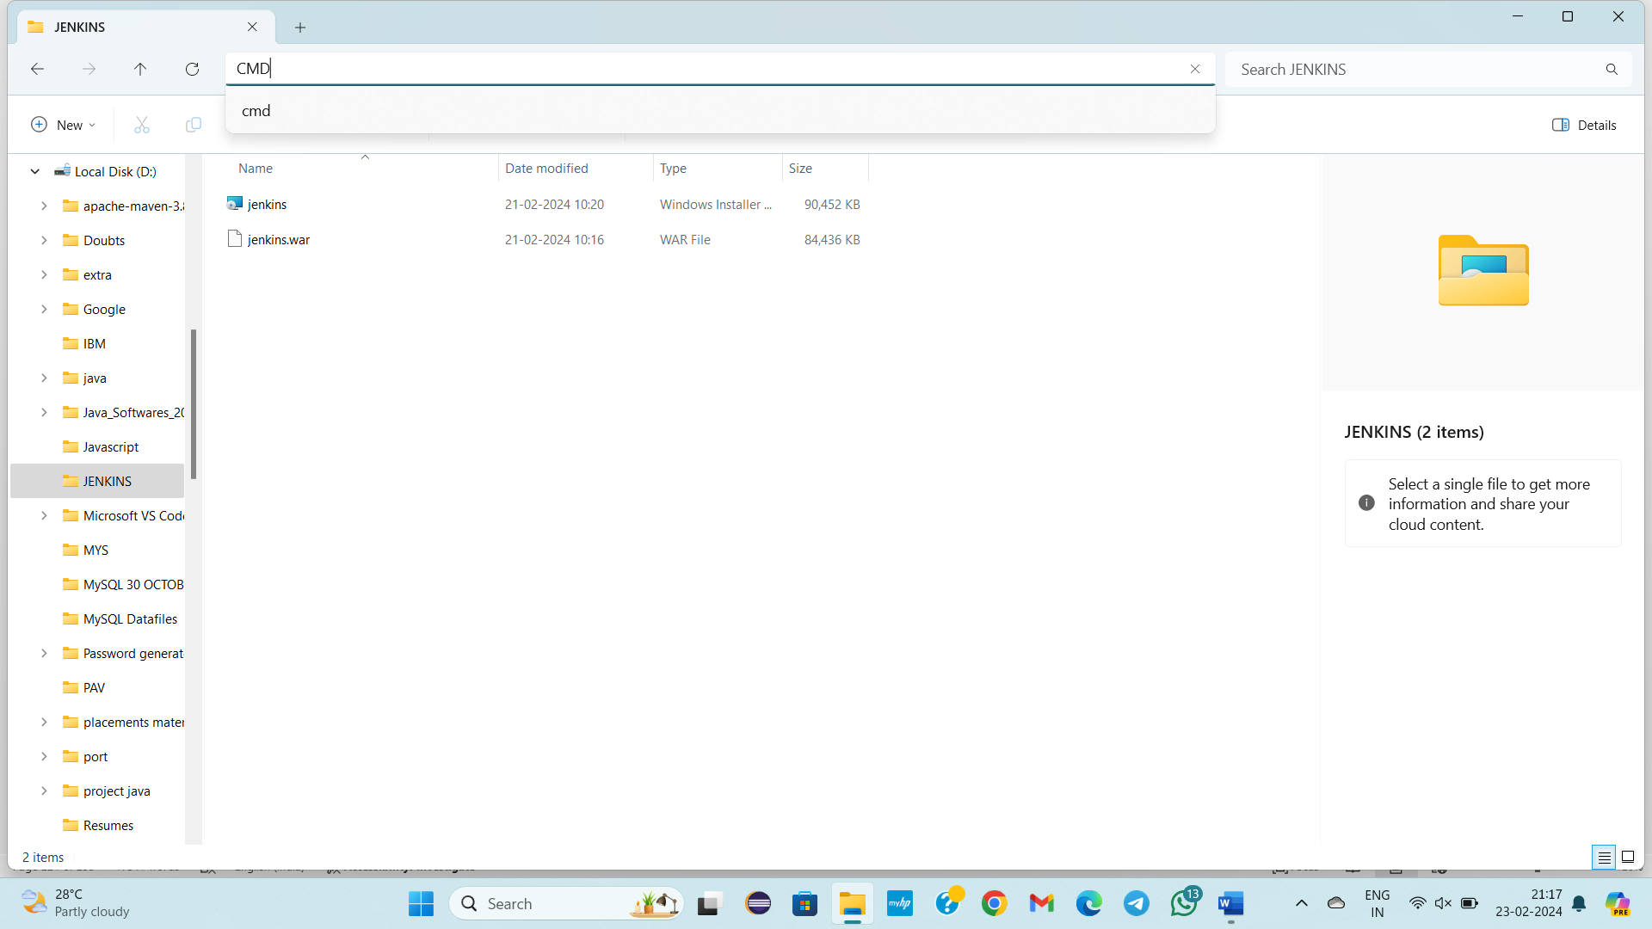

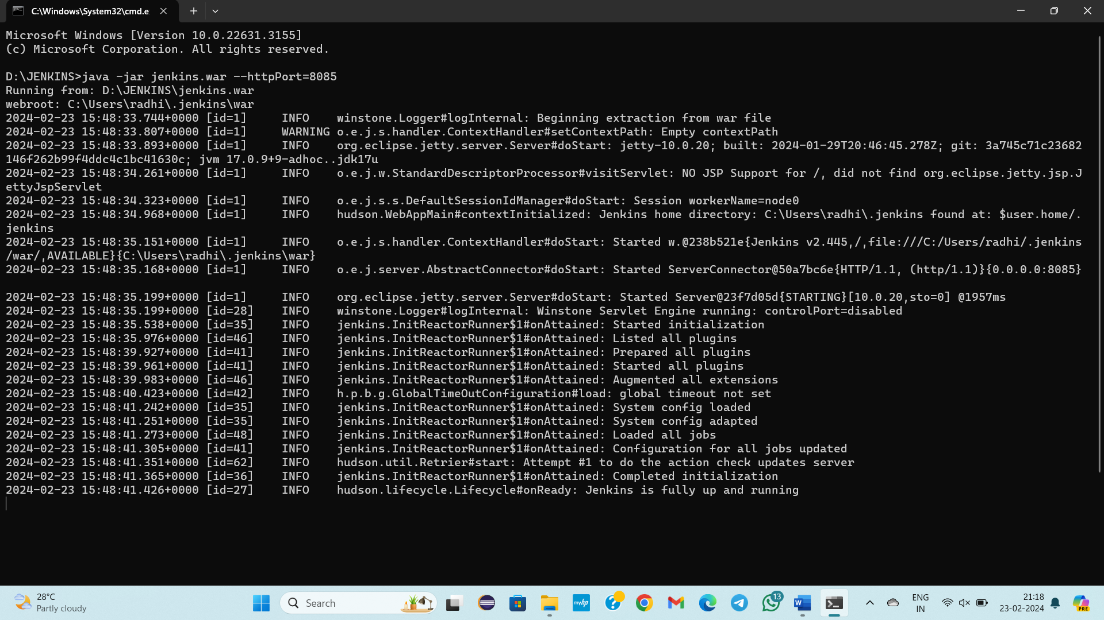

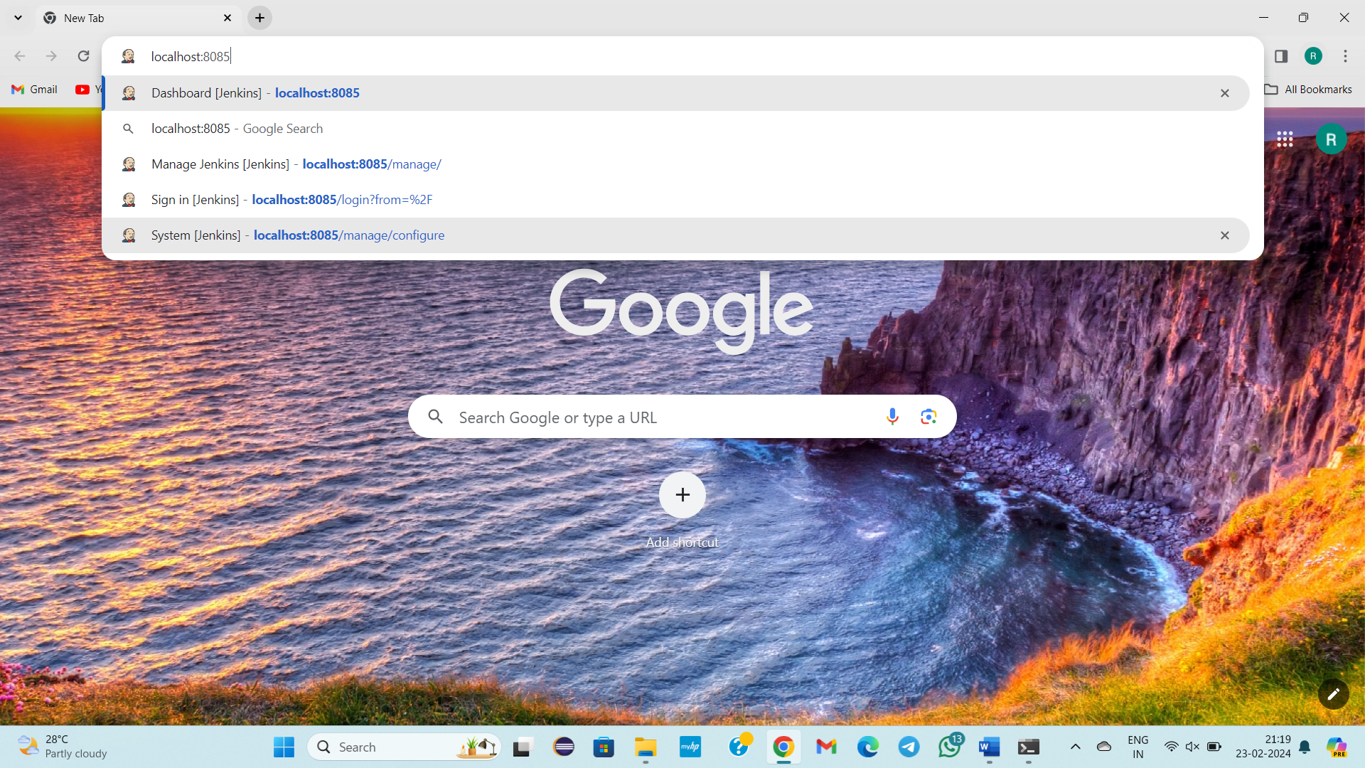

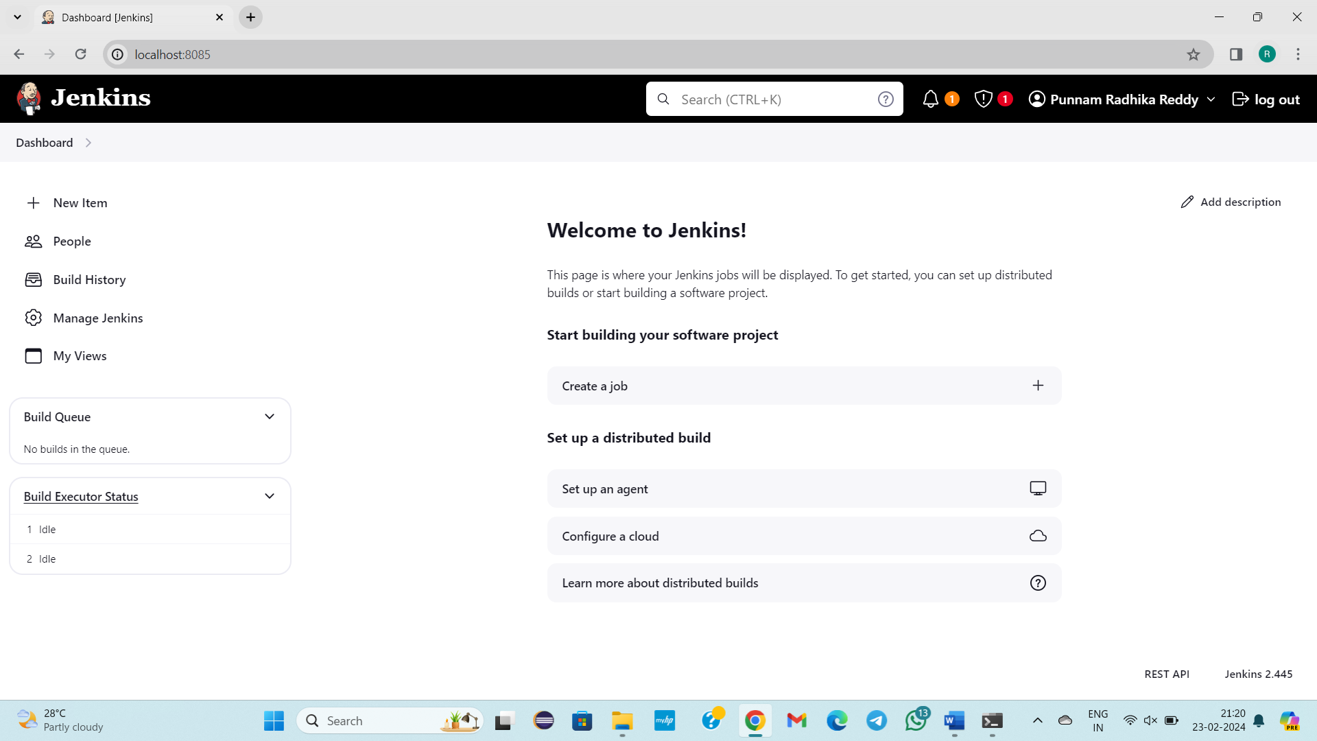

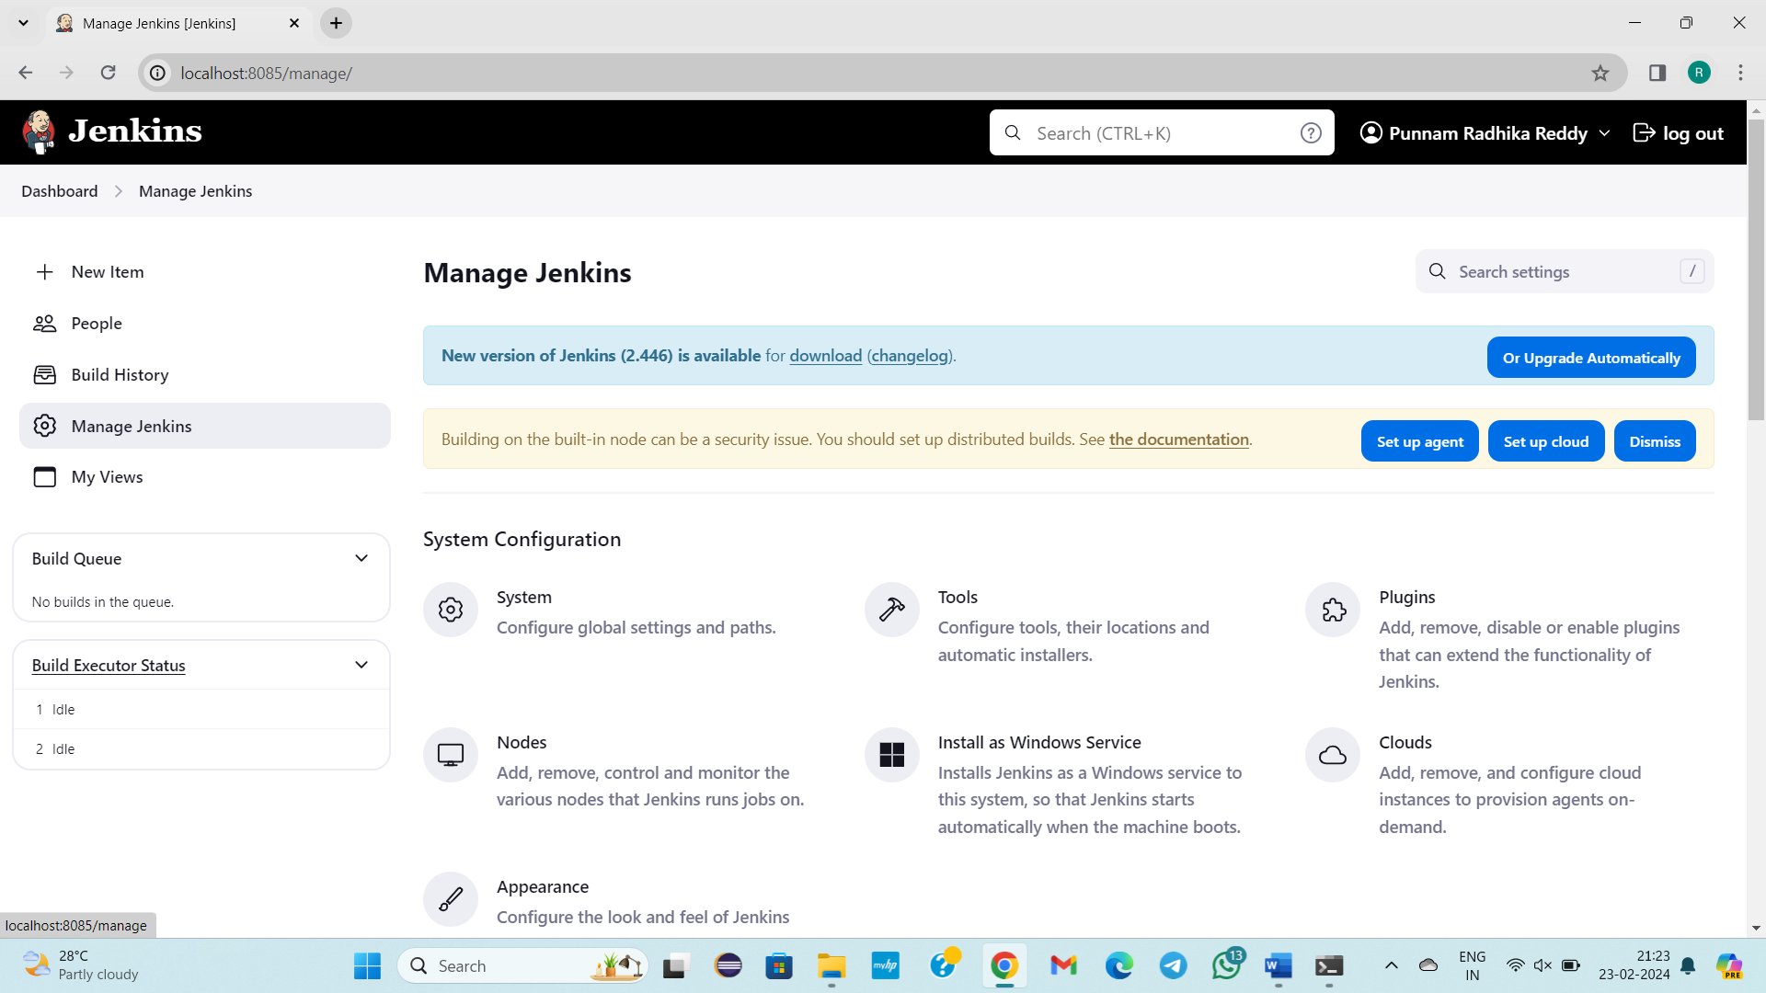

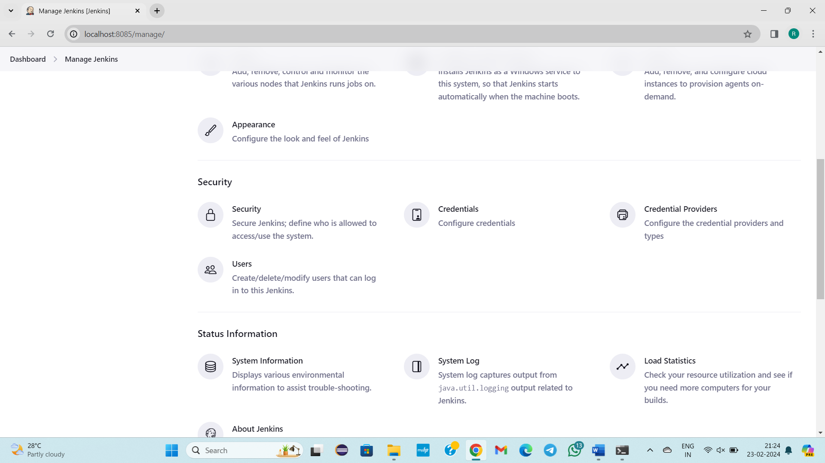

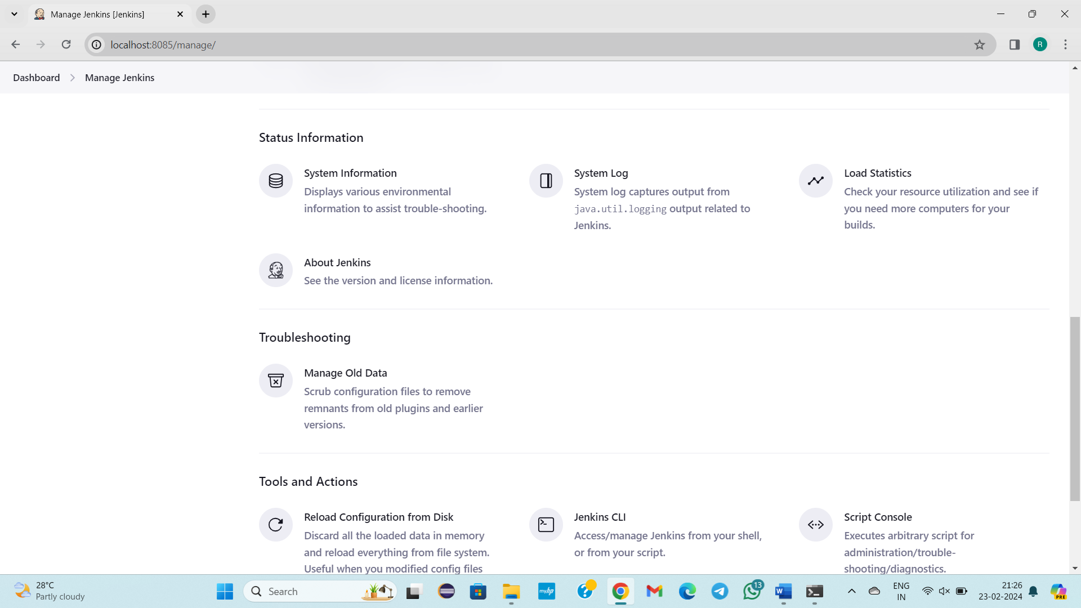

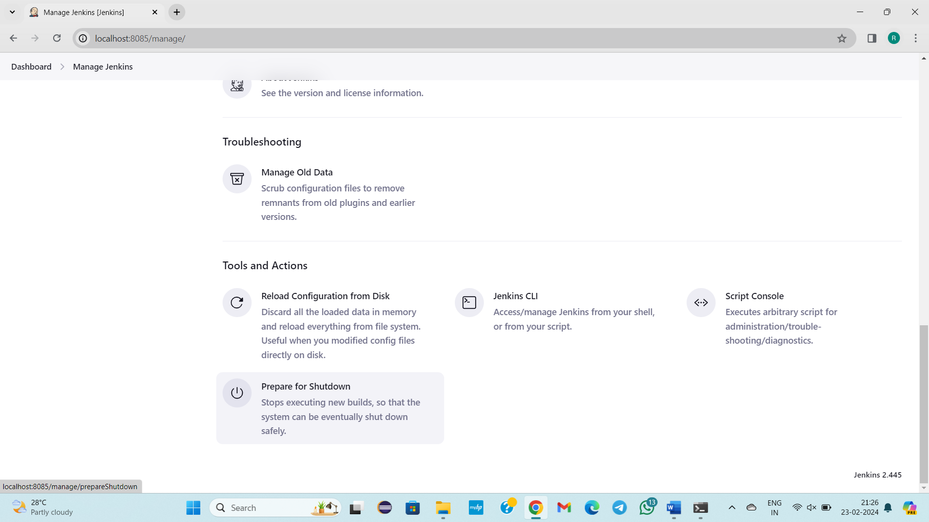

We will only learn system configuration and security

Firstly click on create a job.

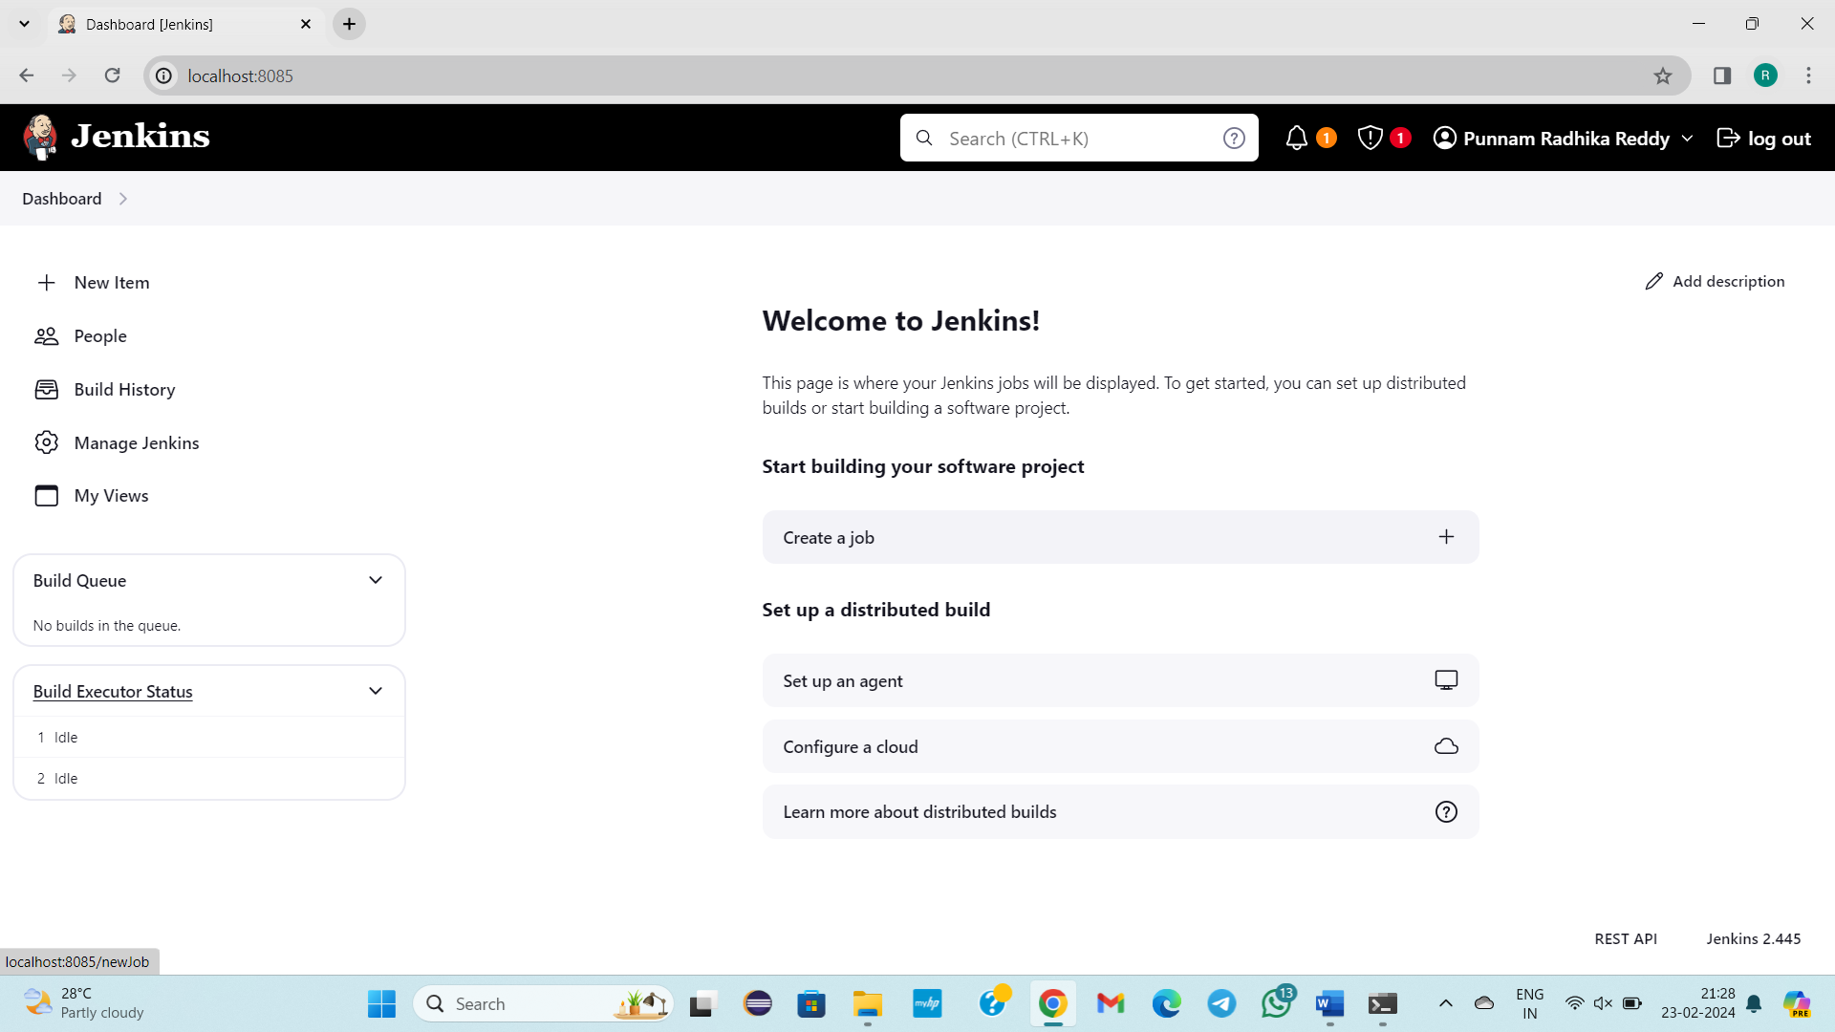

Job1🡪Free style project🡪ok

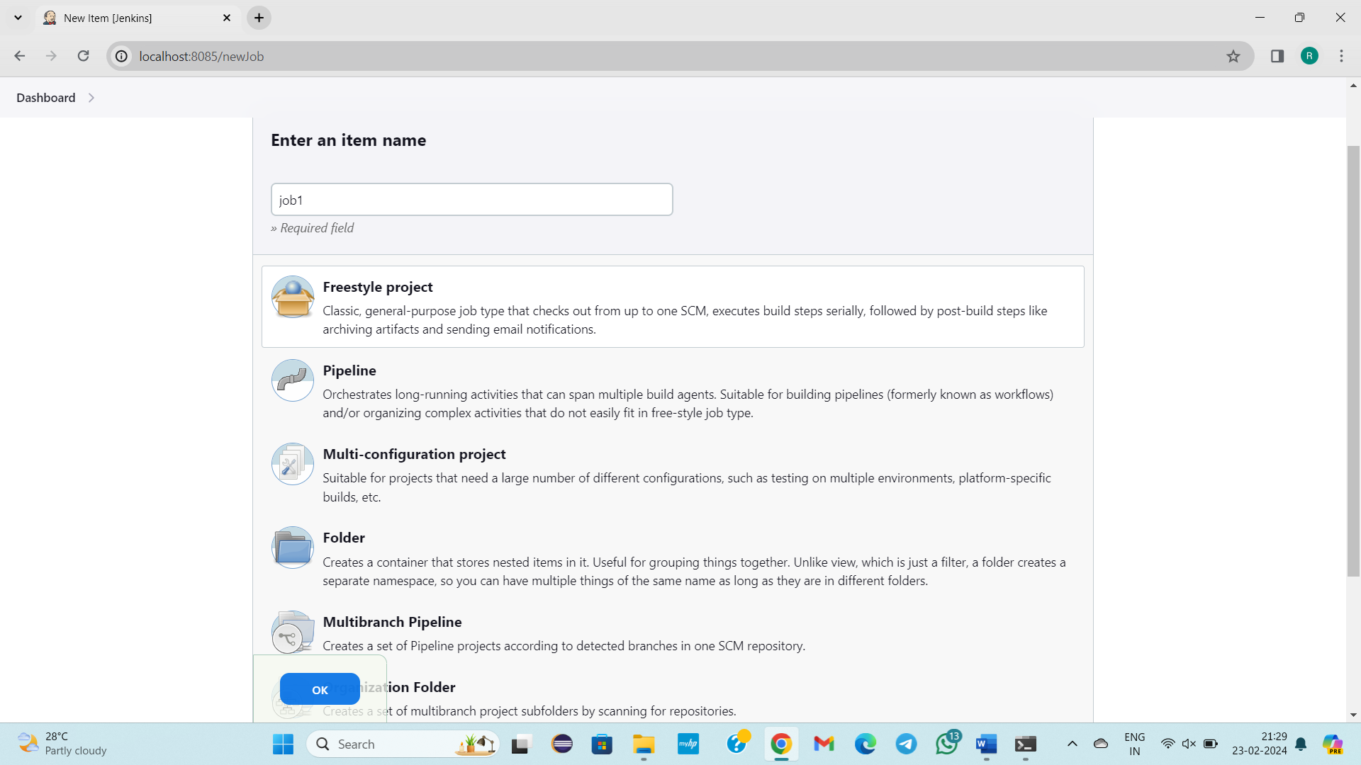

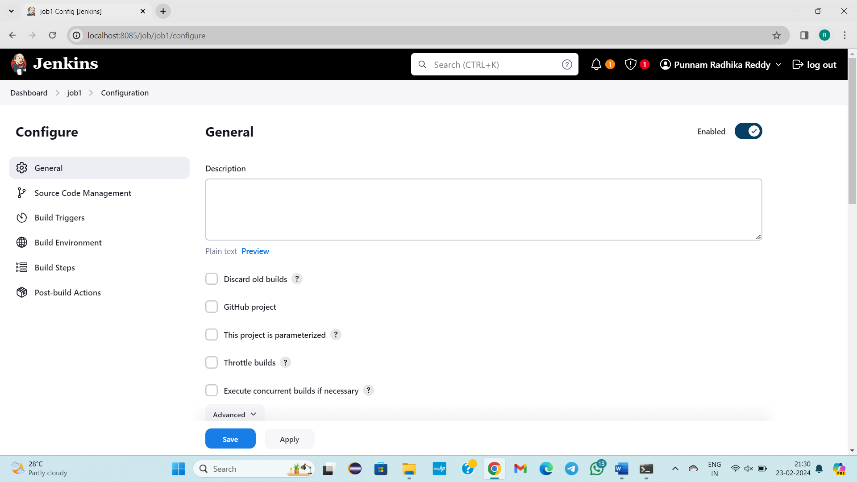

Just click on save

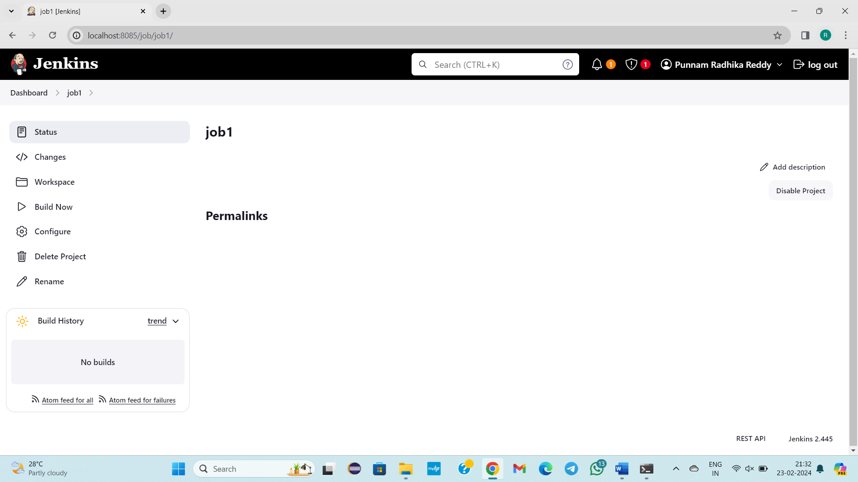

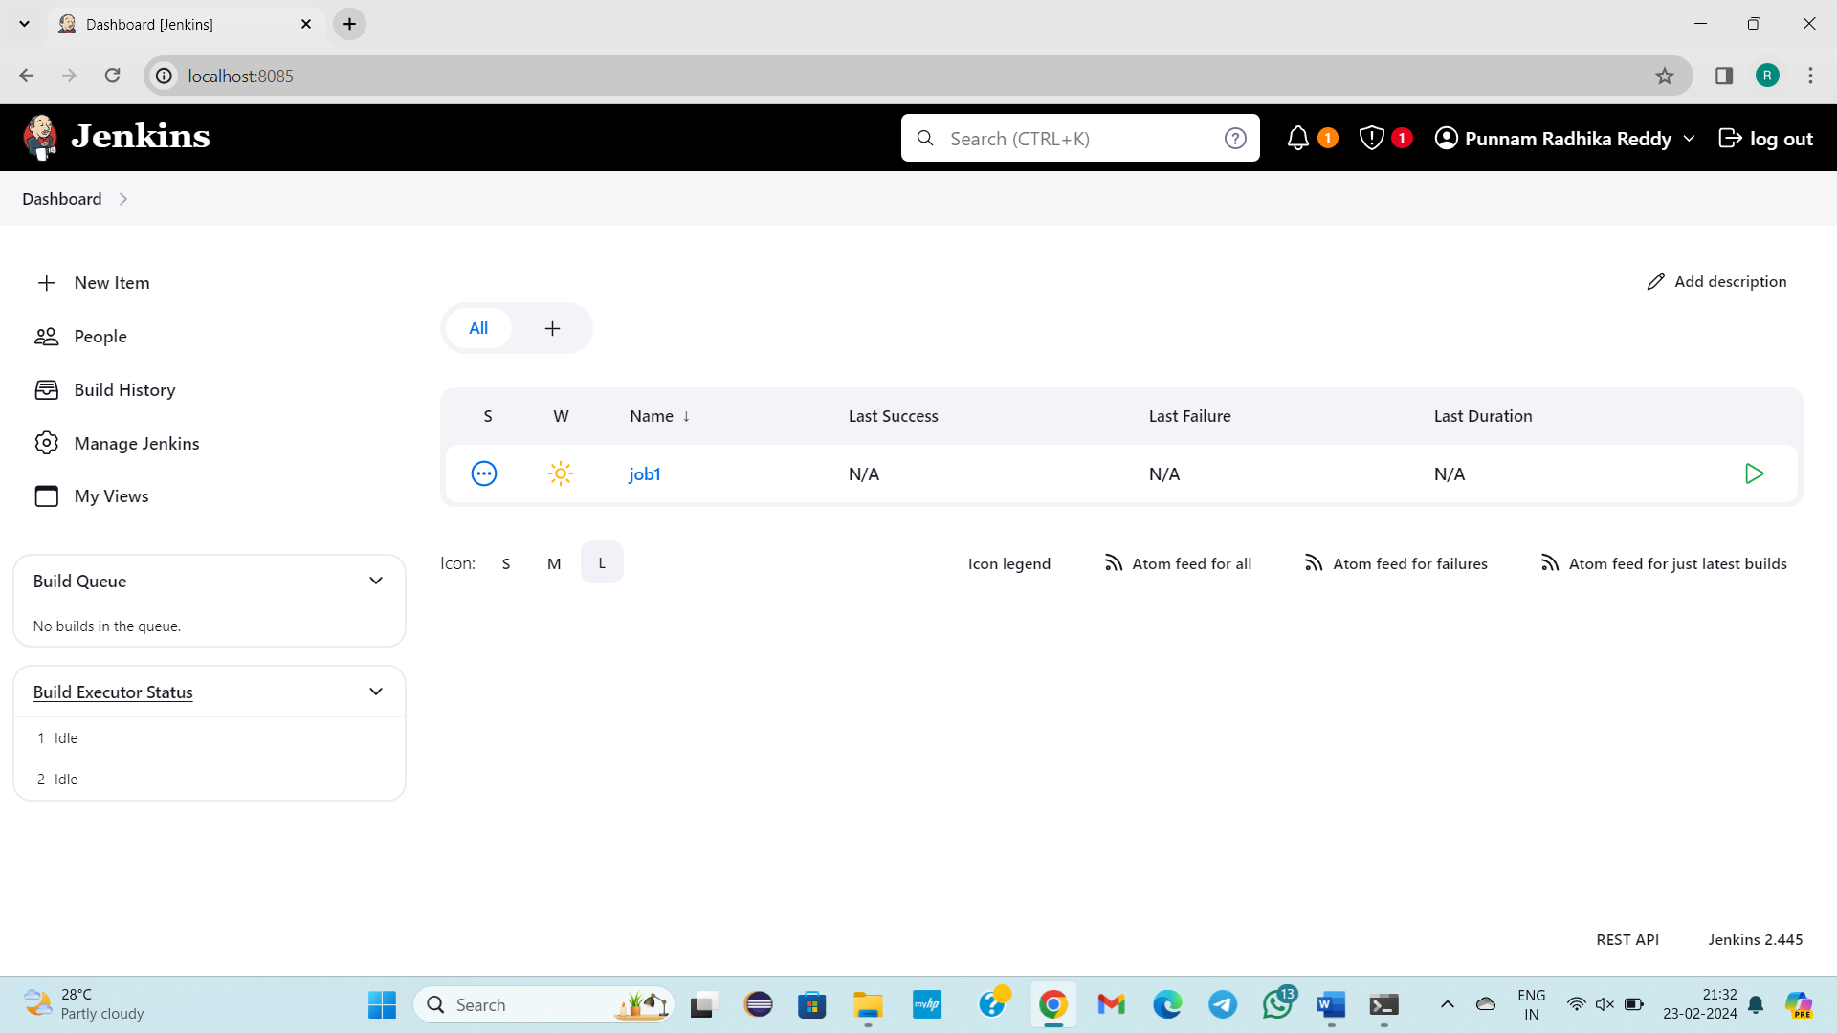

From 2 time how to create a job

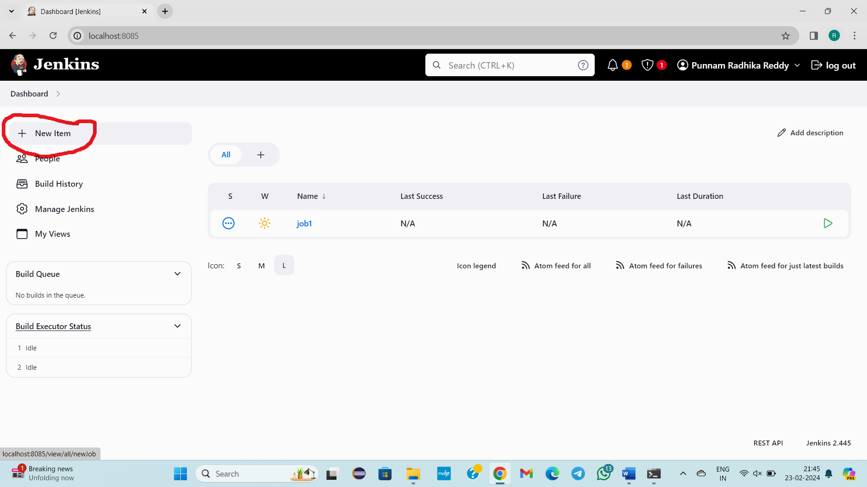

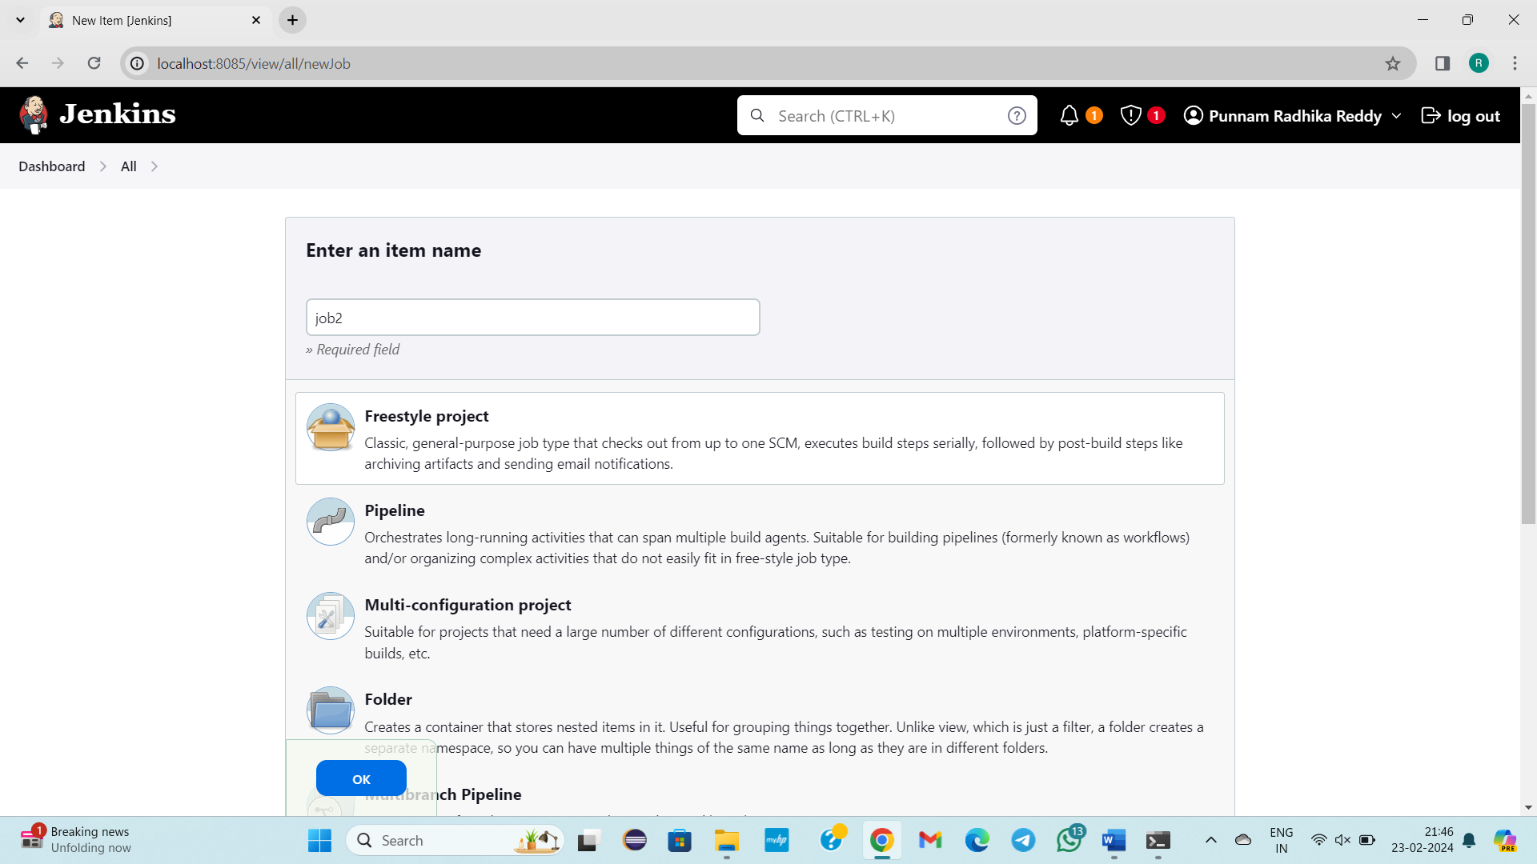

Click on ok

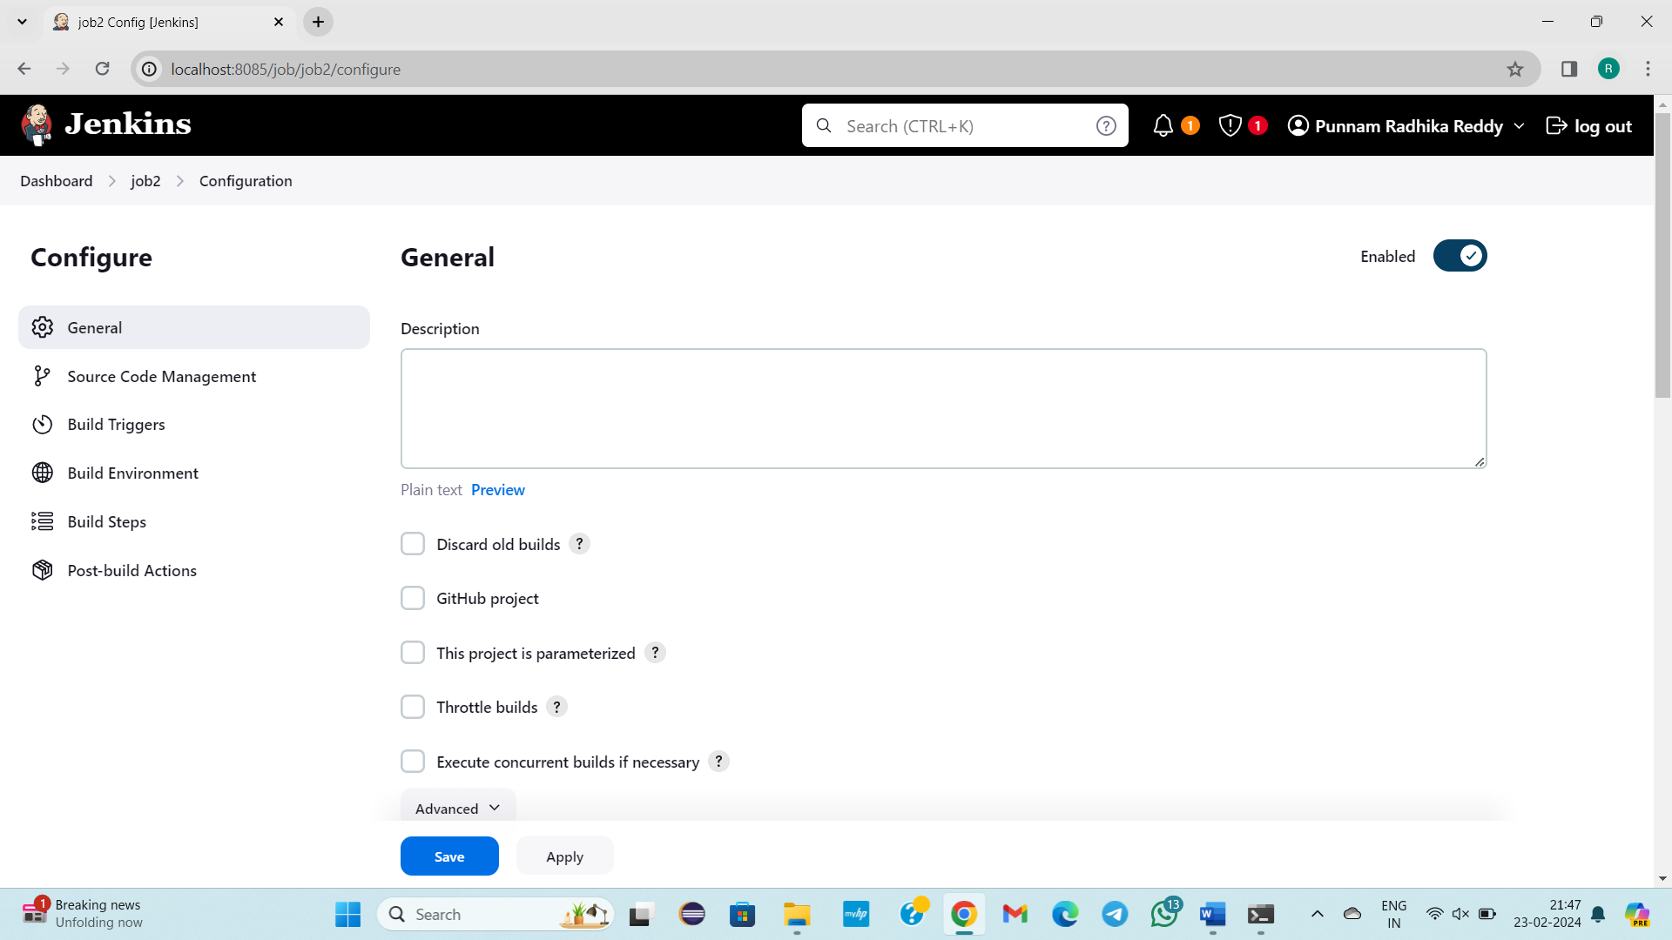

Click on save

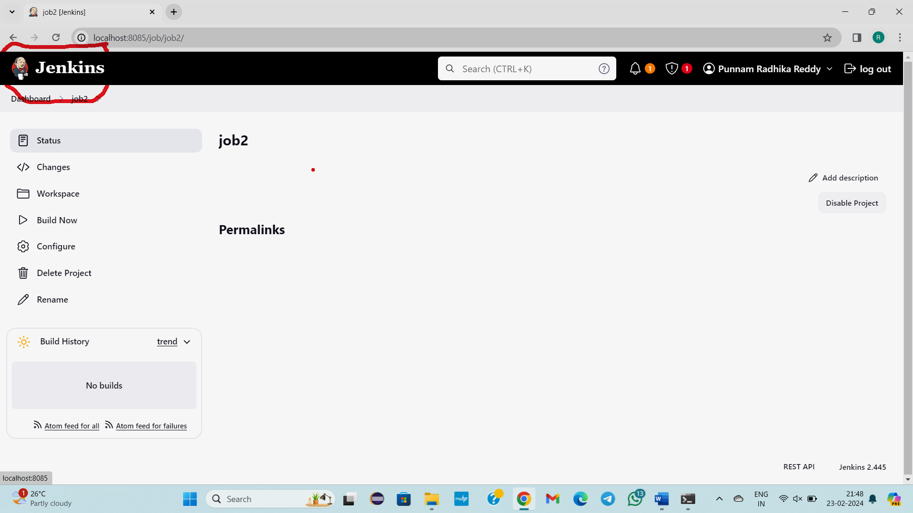

Click on Jenkins



I created 2 jobs freestyleproject jobs

I will run these jobs

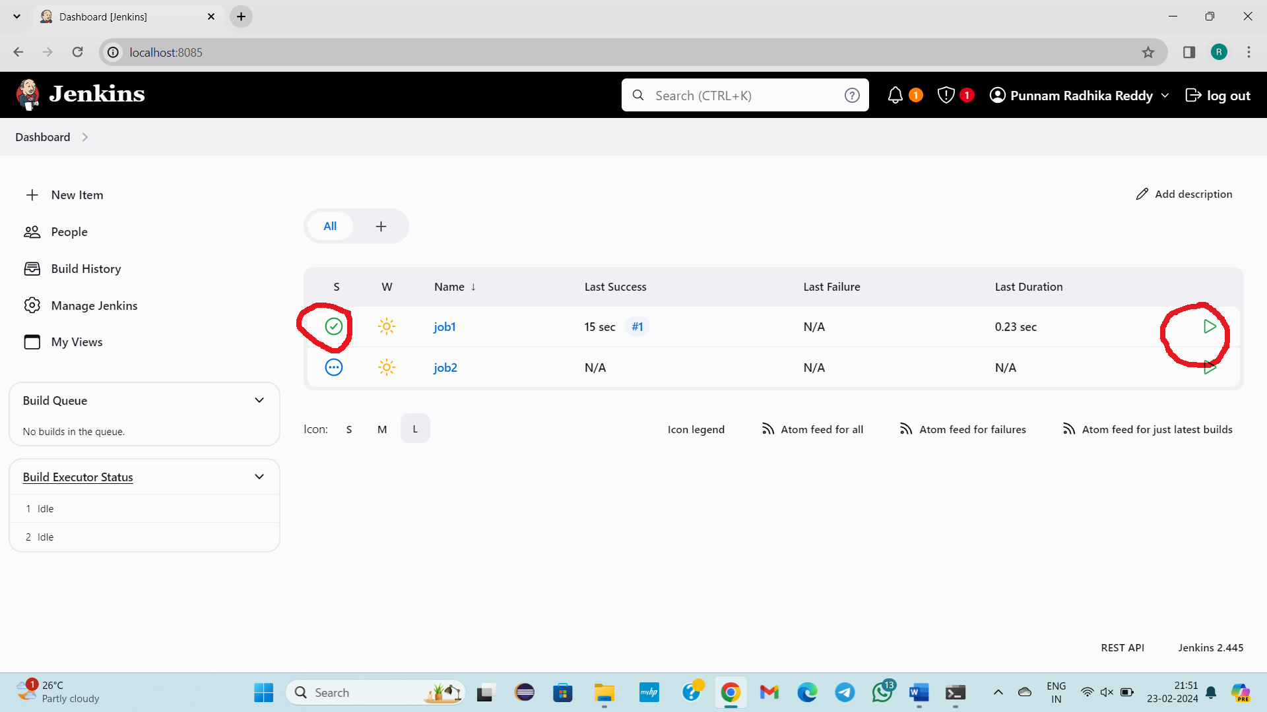

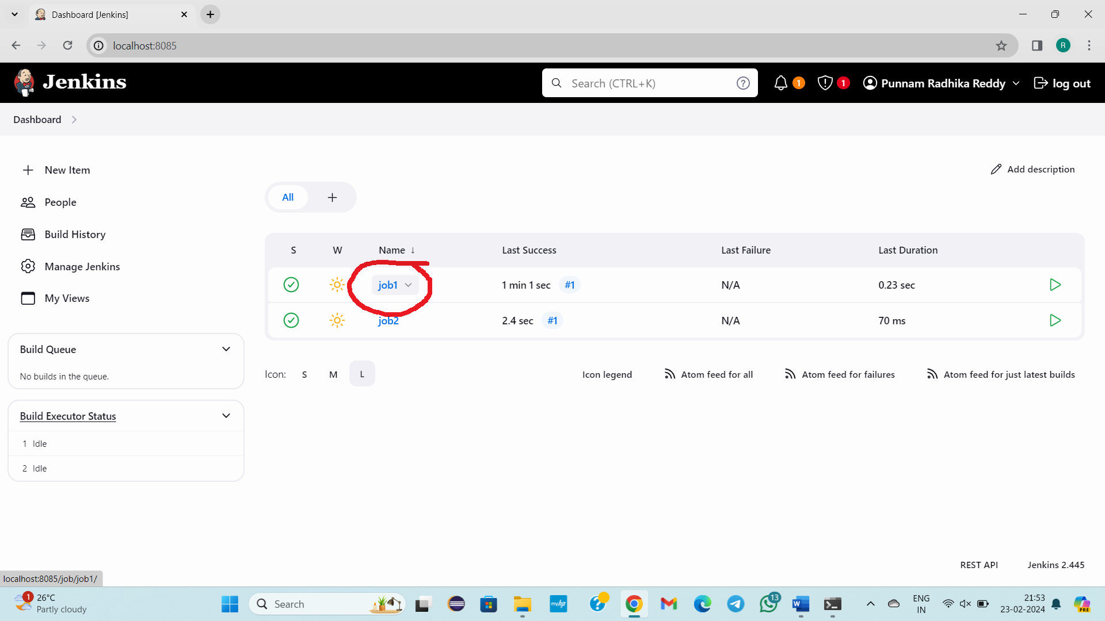

Click on job1

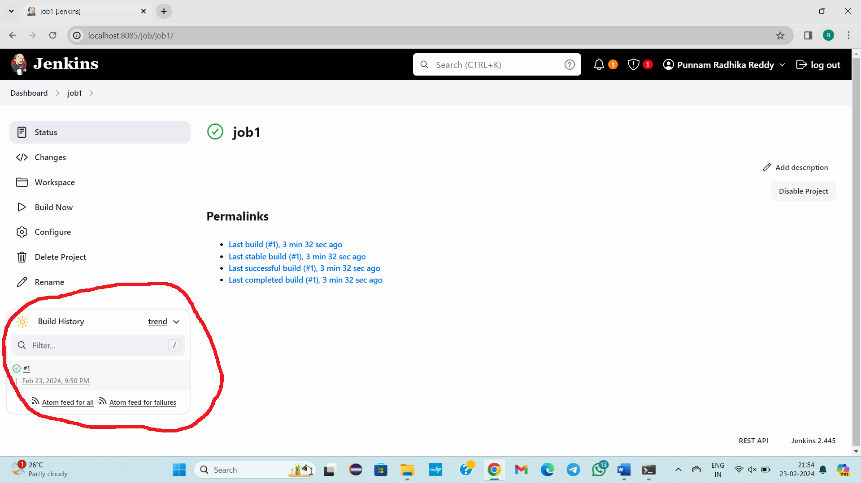

How many times job built is shown in above figure

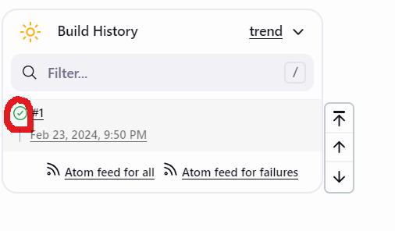

To see output click on green mark

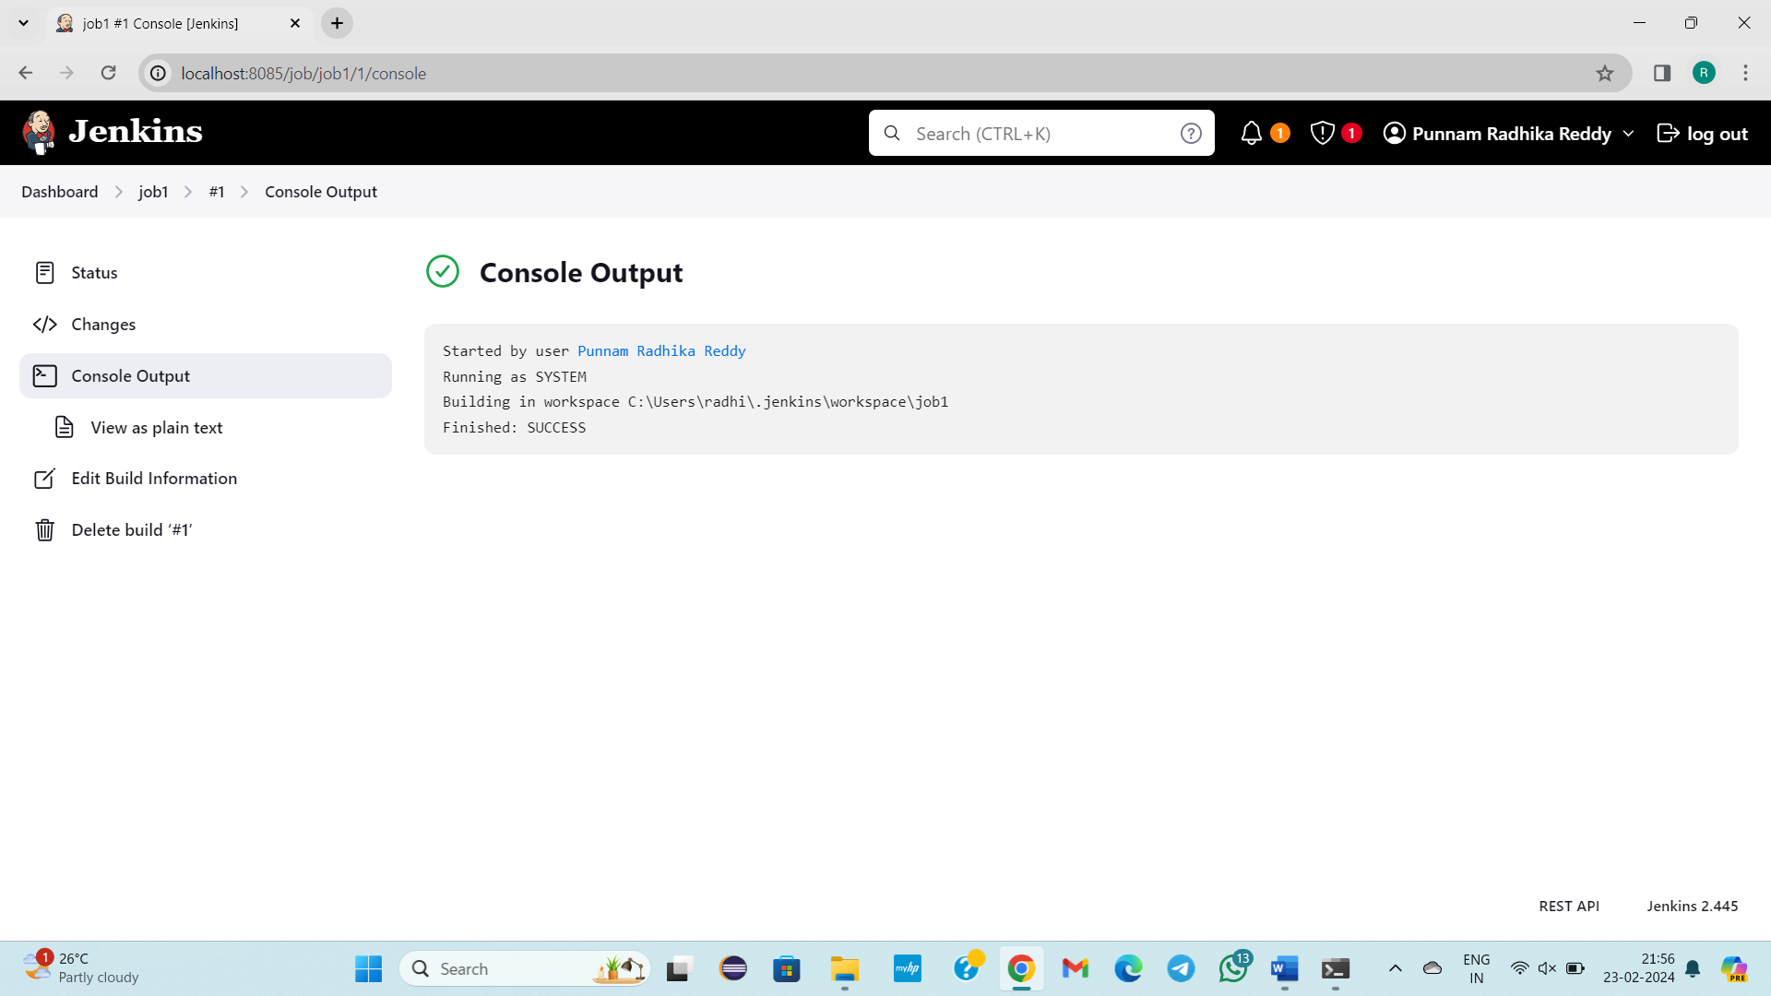

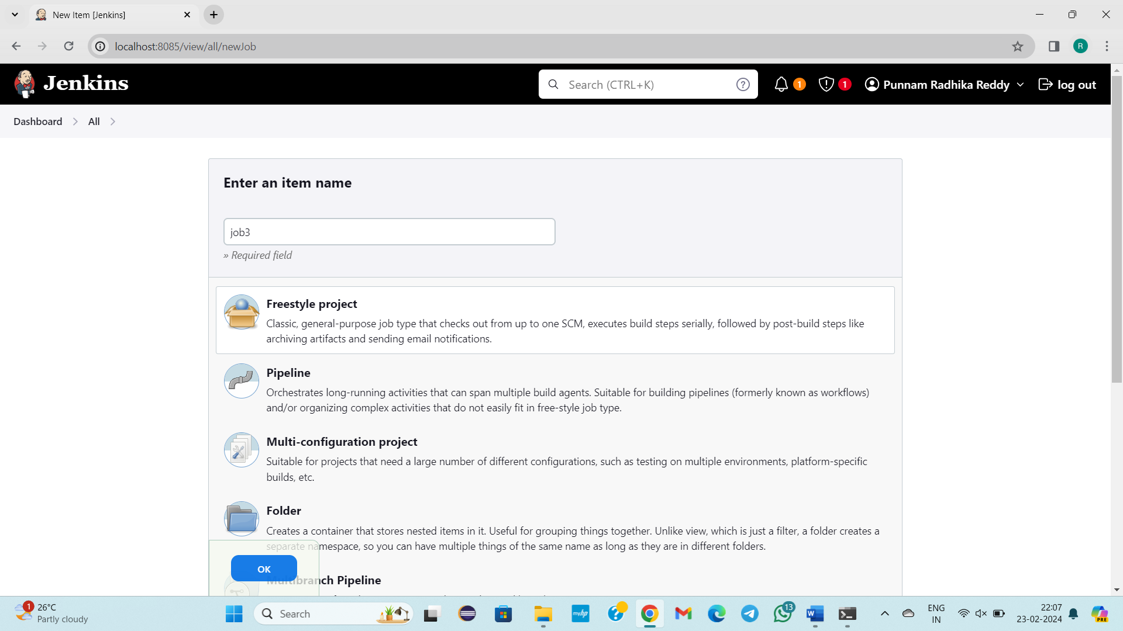

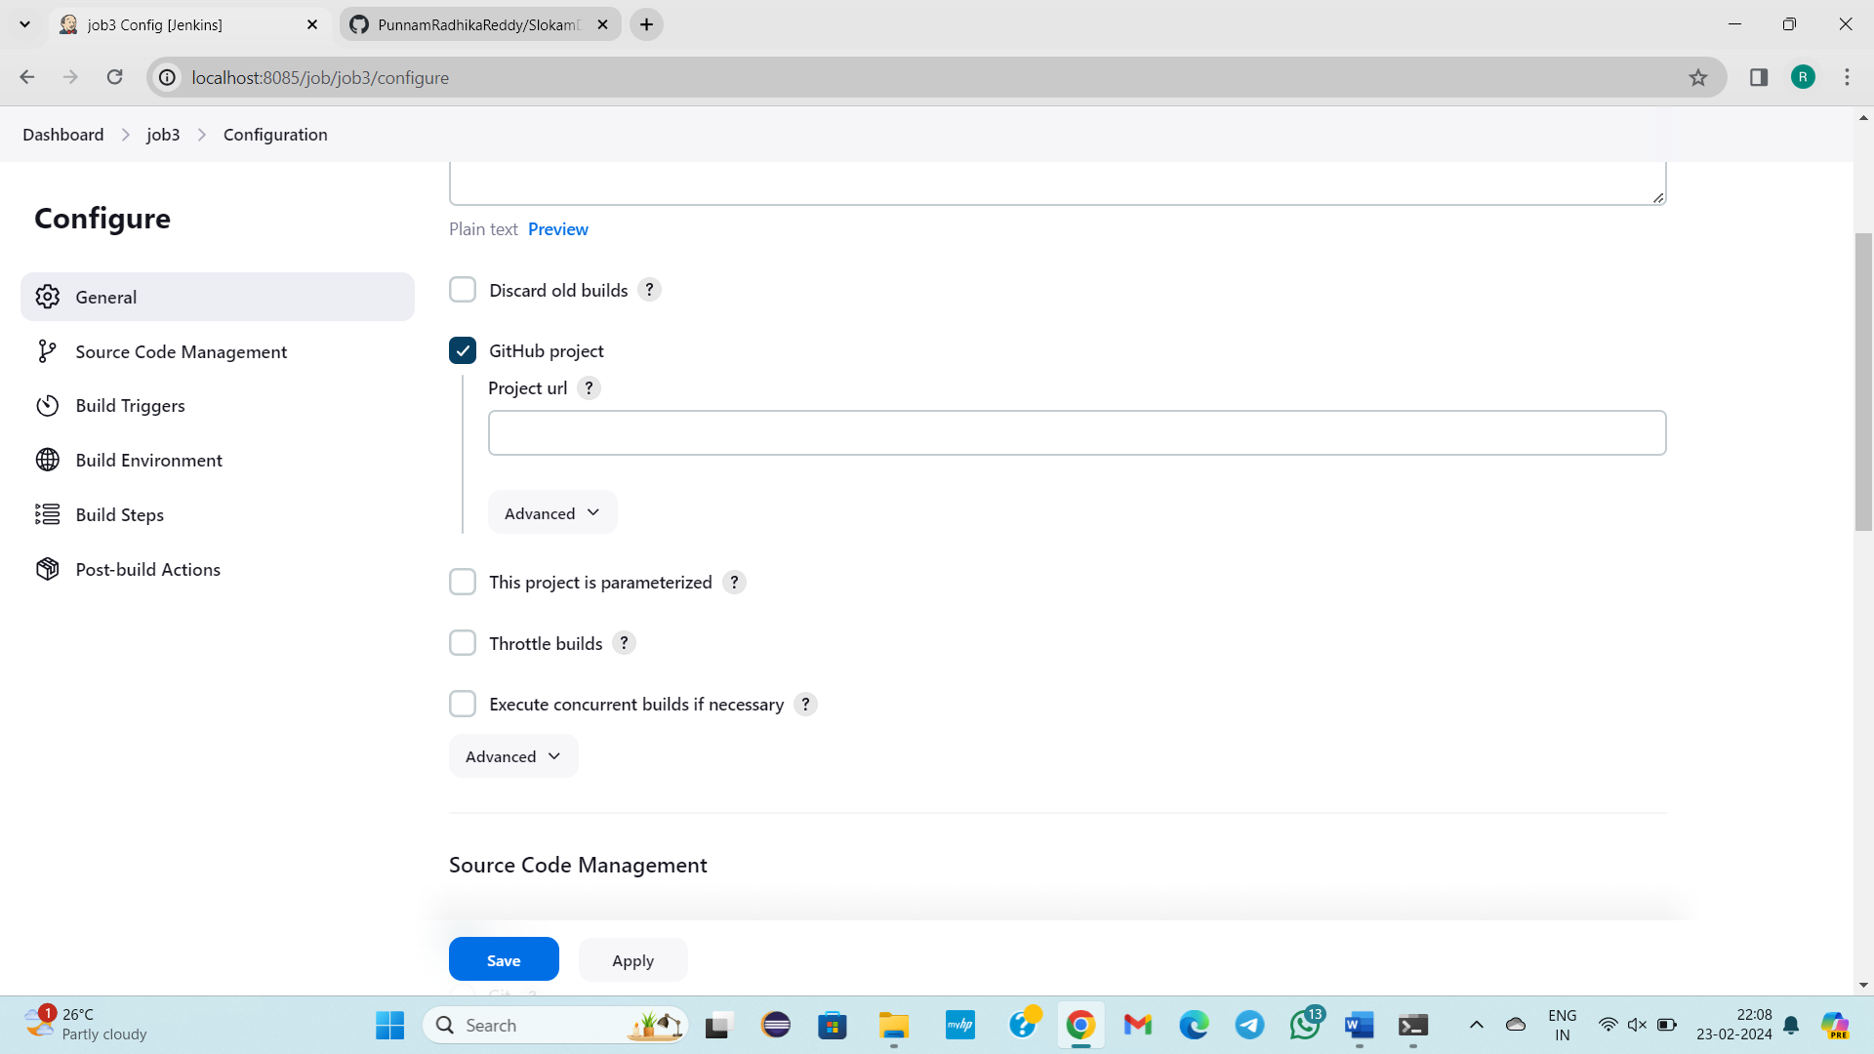

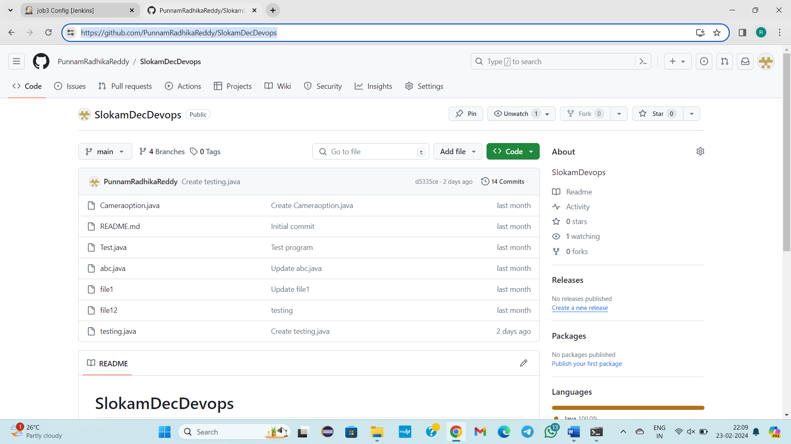

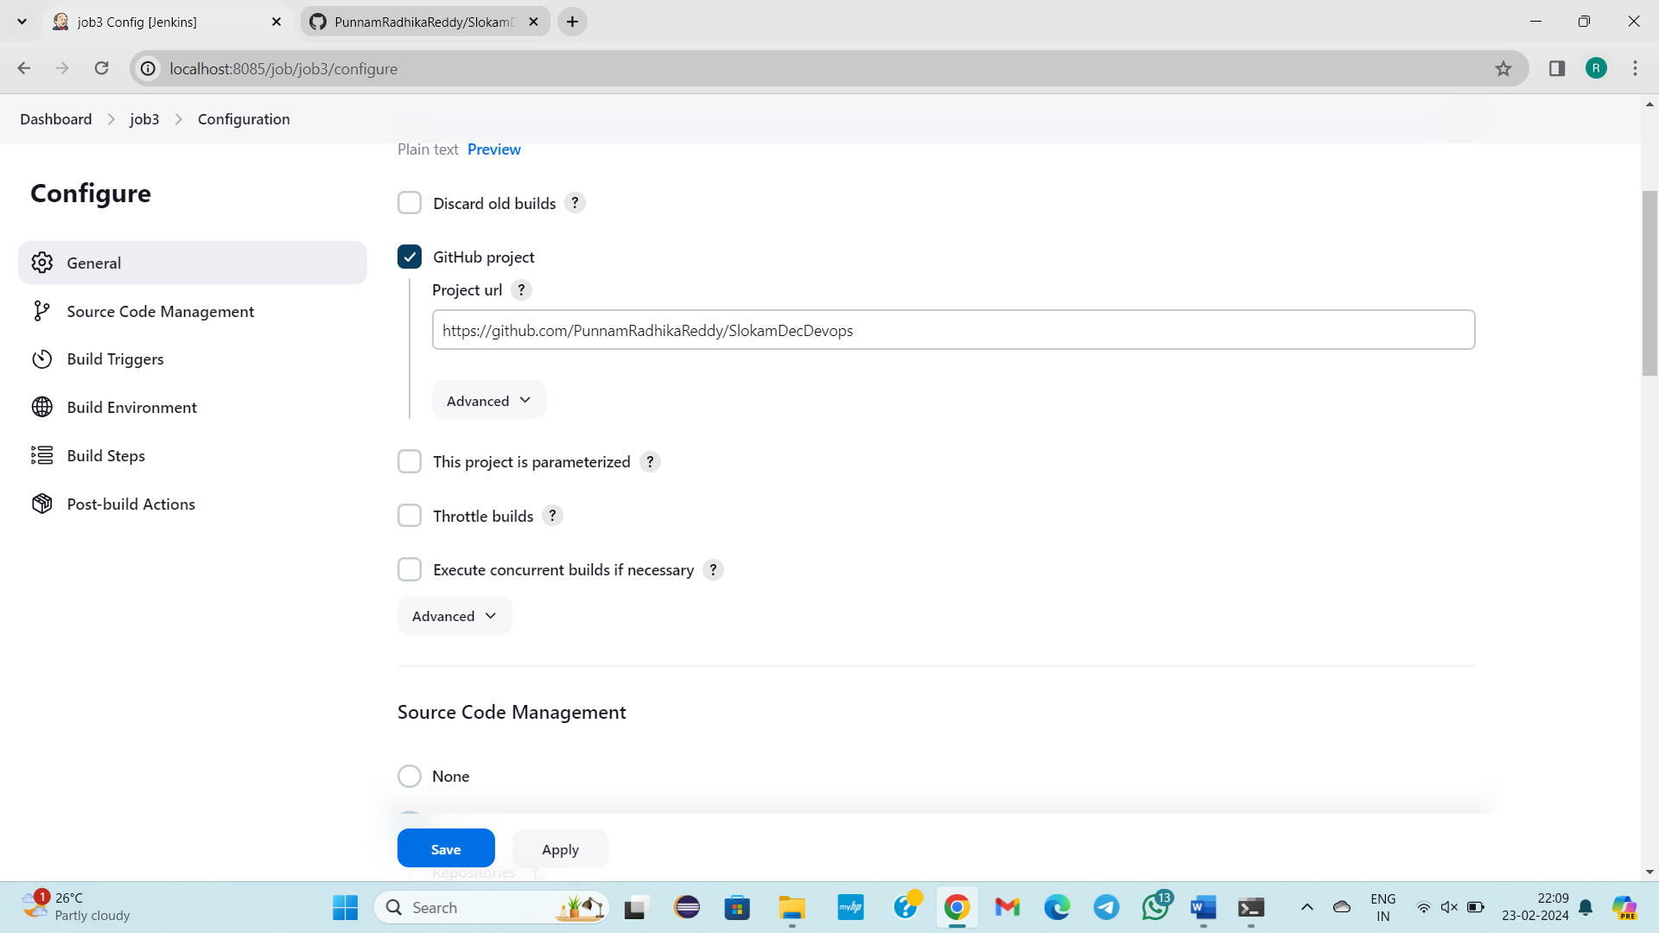

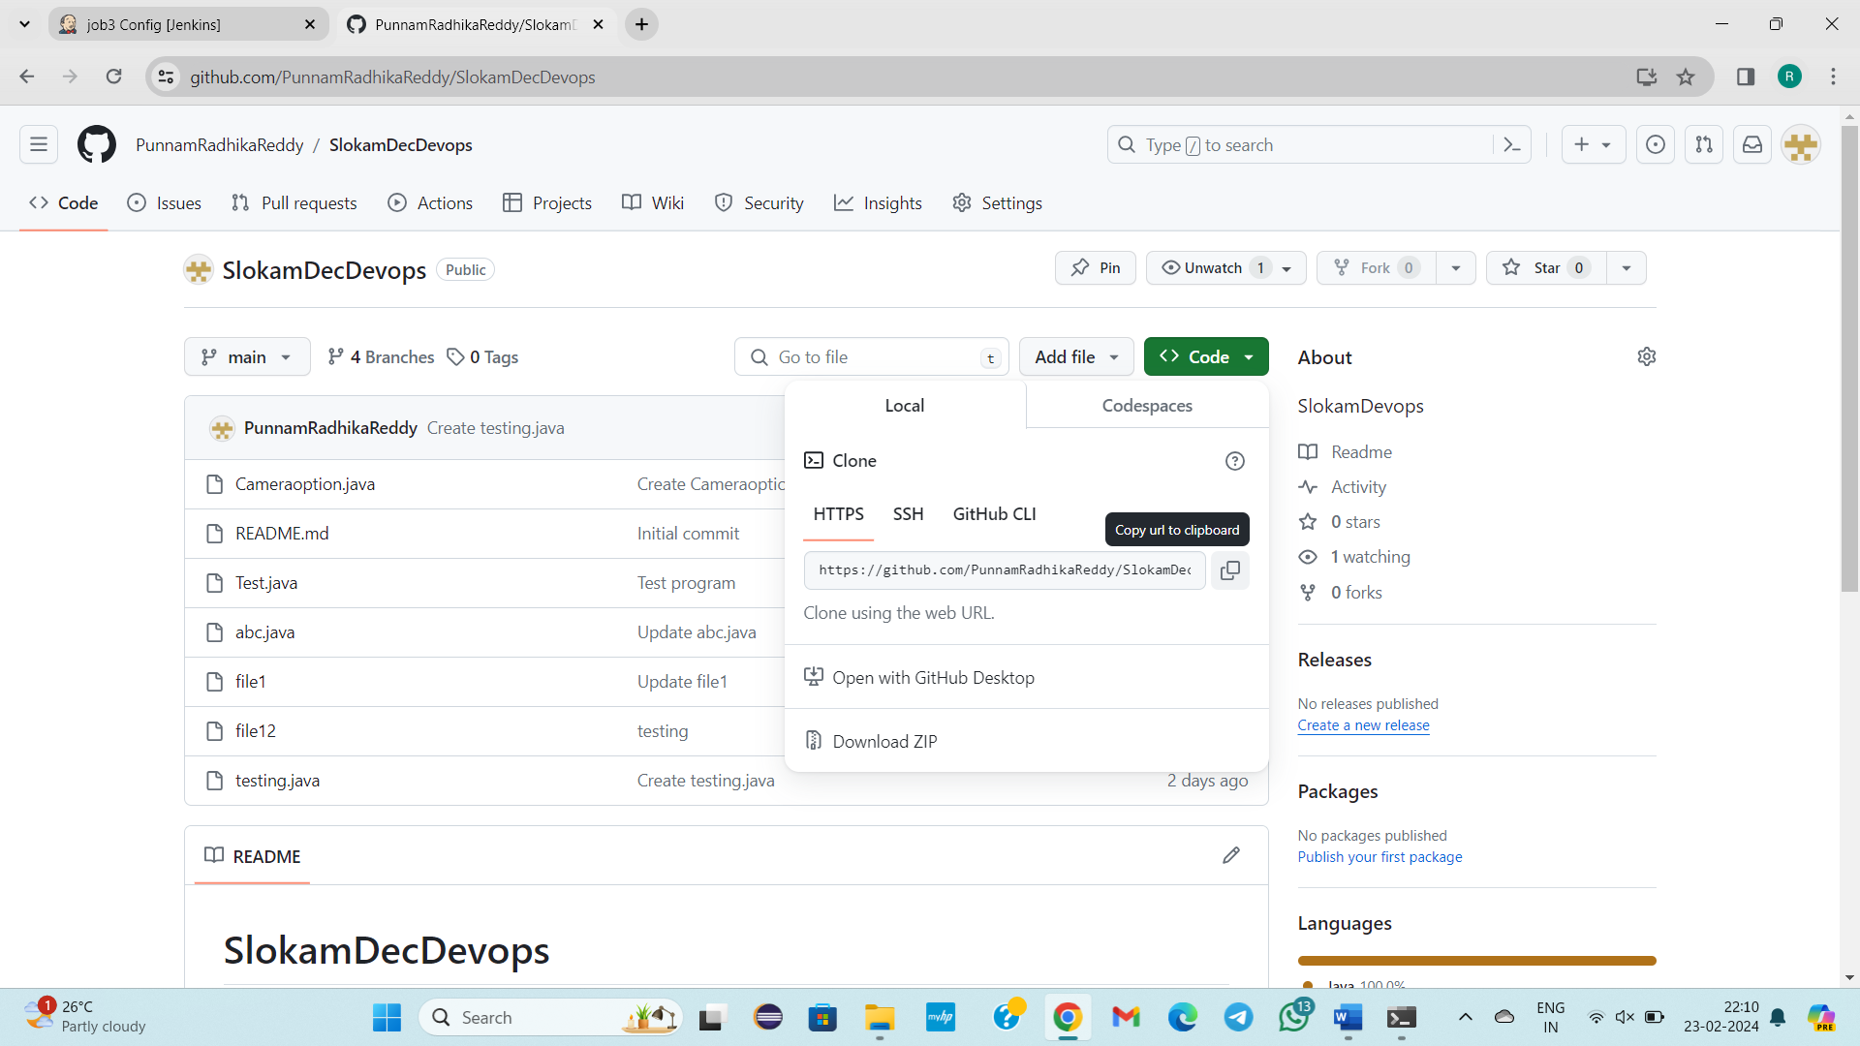

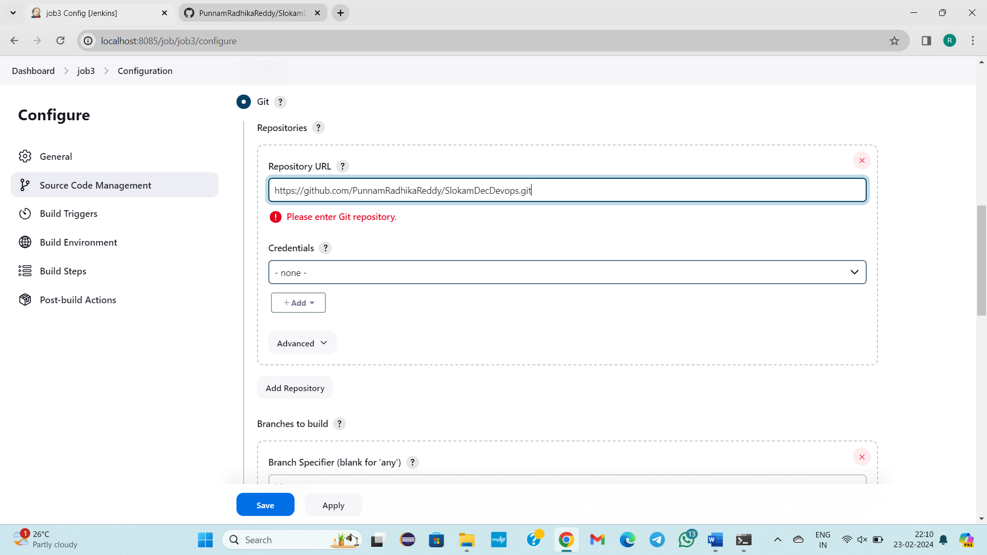

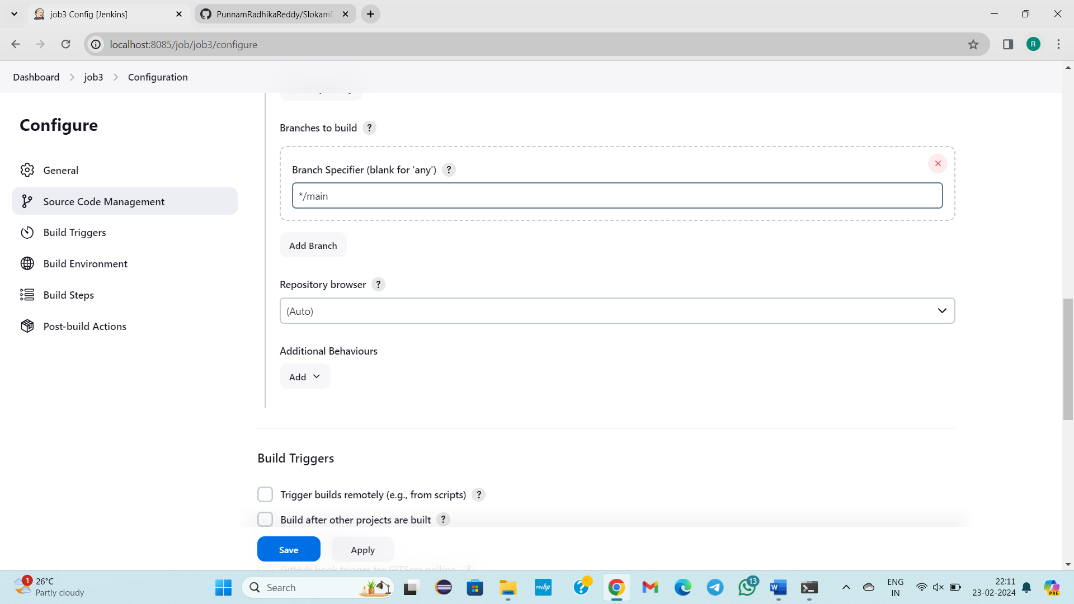

Click on save

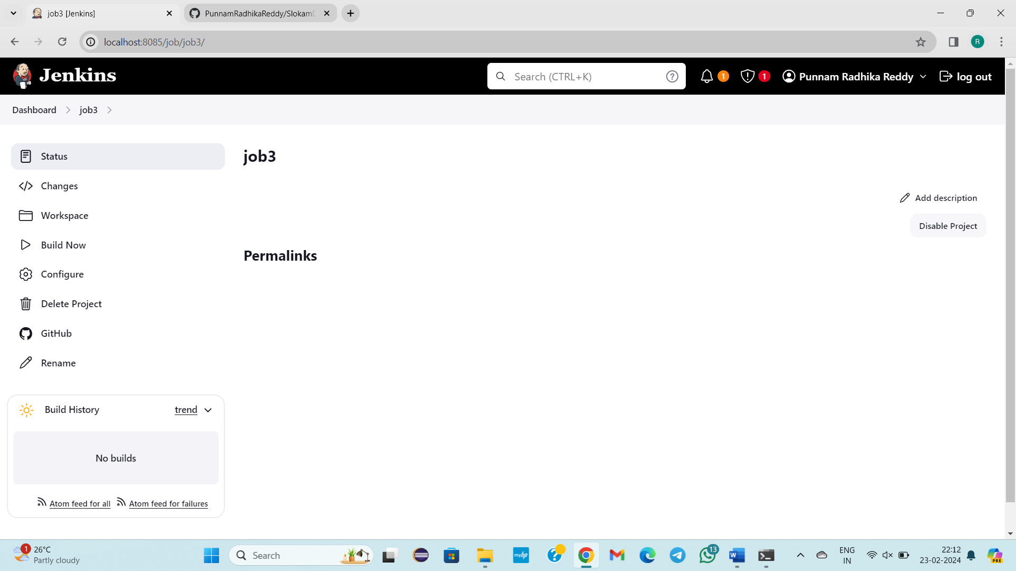

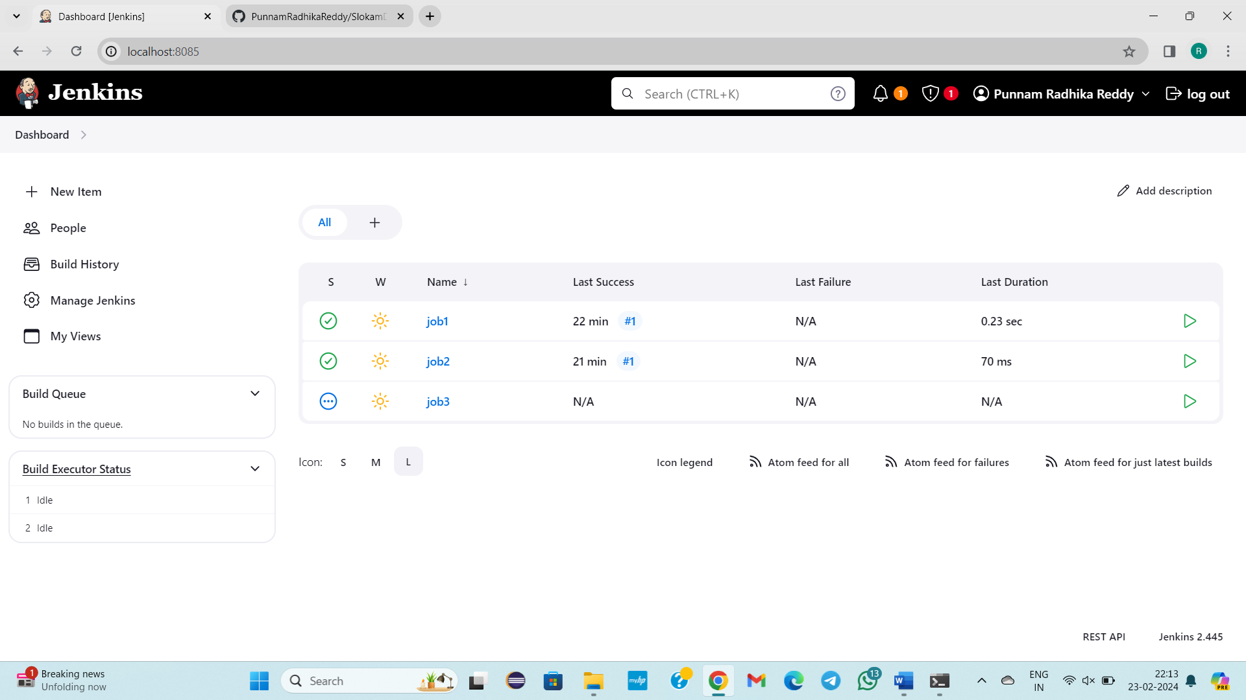

Now build job 3

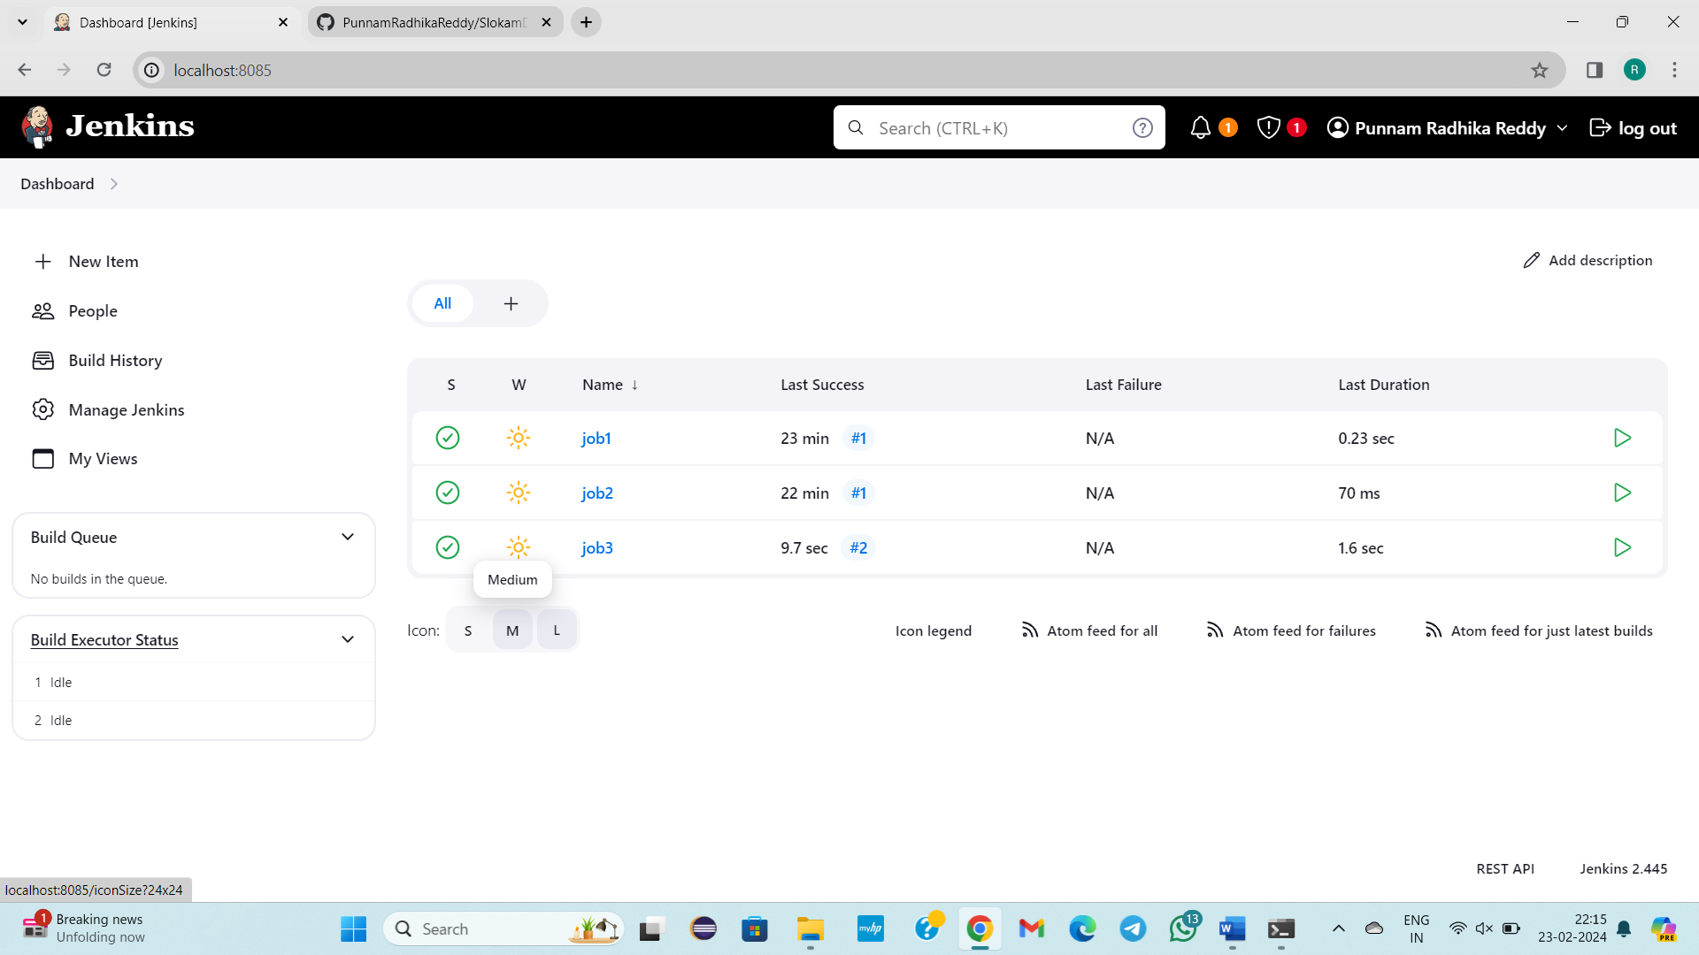

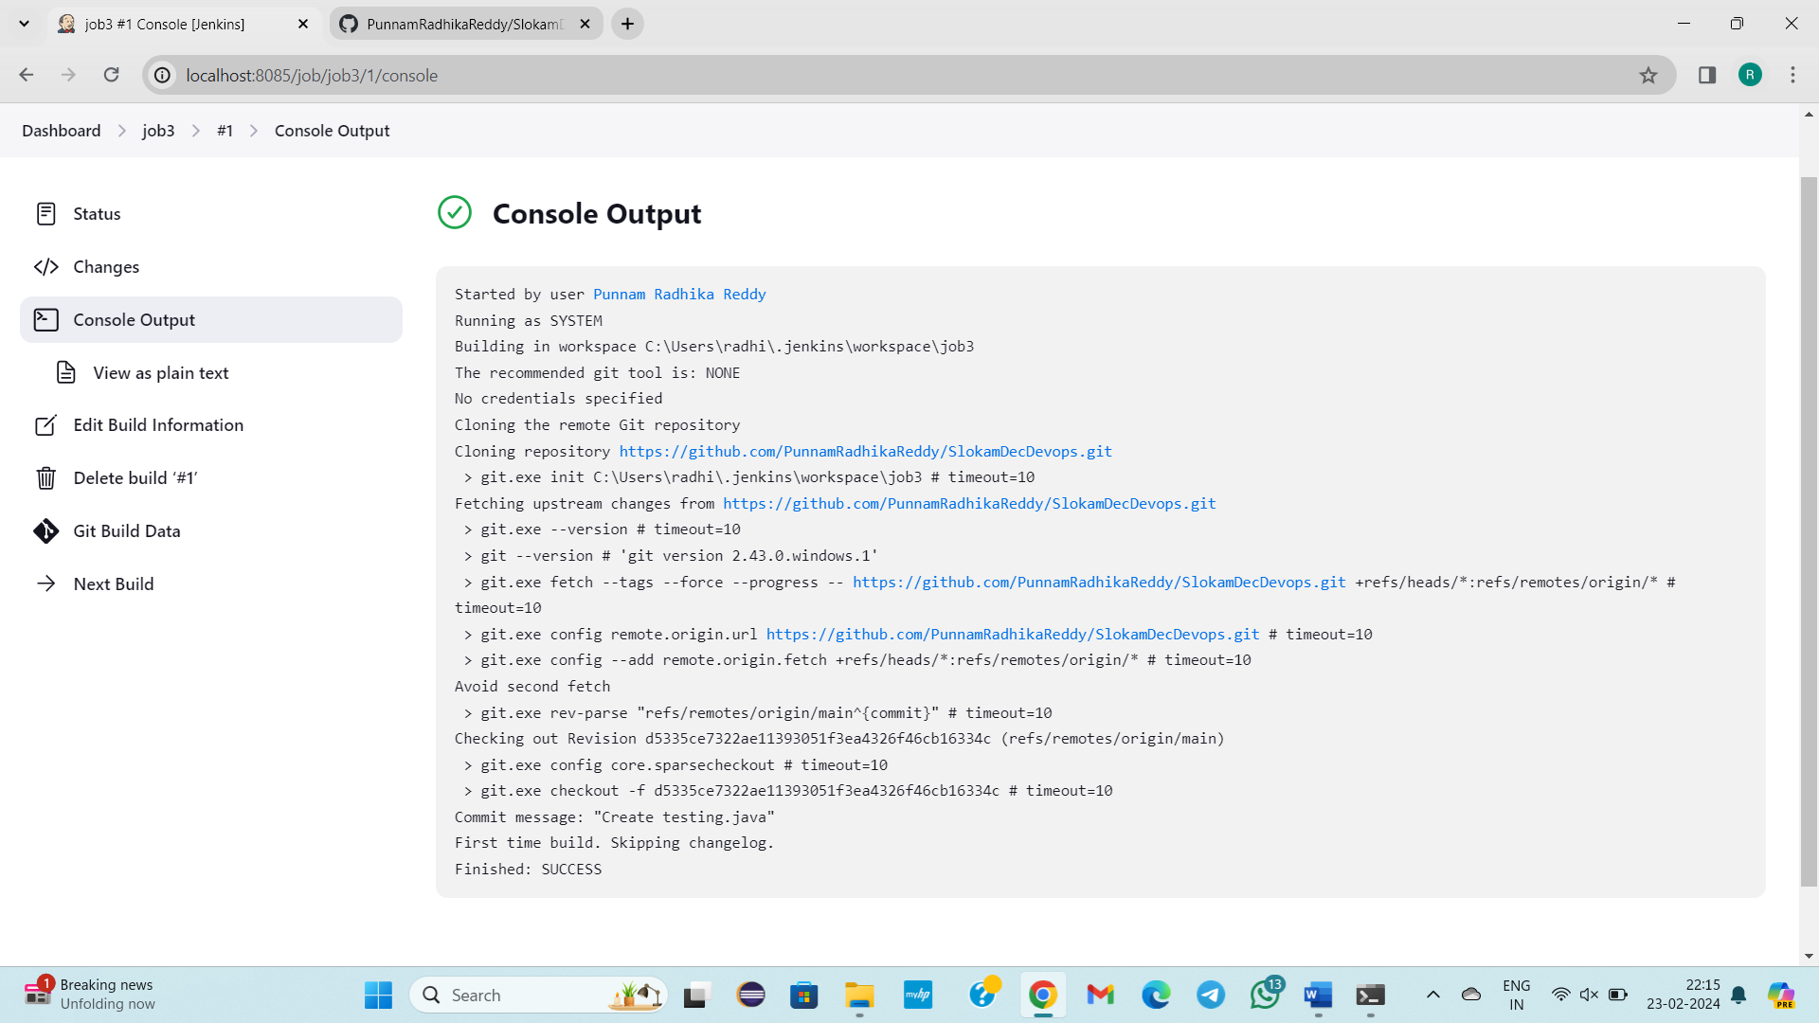

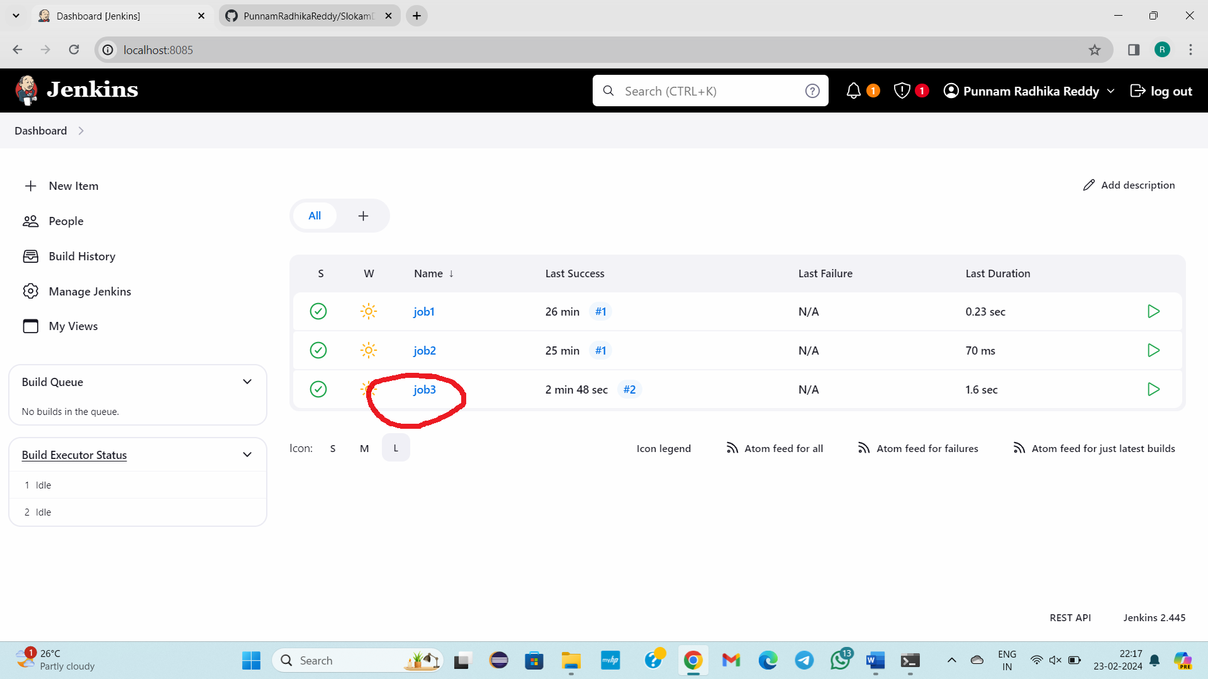

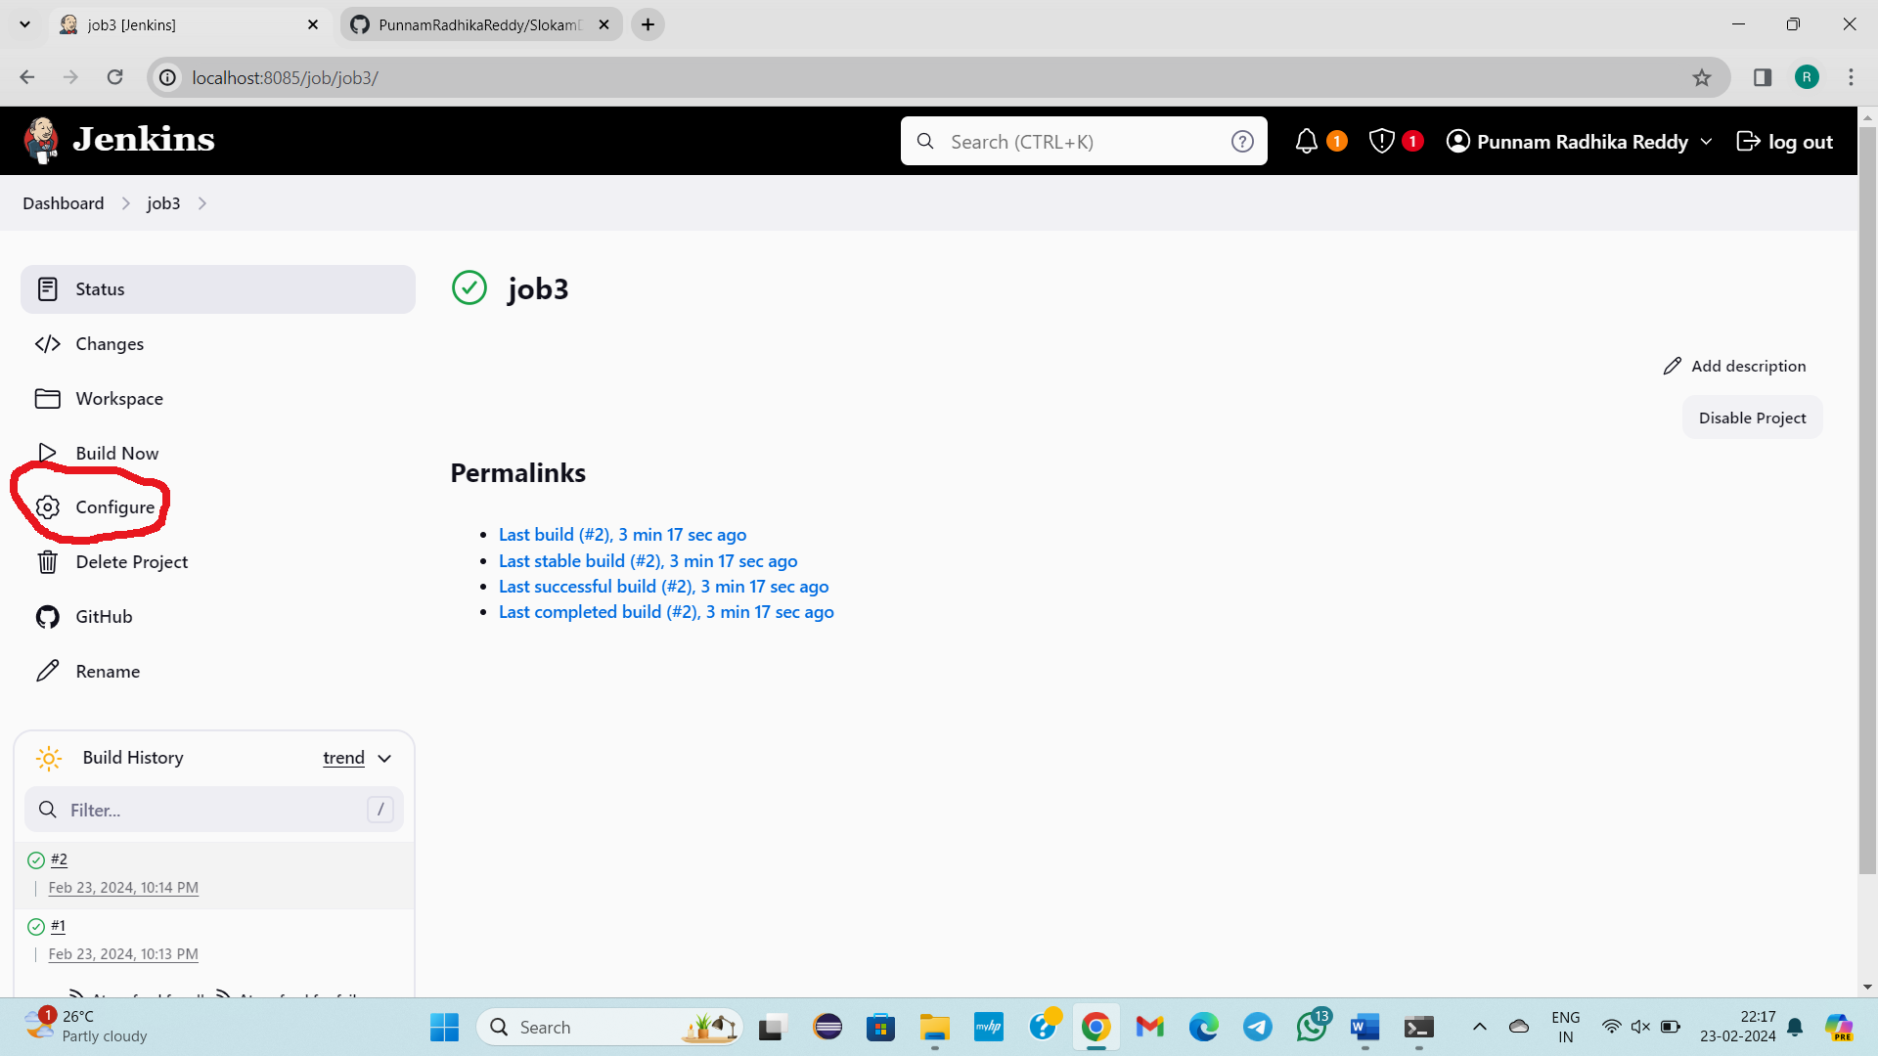

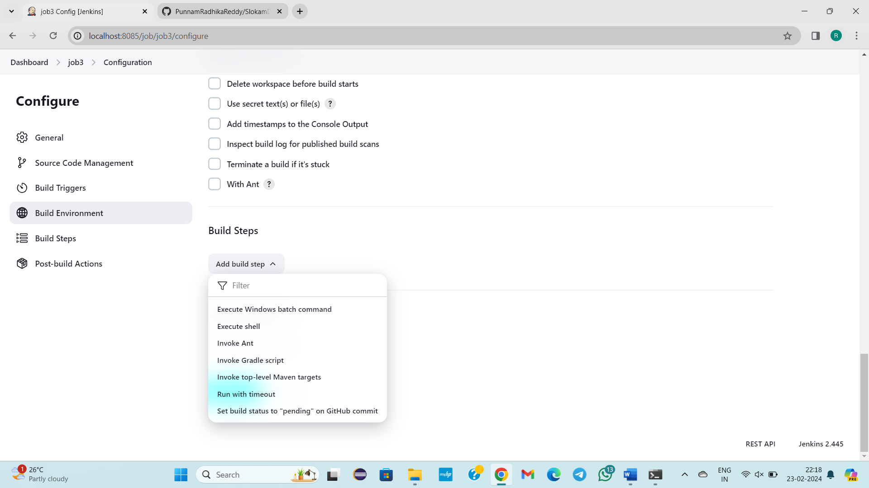

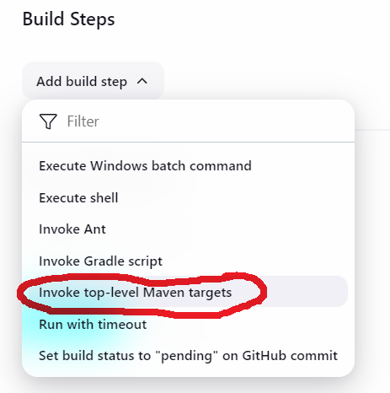

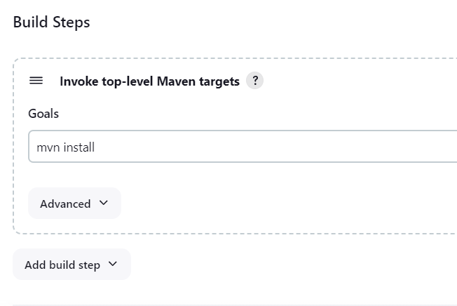

Click on save

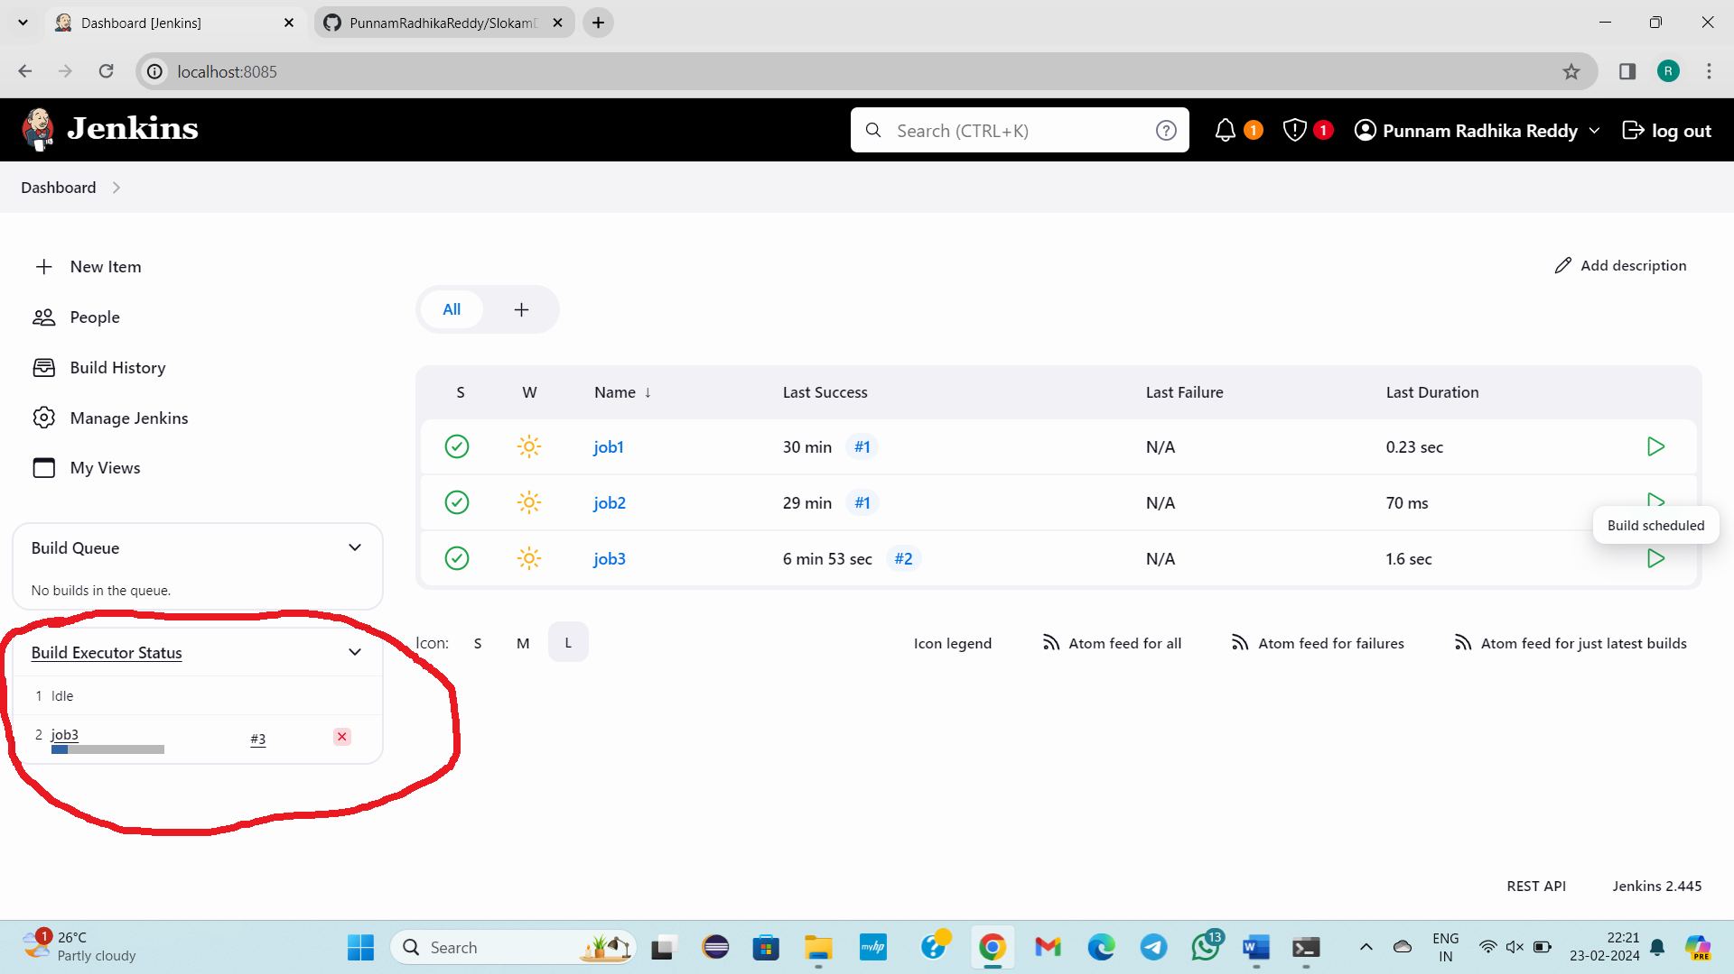

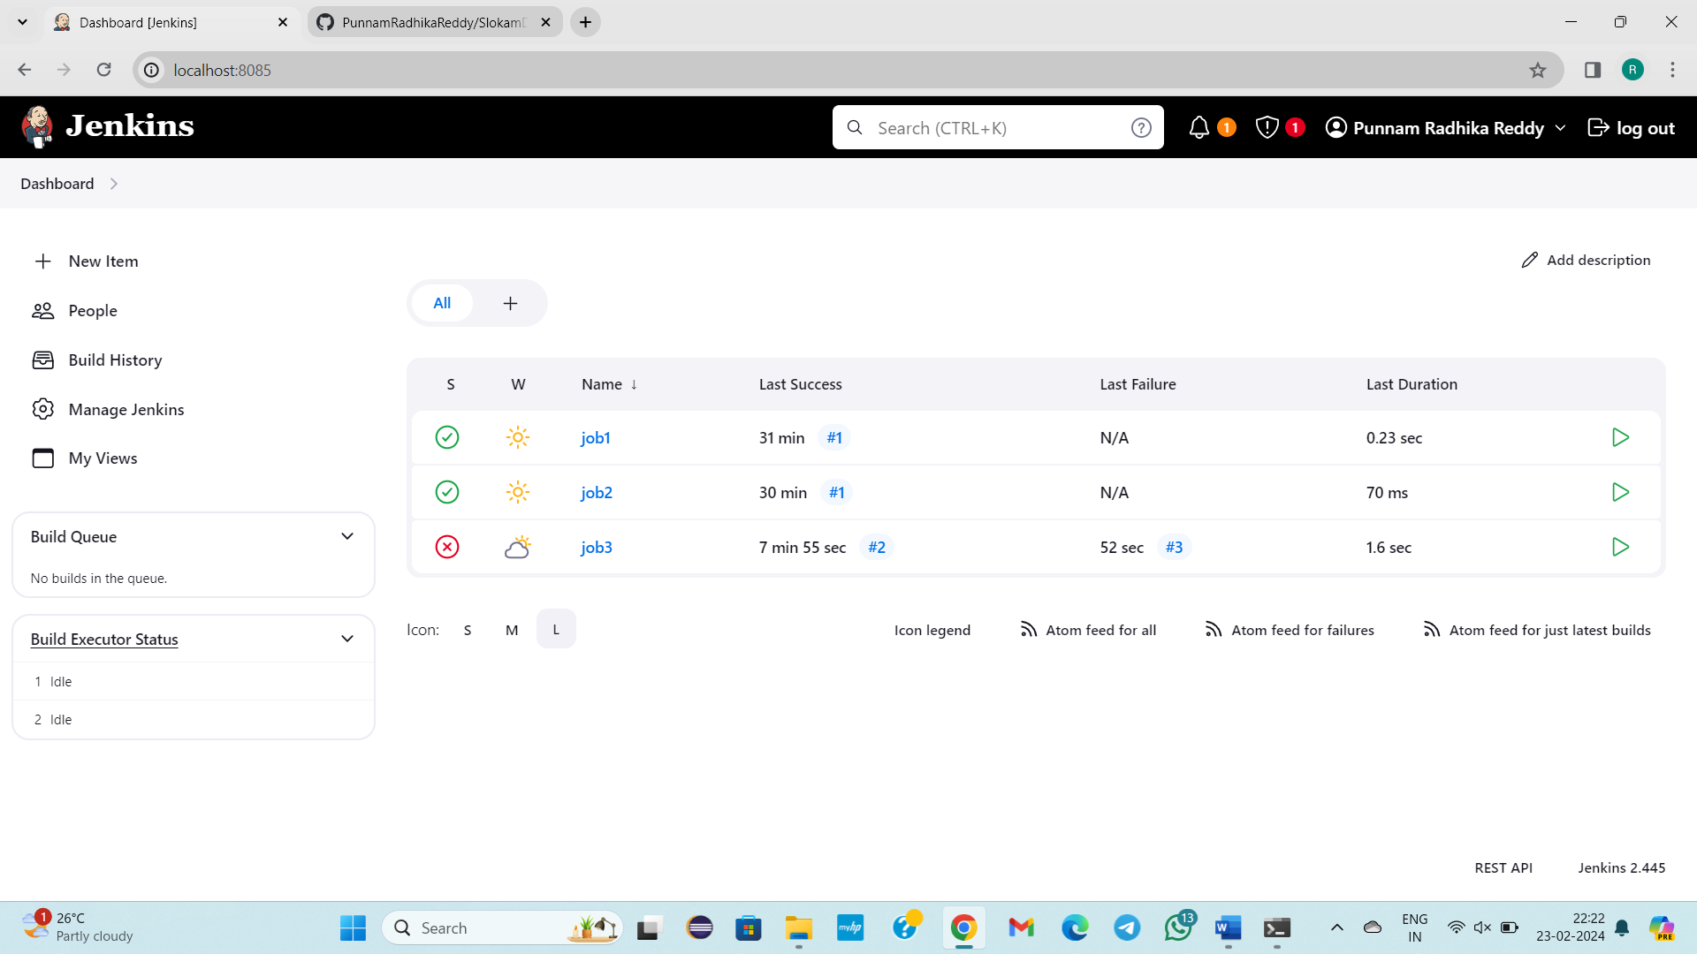

Job 3 Build fail. Why it is failed means see below images

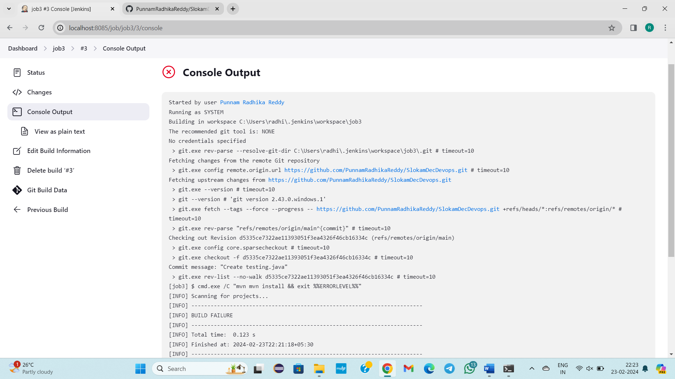

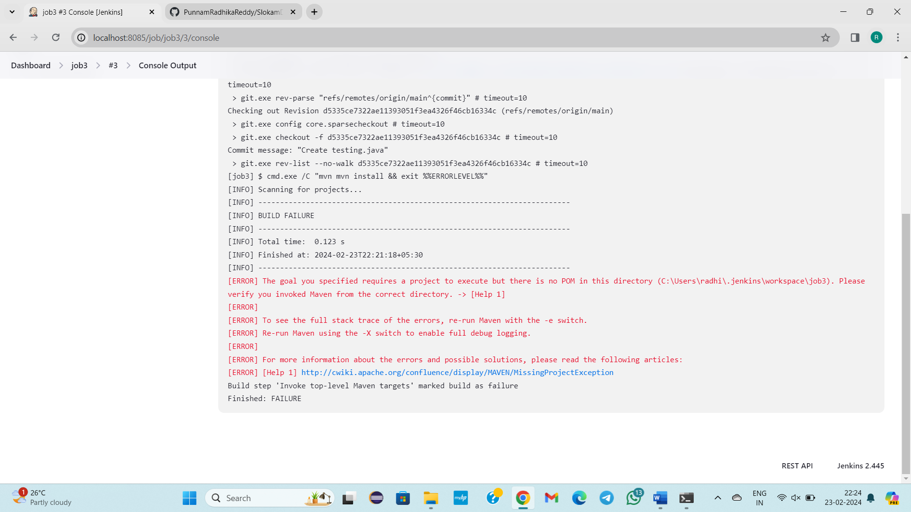

**------------22/02/2024-------Thursday------------------Class – 44------------------**

**TOPIC:**

**In MANAGE JENKINS, Inside the SYSTEM CONFIGURATION We learnt about 2 things SYSTEM, TOOLS**

1. **SYSTEM**

* How to display the message?
* How to increase build executors?
* How to increase Quiet Period?
* How to increase SCM checkout retry?

1. **TOOLS**

* Jdk
* Git Set the paths For these three
* Maven
* **Refer steps for execution below**

New item, Manage Jenkins, To integrate no of tools in Jenkins job firstly we need to do configure Manage Jenkins.

SYSTEM CONFIGURATION

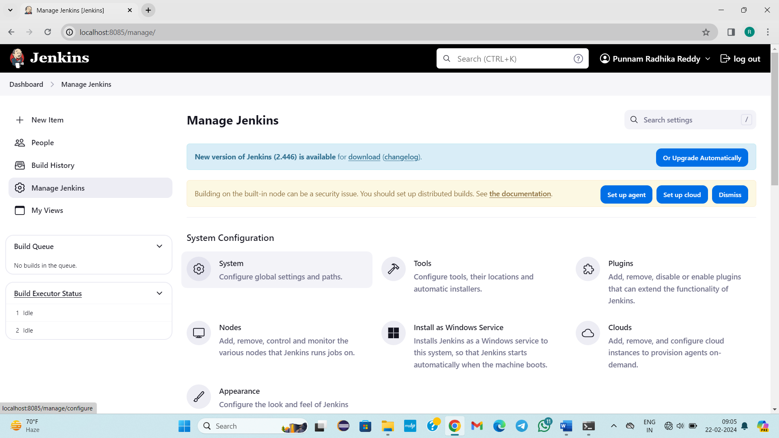

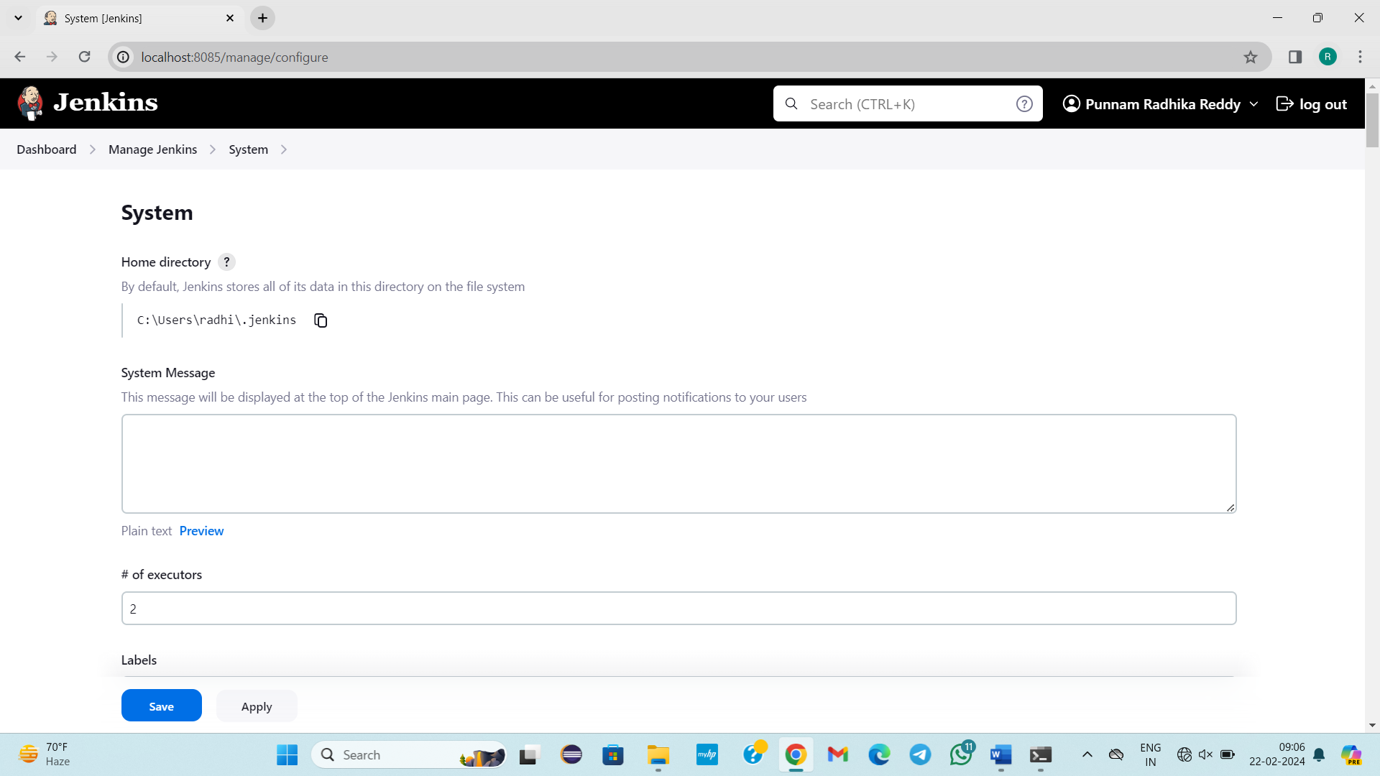

Here Each and every path is already setup

C:\Users\radhi\.jenkins by default path, and Jenkins is running here.

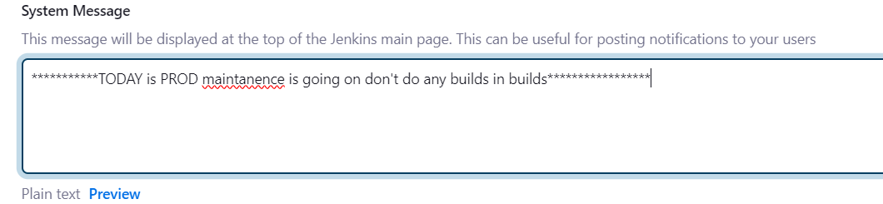

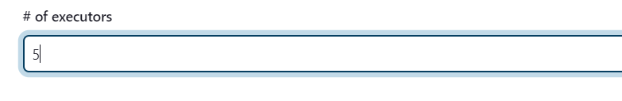

Build Executors are 2 by default.

By clicking on this, bulid executors (2), job will be created by any of the one

If more jobs, more build executors are required.

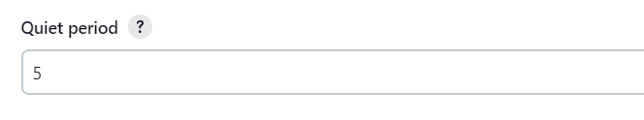

Ideal 1🡪Job1

Ideal 2🡪Job2

🡪Job3(Waiting state)

When Ideal1 built Job1 , now Ideal 1 should take rest 5 sec rest to perform job3 building.

SCM checkout retry count default value is 0

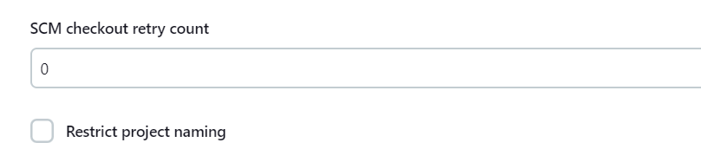

Jenkins job enters into github repository and checks 1 time if any new changes came or not ( 0 means 1 time && 1 means 2 times). If any changes buld will be triggergered.

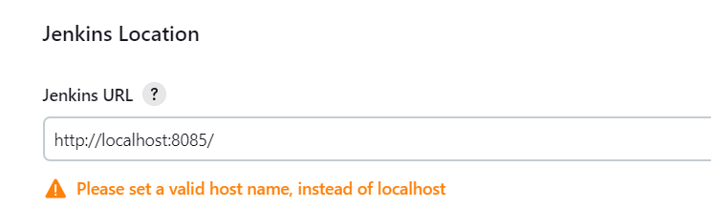

Jenkins URL is running with this url

Manage Jenkins configuration is old style

New style is

While Creation of job only we will integrate the tools.

In SYSTEM We have learnt about below Four things:

* How to display the message?
* How to increase build executors?
* How to increase Quiet Period?
* How to increase SCM checkout retry?

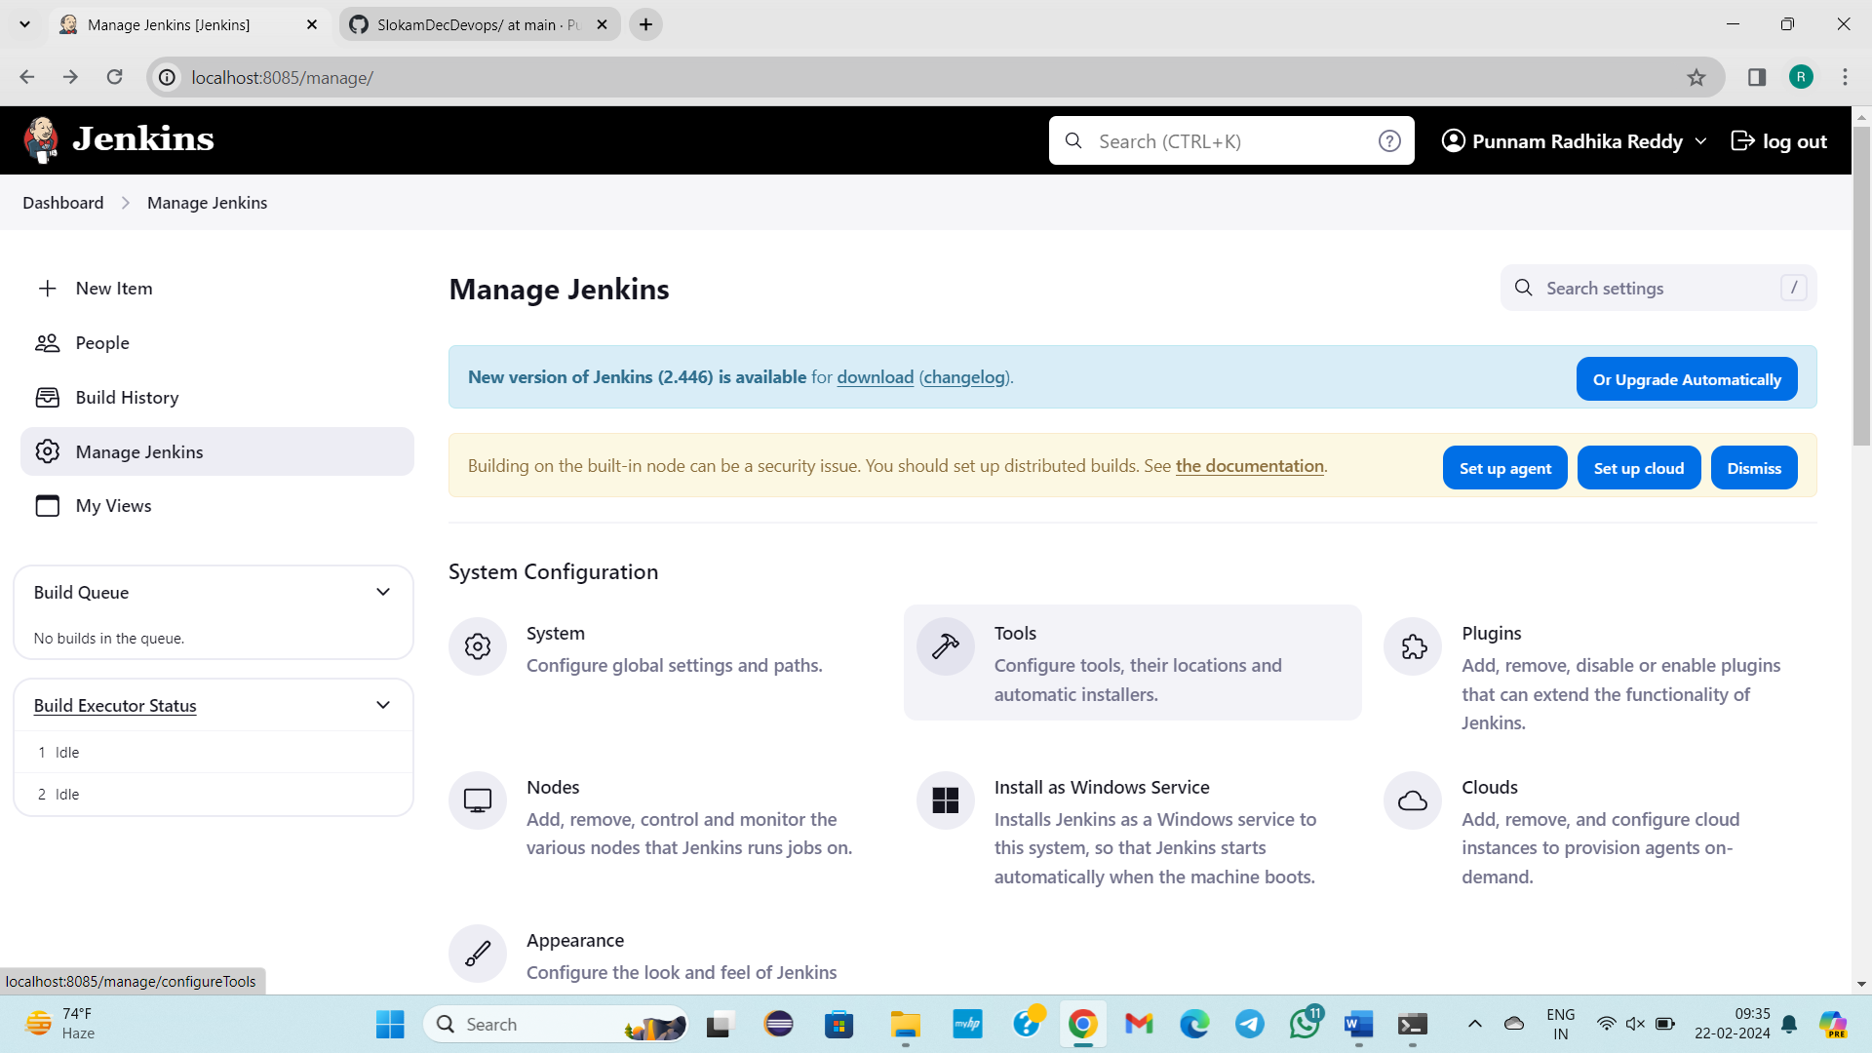

By default Jenkins, run with the JDK

Manage Jenkins

TOOLS:

Jdk

Git

Maven

Set the Paths

**STEPS FOR EXECUTION:**

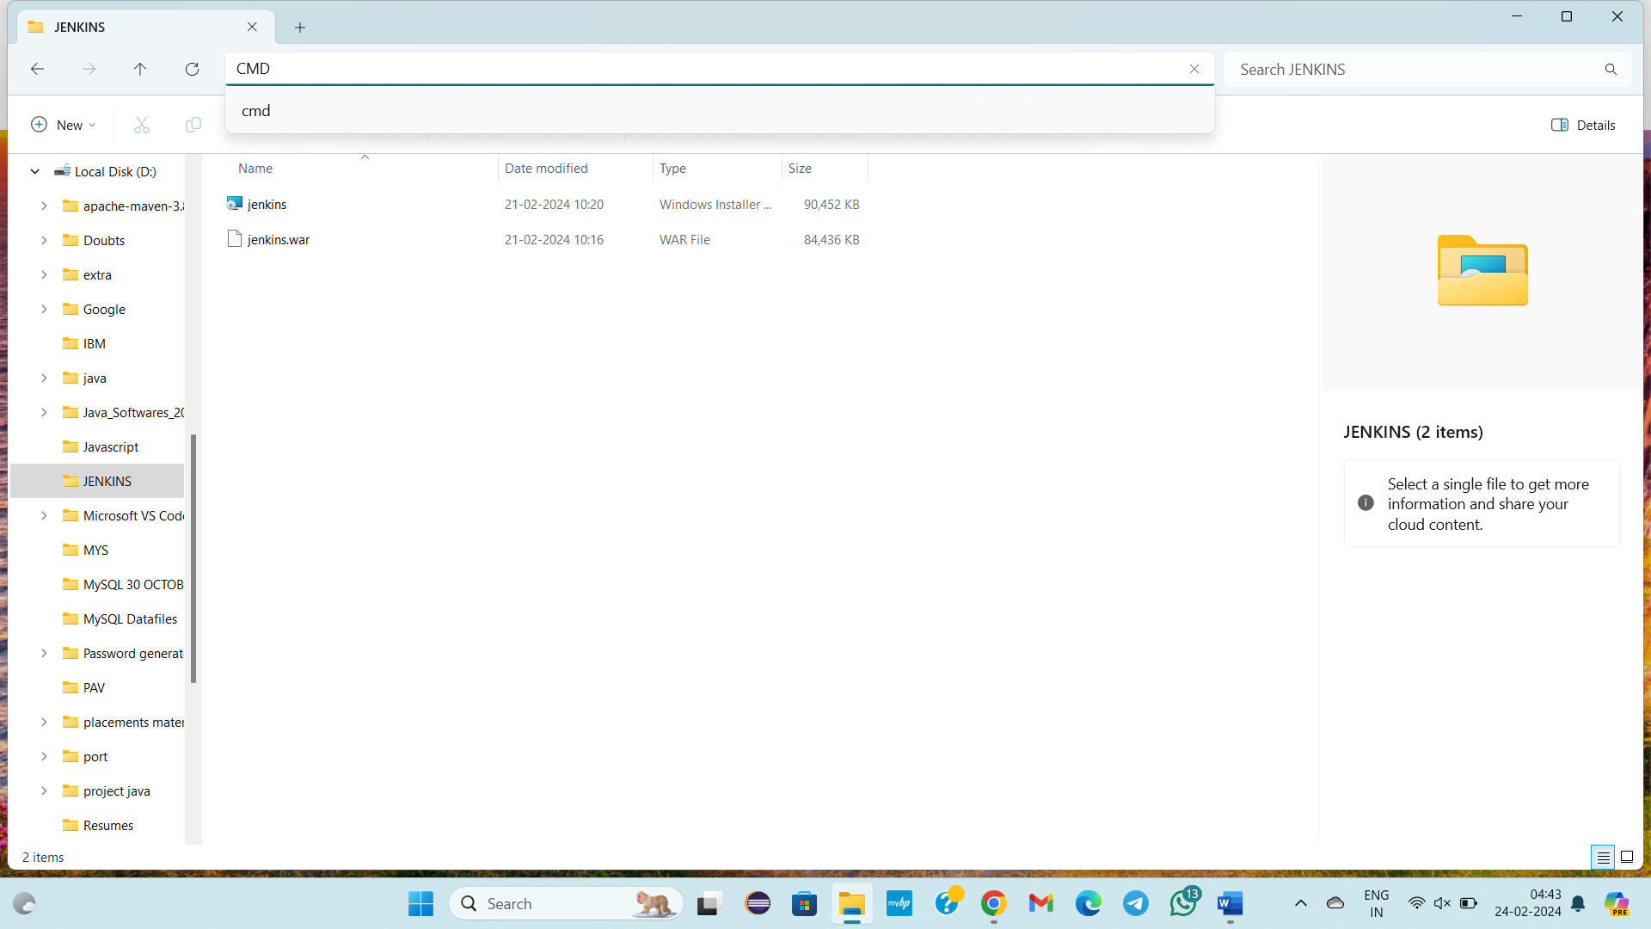

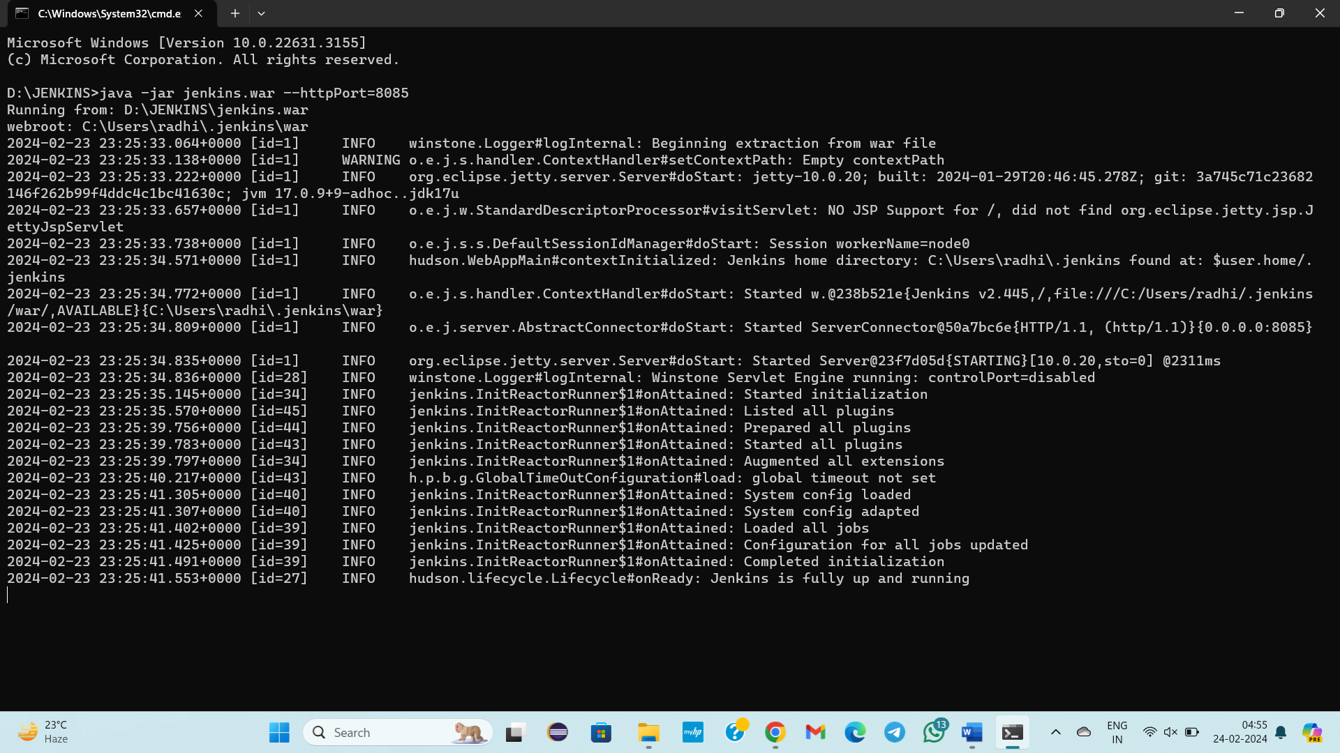

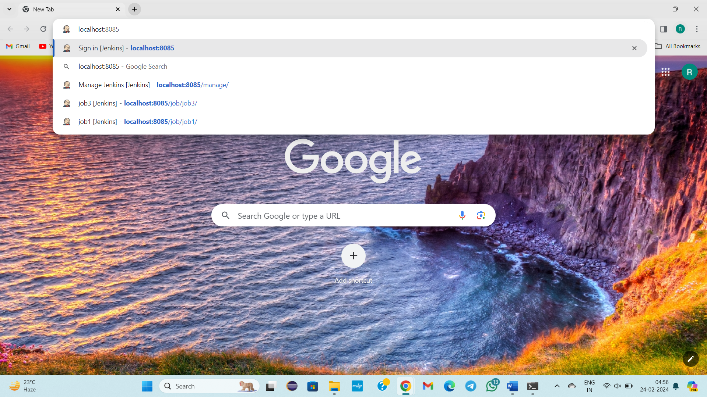

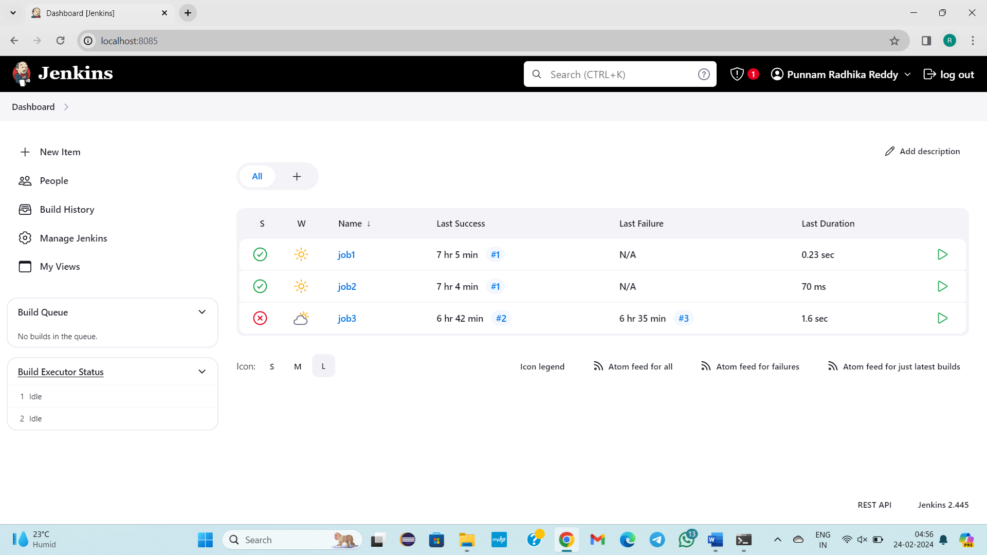

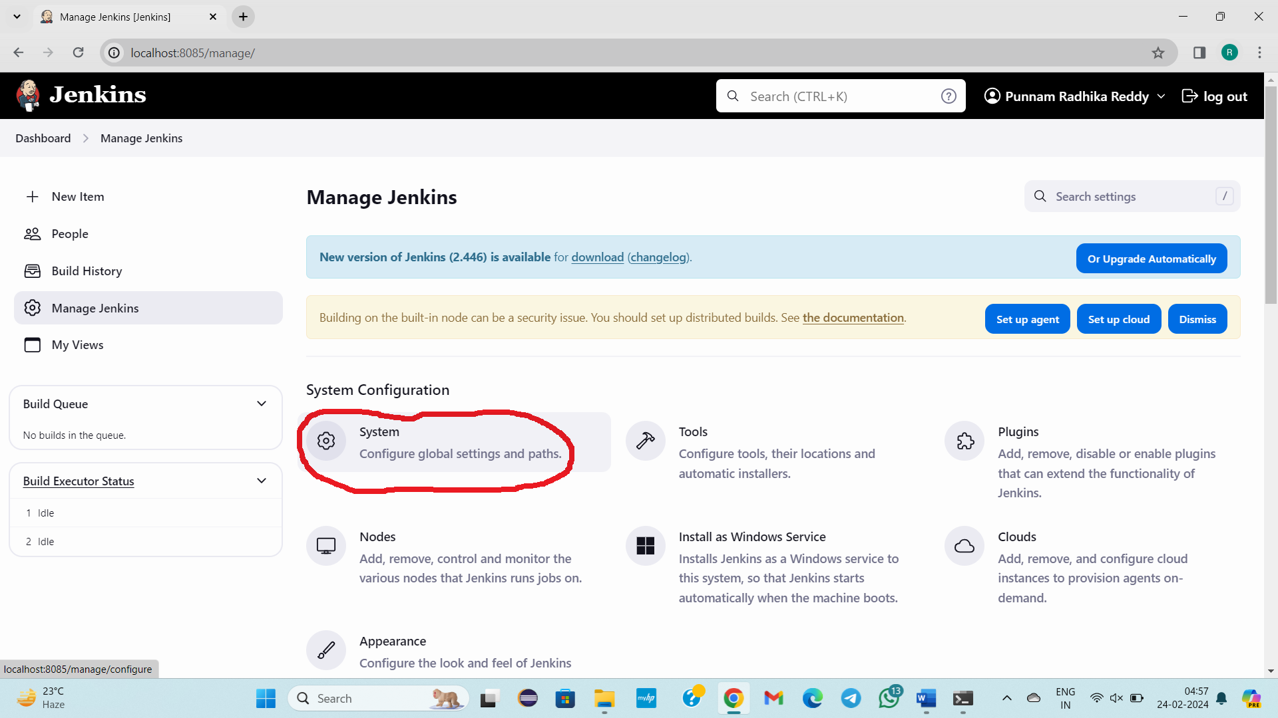

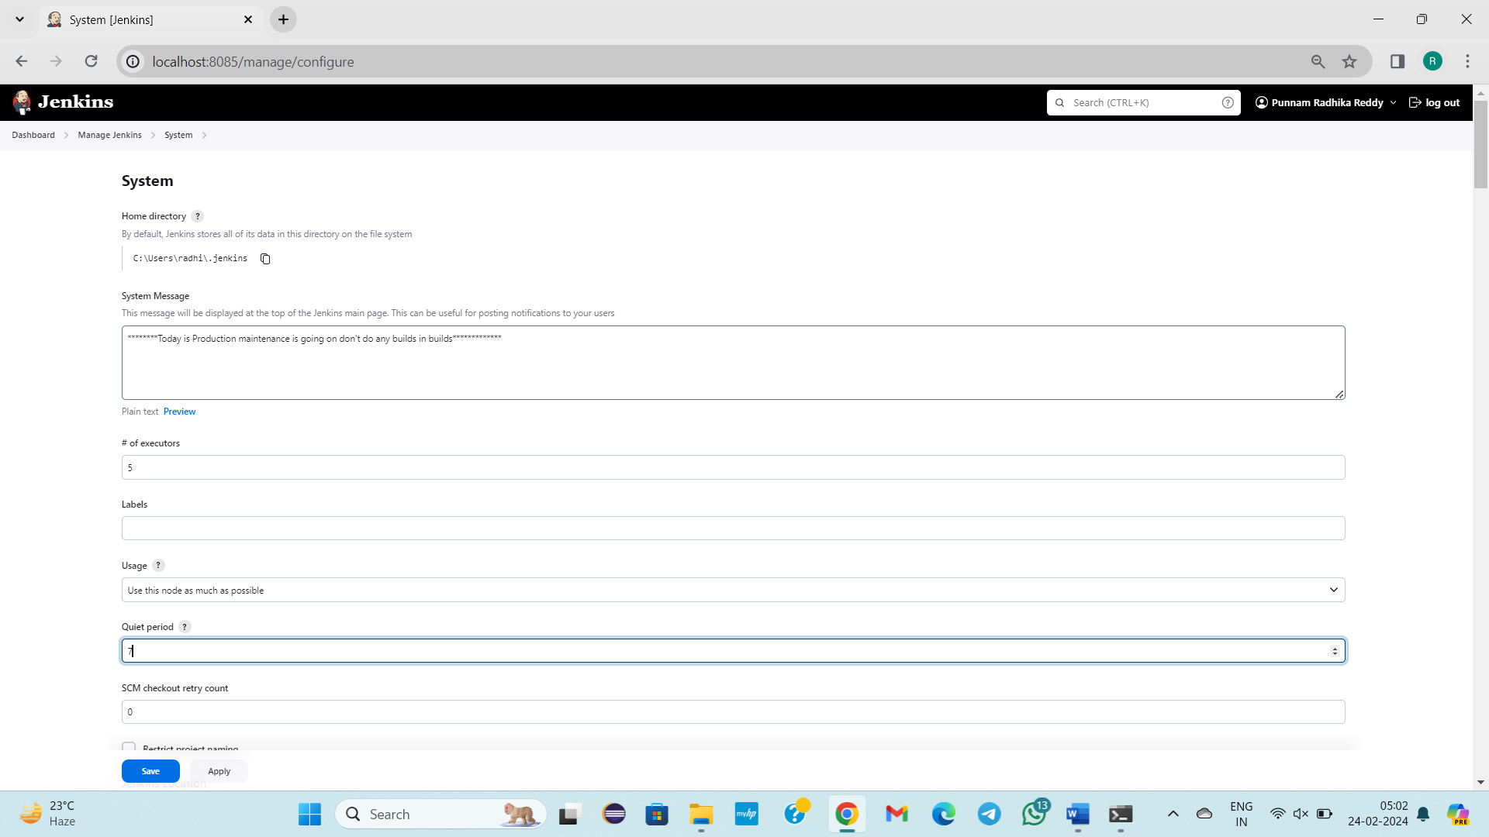

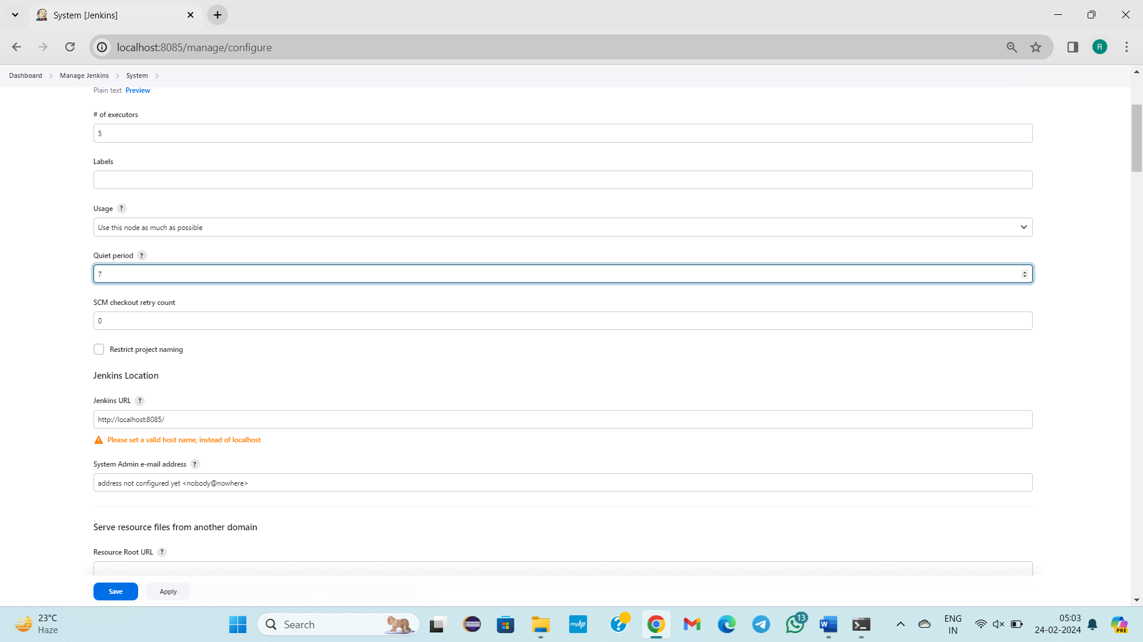

Click on save

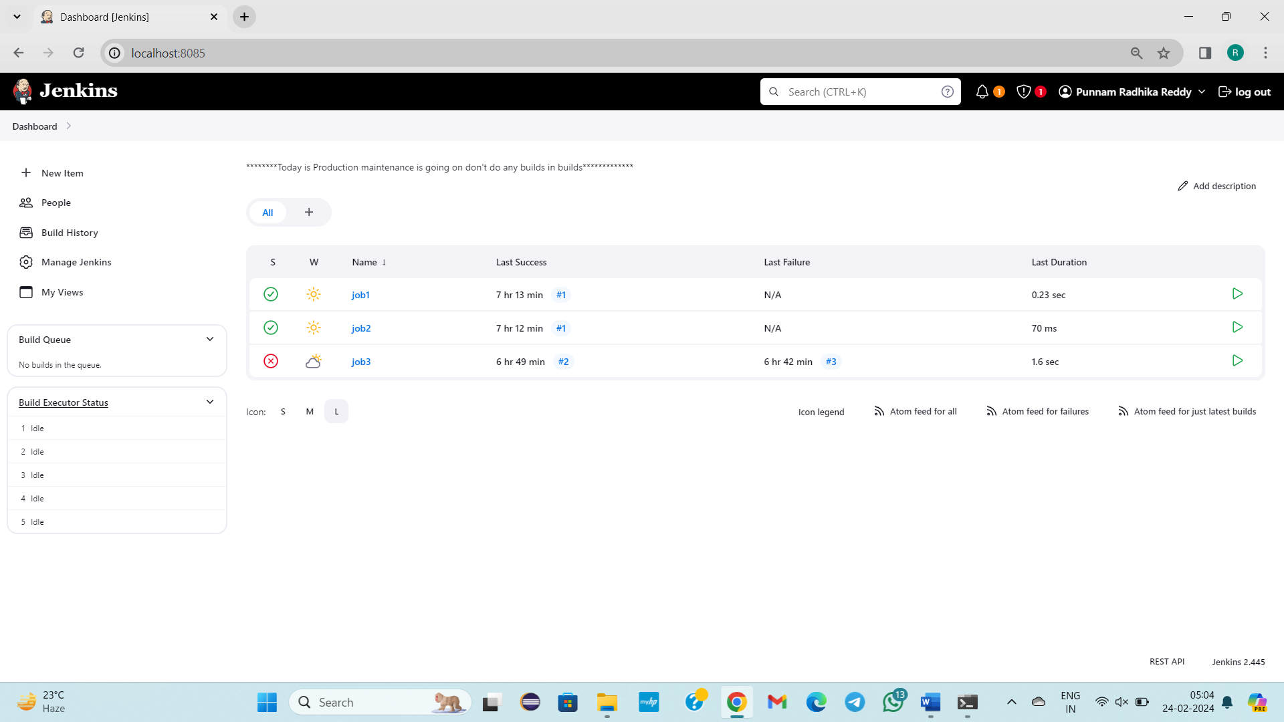

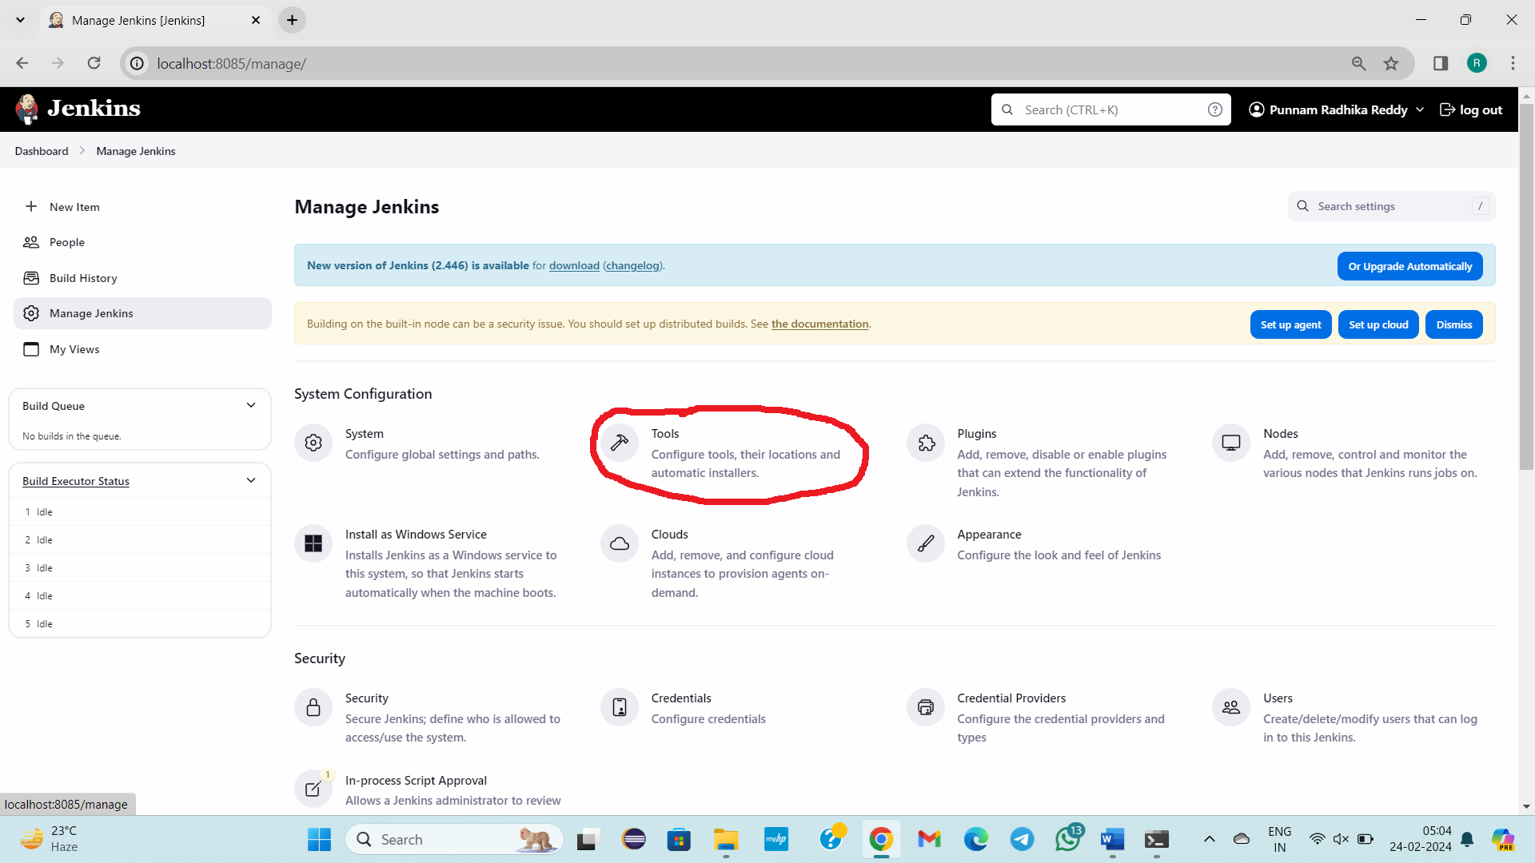

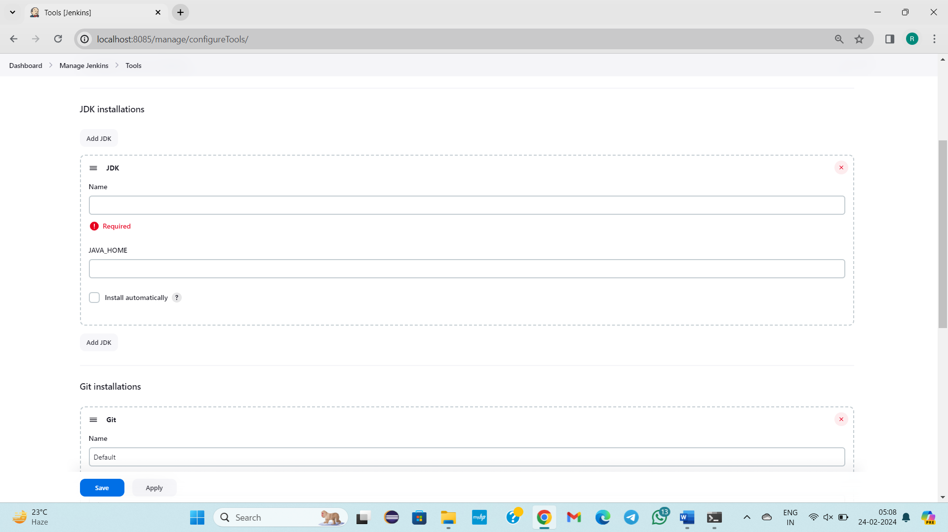

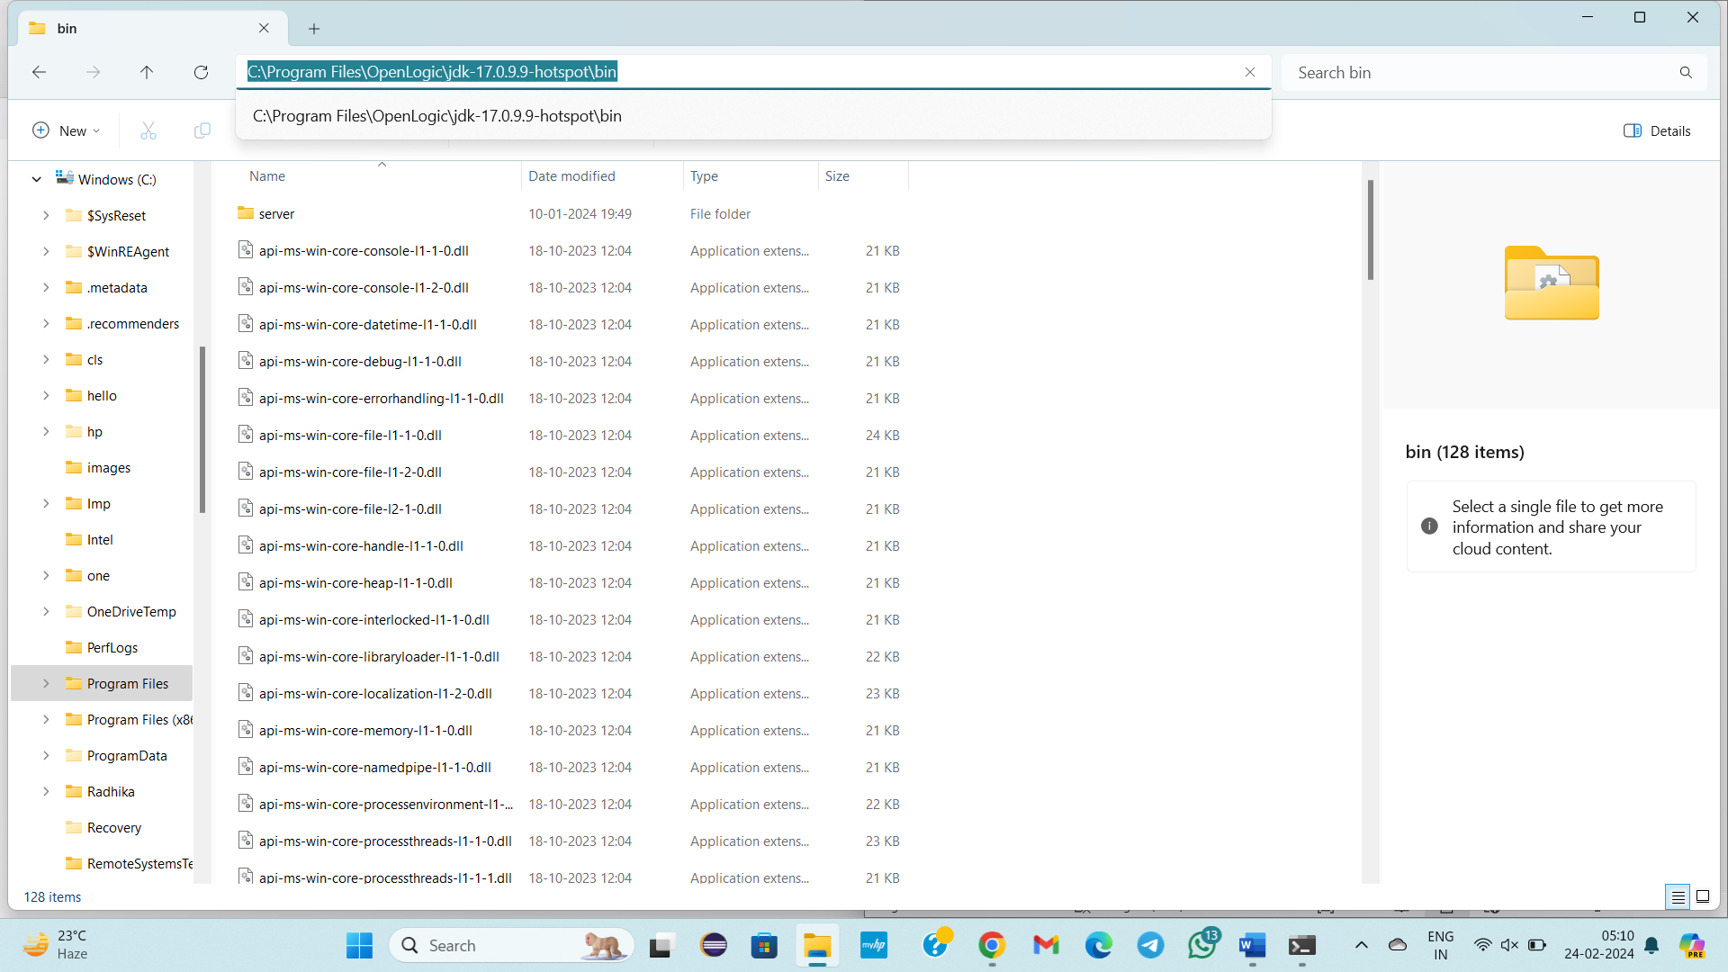

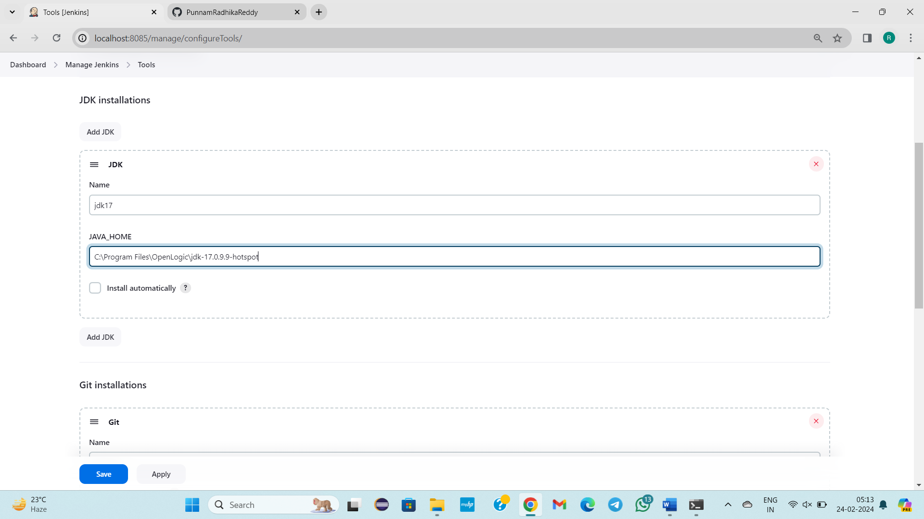

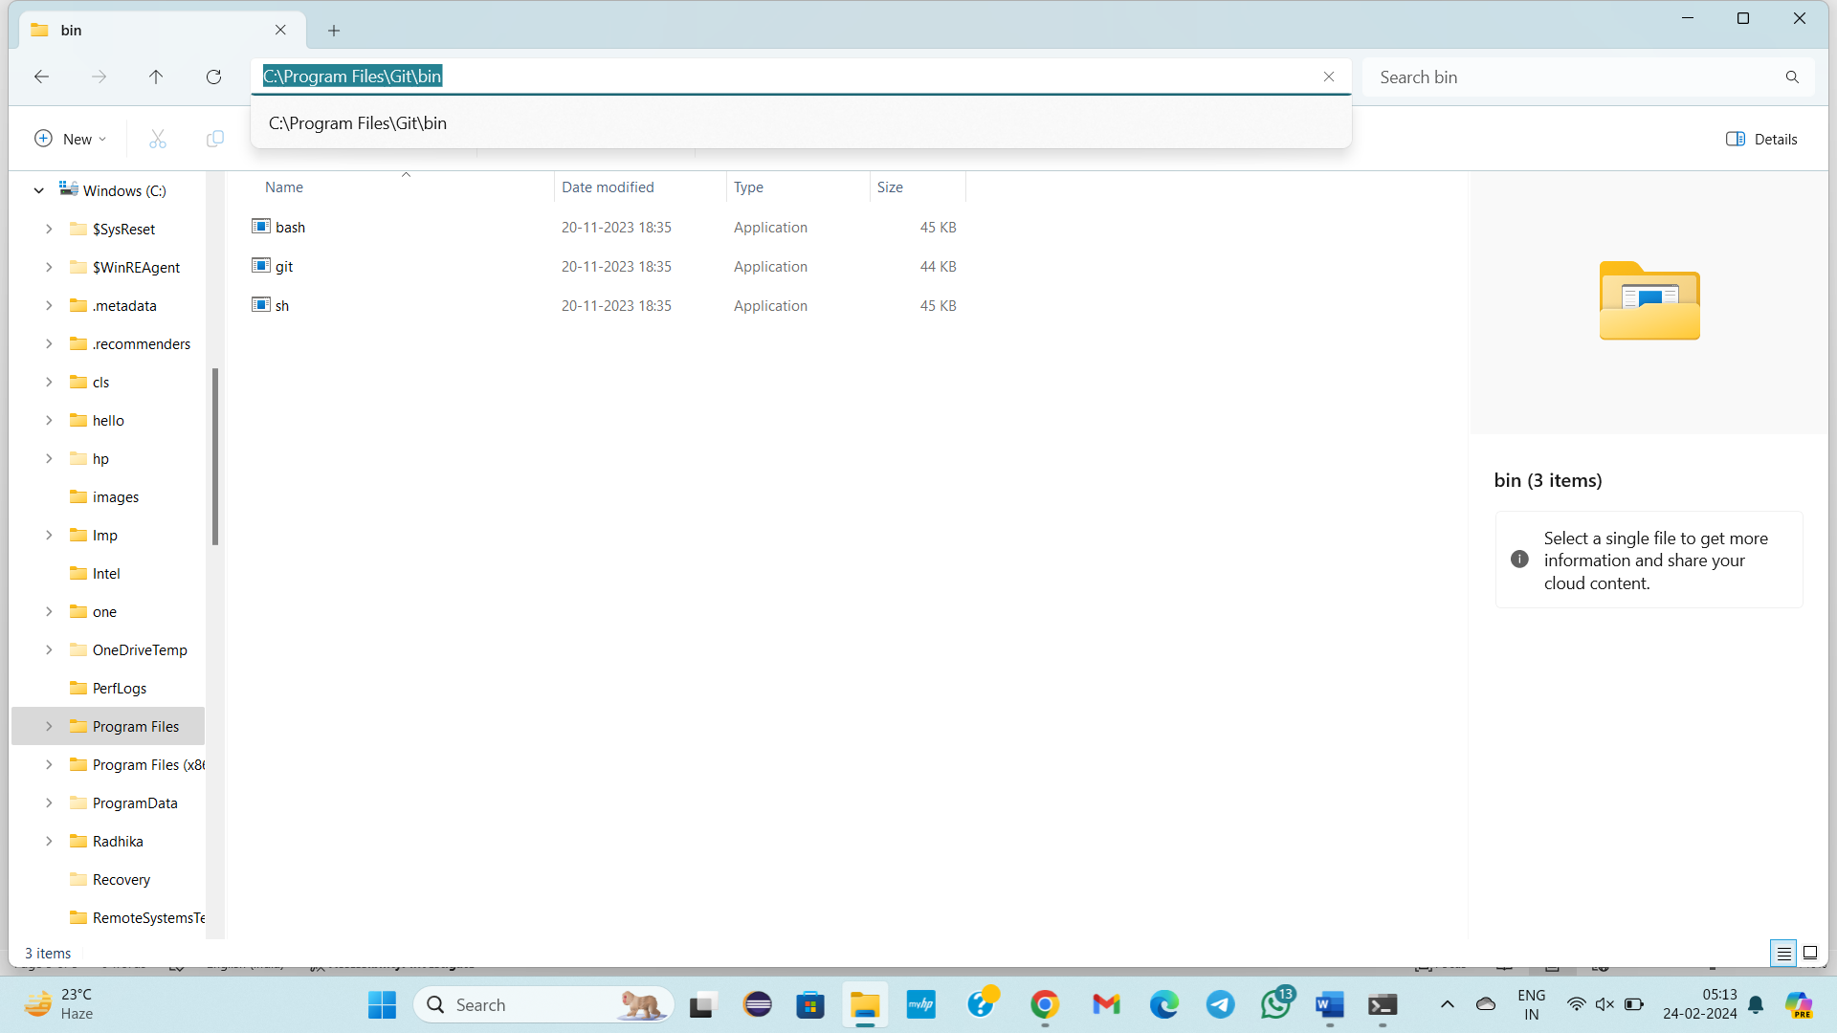

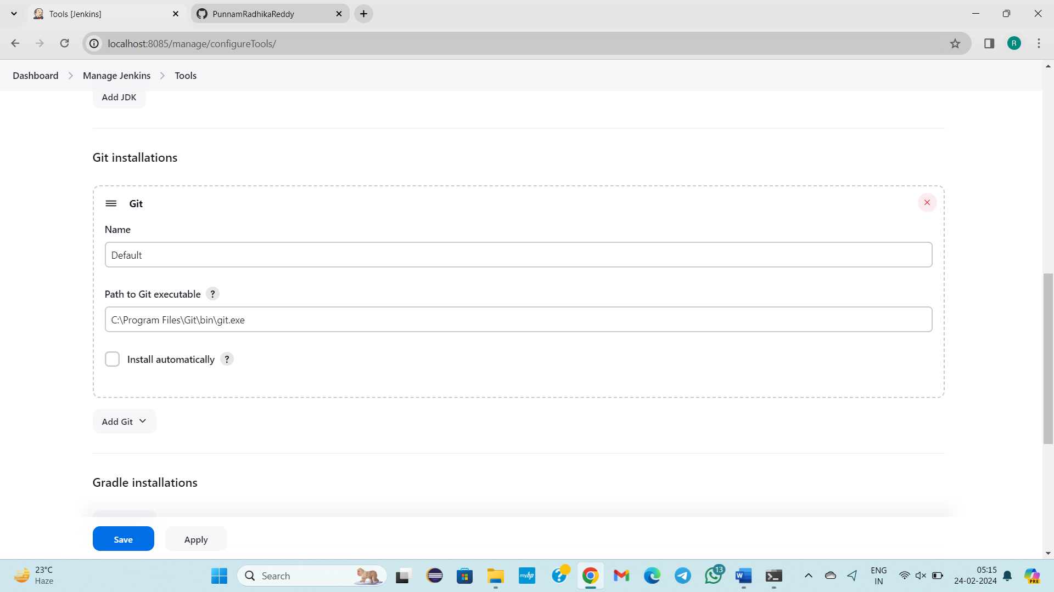

If we don’t know mvn path go to cmd enter **mvn -v**

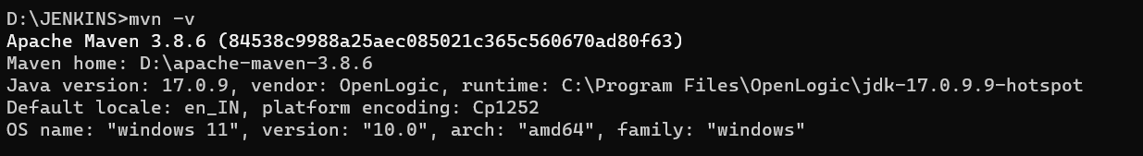

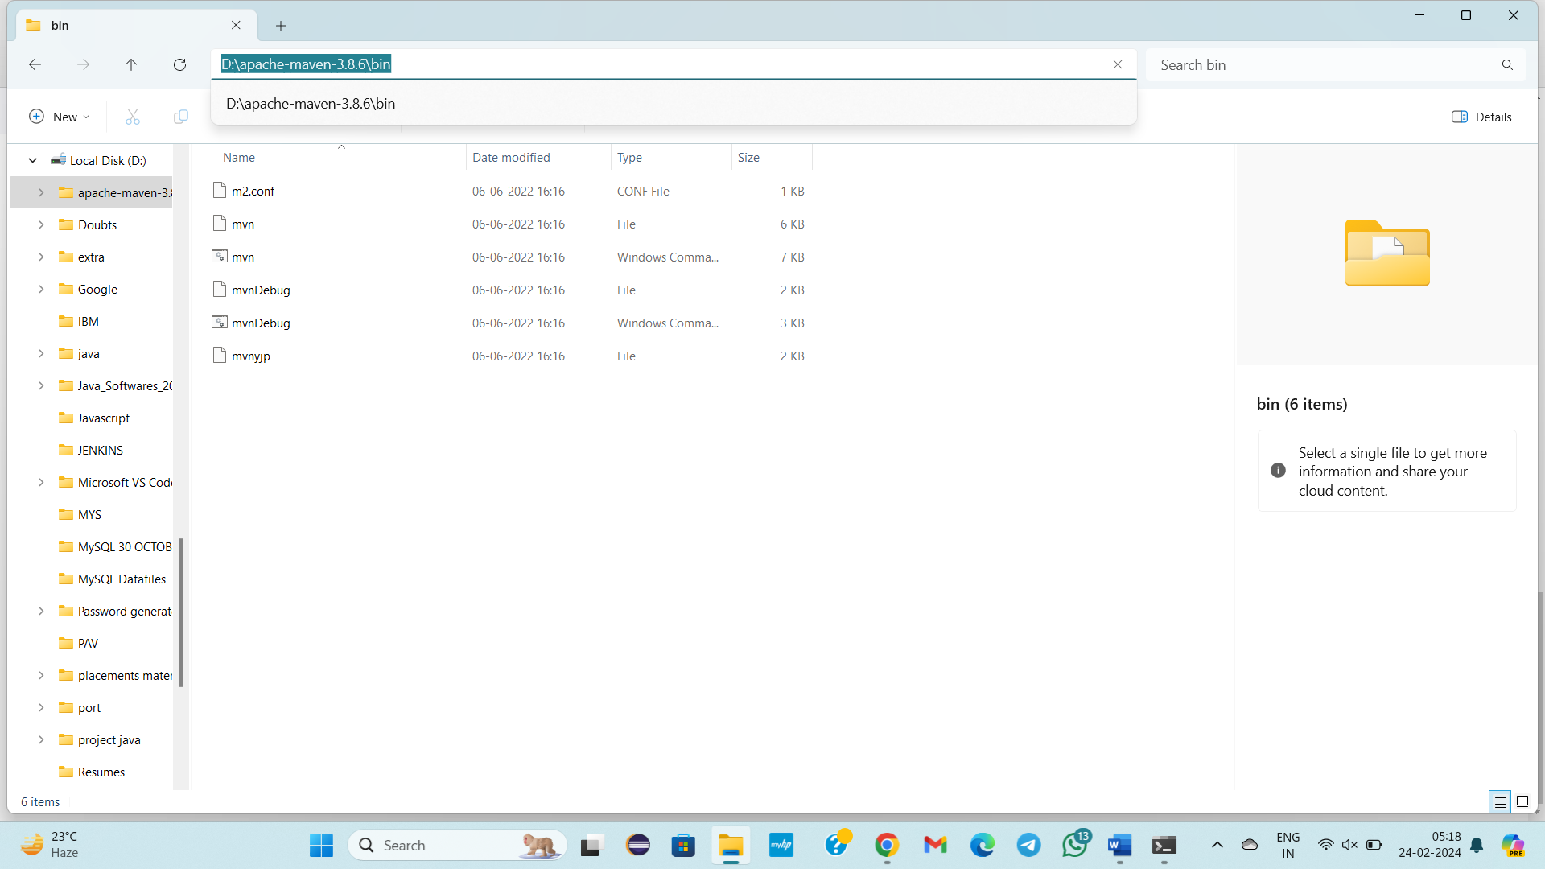

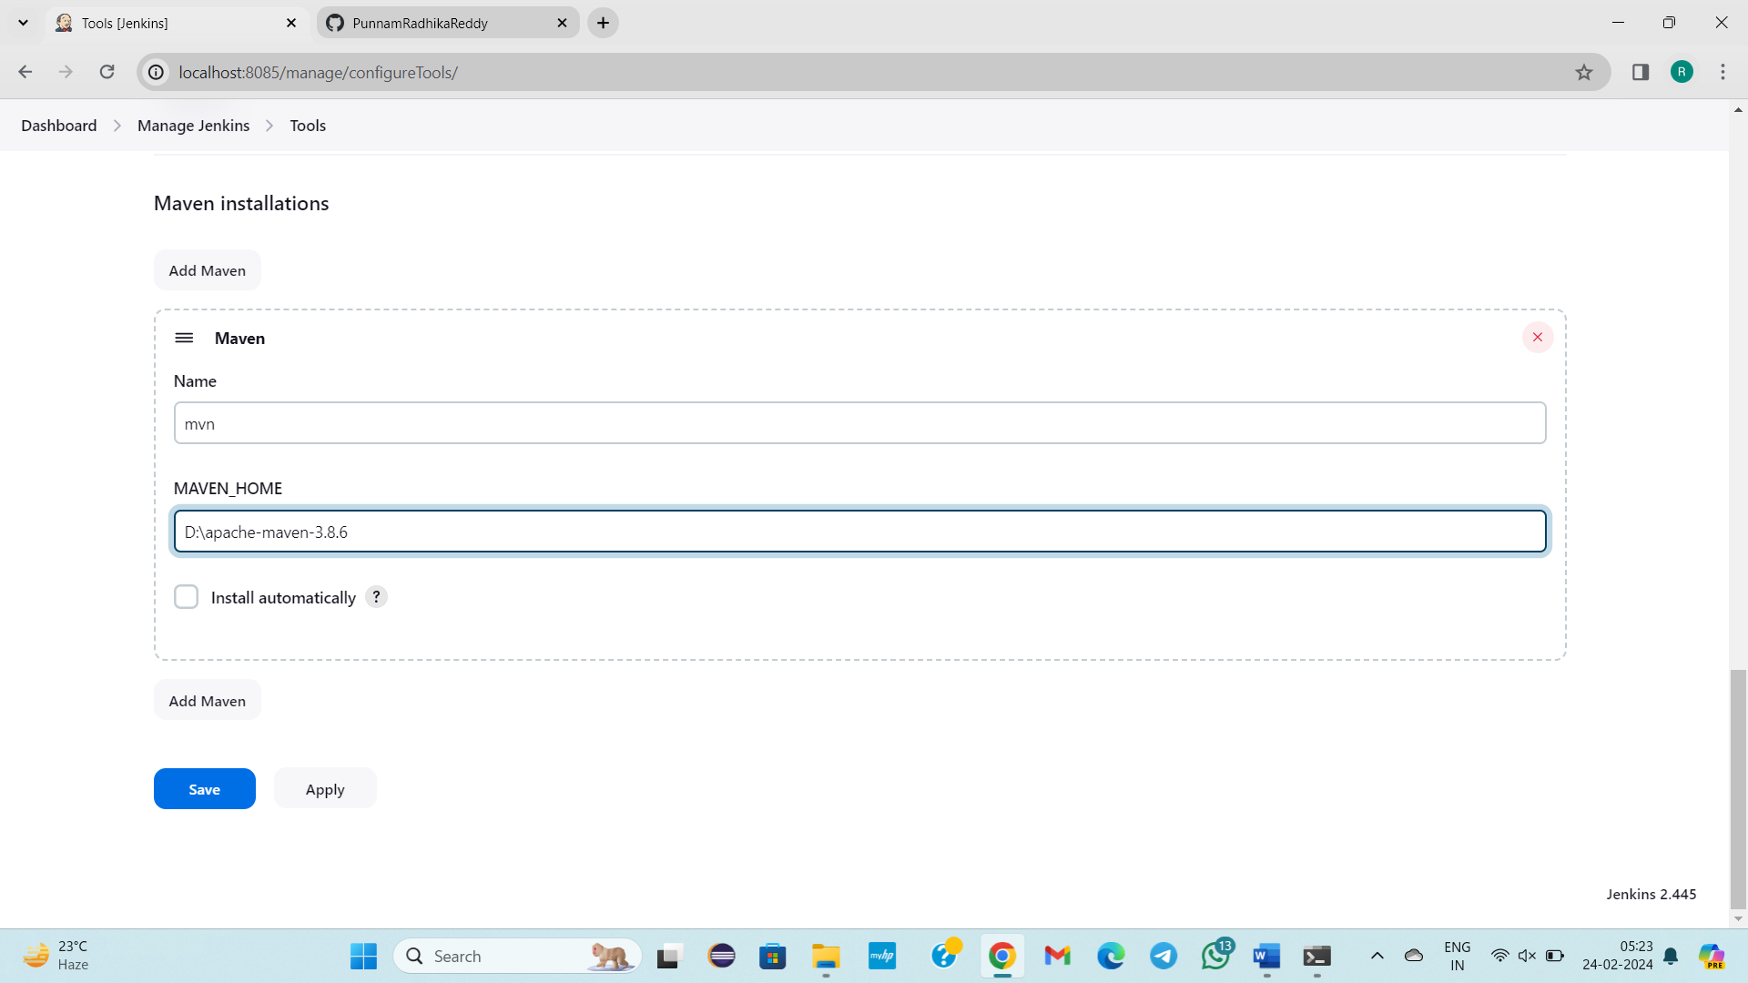

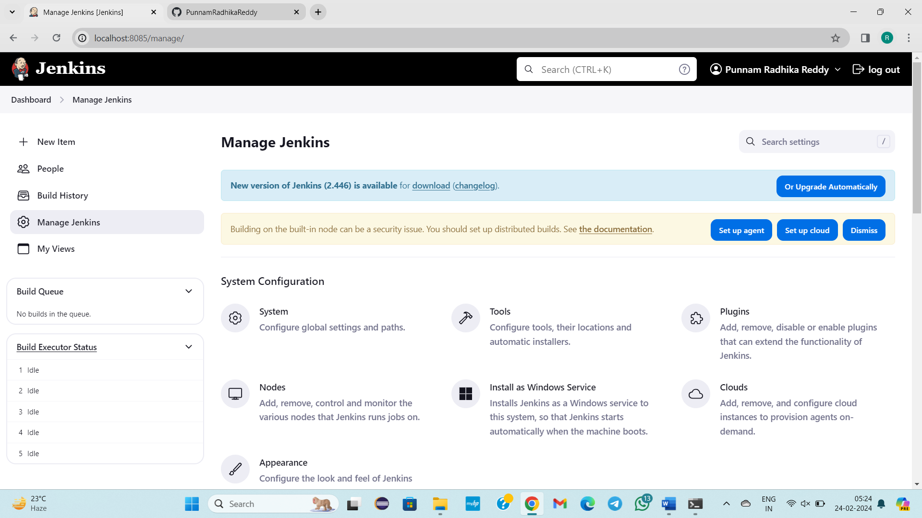

**--------------23/02/2024-------Friday------------------Class – 45-------------------**

**TOPIC:**

* **Creation Of Job, in Declartive Pipeline Kind**
* **Configuration of below steps should be done, Actually There are 6 in Configuration**
* **Today We have learnt about 2 , they are General, Source code Mangement Tool, Remaining 4 can be discussed in further classes**
* **Jenkins**🡪**job**🡪**Configure[1)General, 2)Sourcecode ManagementTool]**
* **Refer steps for execution below**

**1)General**

**a)description**

**b)days to keep builds**

**c)GithubProject urls**

**d)Throttle builds**

**, 2)Sourcecode ManagementTool**

**a)Git**

* **Repo url,**
* **crendiatals add,**
* **specify branch**
* Launch the Jenkins server
* Go to Cmd
* Enter the command **java -jar jenkins.war –httpPort=8085**
* So, far we deployed ui based application .war in below enviroments
* 1)Tomcat
* 2)docker
* 3)Kubernetes
* We deployed .war file in manual process
* In Jenkins we are going create jobs
* Jobs are of 2 kinds

1) Declartive pipeline

2) Scripted pipeline

* In Declartive pipeline we are going to lauch 3 enviroments.
* In Scripted pipeline we are going to launch 3 environments

1. Declartive Pipeline:

* We need to select Free Style project
* we are going to provide only urls

1. Scripted Pipeline:

* We need to select Pipeline option selection
* Groovy Script we need to write

STEPS:

* Go to chrome
* Localhost:8085
* Sign in
* Click on new item
* Give name as Decjob1
* If we want to create declarative pipeline job then select on Freestyle or if we want to create Scripted pipeline job then select on pipeline
* Initially, I want create a declarative pipeline job
* Select Free Style Project
* Click on Ok
* Configuration
* Here 6 steps are present, to full fledged jenkins

1. General

* **Description**🡪 Purpose of creation of job

Eg: This job is going to build to build HTML pages of UI App

* **Discard old builds:**

When you click multiple times. Check logs.

If I click on 100 times. These all build logs are not necessary

Press on job🡪configure(left side)

Days to keep builds🡪How many days builds do you want eg:1

Latest 2 builds only be there to appear in Jenkins Dashboard.

Click on Buildnow or to build a job

* **Github Project:**
  + - Project url 🡪 give the url which is in google search bar
    - Diff b/w Project url & Repos url
* Projecturl means which is present in google searchbox.
* Repositoryurl means which is present in HTTPS search box.
  + - This Project is parametrized🡪 In one job we are going to configure git, maven(By default they should be configured), tomcat/docker/Kubernetes( Any of the one of them should be configured according to requirement), Afterwards it can be discussed,

In this No of tools can be provided by selecting this option.

* **Throttle builds:** The timegap should be taken between the jobs builds

No of builds: 1

Time period: second

* **Execute concurrent builds if necessary** 🡪 This can be discussed afterwards

**2)SourceCode Management**

**a)None**

**b)Git**

* **Repo url** 🡪 Give the working repository url
* **Credientals** 🡪 Click on add Jenkins

Give github username, pwd, Id can be anything (github), Description(github crenditals)

Click on add

* **Branches specifier**

*/main

Click on build

Now Jenkins login into github and clone repository.

Actually why github?

To bring the code git is important.

In manual process, git clone url.

Repository comes in a format of folder.

cd folder

mvn install 🡪 .war can be generated

But Jenkins is Automation tool right, by above steps Jenkins is automatically cloning given repository.

Build Success should display.

**STEPS FOR EXECUTION:**

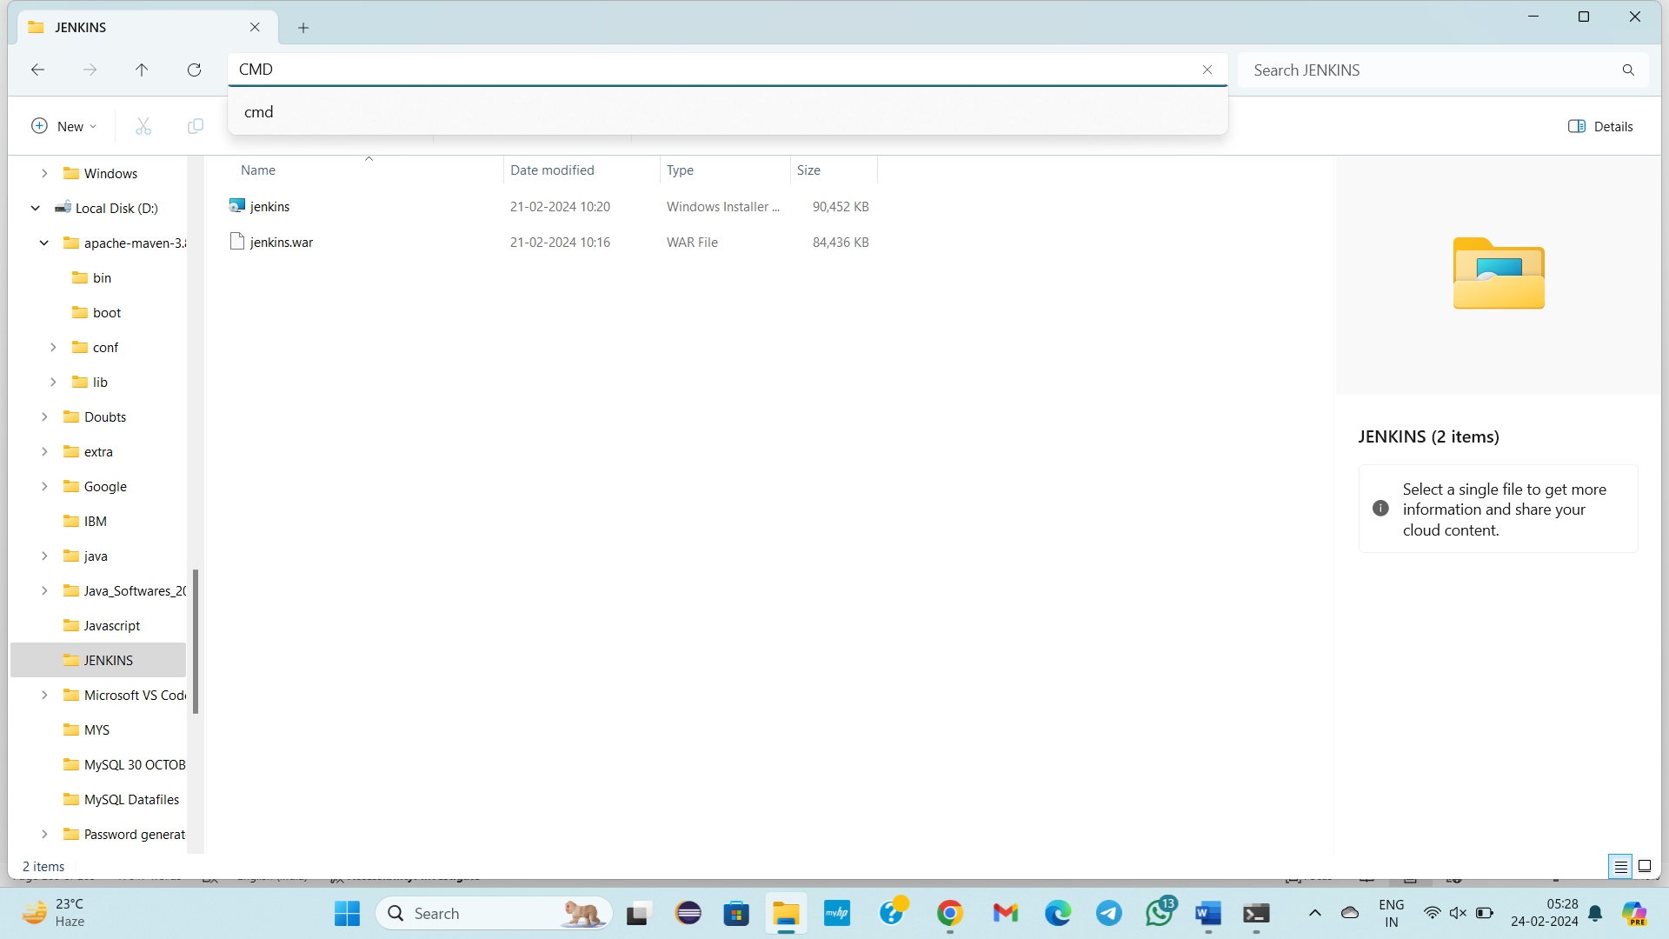

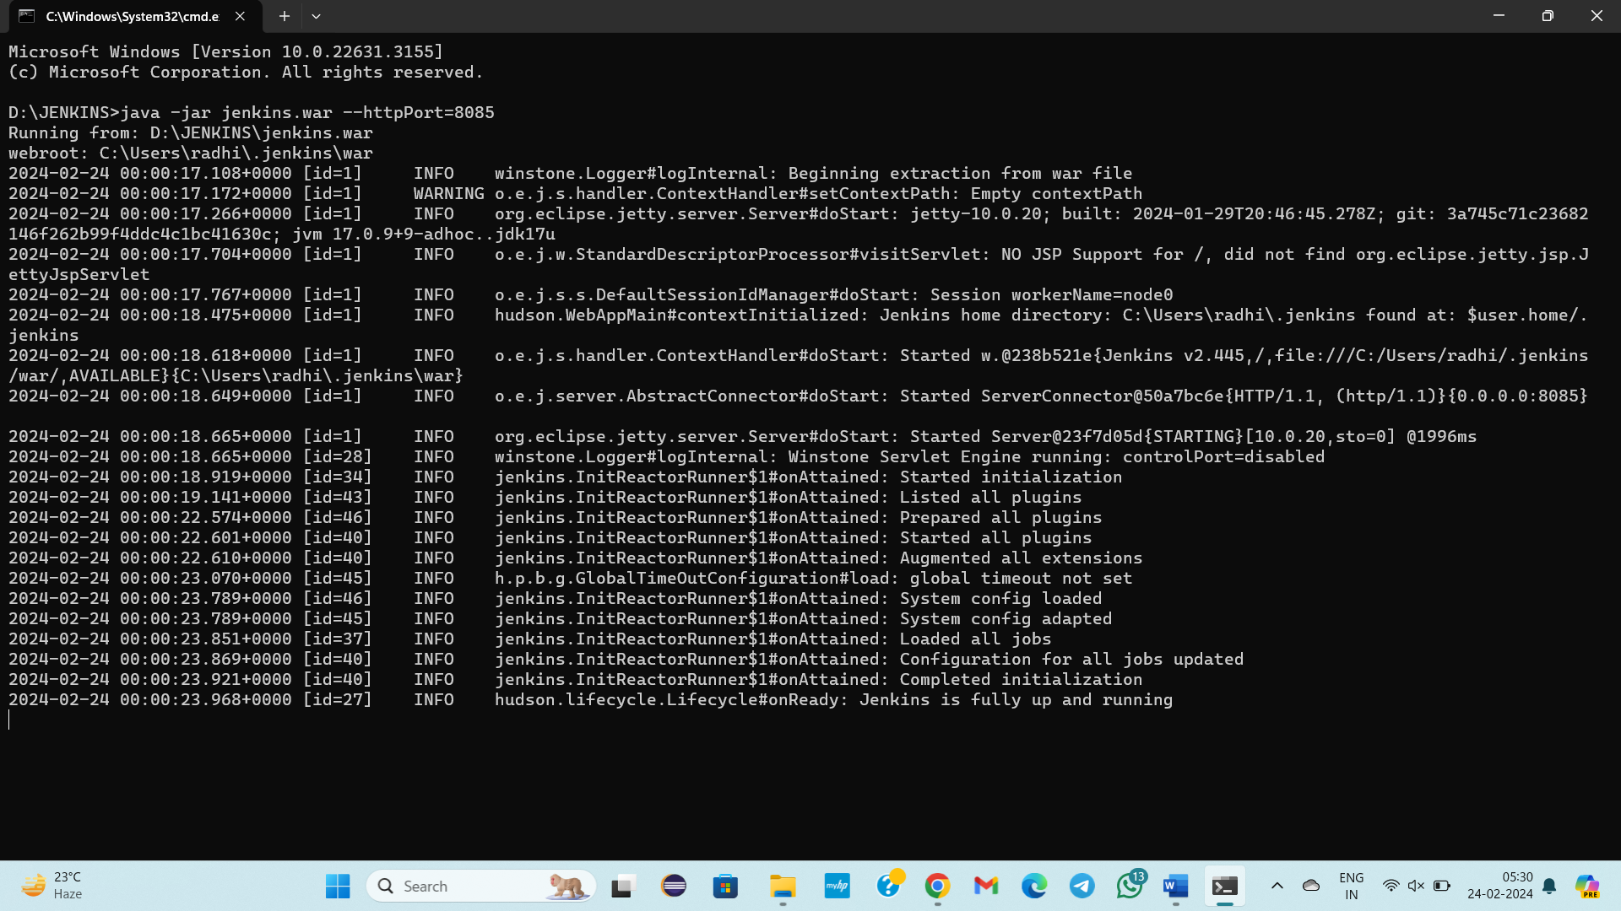

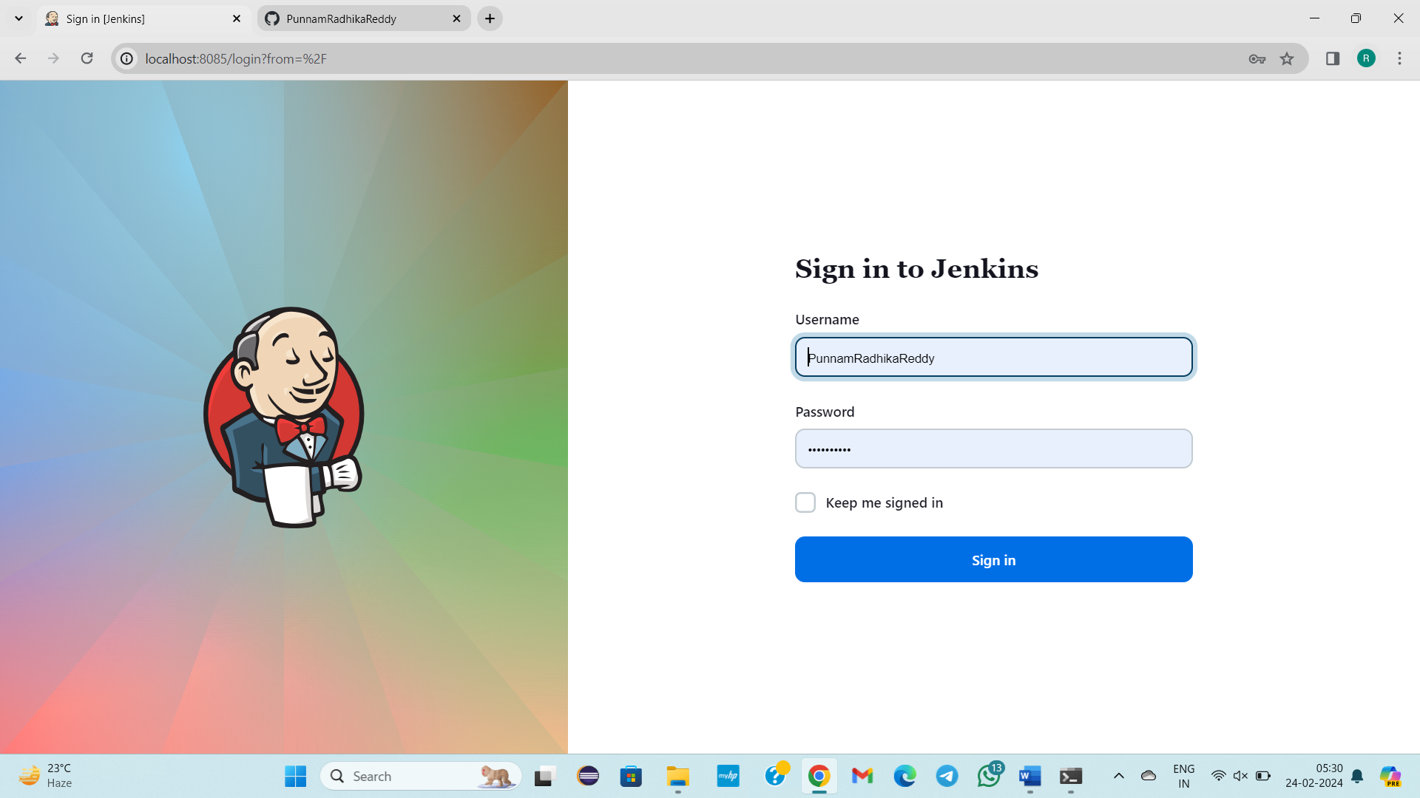

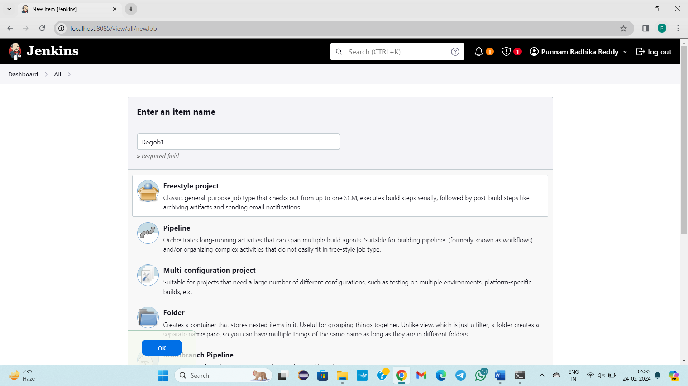

Click on ok

**1)GENERAL**

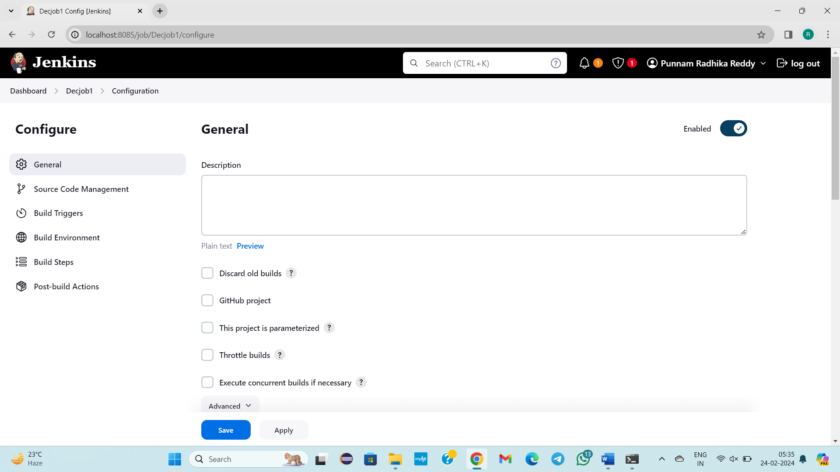

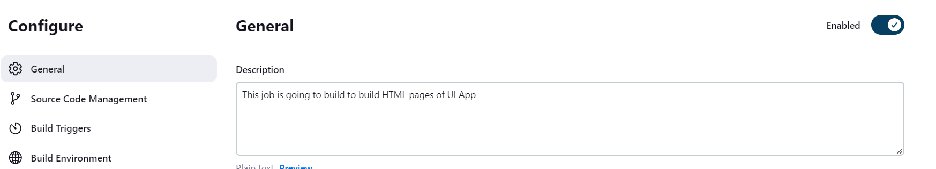

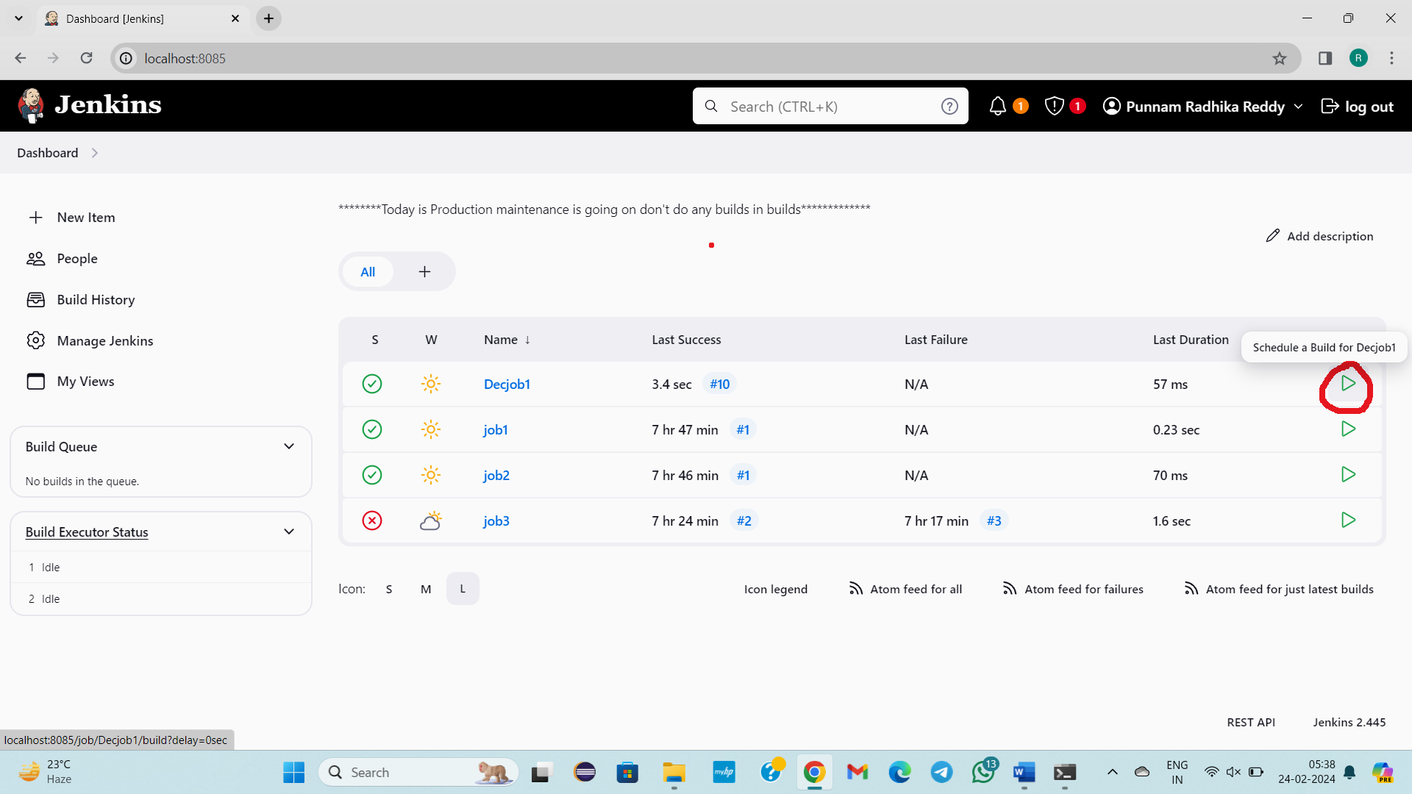Click 5 -10 times

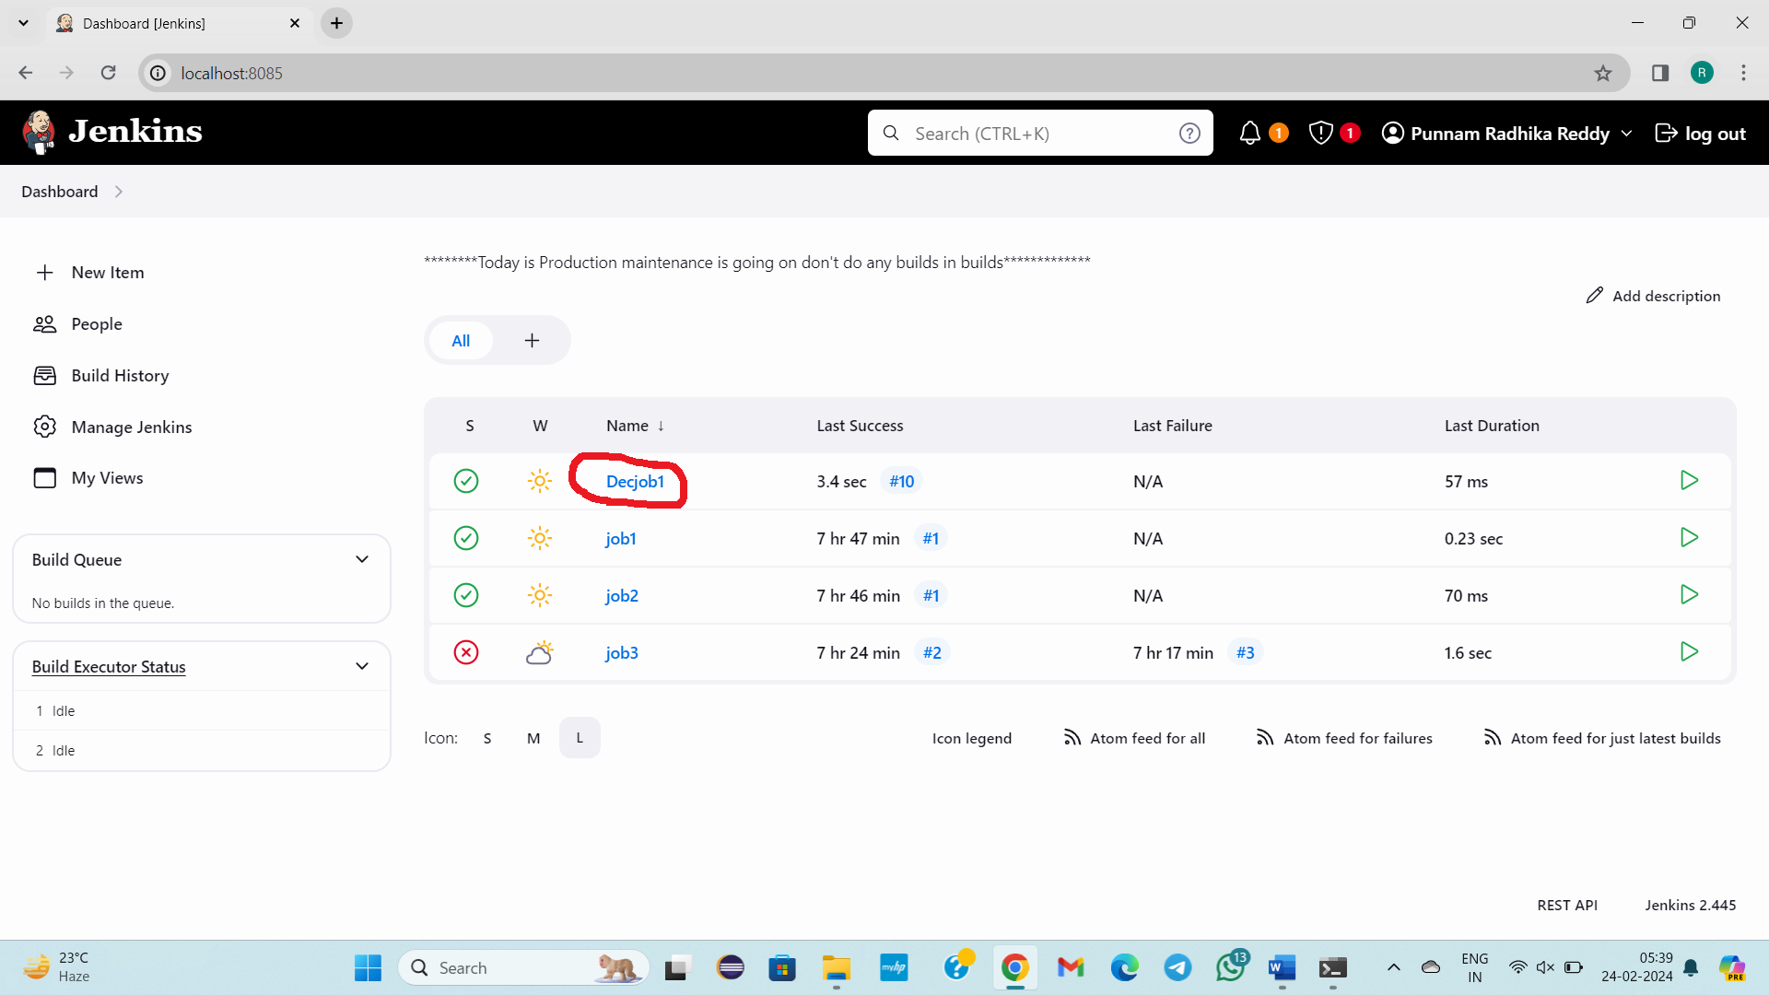

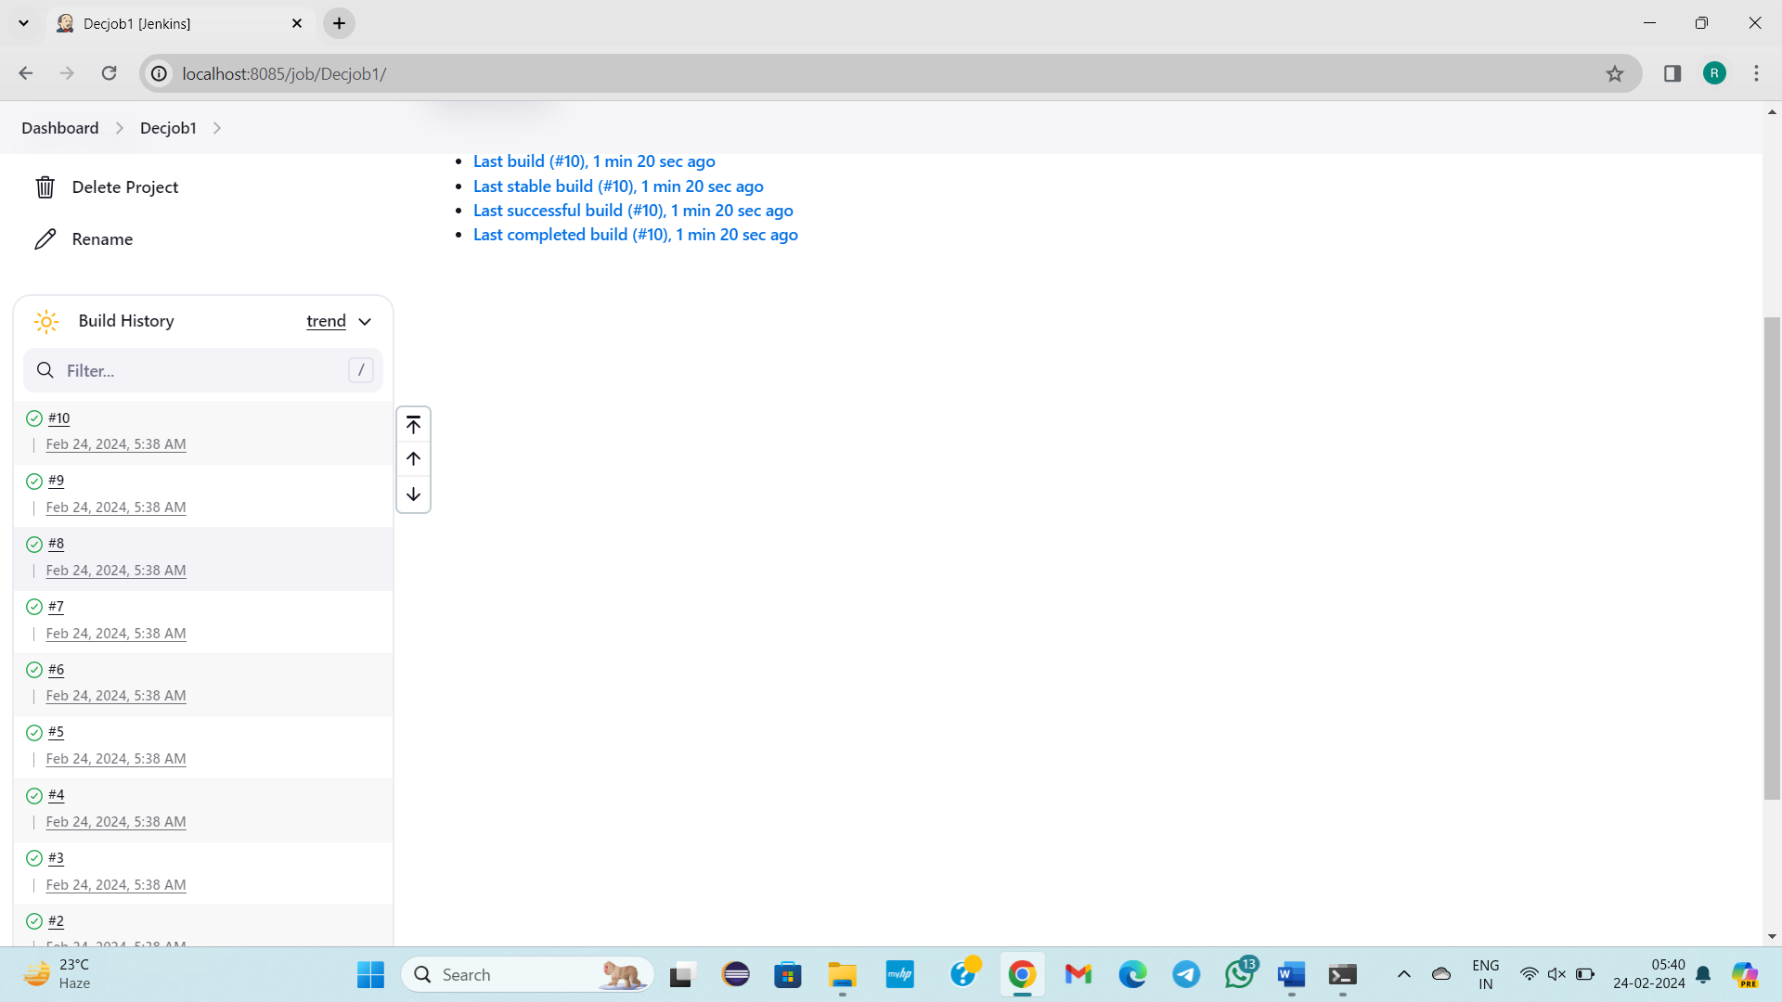

Now I want to view only latest 2-3 build history in logs and it should be present for only one day after that it must delete

For that,

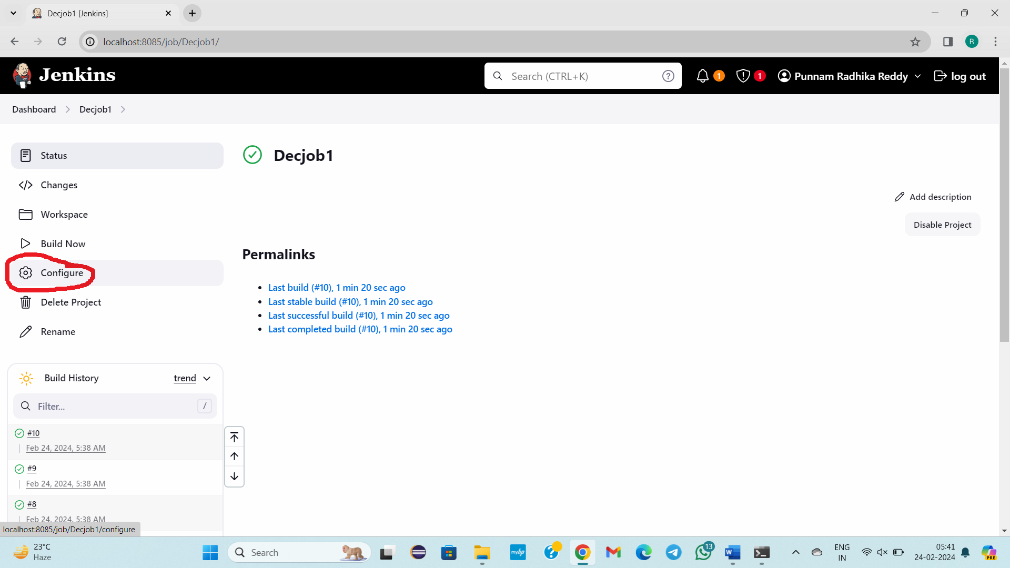

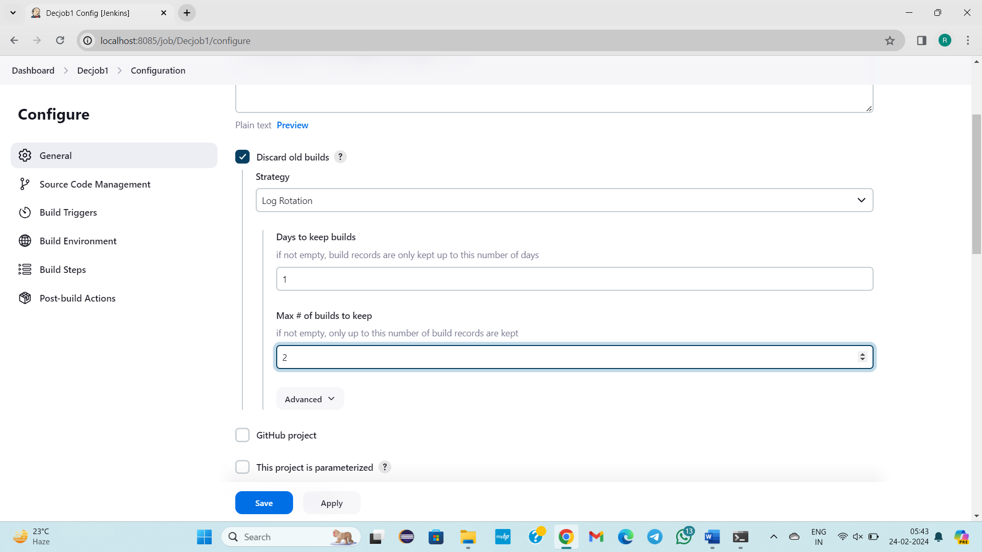

Now let’s see either it is working or not

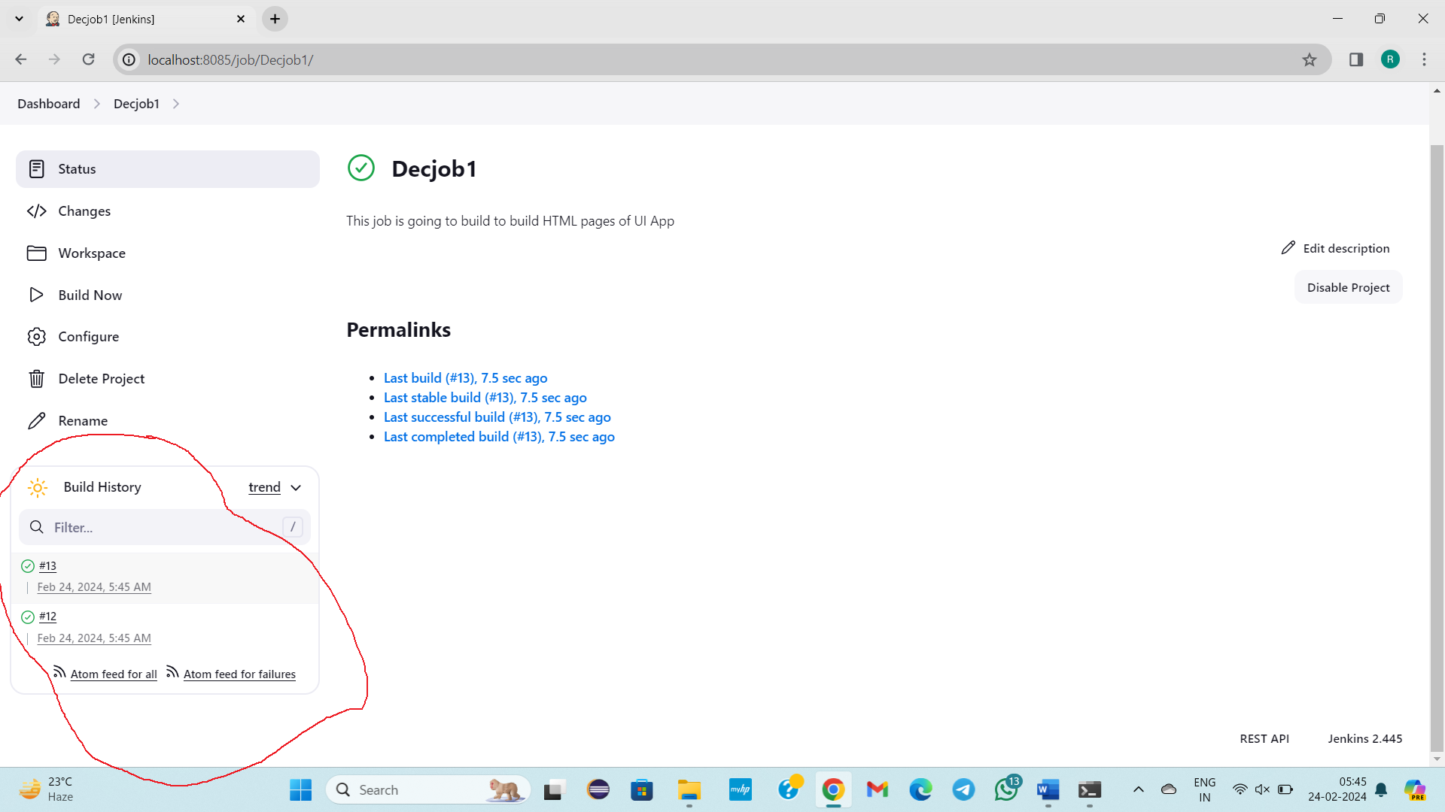

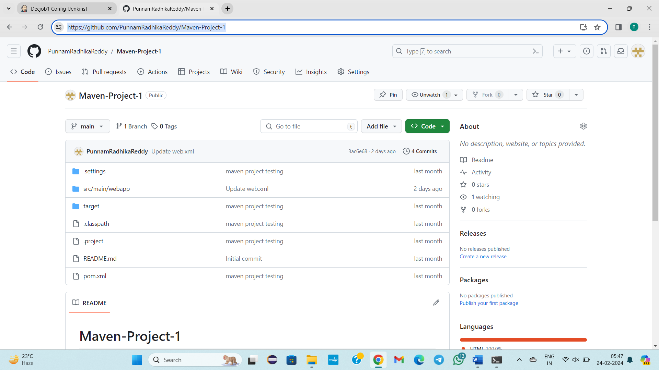

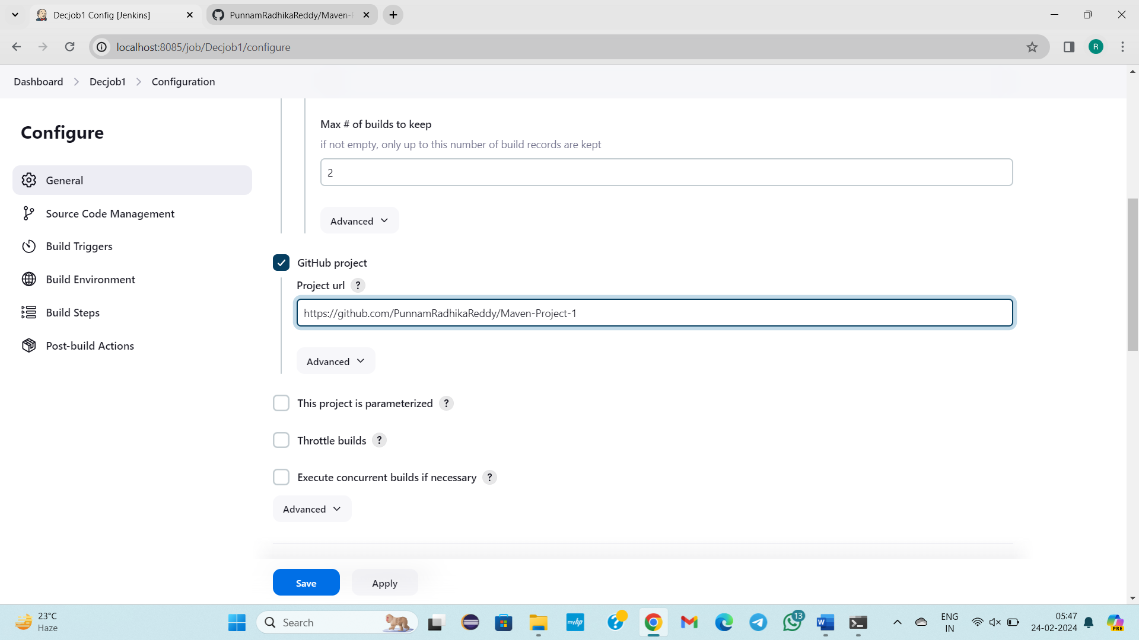

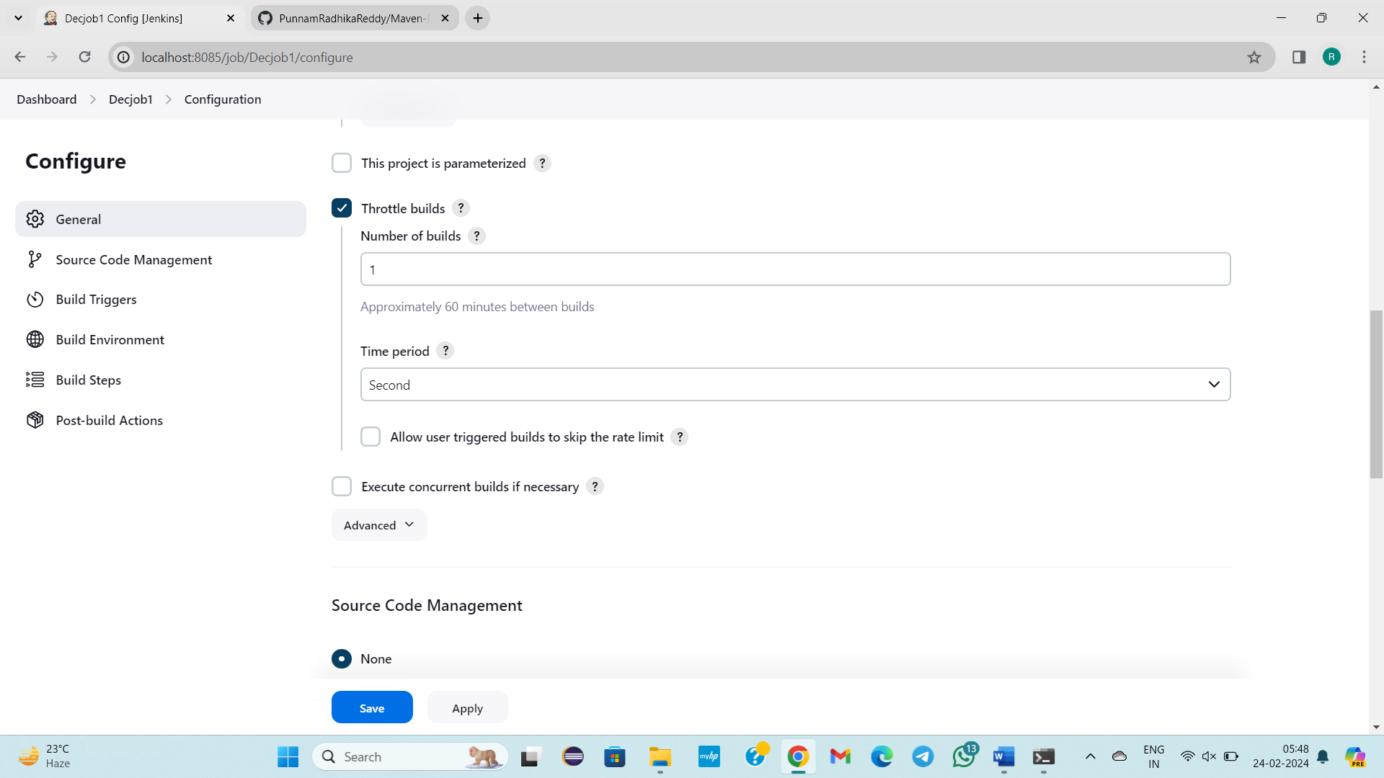

**2)SourceCode Management**

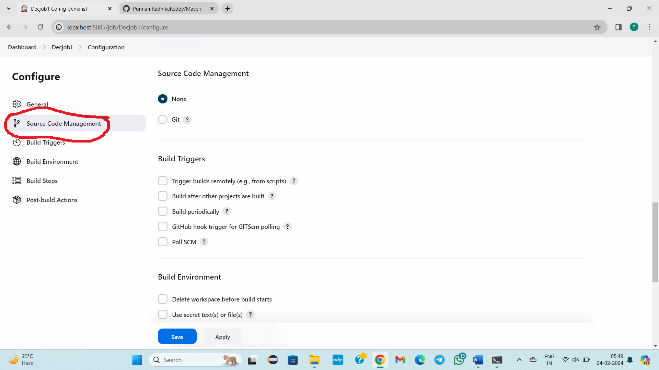

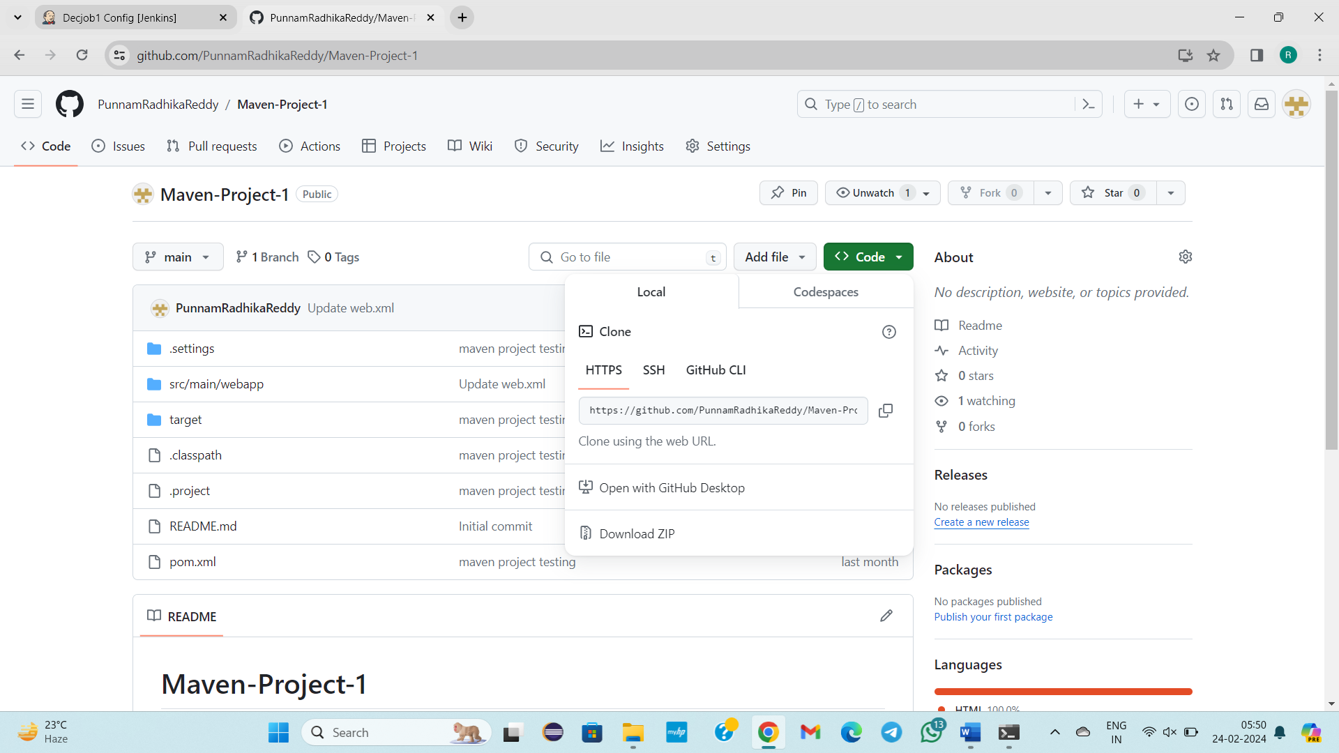

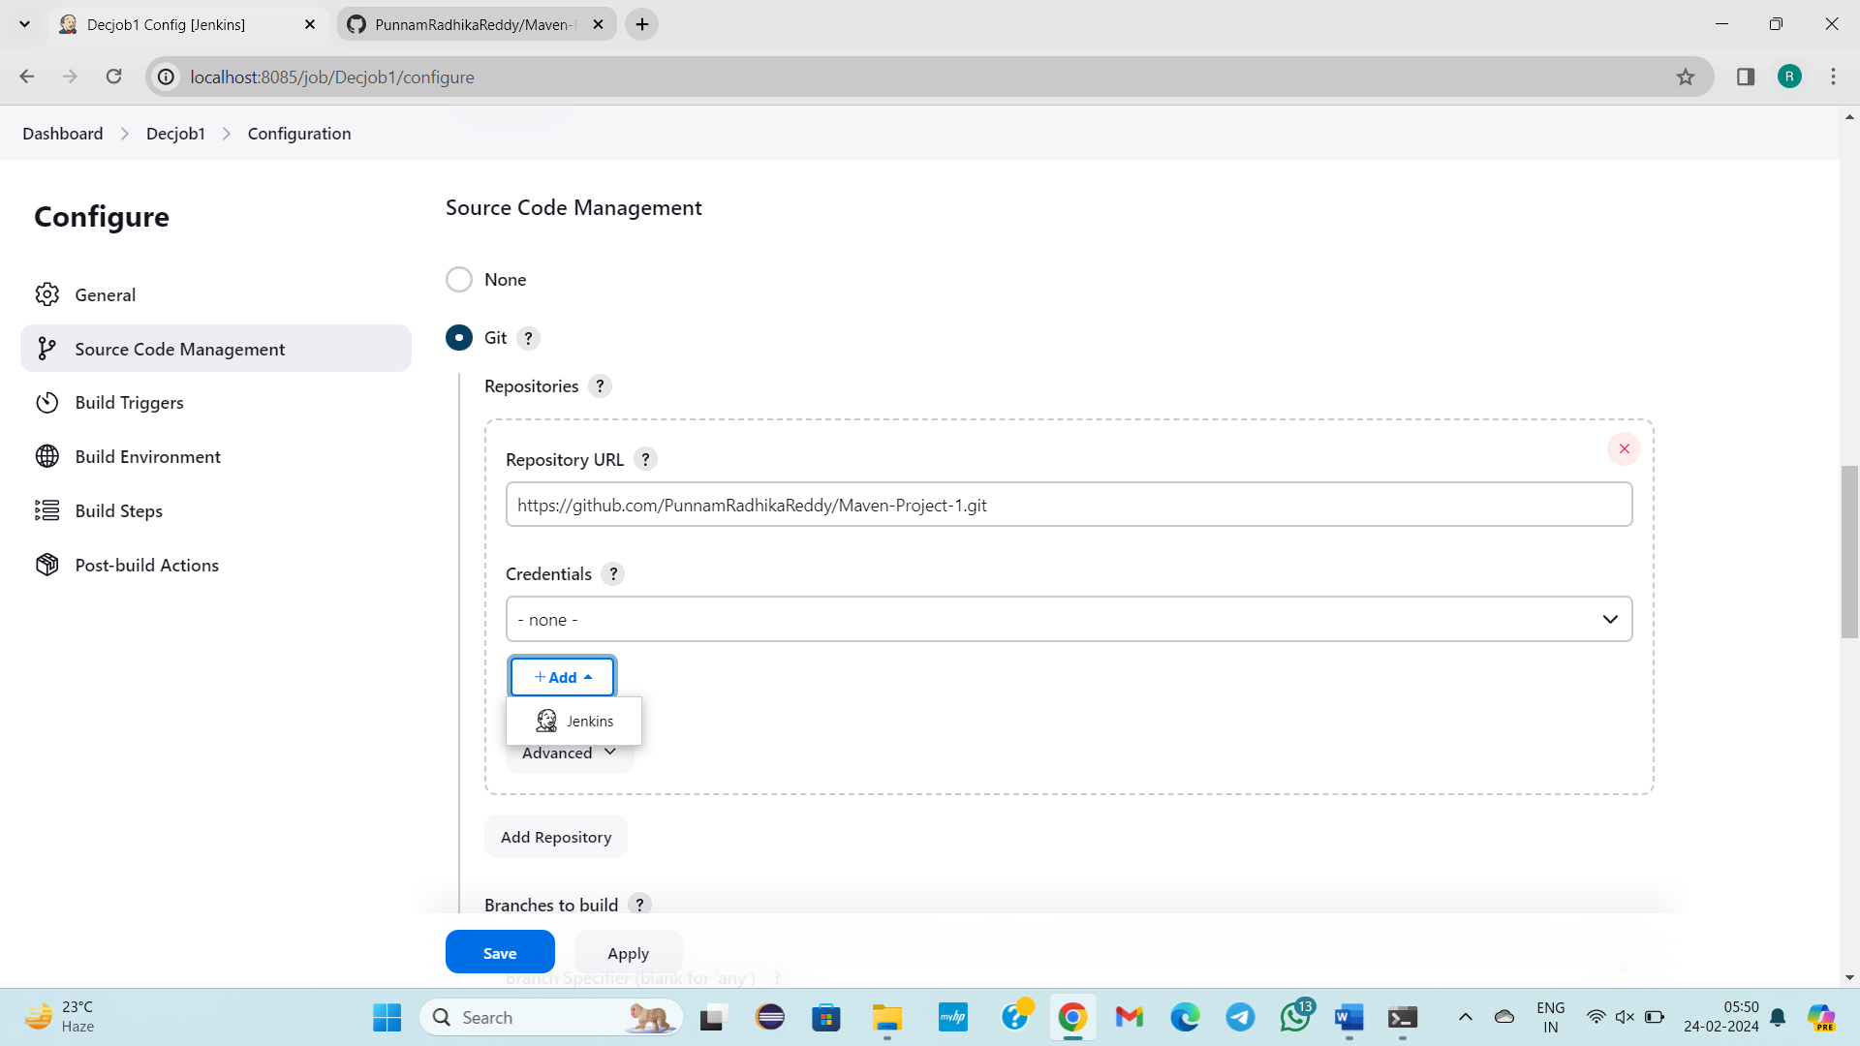

Click on Jenkins

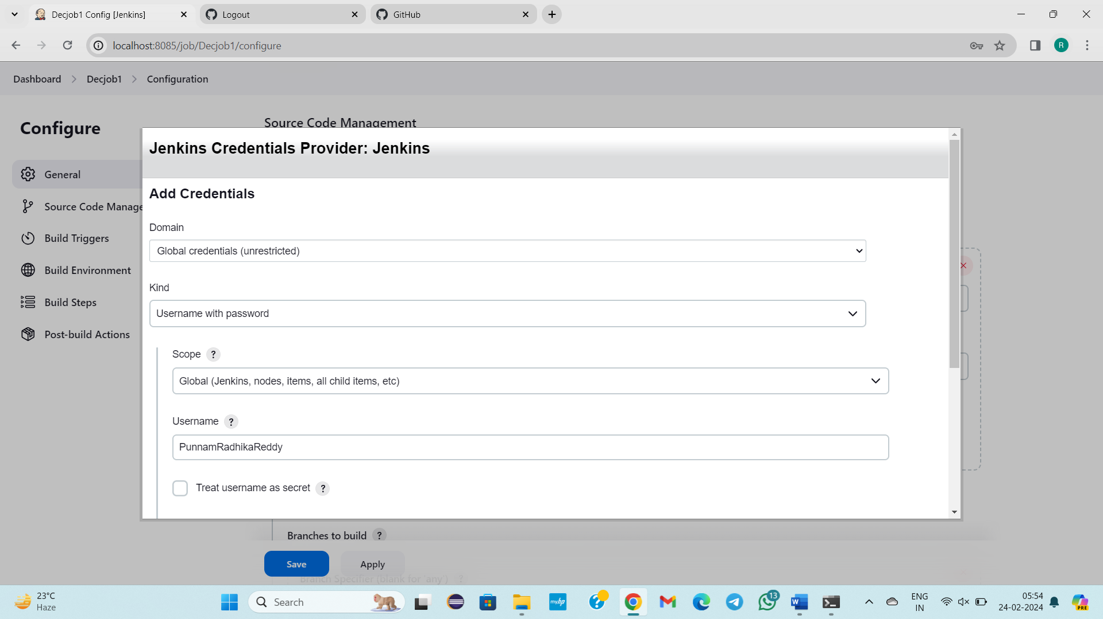

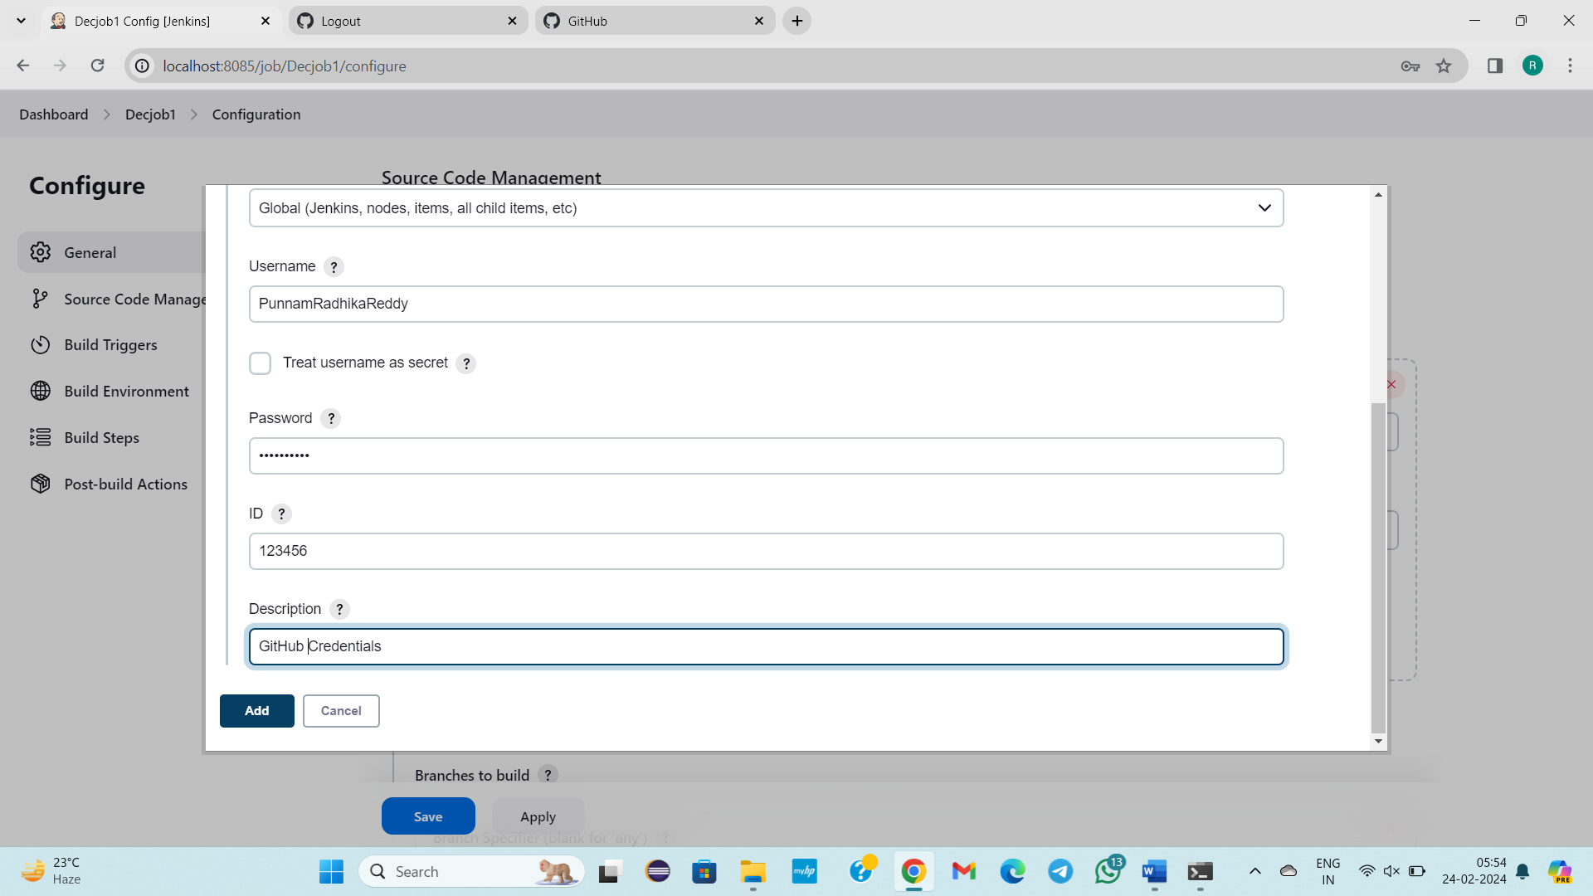

Click on add

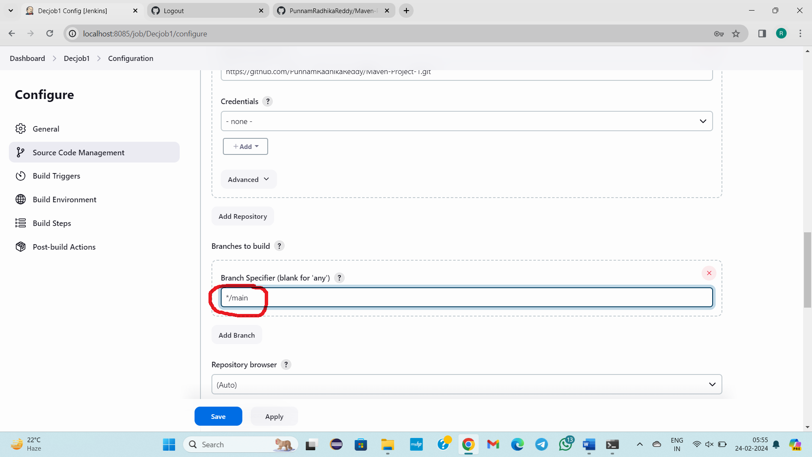

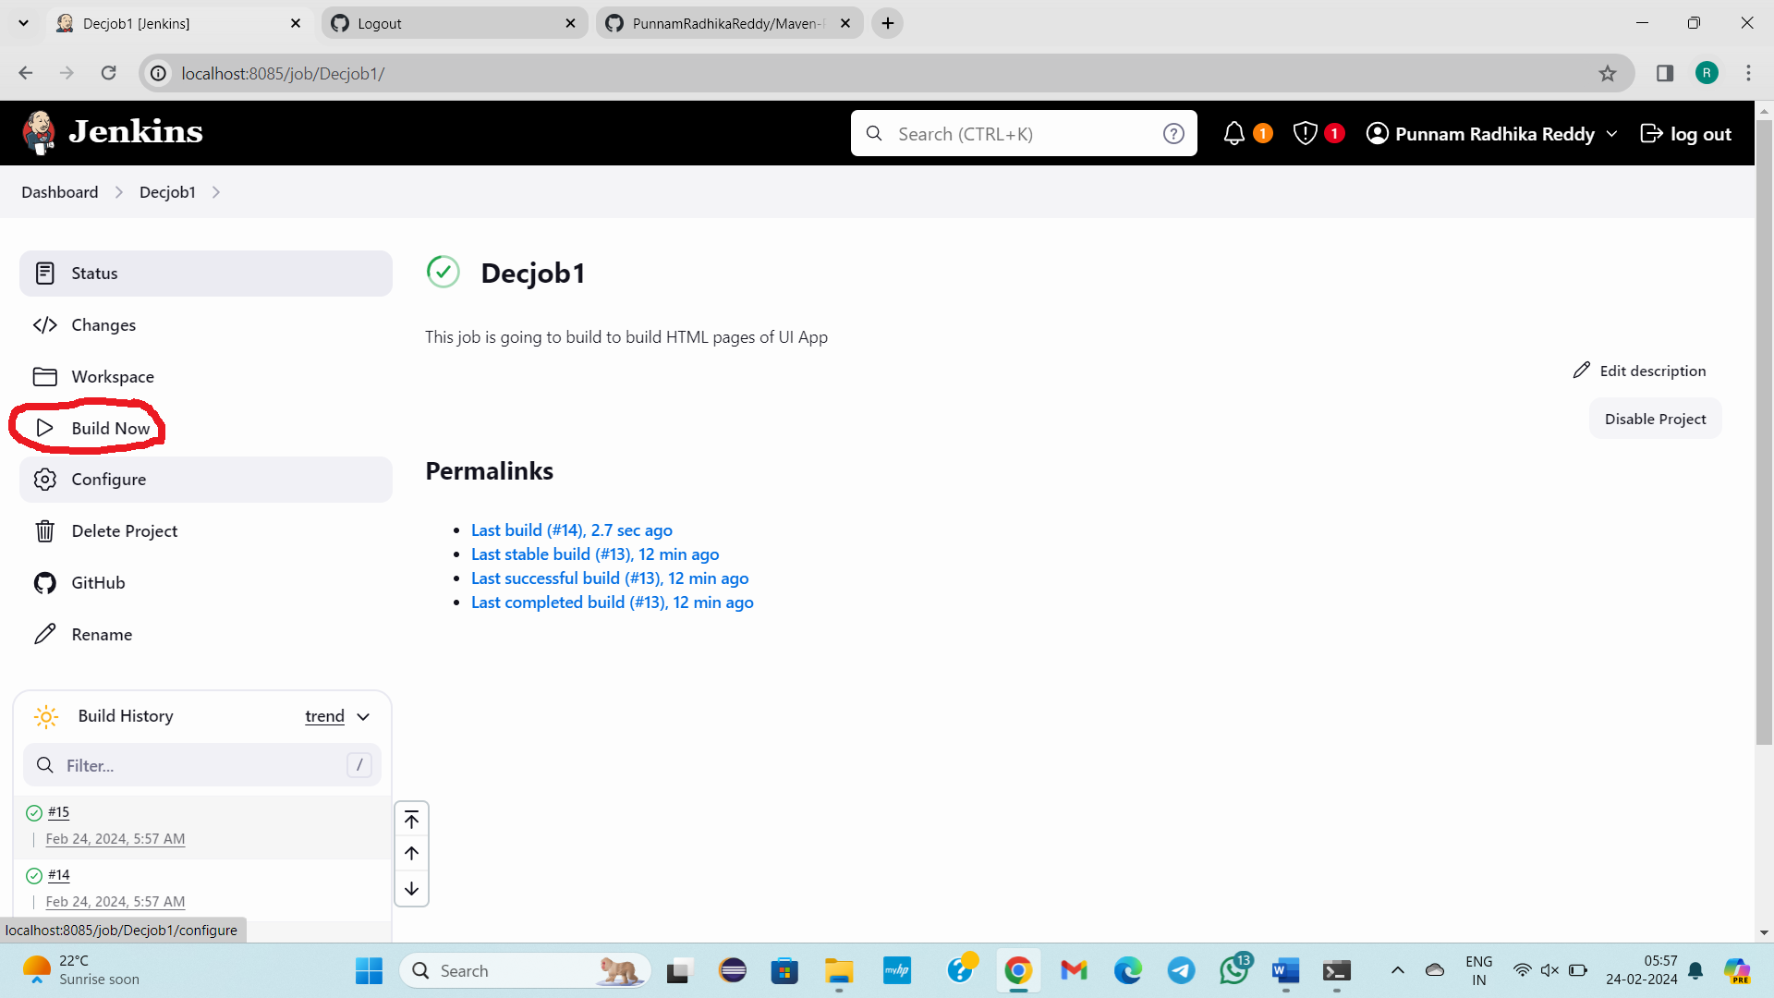

Click on build now

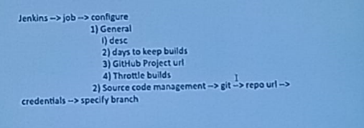

**--------------24/02/2024-------Saturday------------------Class – 46------------------**

**Topic: What are the 6 ways To Build a Job**

**1)By Clicking on button**

**2)By Clicking on 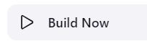 option**

**3) Trigger builds remotely (e.g., from scripts)**

**4)** **Build after other projects are built**

**5) Build periodically**

**6) Poll SCM**

**5 ways To build a job are discussed today Only Poll SCM is pending.**

**REFER 5WAYS TO BUILD JOBS EACH AND EVERY STEP IN DETAIL for execution.**

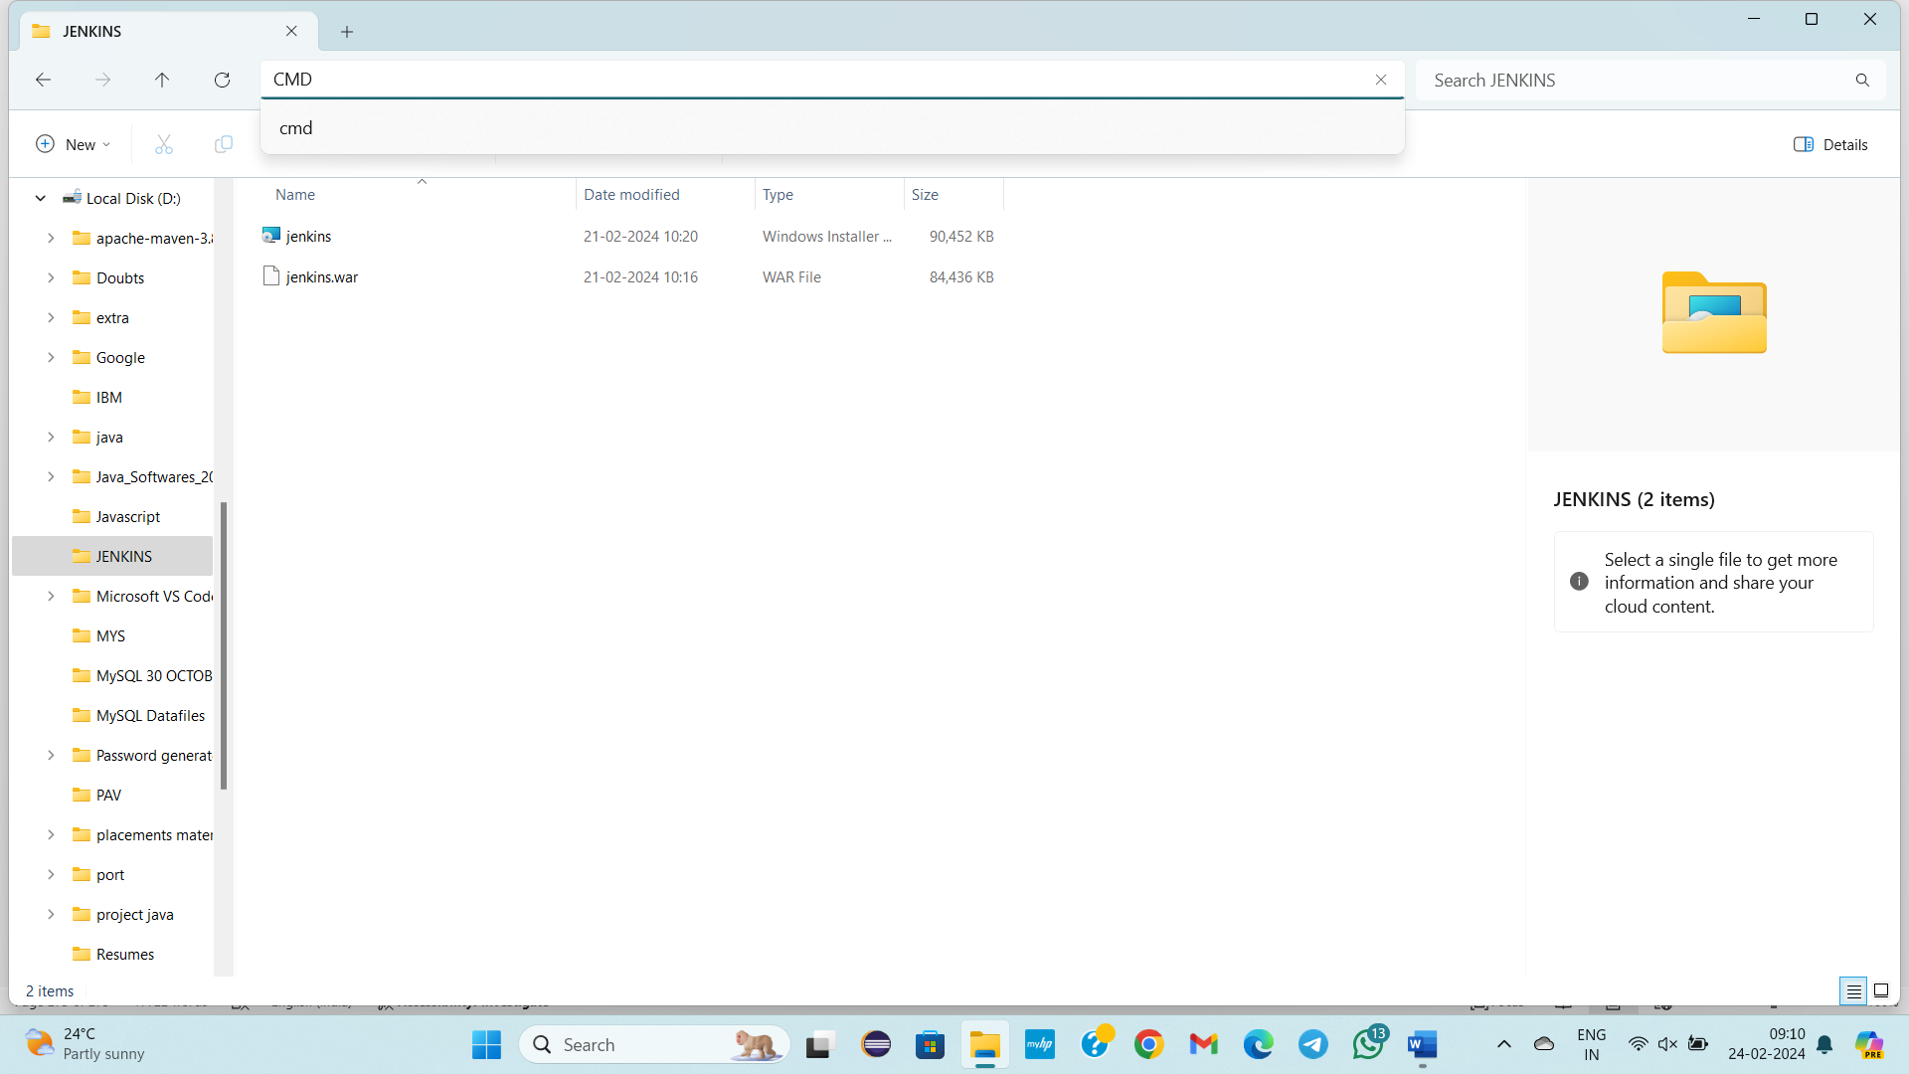

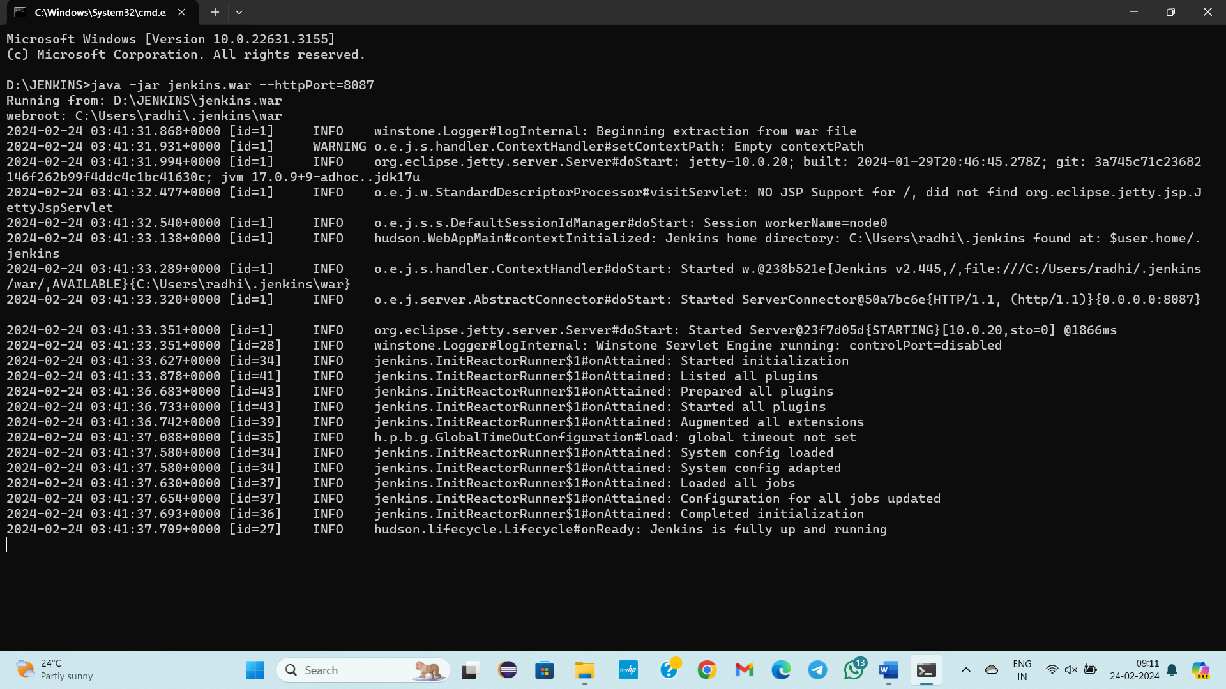

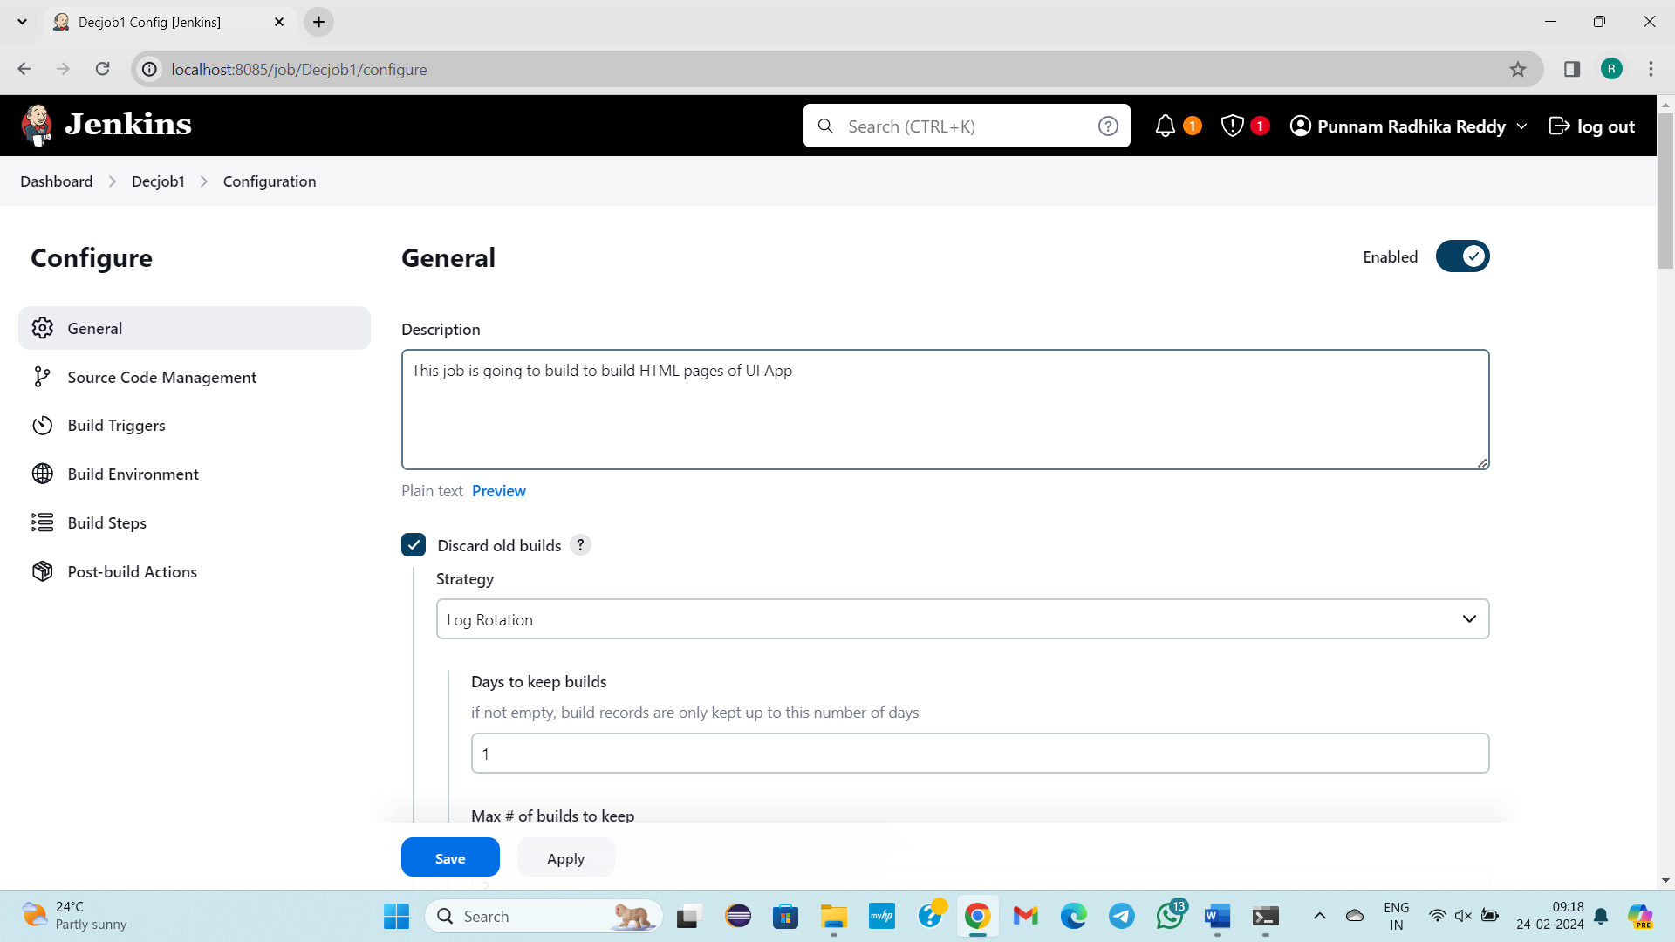

Yesterday we have learnt about the general, Source code Management

Build Triggers

We have built job in 2 ways

1)

2) Build now option

These are manual pprocess

But without manual process how to build a job

1)Trigger builds remotely (e.g., from scripts)

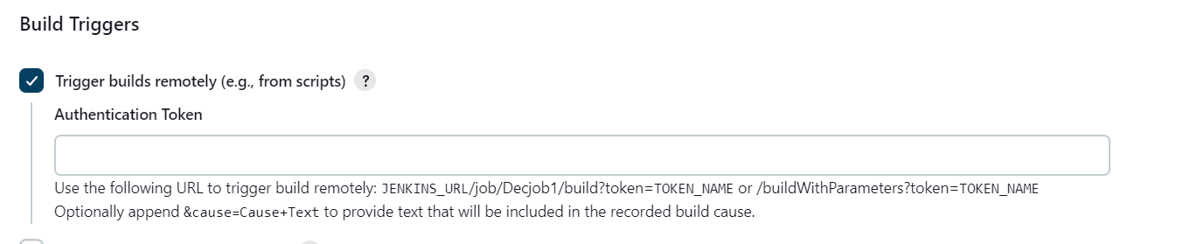

JENKINS_URL/job/Decjob1/build?token=TOKEN_NAME

http://localhost:8085/job/Decjob1/ build?token=slokamawsbatch

2) Build after other projects are built

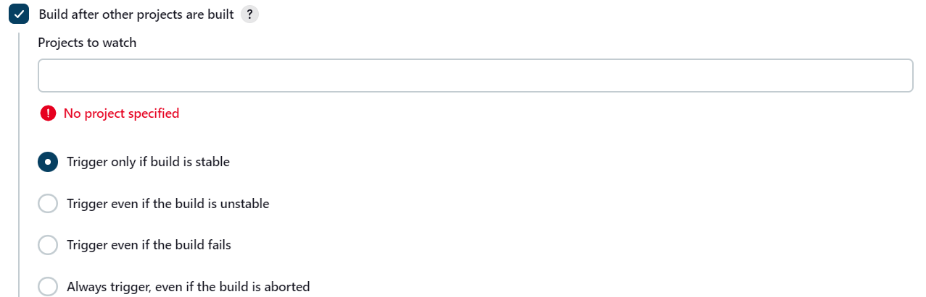

**decJob1**

**Job 2**

**Job 3**

**Create dec job2 and dec job3**

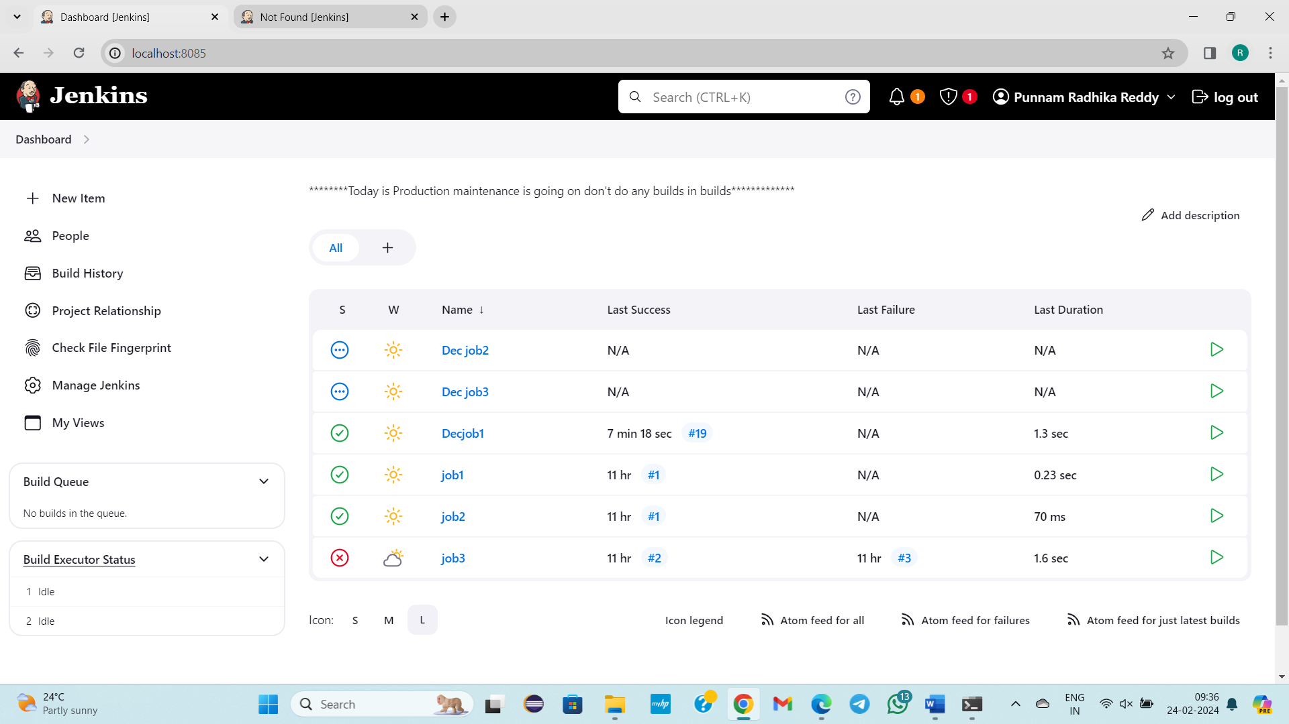

**We will build job1 manually.**

**After job1 build it triggeres job2**

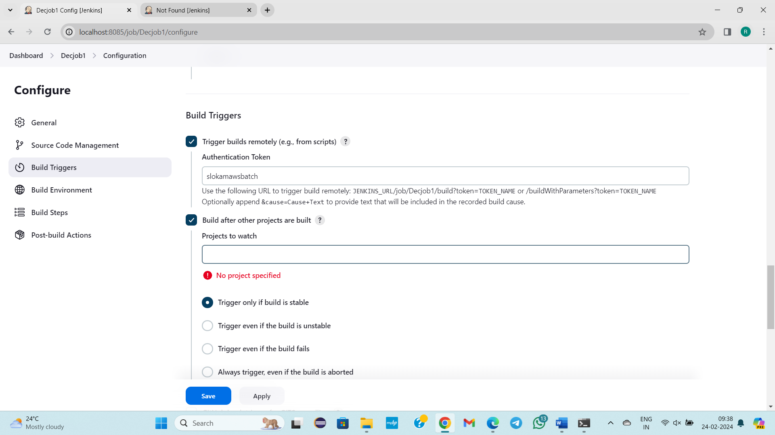

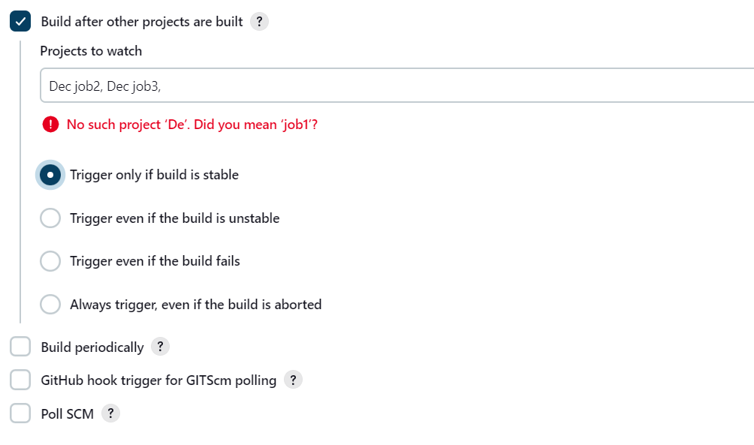

JENKINS_URL/job/Decjob1/build?token=TOKEN_NAME

**http://localhost:8085/job/Decjob1/** build?token=aws

3)URL, TOKEN

4)JOBS BUILD🡪 Depending on other jobs

**\*\*\*\*\*\*Build PERIODICALLY**

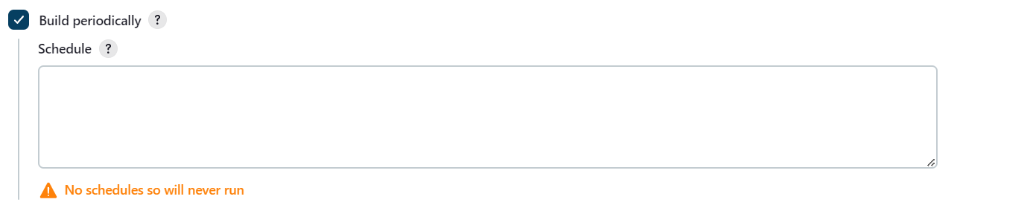

**crontab format**

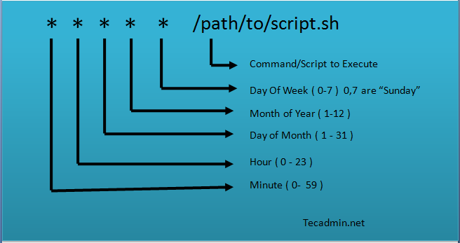

Cron tab format

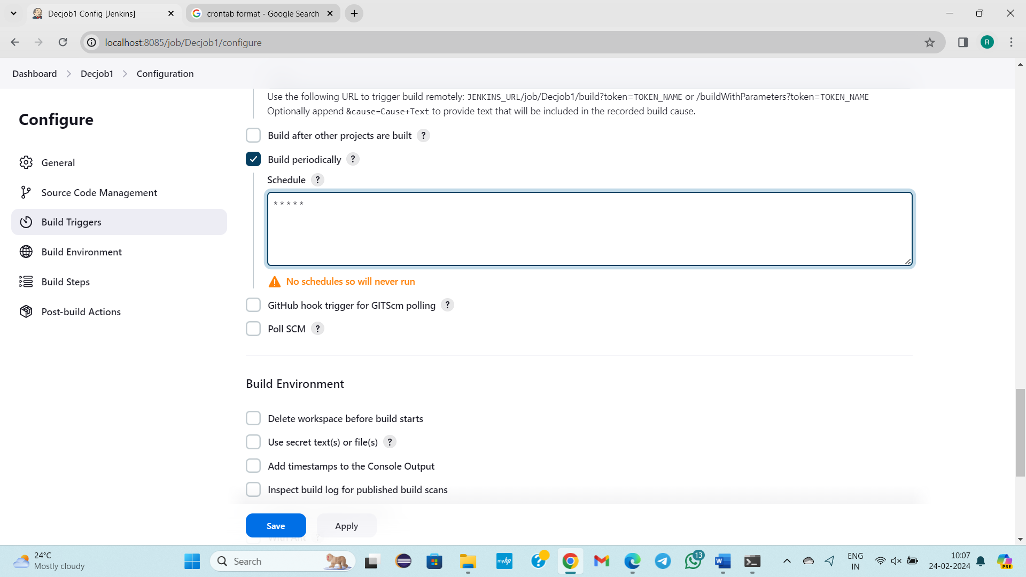

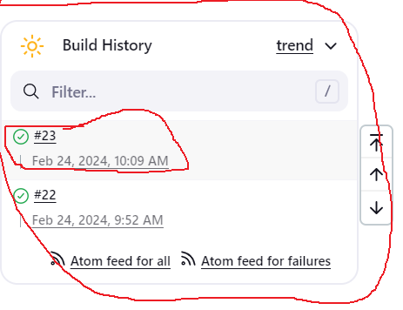

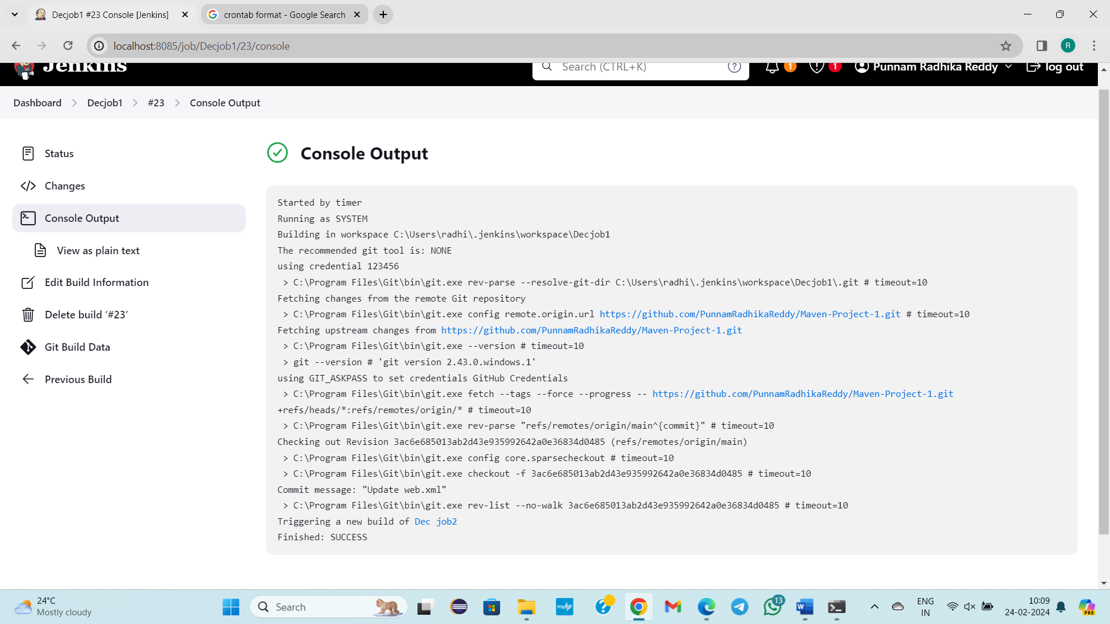

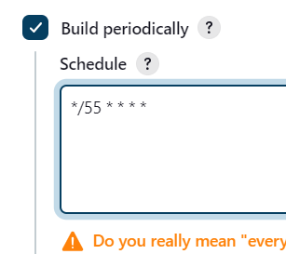

For every 55 minutes build should happen

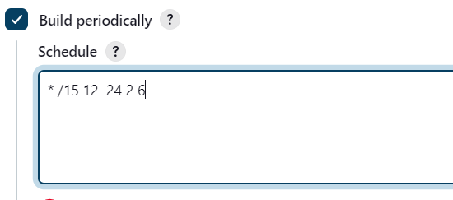

15 minutes, AN 1 clock, 24 date, Feb, Saturday

**\*\*\*\*\*5WAYS TO BUILD JOBS EACH AND EVERY STEP IN DETAIL\*\*\*\*\*\*\*\*\*\***

1. **By Clicking on button**

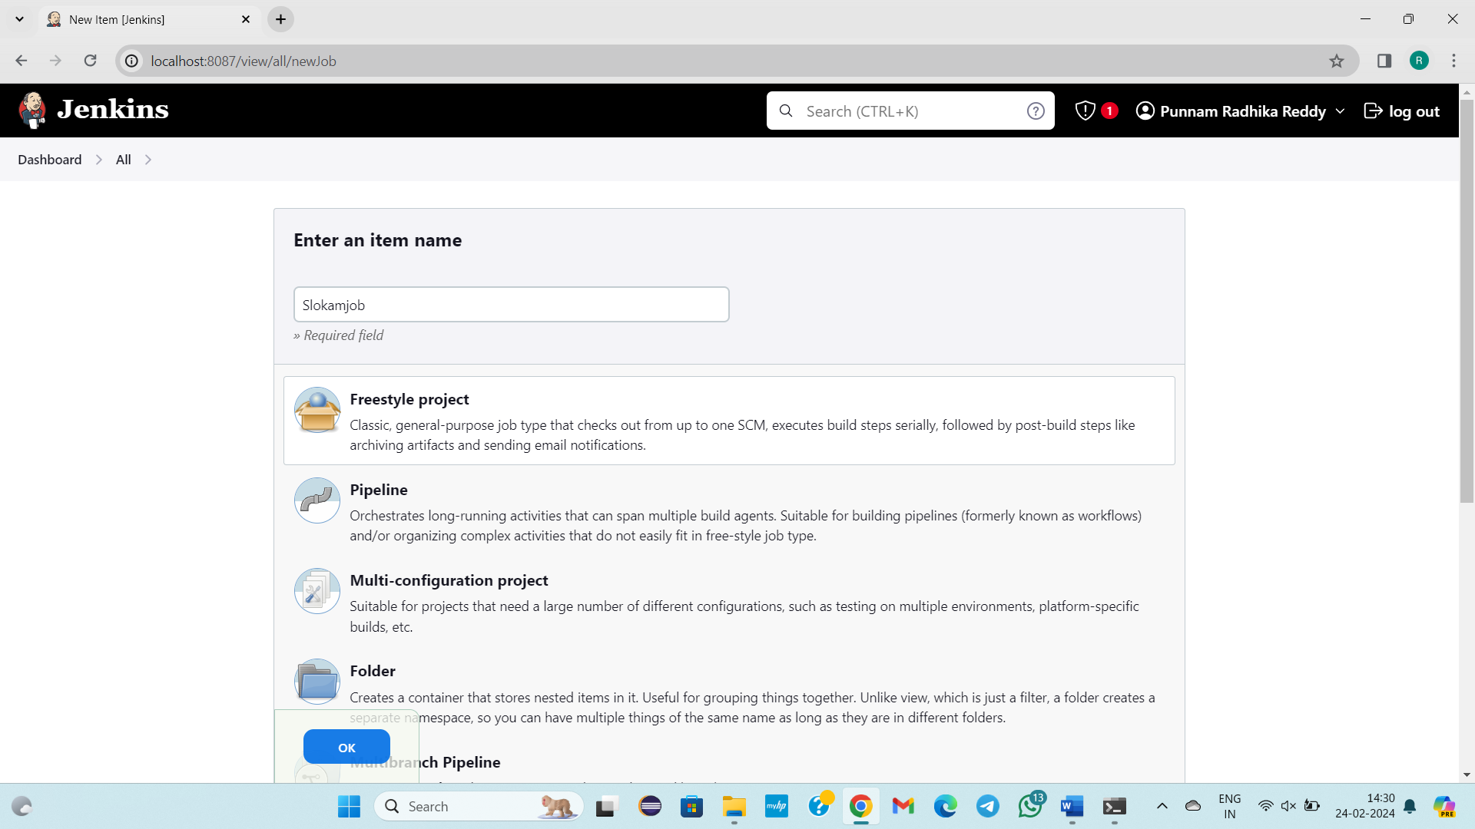

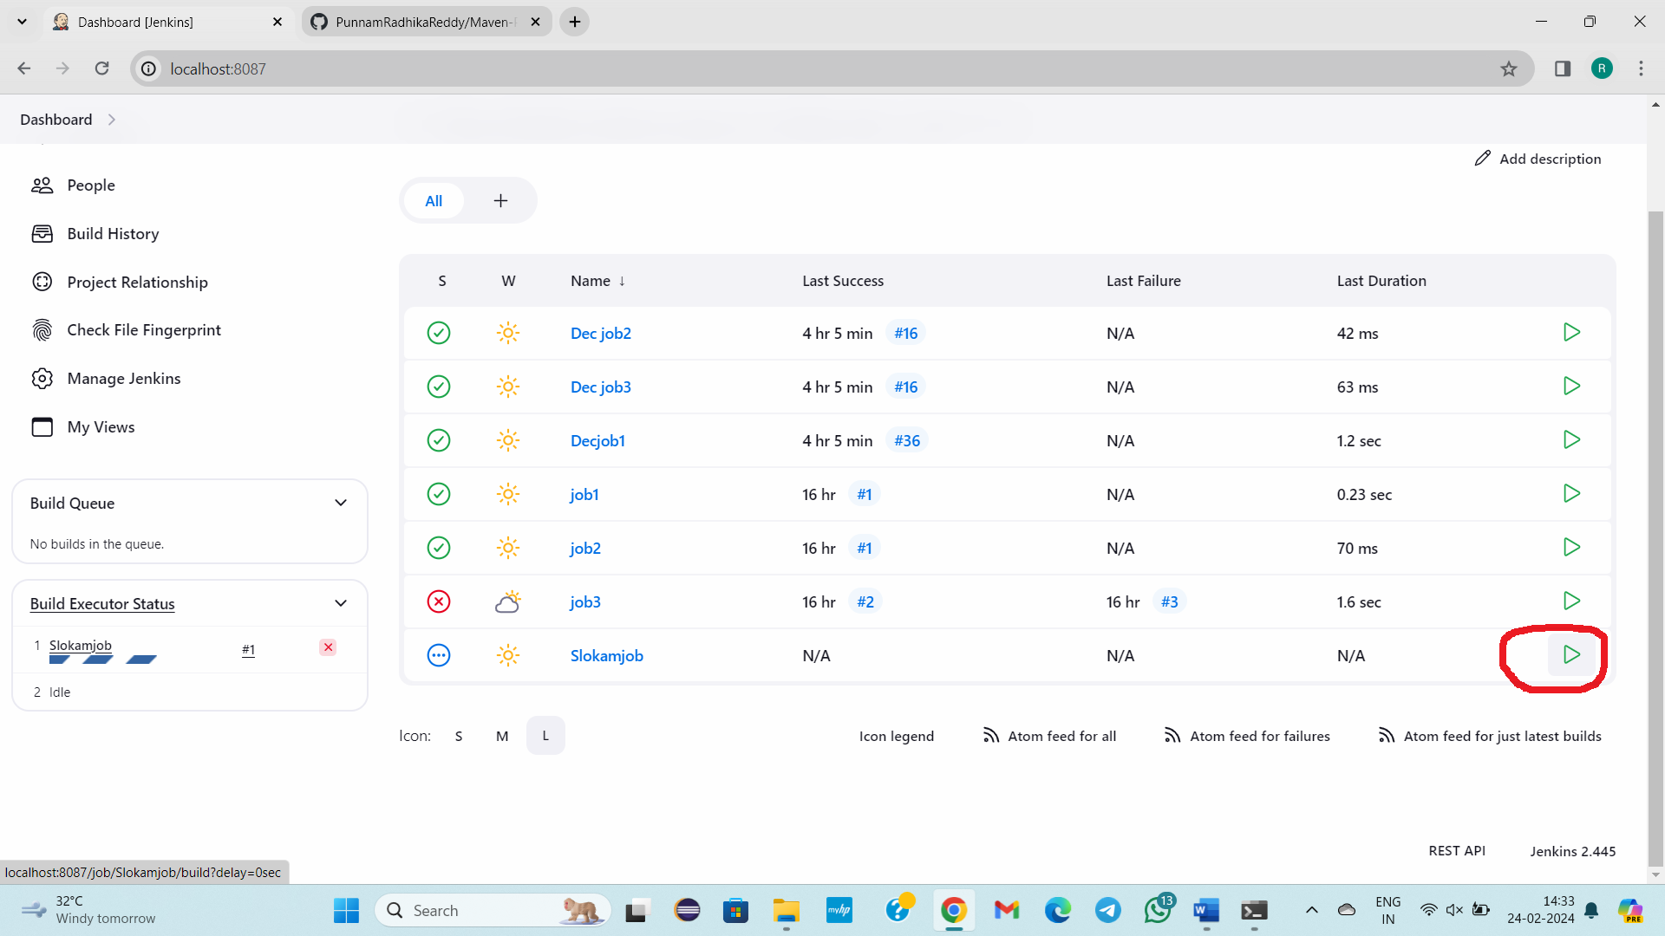

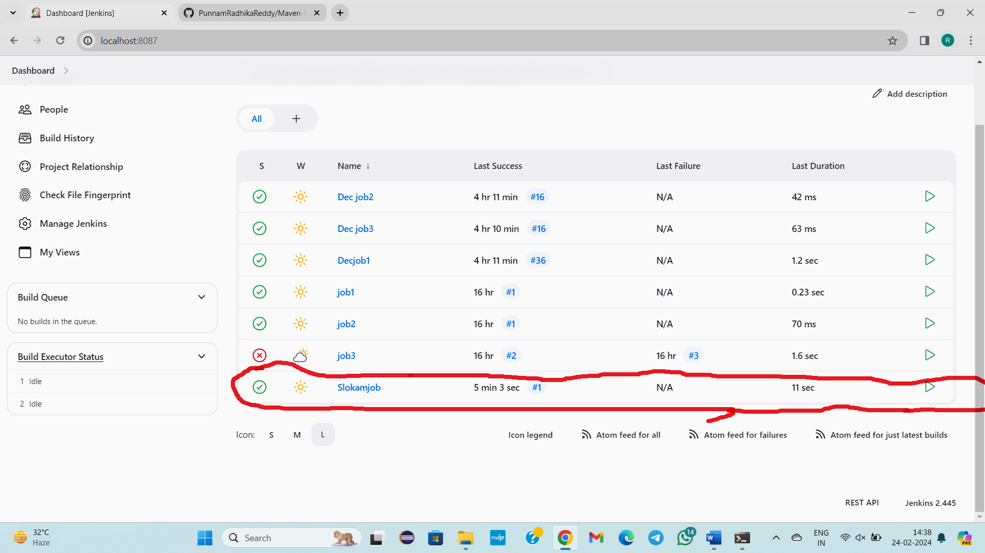

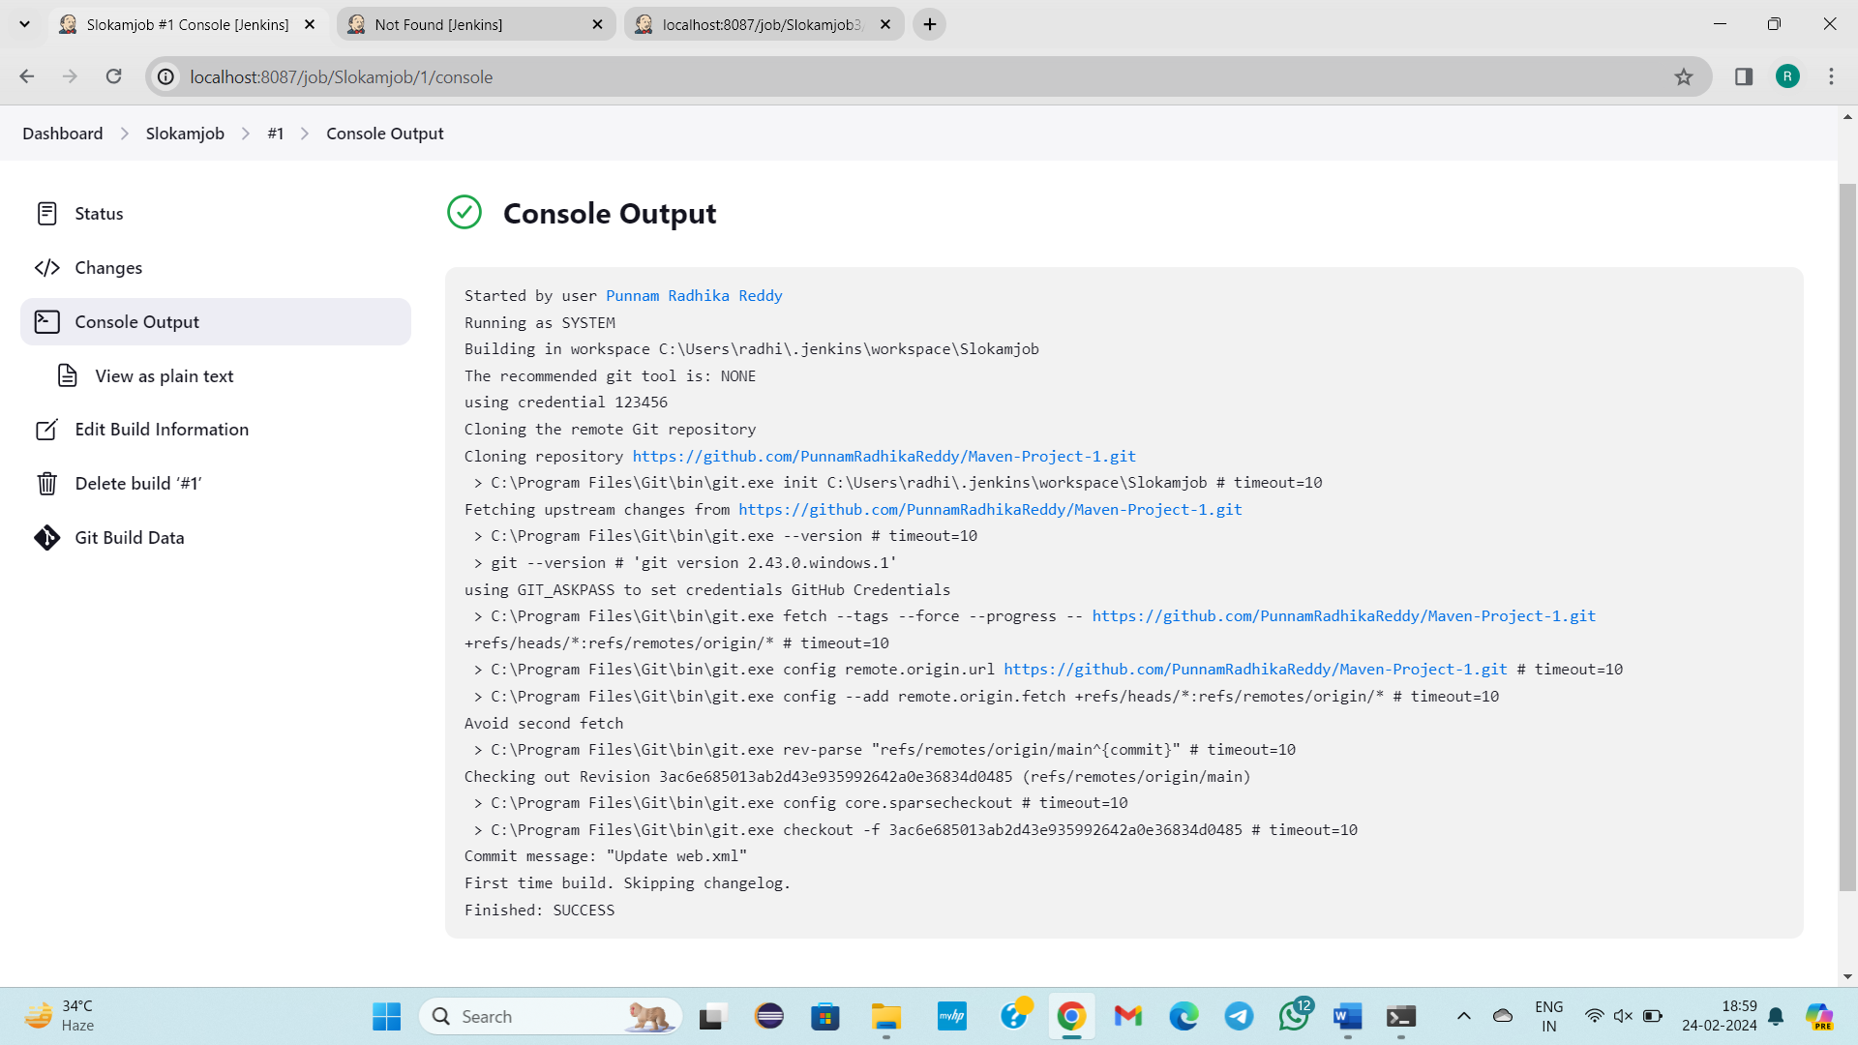

2) **By Clicking on**  **option**

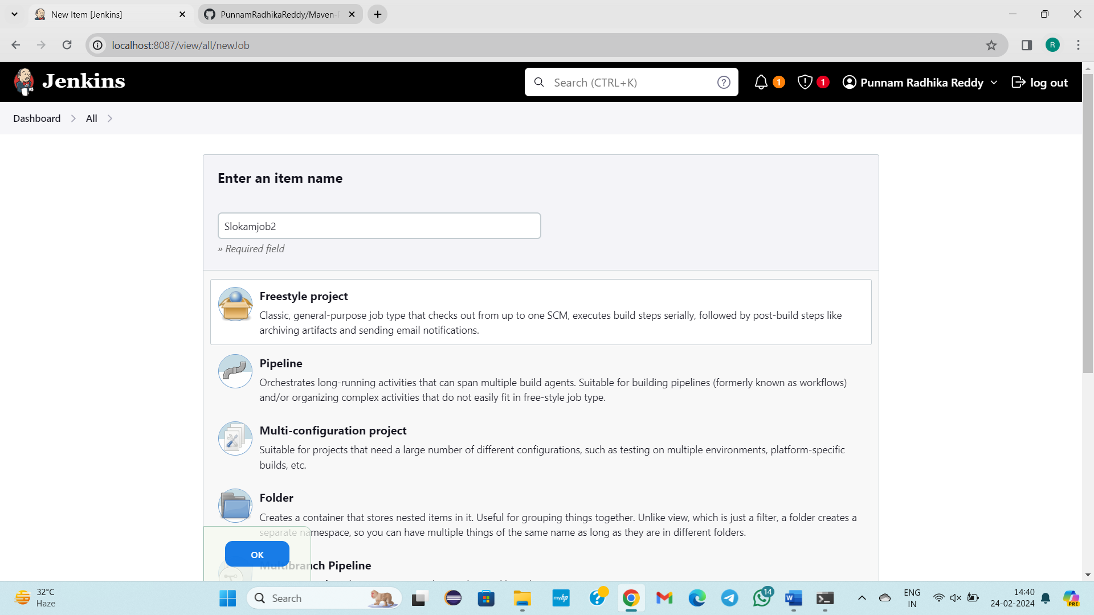

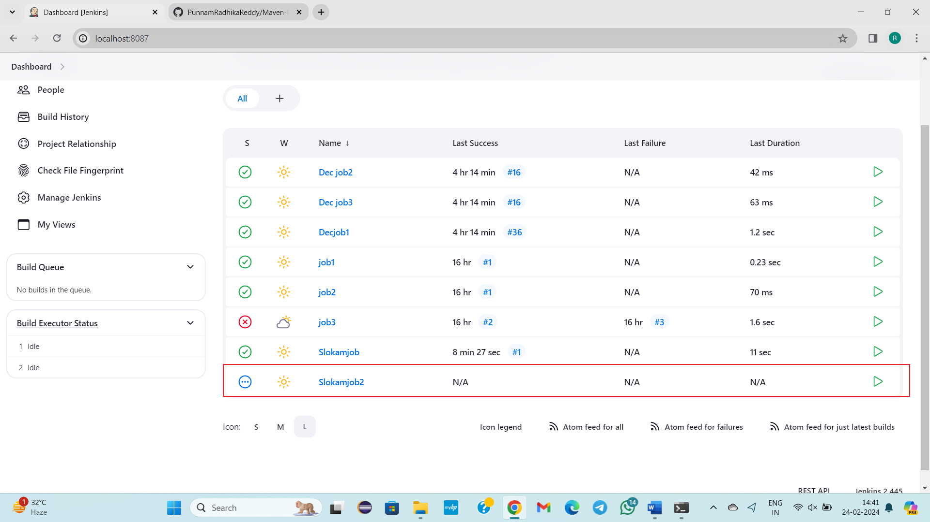

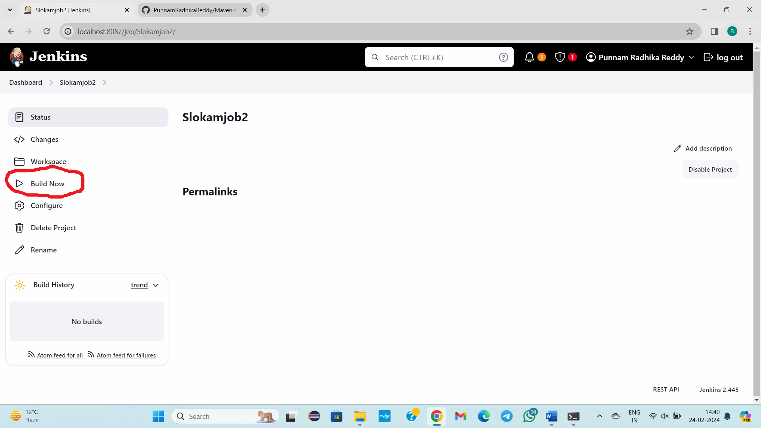

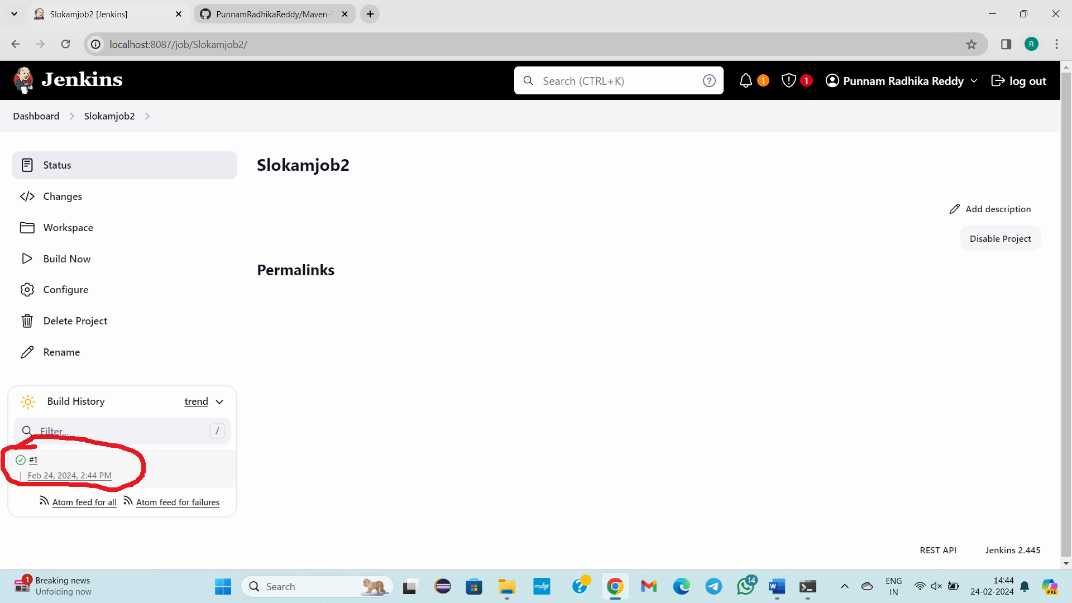

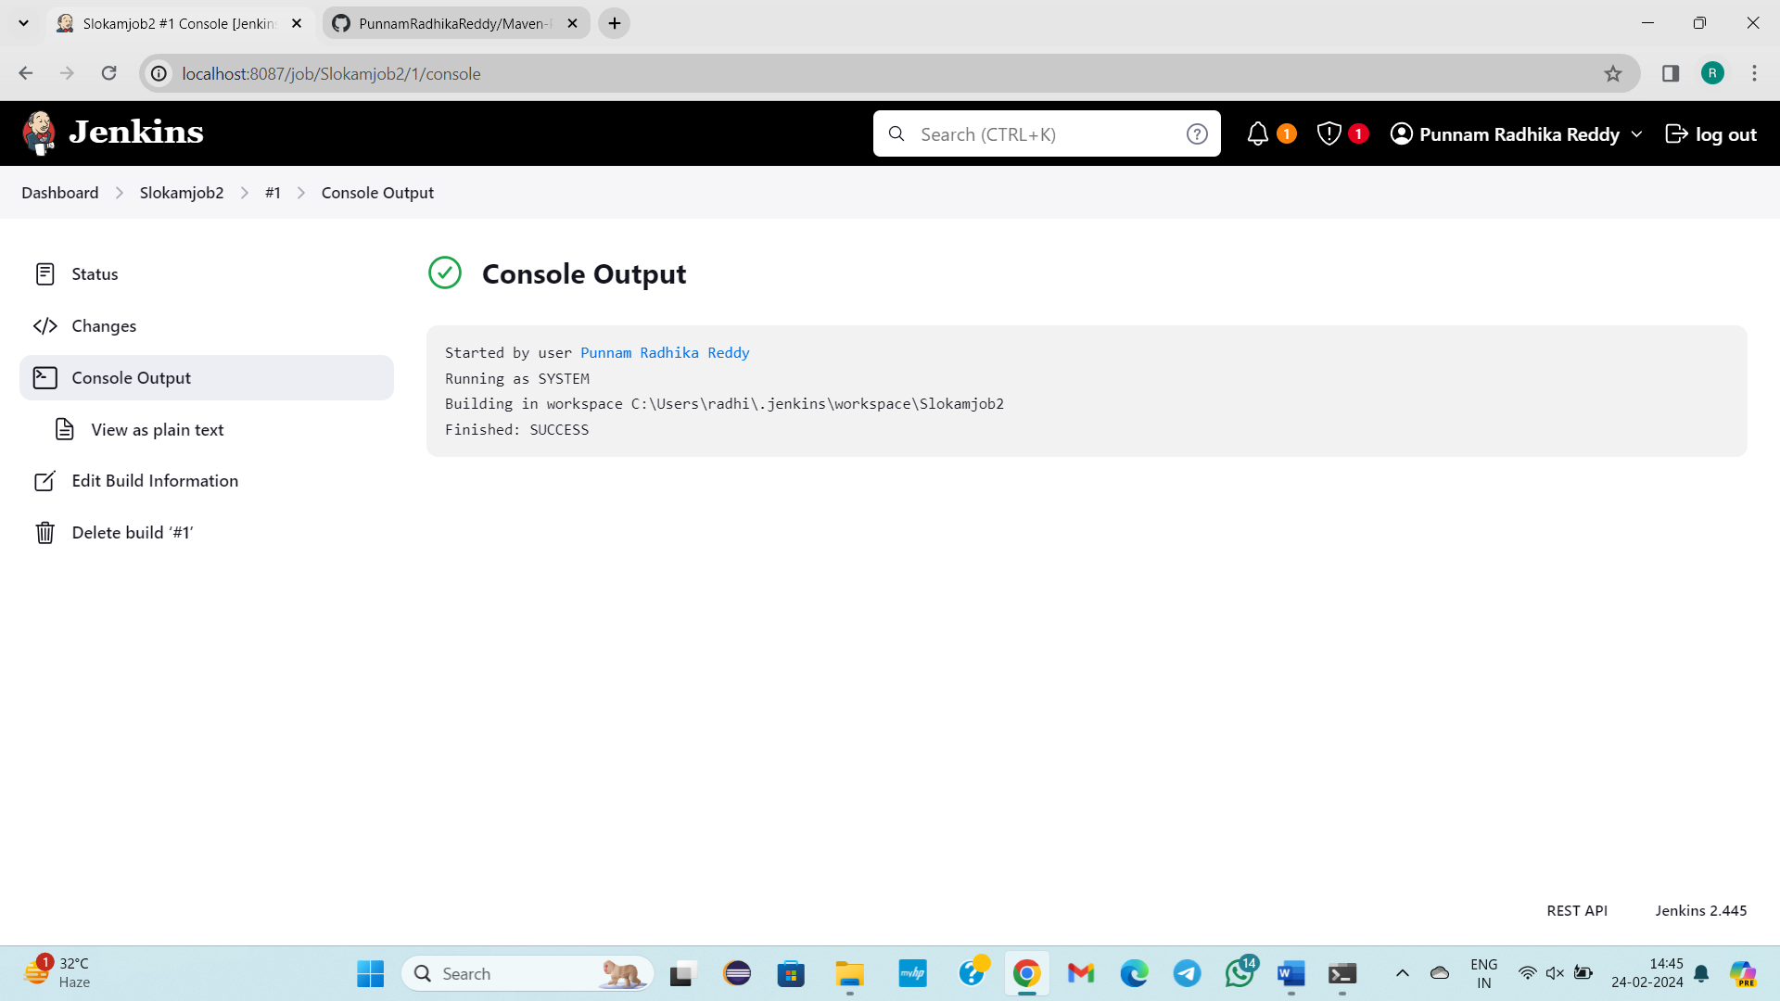

**3) Trigger builds remotely (e.g., from scripts)**

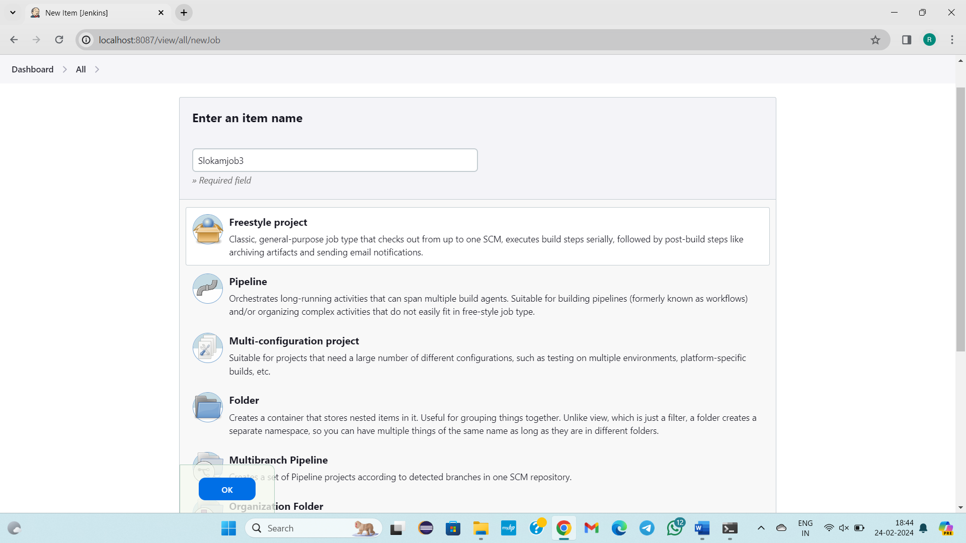

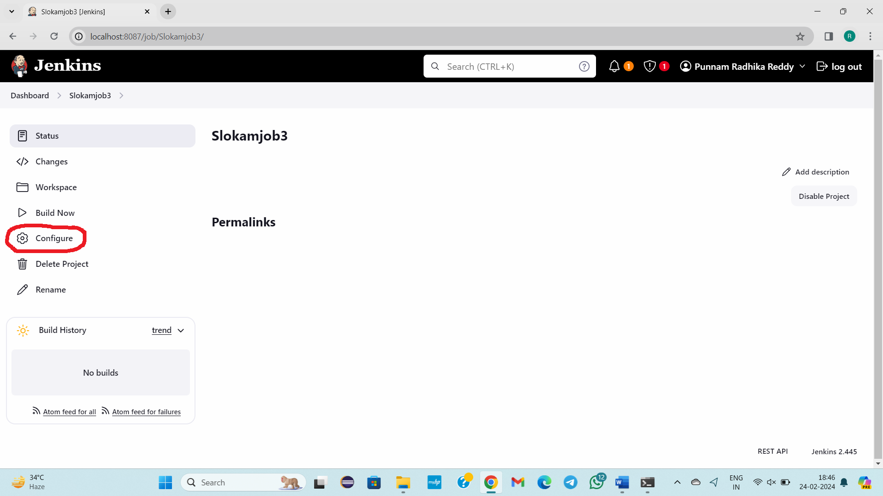

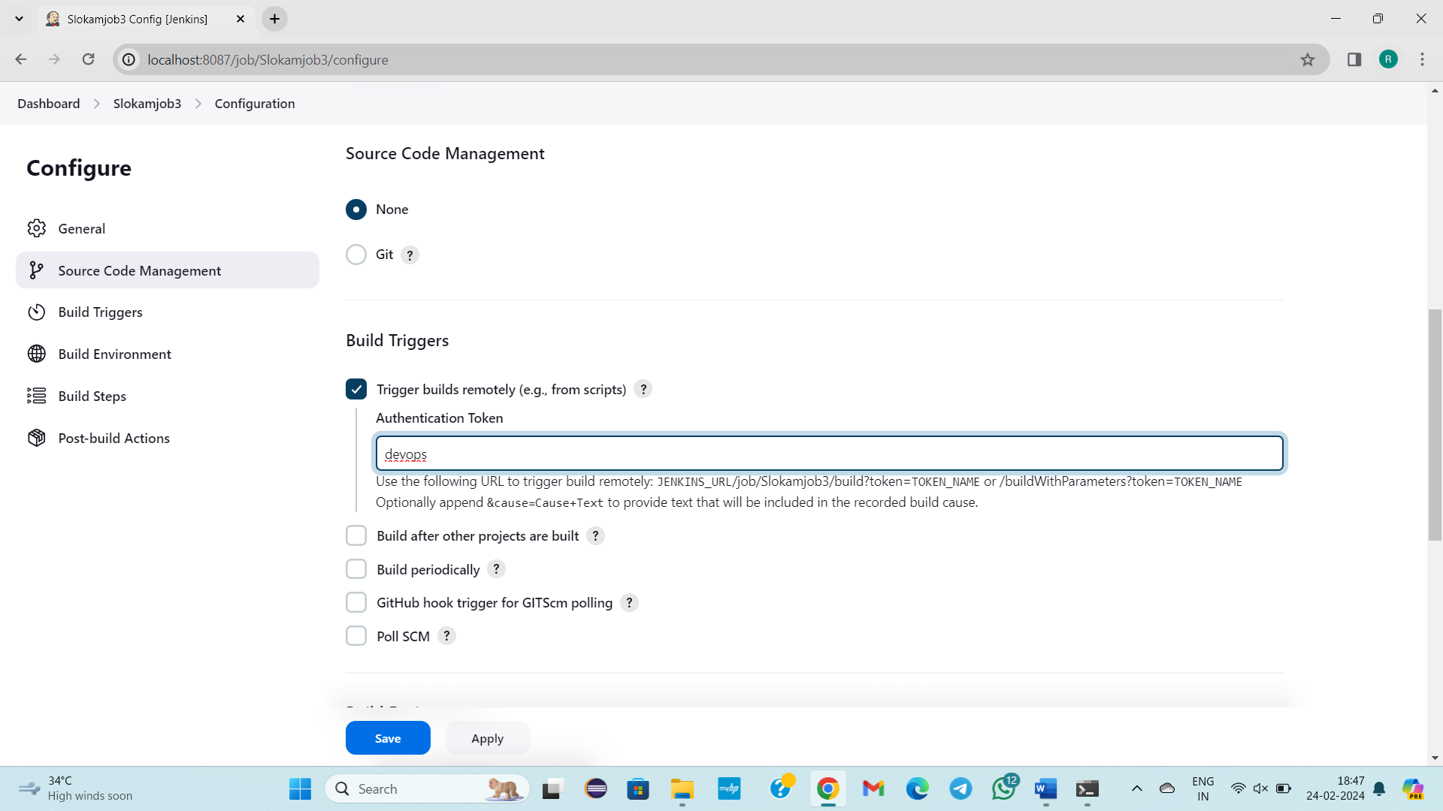

http://localhost:8087/job/Slokamjob3/ build?token=aws

JENKINS_URL/job/Slokamjob3/build?token=TOKEN_NAME

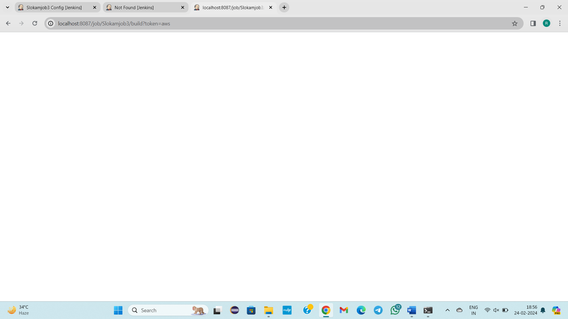

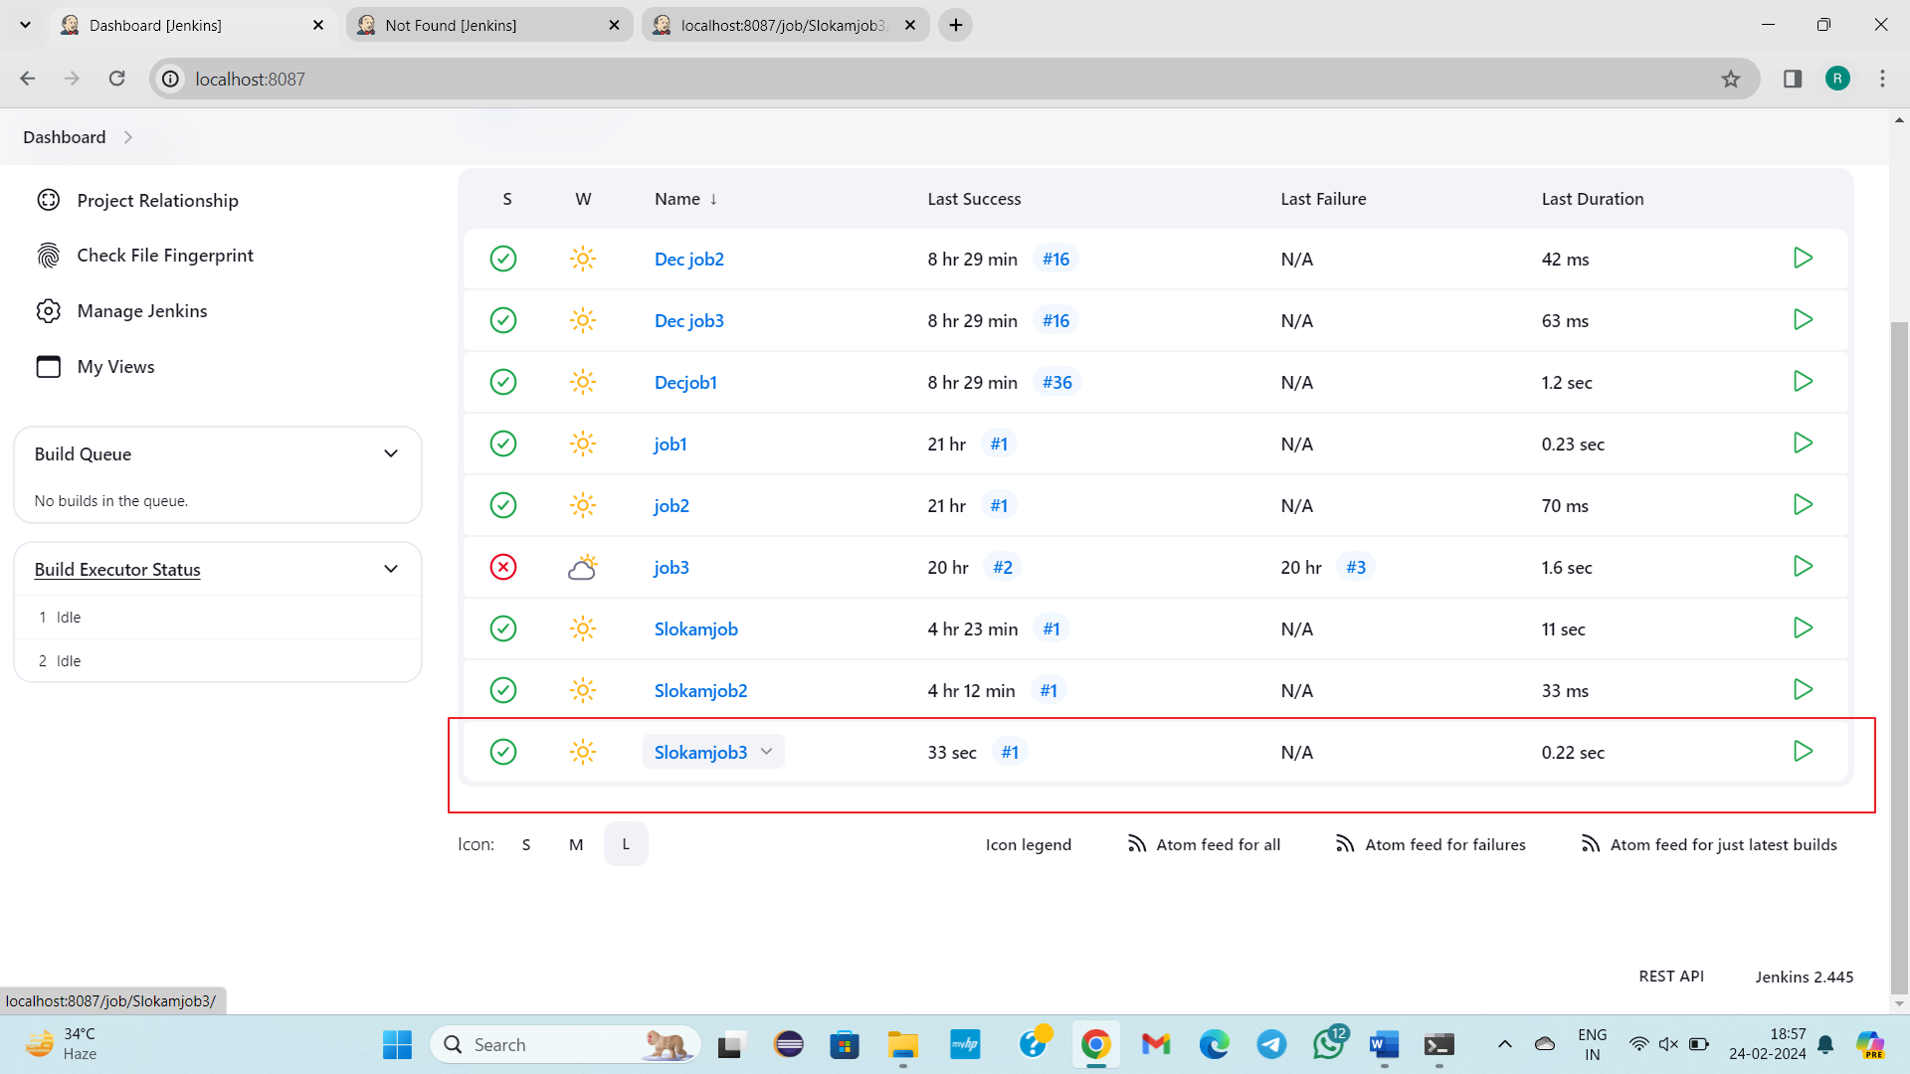

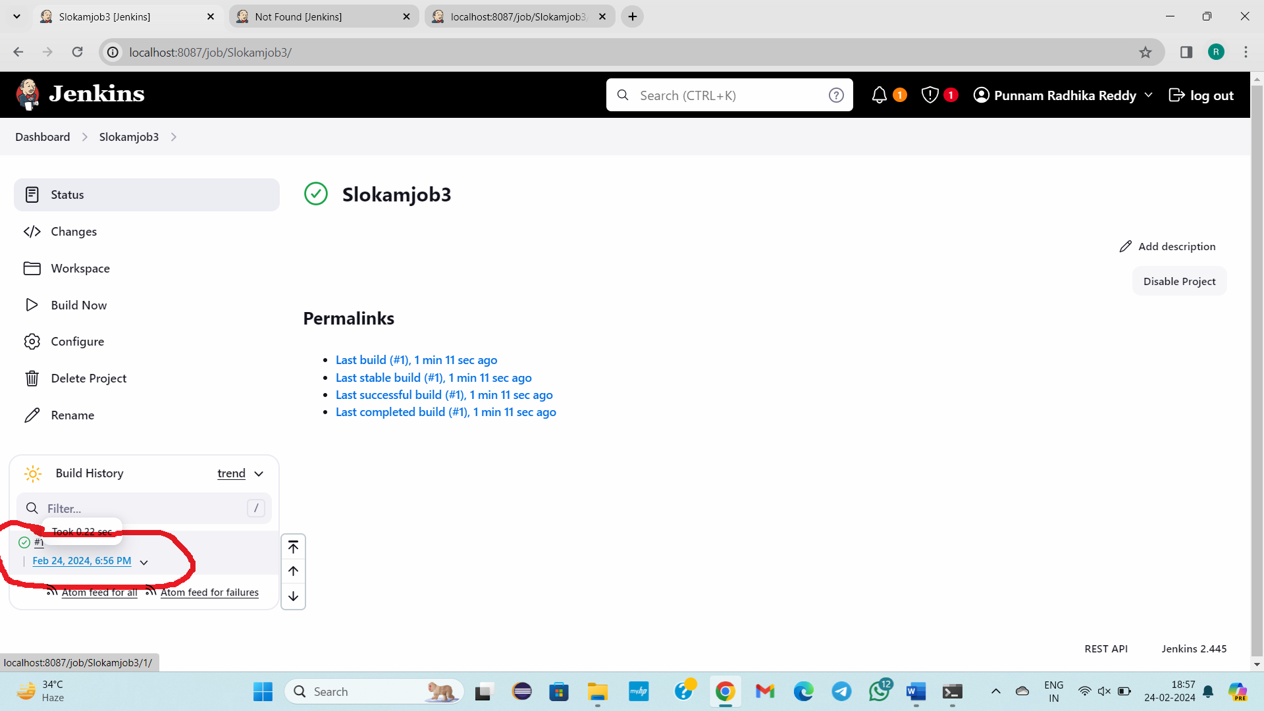

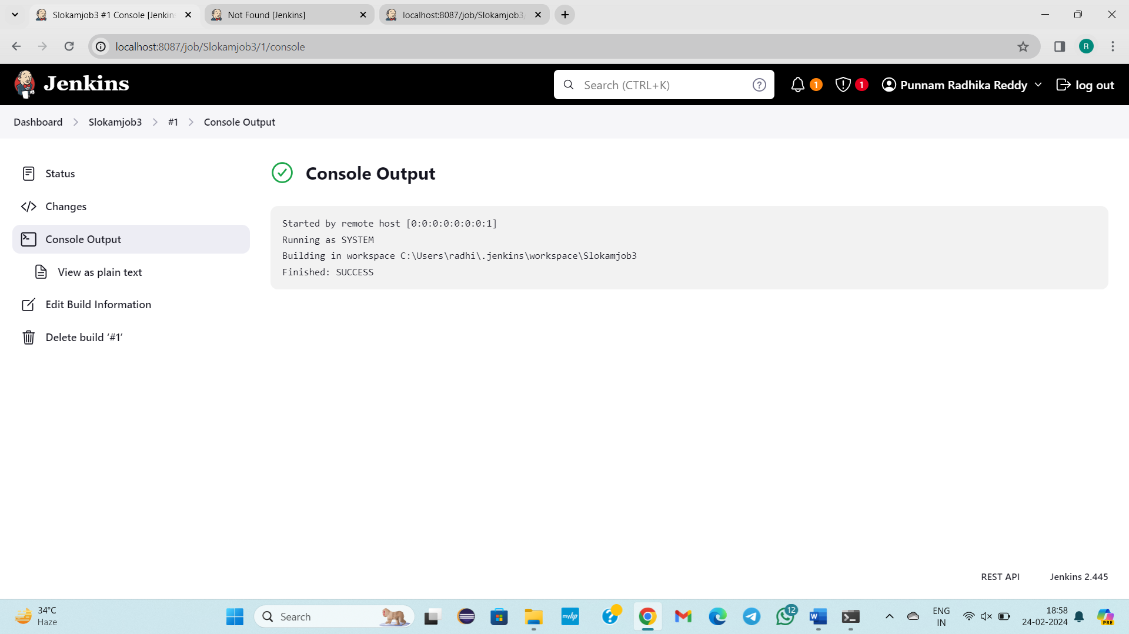

**4)** **Build after other projects are built**

Create a job in free style project slokamjob4,slokamjob5,slokamjob6

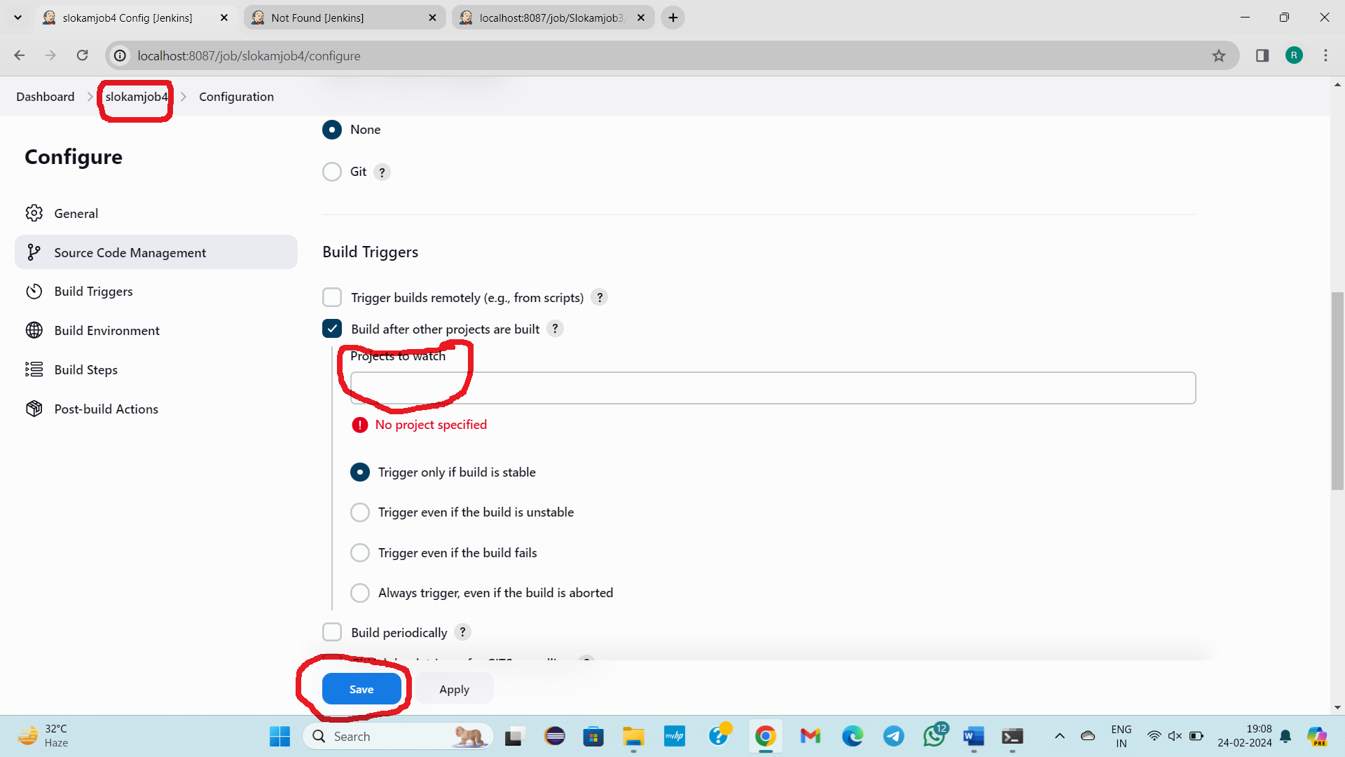

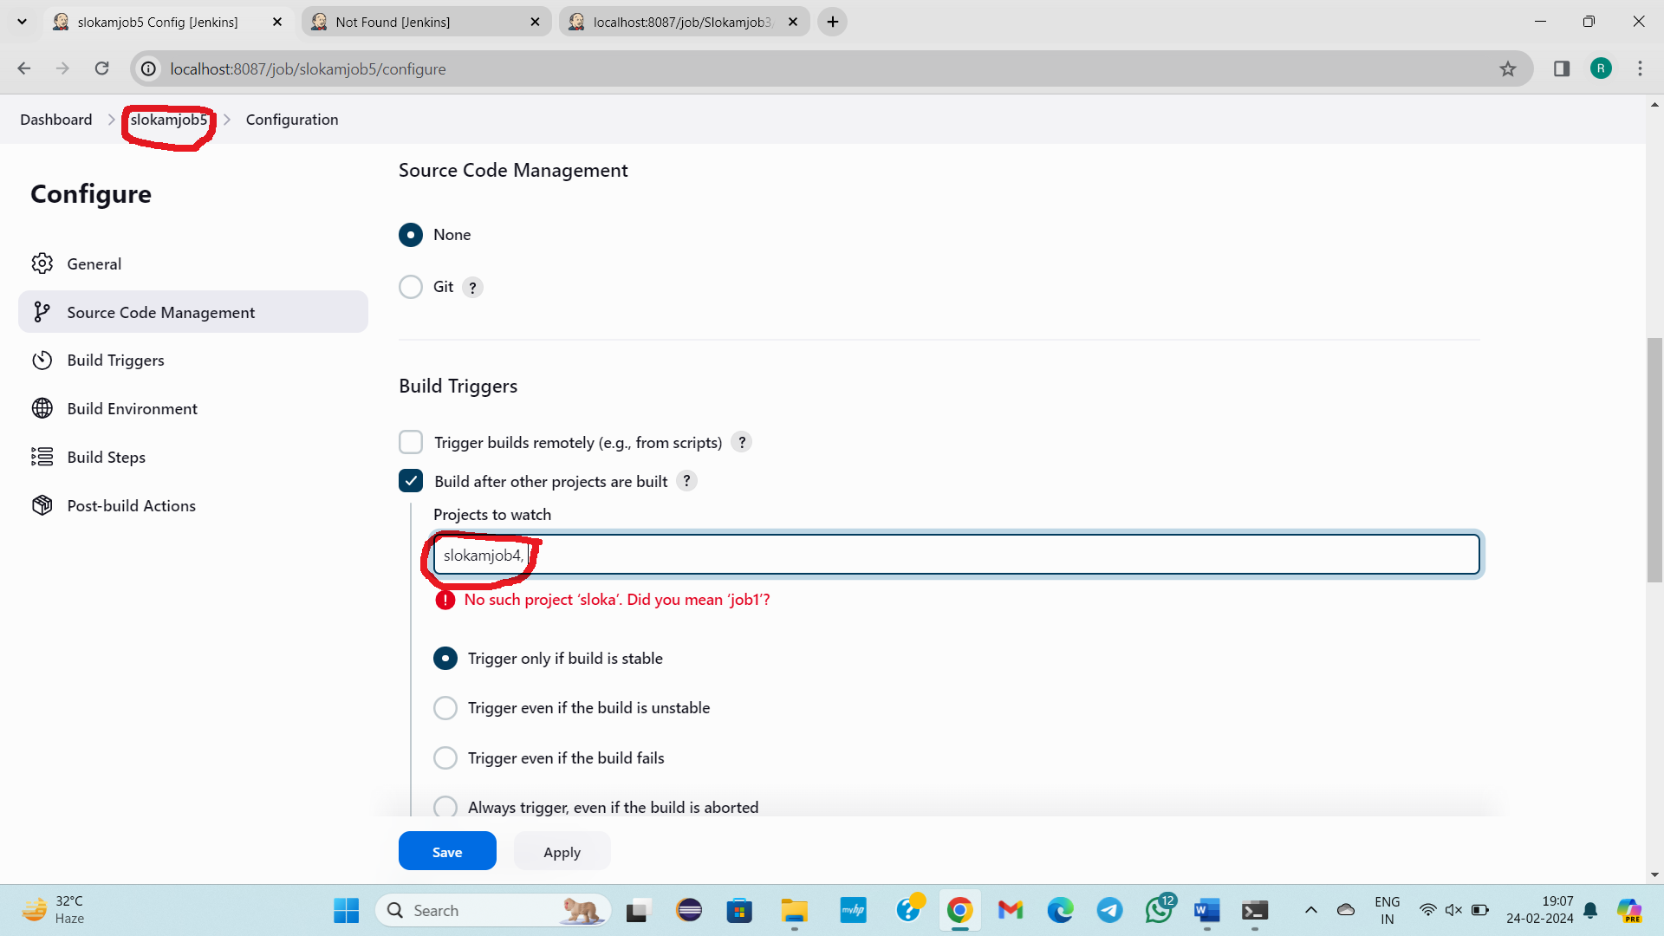

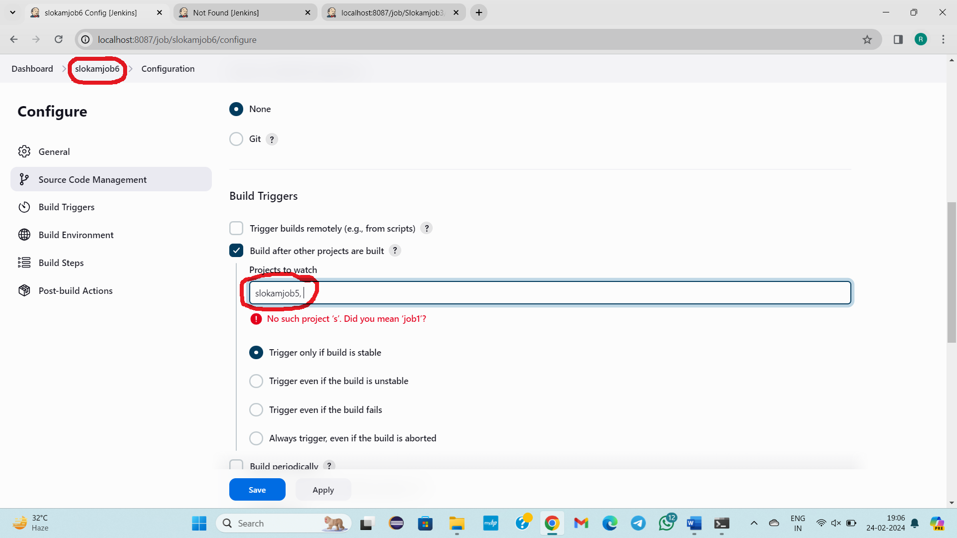

Now we need to build only slokamjob 4 manually sloakmjob5, slokam6 will build automatically.

When the slokamjob4 builds manually, then slokamjob4 automatically builds the slokamjob5.

When slokamjob5 is built automatically, then sloakmjob5 automatically builds the slokamjob6.

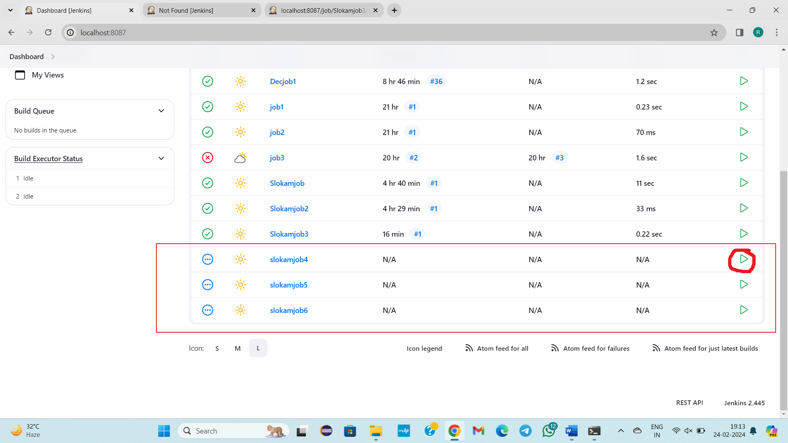

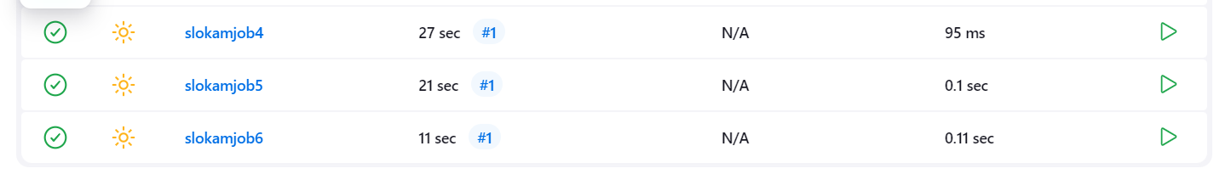

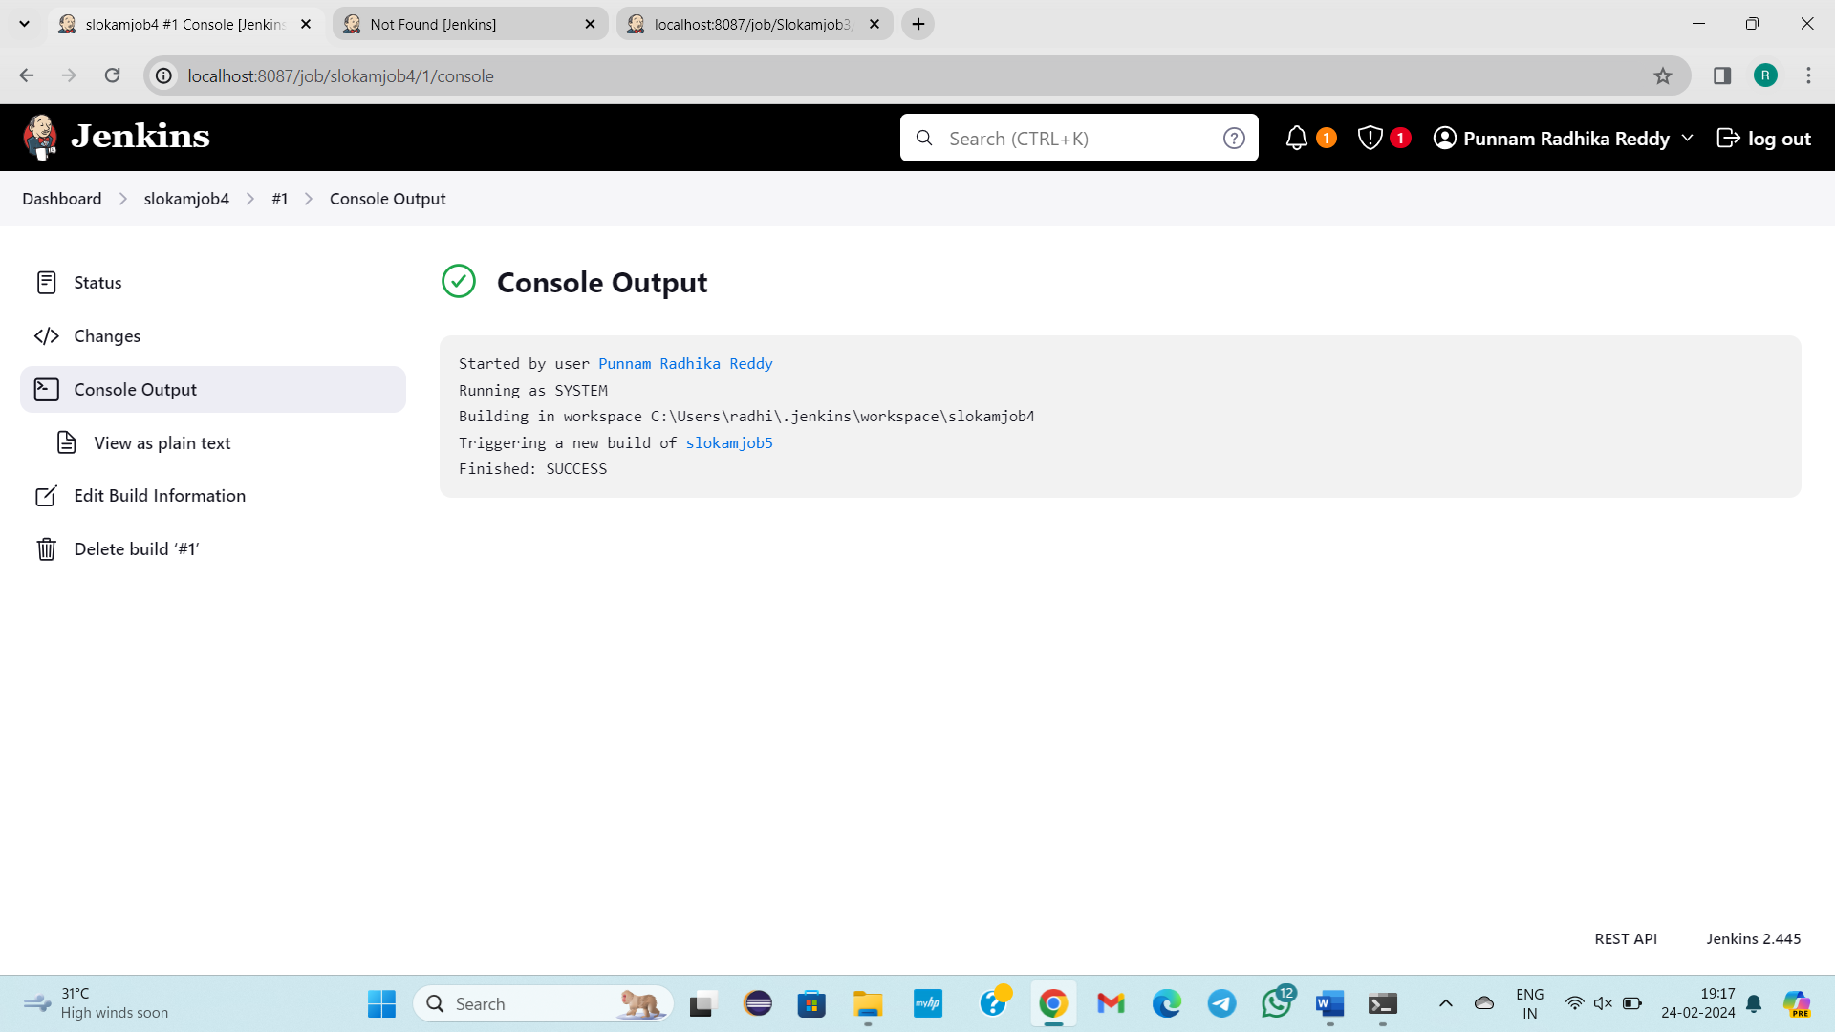

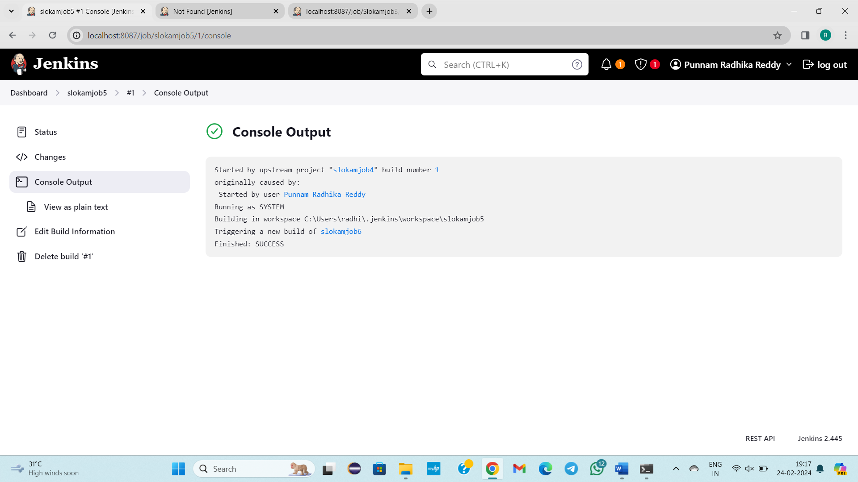

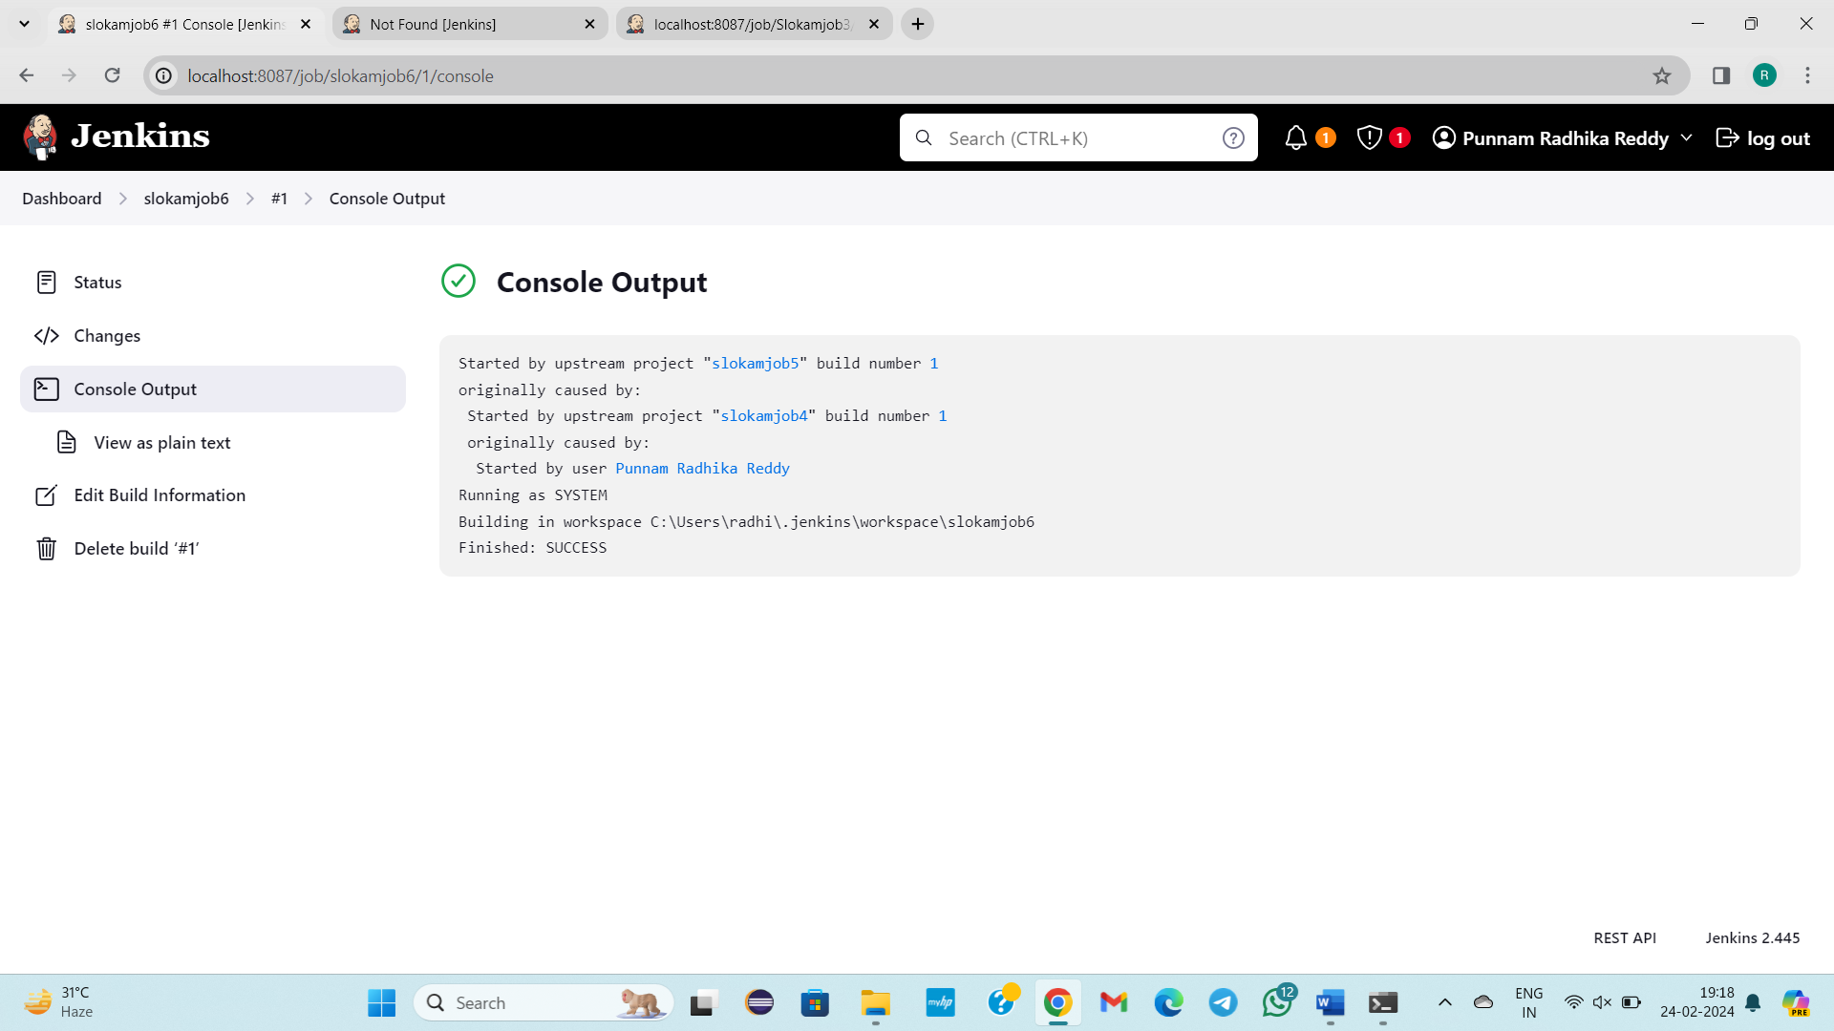

**5) Build periodically**

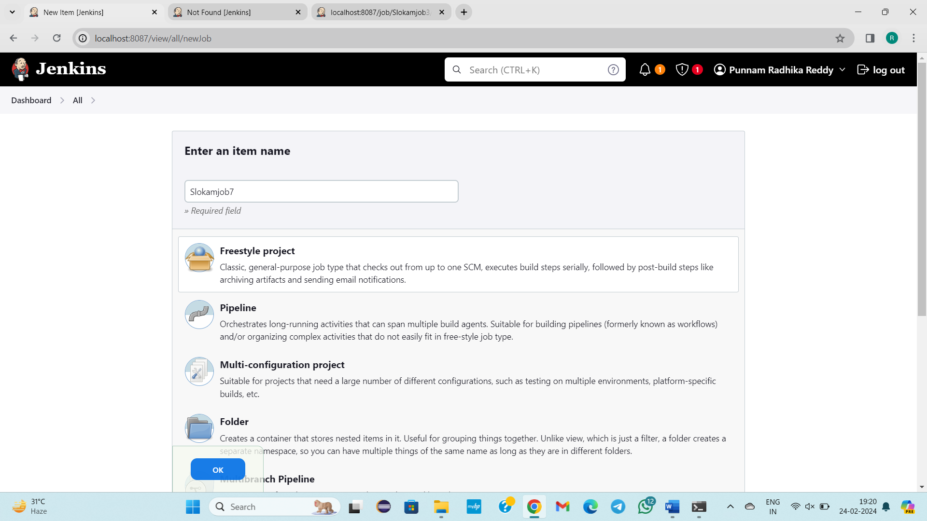

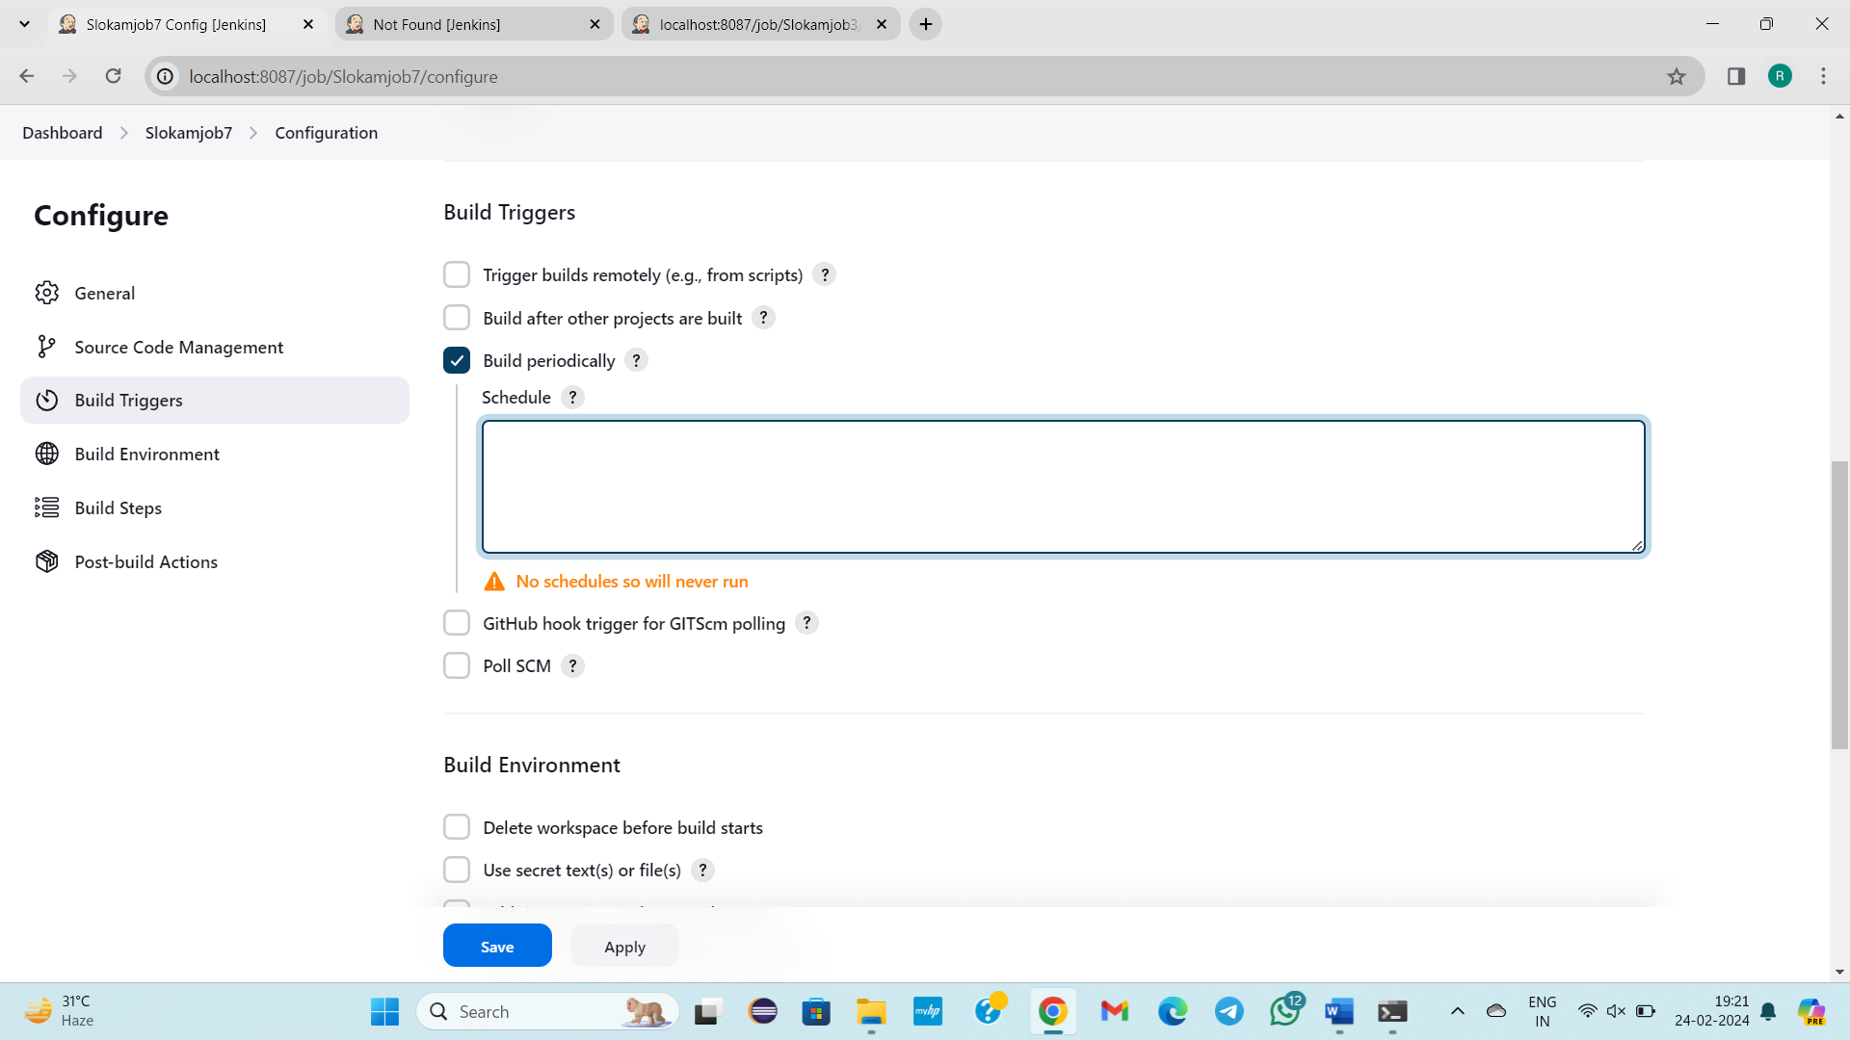

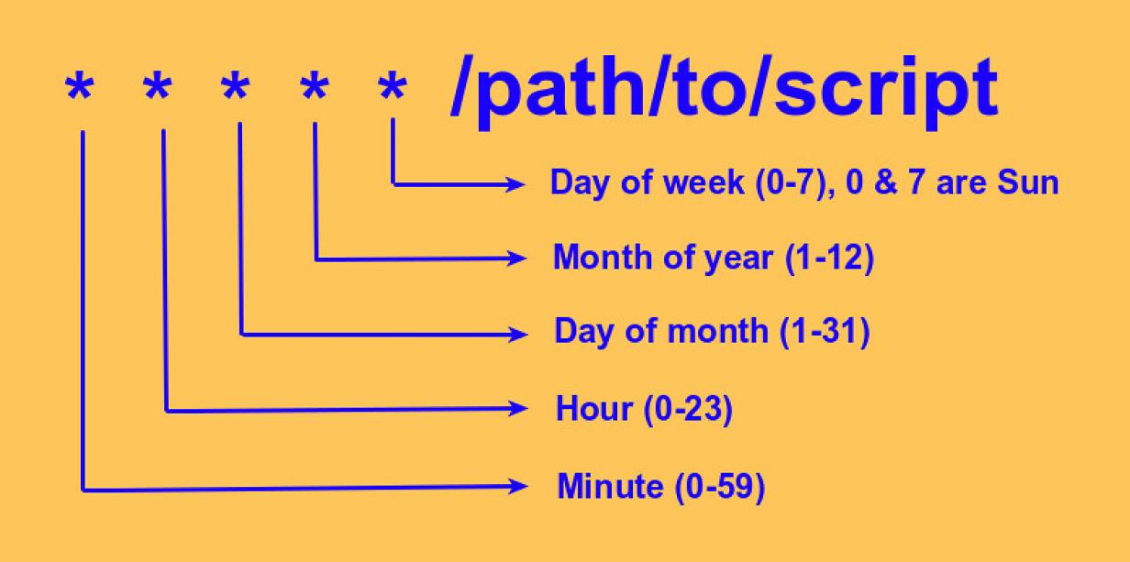

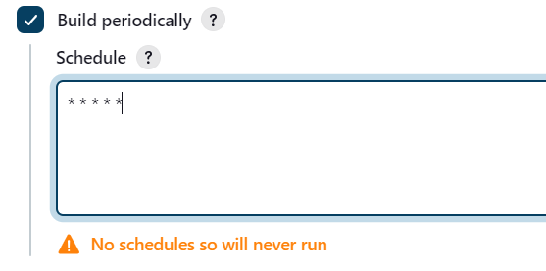[ OR ] 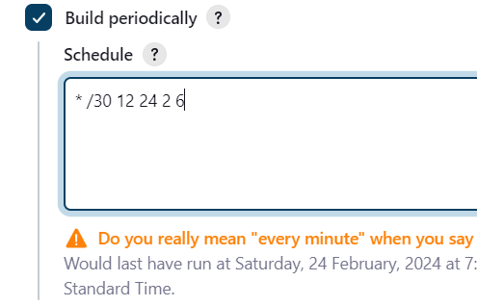

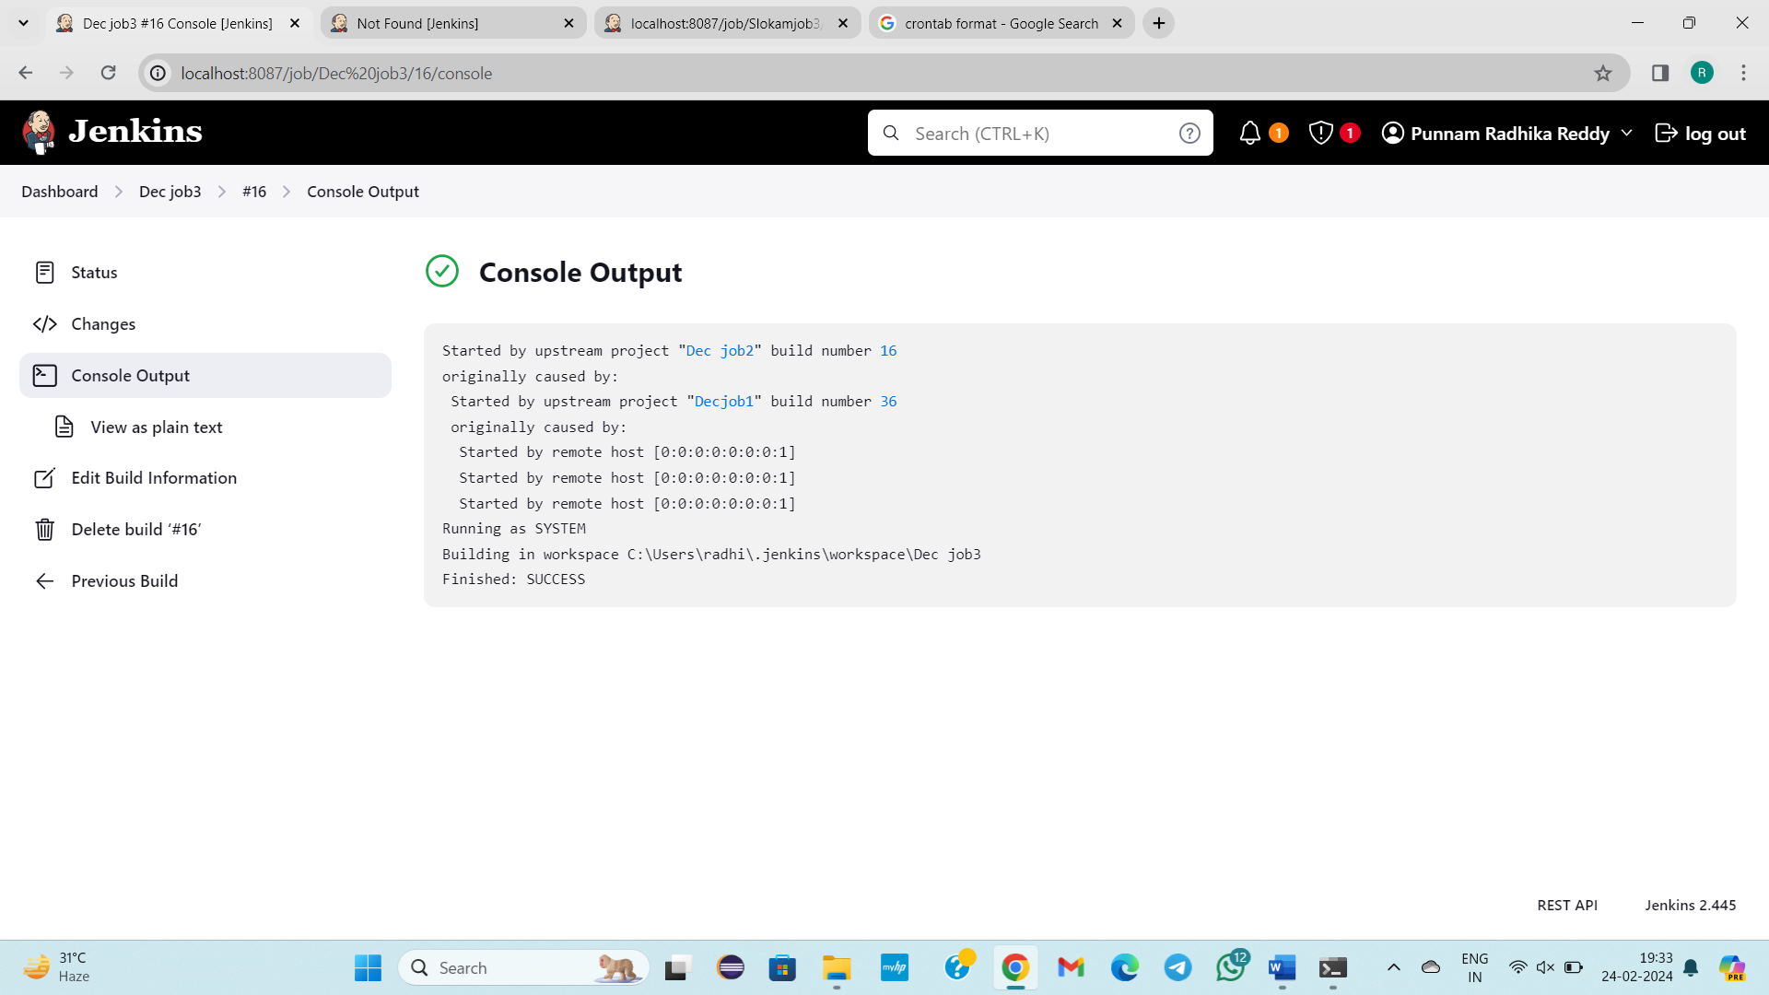

**--------------26/02/2024-------Monday------------------Class – 47-------------------**

**--------------27/02/2024-------Tuesday------------------Class – 48-------------------**

**-----------28/02/2024-------Wednesday------------------Class – 49-------------------**

**------------29/02/2024-------Thursday------------------Class – 50------------------**

**--------------01/03/2024-------Friday------------------Class – 51-------------------**

**--------------02/03/2024-------Saturday------------------Class – 52---------------**